Poem Learning System
Software Requirements Specification

Zhang Keke

Update history:
Time | Edition | Update | author | check
28/11/2012 | 1.00 | New | Zhang Keke | Zhang Keke

Introduction

Intention
After a brainstorm among the numbers of our team, we find that a system providing the ability to collect favorite poem lists and test oneself against new poems would be useful. According to our discussion result, we define the function of the system and draw some user case diagram. This document clarifies the non-function and function requirements. A software requirement specification (SRS) needs to be made so that developers can develop the project via it effectively. That is, the later work will be based on it.

Background
Many people are fond of Chinese traditional poems(唐诗宋词), but there isn’t a product that can help people collect and remember poems. Then we can create a website to help others read and search Chinese traditional poems. More importantly, this product provides both a convenient way to add poems to favorite lists and an efficient way to remember unfamiliar poems.

Definition of Terms
Terms | Explanation
SRS | software requirement specification
B/S | Browser/Server
Visitor | people who visit a site but aren’t logged in
User | people who visit a site and are logged in

References
Software Engineering: A Practitioner's Approach, Roger S. Pressman (Jan 20, 2009)

Task Overview

Target
- the overall design of system
- the requirement analyses of subsystem
- the development of source code of subsystem
- the test of subsystem
- systems integration
- the test of whole system

The types of users
- Visitor: People who enter this site occasionally or already registered in this site but aren’t logged in. They may just want to read a few poems or interested in a special favorite list.
- User: People who are fond of Chinese traditional poems and willing to add new resources to this site. They tend to collect a lot of poem lists and keep learning new poems.

Suppose and restriction
- A network has been prepared for the system. All the visitors and users can use this network.
- All the browsers have been connected to the server, and the server connects to the database.
- The users are good at editing articles online. They can use computer expertly.
- All the facilities run steadily.

System Overview

Use Case Diagram
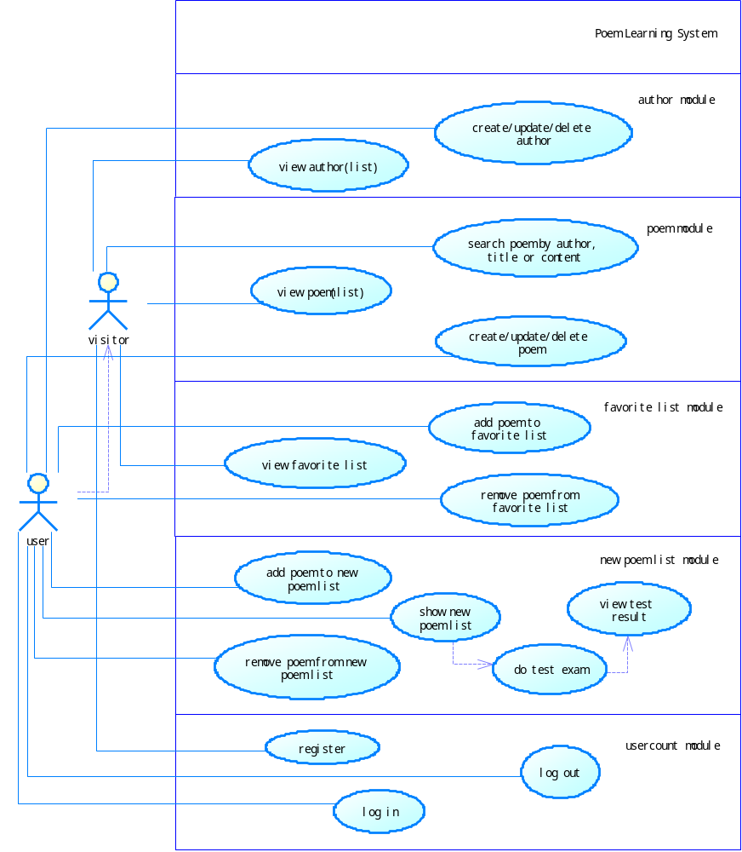
Visitor:
In “author(作者)” module, a visitor can view the information about the poet as well as his poem list.
In “poem(诗词)” module, a visitor can view the information about a poem, including title, poet, content, translation(译文), explanation(词语解释), appreciation(赏析).
In “favorite list(收藏列表)” module, a visitor can view other people’s favorite lists.
In “usercount” module, a visitor has to register an account in order to explore more.
User:
A user can do almost everything that a visitor does. As a prize for register, a user have the ability to do much more valuable things.
In “author” module, a user can create, update and delete authors, but the information about the user will not be recorded. I regard it as collective achievements.
In “poem” module, a user can create, update and delete poems, which is the same as author.
In “favorite list” module, a user can create and delete multi lists. The same poem can be put into different lists for some reason. Also, he can share his lists with others.
In “new poem list” module, each user has a list of new poems, which can be added by clicking the “add new” button in poem show page. Poems in the list will be taken for test in a special and efficient way. If a poem is passed in a test, the poem will be automatically added to “familiar poems” list.
In “usercount” module, a user can whether login or logout.

System Requirements Description

Functional requirements

author module
- CRUD of author.

poem module
- CRUD of poem. When adding or updating, we should check whether the author already exists.
- Search by author. If the author exists, then return the author show page, else return null.
- Search by title and content. Any poems match the string.

favorite list module
- CRUD of favorite list. Maybe we can add a share to weibo button.
- Add poem to a favorite list. It would be nice if the implement of this function is a dropdown list with check boxes in the poem show page.
- Remove poem from a favorite list.

new poem list module
- Add poem to my new poem list. A button in poem show page.
- Remove poem from my new poem list.
- Show new poem list.
- Fill new poem list. All the sentences in a poem should be split into an array of string, punctuations should not be included. Let’s take part of Liu Yong’s “雨霖铃·寒蝉凄切” as example: “多情自古伤离别，更那堪冷落清秋节。今宵酒醒何处？杨柳岸，晓风残月。此去经年，应是良辰好景虚设。便纵有千种风情，更与何人说！” After processing the poem, our array should be: [“多情自古伤别离”, “更那堪冷落清秋节”, “今宵酒醒何处”, “杨柳岸”, “晓风残月”, “此去经年”, “应是良辰好景虚设”, “便纵有千种风情”, “更与何人说”]. By default half of the array will be blanks, so we need a random function to accomplish the task. Then we can compare what the user filled against the array.
- Test result. According to the Ebbinghaus forgetting curve, we will mostly forget the thing we just learnt. So every poem in the new list should be answered correctly for at least 5 times. If the user login every day, then a newly added poem will be tested in the following 1st, 2nd, 4th, 8th, 16th day. In pseudo code, that is: if testday != today and (today – testday) > 2^count then test this poem. If the test count reaches 5 after a test, then the corresponding poem to ”my familiar list”.

usercount module
- Register.
- Log in. When we are adding actions, every action begin with a log in action.
- Log out.

Non-functional requirements

Data accuracy
- When search poems by author, the input field should be exactly the author and can’t have a little mistake, or no result will be returned.
- The create date and test date of new poem should accurate to day.

Security
- To make sure the data of poem learning system is secure and integrated, network must contain 3 levels of verification: communication, program, network.

Performance
All the operation should be done within 1 second.

GUI
The GUI should be vivid style, but superfluous pictures should be avoid to prevent misleading them.

Input
- Keyboard
All the inputs must obey the origin setting(length and valid characters).

Output
- Display to the screen.

Portability
Some part of the system should be coded as an interface.

Environment
User Interface: The user no special requirements, customized by developers (interface is unified appearance)
Hardware interface: Some basic facilities, such as CPU, Memory, Hard Disk.
Software Interface

