INTRODUCTION OF THE BUSINESS SUPPORT SOFTWARE

FINANCING – ACCOUNTING MANAGEMENT SYSTEM

“VINET SMES”
Business Accounting System

- Conforming with the “Small and medium enterprises accounting system” according to the Decision No. 144/2004/QĐ-BTC of the Ministry of Finance of 21 December 2001 for enterprises of all fields.
- Enterprises accounting system according to the Decision No. 15/2006/QĐ-BTC.
- Automatic setting up the latest VAT Reports of the Tax Department of Ho Chi Minh City.
- Total management of enterprises finance.
- Customized to the specific requirements of each enterprise.
- Using the standard Unicode font.
- Data ViNet SMEse administration system SQL Server 2000

I. OUTLINE OF OPERATIONS:

Built on the general operation model of production, business, service accounting system, B.A.S operates as followed:
- Operation outline:
PURCHASING
SALES
STAFF
ASSETS
GENERAL ACCOUNTING
INVENTORY
MONEY
FINANCE REPORTS
TAX REPORTS
MANAGEMENT REPORTS
REPORTS SETTING
DATAB.A.SE WAREHOUSE

- Detailed description:
  - Purchasing:

The Purchasing module controls all the transactions of buying goods, materials from suppliers; all the costs raised from purchasing of the company:
- Setting up and keeping track of Purchasing Orders.
- Storing data of suppliers and goods, materials related.
- Updating receiving information, Purchasing Invoices.
- Updating information of payables to suppliers.
- Making up Declaration of VAT input.
- Building the dataViNET SMEse of goods input.
- ViNET SMEsed on the buying information, the system will automatically carry updating good-out price
- Supplying data for general accounting which extract to all the forms and reports.
- The Purchasing Accounting module includes:
  - Making up Purchasing Invoice from suppliers.
  - Making up Buying Services Invoice.
  - Making up Returning voucher to suppliers.

  - Sales:

The Sales Accounting module control all the transactions related to the sales progress of company; keep track of turnover of goods sold, receivables of customers...:
- Receiving Sales Orders and setting up the orders tracking system.
- Updating information of goods, services, invoices, receipts...
- Supplying data for all the reports related to customers’ receivables, both in general and details.
- Making up Declaration of VAT output.
- Setting up data of goods sold.
- Supplying information related to turnover, VAT, receivables,...
- Supplying data for general accounting which extract to all the forms and reports.
- The Sales Accounting module includes:
  - Making up Sales Invoice to customers.
  - Making up Services Invoice.
  - Making up Returning voucher from customers.

  - Account Receivable/Payable:

The Cash Accounting module set up and store all the transactions related to the payment, receipt of cash; cash on banks... for the purpose of keeping track of the cash flow in company; beside that; it also connect to the Purchasing module; Sales module to control the A/R of customers, A/P to suppliers.
- Making up Cash Payment, Cash Receipt, and Order to Payment...
- Keeping track of the amount got from customers; the amount paid to suppliers.
- Supplying information for the General Accounting module.
- This module includes:
  - Making up Cash Receipt.
  - Making up Cash Payment.

  - Inventory :

The Inventory Accounting module set up and store imports, exports of goods and materials; keep track of inventory both in general and details; classify, update good-out price, then provide the timely and exactly the inventory of materials, goods in stores.
- Making up Inventory Receiving, Inventory Delivery of goods and materials.
- Keeping track of the quantity and values of import, export, balance of goods, materials.
- Supplying information for General Accounting module.

  - Payroll:

The Payroll module set up and store information of staff, HI fees, SI fees, Union fees... It also controls the fluctuation of workforce, set up Salary reports and then connects to the General Accounting module for all collective reports.

  - General Accounting:

The General Accounting module manages all the internal transactions of the company; the adjusted transactions and summarize all data from other modules to set up a dataViNET SMEse warehouse used for all necessary reports.
- Making up all internal transactions.
- Making up all the adjusted transactions.
- Updating good-out price.
- Posting data at the end of period.
- Summarizing data for all the necessary reports.

  - Assets Management:

The Assets Management Module helps you to control all the assets of your company according to departments, assets categories. It also keeps track of the depreciation of assets at the formula as specified.

  - Production Management:

This module may be separately designed or integrated with the General Accounting module of your company. It is used to control and calculate the cost price in details of your finished products. It will be customized to your company particular requirements.

  - Setting up reports:

The reports system is an essential module which is integrated with all the above modules. ViNET SMEsed on the data warehouse, this module provides a tool to design and extract all the reports suitable to the specific requirements of your company and your management system. The reports system classifies into 3 parts:
- Financial reports.
- Tax reports.
- Customized management reports.

- USING MANUAL:
  - Lists setting
  - Inventory List:
- Function: Setting up a list of stores, categories, items of your company (account 15)
- Content: including the follows:
        - Stores: a list of all physical stores.
        - Items Types: an enterprise (especially a factory) often have some normal items types as followed:
- Goods
- Finished products.
- Tools.
- Materials, fuel.
        - Items Categories: a list of all categories classified for easy management. Each item belongs to a certain category.
        - Items: this is the most important and detailed list of your company; on setting up this list, we should note the followings:
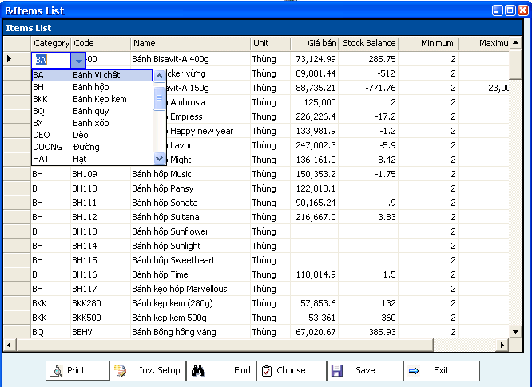

- Item Code
- Item Name
- Unit
- Maximum, minimum balance.
- Find items: click on “Find”, the system will allow you to find all the items stored:
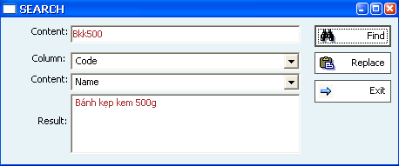

Choose the column need to be found, enter the content; the click “Find”, all the right values shall be found. You can research if necessary and display the total results found.
- Instructions:
        - Updating stores: coming into the Stores List, entering all the stores of company then save only on time.
        - Updating item types: coming into Item Types, entering all the item types of company then saving only one time.
        - Updating categories: coming into Categories List, each category must belong to a item type; entering all the categories then saving only one time.
        - Updating items: coming into Items List, each item must belong to a category, so we must choose the suitable category for each item; if the needed category is not available; click on “Add New” in the combo box.

  - R/P List
- Function: Setting up all lists related to R/P objects that do business with company.
- Content:
        - Sales Executives: a list of all sales executive of your company. Normally, each sales executive will be responsible for and area or a field of company.
        - Areas: each business area will be of the operation of one sale executive. Thanks to that, we can control not only the turnover of each area but also the turnover of each sale executive and then suggest the suitable bonus.
        - R/P Categories: setting up a list of all R/P categories for easy management.
        - R/P Objects: each R/P object is of a specific R/P category and of a specific business area; it includes all the customers, supplies who do business with your company.
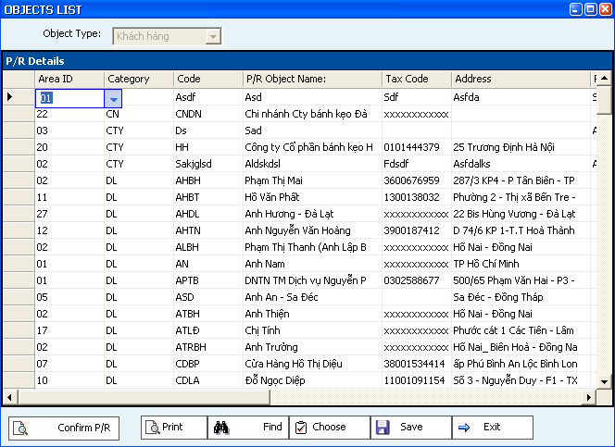
The followings should be noted:
        - Code
        - Name
        - Tax Code
        - Representative Name
        - Representative Position
        - Phone, Fax
        - Maximum R/P (amount, number of days)
        - Searching: similar as items searching.
- Instructions:
        - Sales Executives: choose the list of sales executives.
        - Business Areas: choose the Areas List, each area will be under management of one sale executive; this will help to control turnover, bonus of sales executive easily and simply.
        - R/P Categories: coming into the List of R/P Categories to making up all the suitable categories.
        - R/P Objects: each R/P object must belong to a specific R/P category and is in a specific business area.

  - Jobs:
  - Purpose: setting up list of all jobs as followed: expenditure, turnover, goods source, business types, contracts, building... which allow company to make up the jobs as requested.
  - Content:
        - Jobs Categories: classified by different management elements such as: turnover, goods, expenditure, contracts...
        - Jobs: all the jobs practically rose. Ex: Contract 02/01, 02/02...

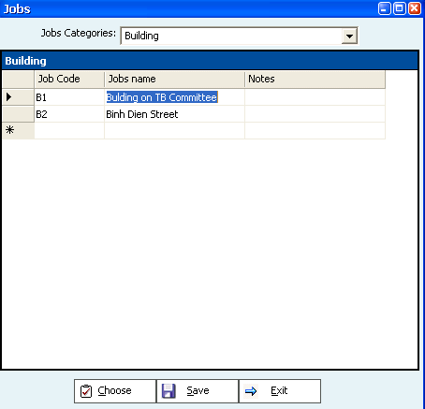

  - Instructions
        - Jobs Categories: choose 2.List -> 2.Jobs -> 2.Jobs Categories.
        - Jobs: choose 2.List -> 2.Jobs -> 1.Jobs. Each job will belong to a specific jobs category declared.
  - Chart of Accounts:
            - Function: making up the standard chart of accounts for company which is designed according to the Chart of Accounts of Ministry of Finance; you are entitled to change it if required.
            - Contents: The follows should be noted:
        - Account Code
        - Account Name
        - Account Level (1, 2, 3...)
        - Debit (N) or Credit (C) account.
        - Having child accounts or not? (the parent account could not be used directly on recording transactions)
c. Instructions: Choose 2.Lists -> 5.Accounts System -> 4.Chart of accounts

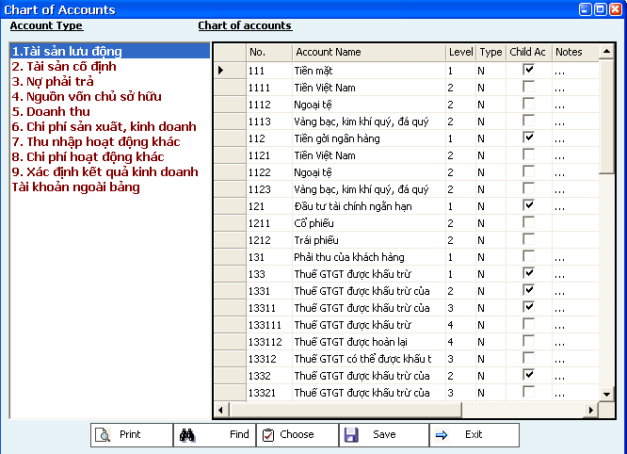

Searching accounts is the same as searching items or R/P objects.

  - User Permissions:
B.A.S support multi-user, so the Administrator can manage the right of all users on using this system upon to the accounting system of company.
    - Groups:
Setting up a list of groups, each group will assigned many functions of the accounting system.
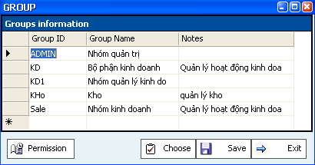

Coming into the Administration function, you will find 2 types of administration:
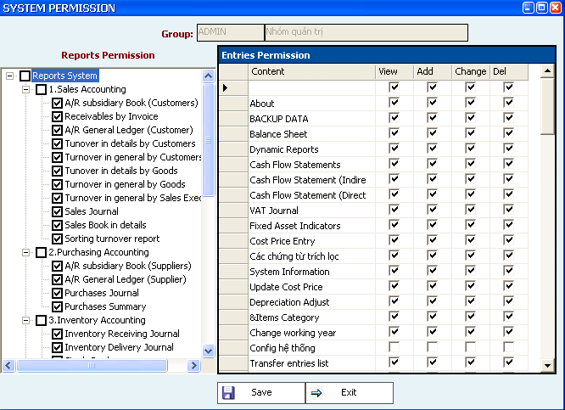

        - Entries permission: including a system of entries vouchers, the common lists for the accounting system. Each group is entitled to some specific functions upon to the assignment of administrator.
        - Reports permission: the reports system is classified according to specific transactions which allow the administrator to assign to each group, so guarantying the security of financial data.

    - Users:: each user belong to a specific group which has been assigned.

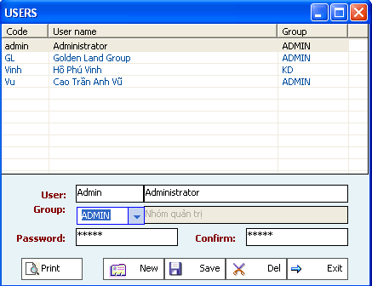

    - Instructions:
        - Groups: choose 1.System -> 1. Administration.
        - To assigned permissions to a group; choose this group, then click on “Permission”, the system provide 2 type of permissions:
- Entries Voucher: it allows users right of View, Add New, Change or Delete upon to the requirement of the Administrator.
- The system of reports to be kept track of.
- Choose the function permitted, click on “Save” to save all changes having been made.
        - Users: choose 1.System -> 2.Users List; updating all information about users. Each user belongs to a group; so you must enter the group of any users to be added.

      - Transactions Entry:
- Functions: this is the main function of the accounting system which takes charge of all the daily transactions, all the vouchers, invoices, receipts… All the forms are classified into the suitable modules; despite of the difference in contents, all the forms have the following general fields:
        - Code: automatically increasing ViNET SMEsed on the number of vouchers.
        - Input Date: the date of entries.
        - Voucher No: the original voucher number (Ex: invoice no, Delivery Note no, Receipt No…)
        - Voucher Date: the date of original voucher.
        - Payment method
        - R/P Objects: customers, suppliers, employees… from the declared list.
        - Jobs: the detail of all the jobs declared.
        - Content: the description of the transaction.
- Details:
      - Description: the name of goods, materials; the content of the transaction.
      - Amount: the amount rose of the transaction.
      - Debit Account: the debit account of the transaction.
      - Credit Account: the credit account of the transaction.
      - Except Cash Flow, all the fields which are got from the declared lists (Ex: items, R/P objects, account…) have a combo box allowing the user choose the suitable values.

- General operations:
All the forms contain new information, customers, suppliers, items, stores, jobs… which are firstly declared. All the information from the declared lists must be exactly entered; otherwise, the accounting system will display the needed lists which allow the users to get the right values.
The followed operations can always be performed:
      - Add new: click on “New” to add a new transaction.
      - Save: after entering all the content of the transaction, click on “Save” to store all of them into dataViNET SMEse warehouse.
      - Delete: if the transaction is incorrectly entered; you can delete it by clicking on “Delete”.
      - Exit: exit away from the form.
      - Print form: allowing printing the forms as: Cash Receipt, Cash Payment, and Delivery Note…

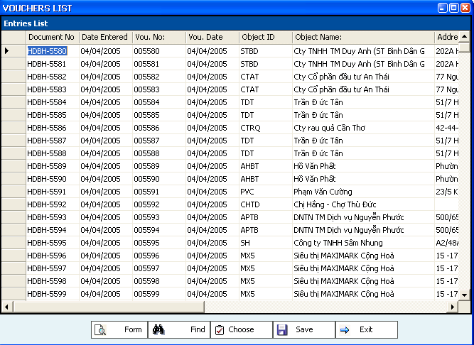

The searching of a voucher is similar as the searching of other items.
And now we shall come into the details of all the functions of the accounting system.
  - The main modules
    - Inventory: control delivery, receiving of goods, materials, fuels, finished products...
            - Inventory Receiving Entry:
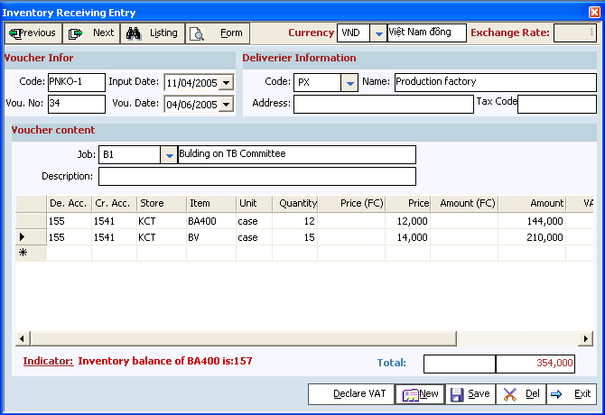

The Inventory Receiving Entry is often used in cases:
        - Receiving finished products from factory.
        - Receiving redundant materials, fuel... from factory.
        - Receiving goods, materials from subsidiary.
        - Deliverer information: entering all information about the deliverer including:
- Code: if you wish to keep track of the suppliers or the goods source, you must enter the code of the deliverer which has been declared before in the R/P Objects List (suppliers).
- Name, address, tax code
- With this entry, the Debit Account is always the inventory accounts (152,153,154,155,156), the Credit Account can be 621, 627, 336, 154…
  - Inventory Delivery Entry:
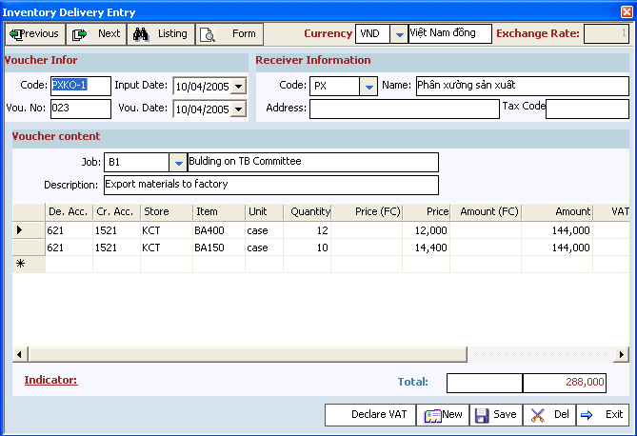
The Inventory Delivery Entry is often used in cases:
        - Exporting materials, fuels, tools to factory.
        - Re-exporting finished products which are made as input materials to factory.
        - Delivering goods, materials, finished products to subsidiaries.
        - Deliverer information: entering all information about the deliverer including:
- Code: if you wish to keep track of the customers, you must enter the code of the receiver which has been declared before in the R/P Objects List (customers).
- Name, address, tax code
- With this entry, the Credit Account is always the inventory accounts (152,153,154,155,156), the Debit Account can be 621, 627, 336, 154…
In values, this entry often has no price of exported materials or goods and the amount raised is ViNET SMEsed on the items’ cost price. The accounting system will update cost price and amount of the entry according to different method of calculating cost price.
    - Sales: control the sales of goods, services and output VAT attached...
            - Sales Invoice (Item):
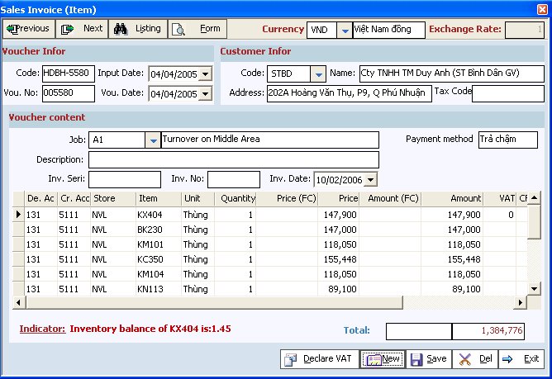
Besides the normal information of one entry, for the Sales Invoice we should note:
        - Customer information: you must enter the information of the customers because it is very important and necessary to keep track of the A/R of all the customers buying your goods.
        - Invoice information: for each invoice exported, you must supply information about it as: invoice number, invoice Seri, invoice date which are ViNET SMEsed on the latest invoice. Certainly, you have right to change it if required.
        - Cash flow (CF) information: for the company using the Direct Cash Flow method, you must supply the CF Code once the entry has cash account or banking account.
        - VAT: for each Sales Invoice, after entering all the items, you must enter the information of the requested VAT.
        - Cost Price Entry: on saving sales invoice, the accounting system will require you to post the cost price entry:
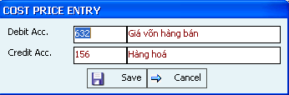

The characteristic of the entry will regulate the account to be posted; the Debit Account is often 632; the Credit Account is 155 (for finished products) and 156 (for goods). At the end of period, the accounting system will calculate the cost price upon to different type of Cost-Price Calculation (FIFO, LIFO, Average...)
For Sales Invoice, we can print out the Invoice which we has registered the Ministry of Finance in 3 copies; or print out the Cash Receipt if payment on cash.

* Making up the Declaration of VAT (output, input): click on “Declare VAT”, the accounting system display the form which allows you to enter information of the related VAT.

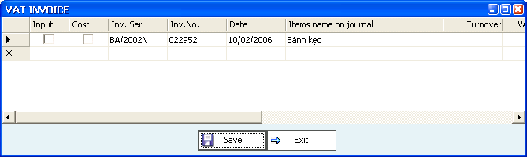

All the information of VAT will be ViNET SMEsed on the initial entry as:
        - VAT account (133, 3331...)
        - VAT amount ViNET SMEsed on VAT rate and turnover.
        - Description
        - A/R name, address, tax code...

Sales Invoice (Service):
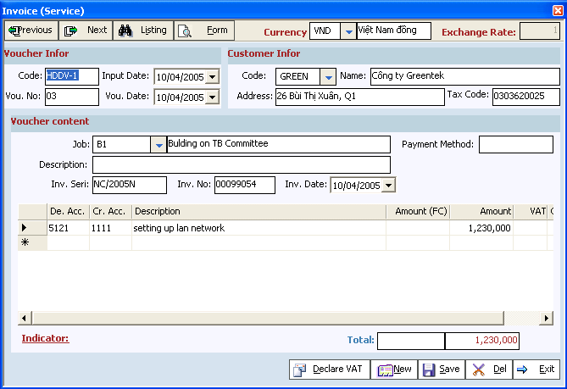

        - Sales Invoice (service) is applied for services companies. Actually, this voucher can be replaced by Receipt Voucher if we have no need to print out invoice directly from computer. So that, we rarely user this voucher but using a receipt voucher in case we get directly cash from customers.
        - Similar to sales invoice (item), we also must enter information of invoice and declaration of output VAT.

Return Inward Entry:
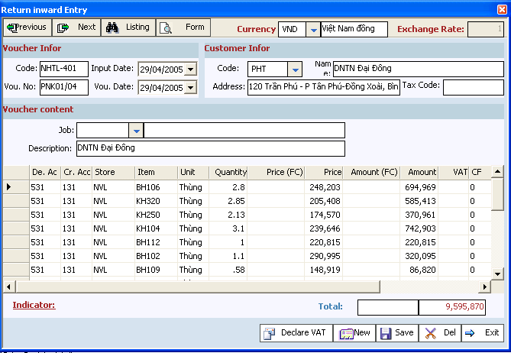
        - When goods is returned, we will enter as sales; your company can use this voucher or not upon to your requirement. Normally, the returning is made by a cancel entry of old invoice; we will find the old invoice, then change all the quantity, turnover, VAT to 0 which is made at a no value invoice.
        - On using this voucher, the Debit Account is 531 or 511; the cost account entry is Debit Account 155, 156; Credit Account 632.
        - For this voucher, we can print out the Receiving Note; print out Cash Payment if directly returning cash to customer.
    - Purchasing:
This module is similar to the Sales Accounting module with 3 main functions:
        - Purchasing Invoice (Item): used for buying goods, materials, fuel...
        - Purchasing Invoice (Service)
        - Return outward entry: returning goods to suppliers.

    - Account Receivable/Payable:
The Cash Accounting module is responsible for all the transactions related Cash (111), Banking (112), Cash on run (113) which are mainly related to payment, receipt...

            - Cash Receipt:
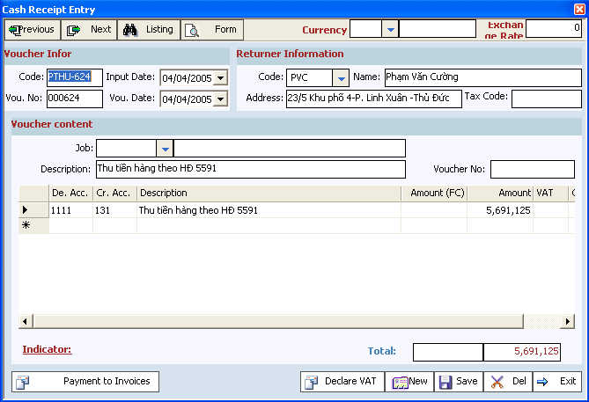

The Cash Receipt Entry performs the followed transactions:
      - Receiving money from customers.
      - Receiving month from other source such as: business contribution, assets liquidation...
      - Receiving surplus advance from staff.
      - All other transactions raise cash budget of company.
      - All these transactions shall be summed up to transfer to Cash Book or Cash Journal.

            - Cash Payment Entry:
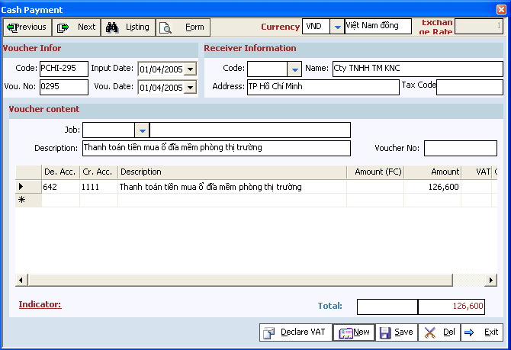

The Cash Payment is similar to the Cash Receipt. It is often applied for the followed transactions:
      - Outside used services.
      - Internal payment: salary, advance...
      - Payment to suppliers
      - Transactions raised shall be summed up to transfer to Cash Book, Cash Journal.
            - Order to Payment:
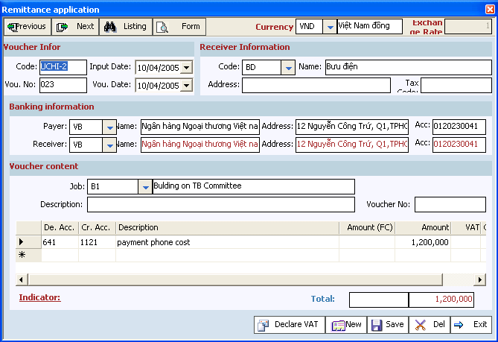
            - Banking Payment:
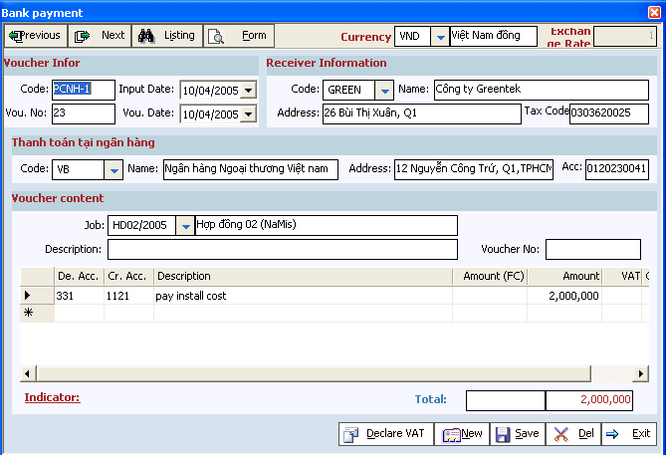
            - Bank Receipt:
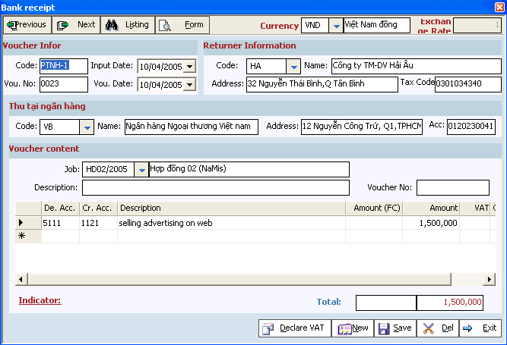
    - Assets Management:
Function: controlling and keeping track of the depreciation of all type of assets of company and monthly extracting depreciation into the general accounting module.
Content: containing the followed lists:
      - Assets Types: enterprise often have 2 types of assets: Tools and Fixed Assets; depending on the value of the assets, we can classify them into tools or fixed assets.
      - Assets Categories: setting up a list of all assets categories to be controlled.
      - Management Section: all the departments which take charge of the assets.
      - Assets List: making up the list of all the assets which include date of production, price, depreciation method... ViNET SMEsed on this information, the accounting system will automatically calculate the depreciation and monthly transfer to the general accounting module.
Instructions:
      - Assets Types: allowing you to control many types of assets of your company which by default includes: Tools, Fixed Assets.

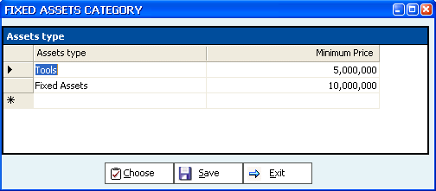
      - Assets Groups: we often classify assets into many groups to help us easily control and keep track of our assets:
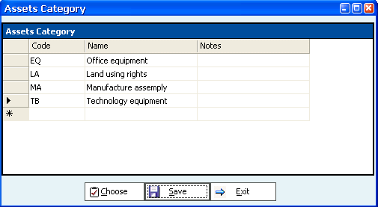
      - Management Section: updating all information of the sections which mange the assets.
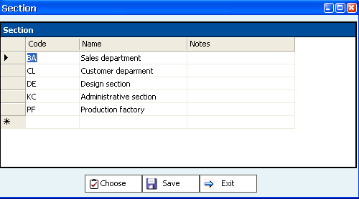
      - Assets List:
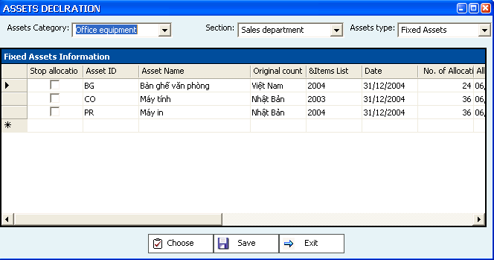
      - Assets declaration: the followings should be noted:
- Stop allocation: if the asset is early liquidated, used to contribute, it will not be allocated anymore; so you must check this box to stop depreciation of this asset.
- Assets Code, Name
- Year of production, Country of production.
- Using date: the date to be used.
- Number of allocation month: the number of months which this asset will be allocated.
- Depreciation month: the beginning month of depreciation.
- Allocated Account: the Credit Account on allocation which is often 242 for tools; 214 for Fixed Assets.
- Cost Account: the Debit Account on allocation.
- Price: the price of the assets.
- Quantity: the quantity of the assets.
- Amount: Price * Quantity.
- Allocated Amount: the amount which has be allocated; it is the case of the asset having been allocated before applying this accounting system.
- Transferring content: the description of transaction on transferring.
      - Assets Depreciation Adjustment: By default, the depreciation of the assets are automatically calculated ViNET SMEsed on the information having been entered; however, you will require to round the numbers within a month to satisfy your specific cases.
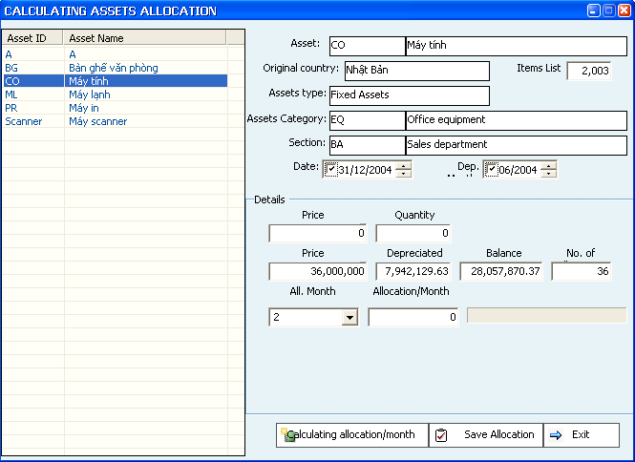
- Click on “Calculating allocation/month” to help the system automatically calculating the depreciation of all the assets in month.
- If you wish to change to allocation amount; change it, then click on “Save allocation” to accept this adjustment.
- Posting depreciation: at the end of month, you will post all the depreciation into the general accounting module for the trial balance.

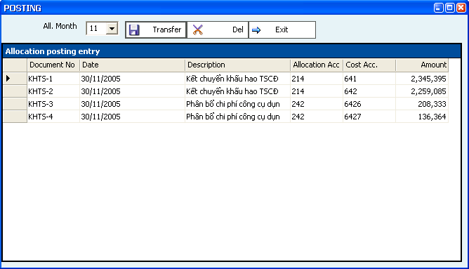
      - Assets Report:
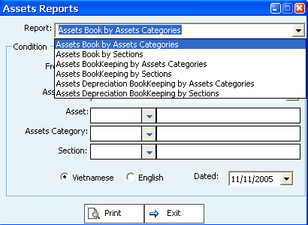
The assets reports are classified into 3 types:
- Fixed Assets reports.
- Tools reports.
- You can choose the suitable criterion to make up the reports as required. By these criterions, you can view summary, details of all the assets within the certain time.
    - General Accounting:
The general accounting module performs the following functions:
            - Internal Entry:
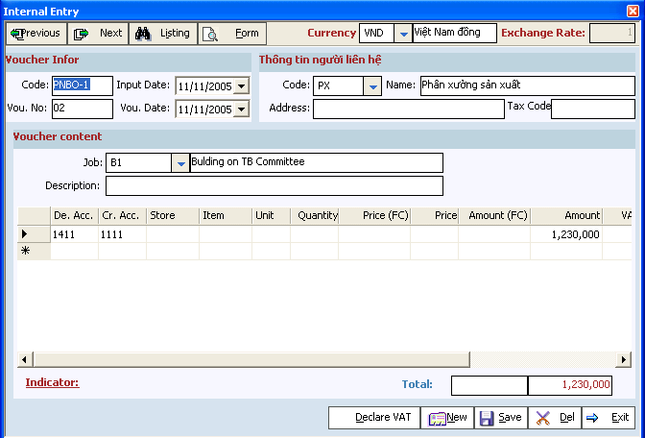
The internal entry is often used for the transactions which are raised within your company, the posting action, differential balancing, adjustment... Normally, the internal entries can substitute the receipt, payment without affecting the result of the accounting system.

            - Cost Price Updating:
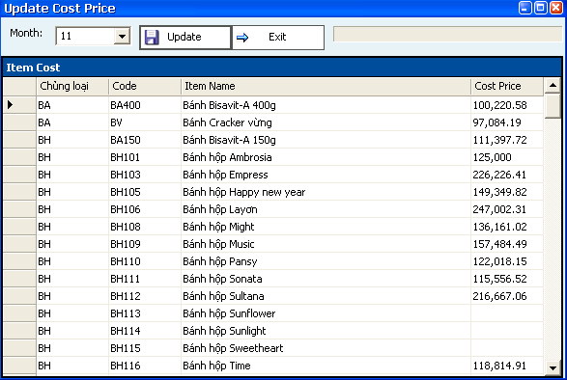
      - This action calculates the cost price of all the good-out, materials exported to production... Just clicking “Update”, the accounting system will automatically calculate cost price for all the goods-out within month.
      - To this function, the Administrator can regulate the content of updating by using function: 2.Lists -> 6.General Management -> 1.Cost Price Entry:
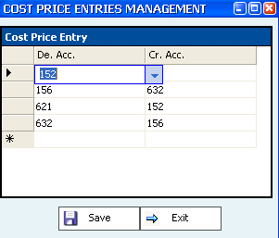
      - The followings should be noted:
- Debit Account: the debit account of the cost-price entry
- Credit Account: the credit account of the cost-price entry.
- For example: Debit Acc: 156; Credit Acc: 632 for selling goods; Debit Acc: 152, Credit: for exporting materials to production.

- Transferring action:
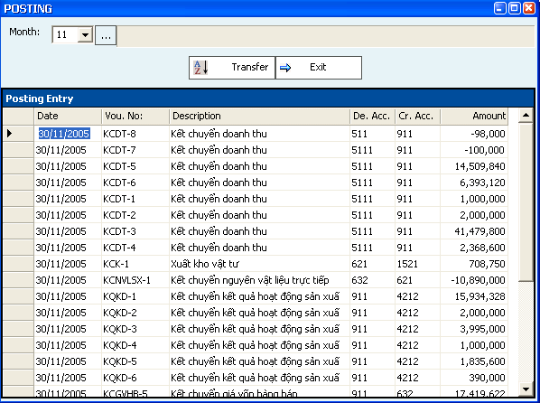
      - At the end of month, we will carry on all the posting entries which balance all the un-surplus accounts (Ex: 632,641,642 -> 911; 511 -> 911; 911->421...). Choose the month to be posted; click on “Transfer”, the system will automatically perform all the necessary actions. Instead of using this function, you can use the Internal Entry to handily perform all the postings.
      - With this function, the Administrator can set up the process and the way to posting the data by using function: 2.Lists -> 6.General management -> 2.Posting:
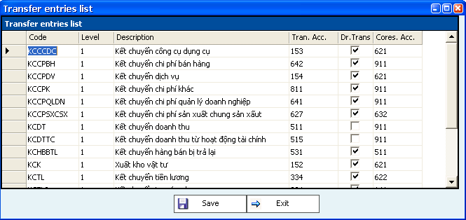
The followings should be noted:
      - Code: the code regulated for each posting action.
      - Level: depending on the order of posting. For example:
        - 621, 622, 627 -> 632: Level 1
        - 632 -> 911: Level 2
        - 911 -> 421: Level 3
      - Description: the content of the posting.
      - Tra. Acc. The account that the surplus will be posted.
      - Dr. Trans: regulating the posting from the balance of Debit Account or Credit Account.
      - Corres. Account: the account to be posted from the balance of Tra. Acc.
- Funds Extraction:
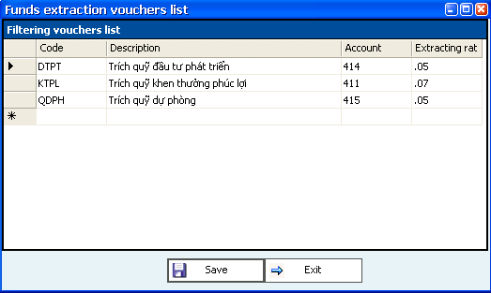
Normally, at the end of year, each company will extract some funds to an extent rate. In the end of fiscal year (31/12), you can come into 3. Accounting Entries -> 5. General Accounting -> 4.Funds Deduction to perform the automatically extraction of all his funds.
You can yourself manage all the information of the extraction by coming into 2.Lists -> 2. General Management -> 4. Funds Management to regulate all the suitable extracting forms:
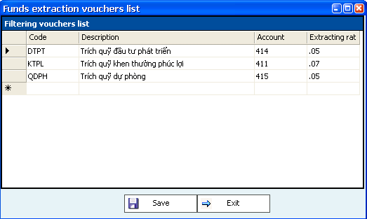
The followings should be noted:
- Code: the code of the extraction entries regulated by users.
- Description: the content of the extraction entries to be transferred to the accounting journals.
- Account: the account of the funds to be extracted.
- Extracting rates: the rate of funds extracting.

- Summarize data:
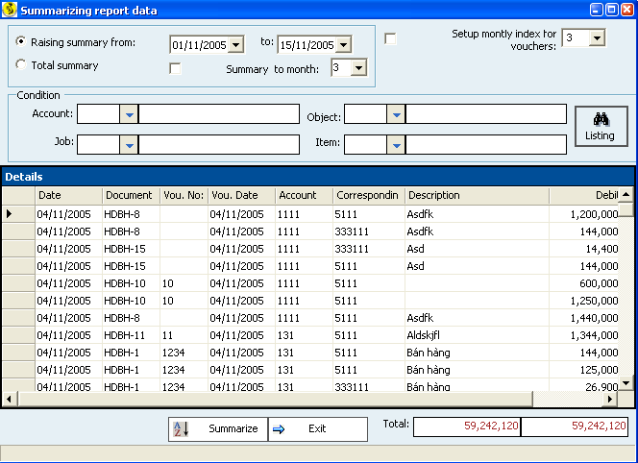
      - The data are from different types of transactions. To make up the end-period books, we must summarize data from all of these transactions. Choose the month to be summarized, click on “Summarize”.
      - There are 2 kinds of summarization:
        - Summarization within a period of time by choosing the time, then click on “Summarize”. This method is used once we perform a transaction or carrying transactions within some days.
        - Total summarization: when the enterprise wish to check the entire data, this function will fasten the summarization.
      - We can shortly view the raisings of:
        - Accounts
        - R/P Objects
        - Materials
        - Jobs
By choosing the field to be viewed, the click on “Listing”
- Locking and Unlocking:
      - At the end of month, after printing out all the reports as well as necessary forms which are all correct; the Admin have a right to lock all the accounting data of this month. Once the data has been locked, the users only view the raising data without the right to edit or change this data.
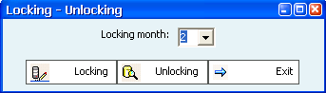
      - Choosing the month to be locked, click on “Locking” to lock all the data of this month.
      - On raising the demand of editing the locked data, you must unlock the data by choosing “Unlocking”.

    - Payroll:
            - Making up the list of employees:
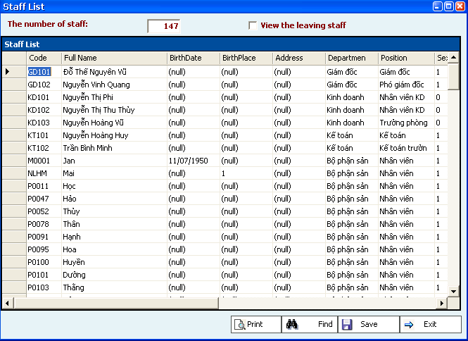
This function allows you to set up the list of employees, information about employees, the leaved employee... The followings should be noted:
      - ViNET SMEsic Salary
      - SI Rate
      - HI Rate
      - Labor Union rate
      - Actual Receiving Rate after deducting all the above extractions.
      - This list is used to calculate the monthly payroll of staff (except the leaved employees before the date of making up the payroll)
            - Setting up Monthly Payroll:
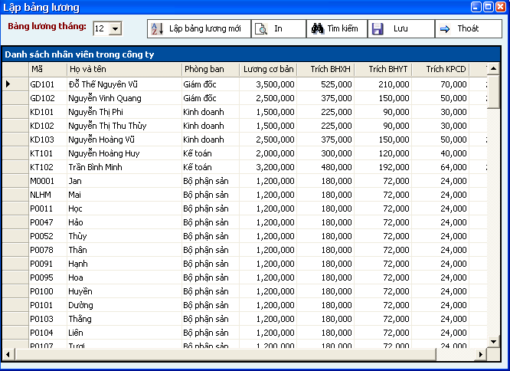
At the end of period, the accounting system allows you to calculate the actual receiving salary, the extraction of each employee. If there is any change within month, it will redo to make adjustment.
            - Salary Receipt: The Salary Receipt is just the Cash receipt which is used to pay salary to employees.
            - Salary Reports:
You can print out all the forms of salary, the SI Reports, HI reports, Labor Union Reports at the government’s requirement.
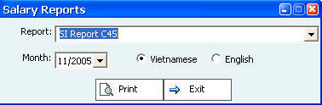
    - System administration:
- Change password:
Each user has the right to change his password to protect him from other non-allowed entrance to the accounting system.
Coming into 1.System -> 3.Change password, the following form will be displayed::
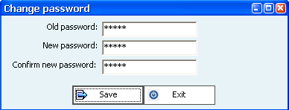

You must enter your old password; then entering new password and confirming the new password. Click on “Save” for the change of your password.

- Dictionary:
At present, “VINET SMES” support 3 official languages Vietnamese – English – Chinese. The special characteristic is that the user has the right to set his definitions for all the sentences of the accounting system for his performance by choosing 1.System -> 5. Dictionary.
Each Vietnamese sentence will be correlative to an English sentence and a Chinese sentence. You can change the sentence or even change the language to be used. Technically, thanks to Unicode supporting and the customization of this dictionary, you can apply any language being used.

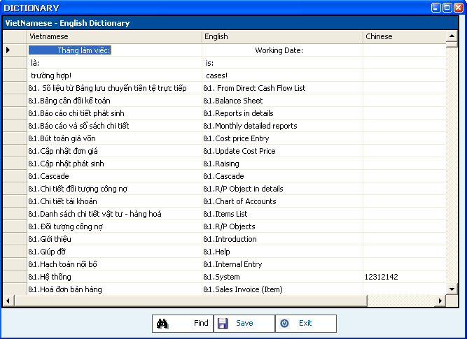
- Working date:
As default, on logging the accounting system, the present date will be got and it will be used for all the entries of “B.A.S”. Therefore, for the company with not many raising transactions, or the company wishing to recheck data of the previous months, you can change the working on logging or directly change the working date of the system by coming 1.System -> 6.Working date:
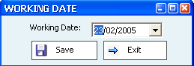
Changing the working date, then choosing “Save” to accept the changing.
- Change working year:
At the end of a year, you must transfer all the ending balances of the present year to the next year by coming 1.System -> 6.Change working year:
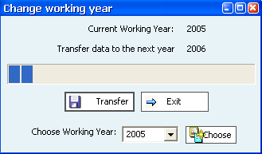
Choosing “Transfer” to help the accounting system automatically transferring all data year – to – year. On completing the transferring, you can choose the new working year in the combo box, then clicking on “Choose” to work on other year.
- Language:
You have the right to use your suitable language on your client program by coming 1.System -> 8.Language:
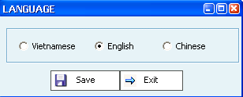
Choosing your language, click on “Save” to accept the new language.
- Transactions Management
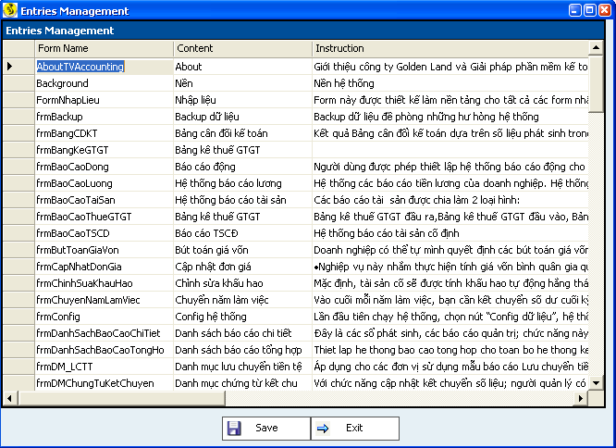
With this feature, “B.A.S” allows the users the highest interaction capacity to all the functions of the system. Each form will be strictly managed to allow the user specify values and instructions for their management.
REPORTS SYSTEM

There are 2 types of reports:
- The detailed monthly reports: ViNET SMEsed on the chart of accounts: this is the trial books, management books; this supplies all the reports which can made according to the very simple but efficient filter criterions that can help your company take up all the financial information exactly and timely.
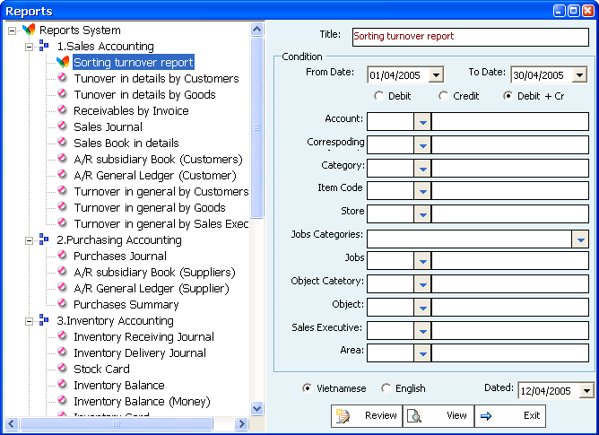
With these reports, you can easily yourself filter the contents suitable to your requirements by choosing the suitable criterions.
This reports system is classified according to transactions similar to the management requirements and the operations of enterprise. To view reports, you just click on the report then choose “View”.
The followings should be noted:
- From date, To Date: this is the function that helps the Admin keeping track of the raising data within any period of time.
- Debit, Credit, Debit + Credit: allowing the users only keeping track of the Debit Account or Credit Account or both.
- Filtering conditions: this is the extraordinary factor of “B.A.S” on compared with other accounting system. With this factor, the Admin can keep track of the entire financial data, accounting, turnover, R/P… both detailed and generally at all the possible levels.
- English – Vietnamese: allowing viewing reports in Vietnamese and English.
- Date: the date of setting up reports.
- Review: with this factor, the user will view the report quickly without retrieving data from server.
- Another good feature of “B.A.S” is the possibility to help the user rebuild and set up the content as well as the organization of the reports for him. Choosing 2.List -> 6. General Management - > Reports Management:
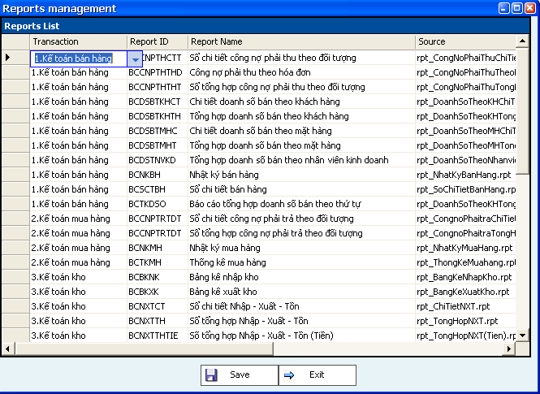
The contents of the reports are organized to each transaction and are analyzed and summarized to the specific functions of enterprise. The followings should be noted:
- Transaction: this report belongs to one certain transaction type.
- ReportID: the code of the report
- Report name: the name of the report.
- Source: the file Crystal report (.rpt) to be used for viewing and printing.
- Condition: you can speed up the reporting by using the suitable conditions.
- Description: the content and the purpose of the report.
- Click on “Save” to save the information of the report.

- Declaration of VAT: including Declaration of input VAT, Declaration of Output VAT, Declaration of Output VAT (expenses):
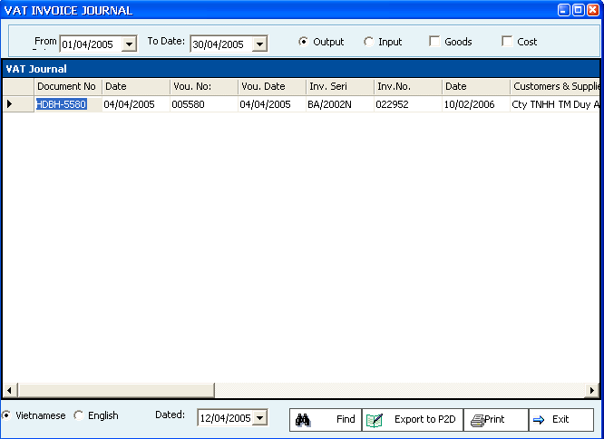
- You can choose the declaration by getting the right criterion. Beside that, the accounting system allows you to export the data to the program P2D (declaration of VAT using bar code of Tax Department).
- Click on “Export to P2D”
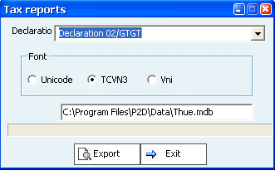
The followings should be noted:
        - Declaration: choosing the form you wish to get.
        - Font: choosing the font to be used, TCVN3 is used by default.
        - Choosing the file to stored data
        - Click on “Export”, the accounting system will automatically export data to the P2D program.
        - Coming into the P2D program, you will find the content which has been exported.
- The financial reports: includes:
      - Balance Sheet:
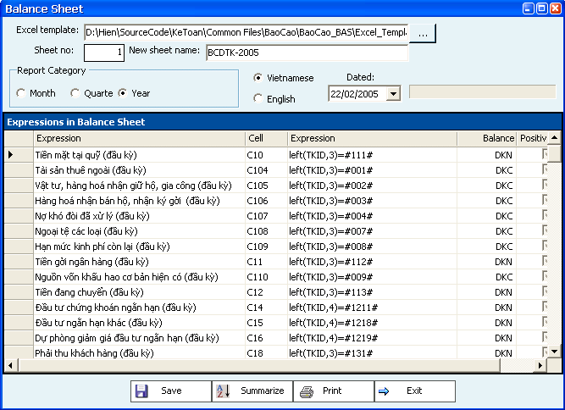
The Balance Sheet result is ViNET SMEsed on the transactions raised within the time of monitoring; by the formulas set before, the accounting system will automatically calculate the right numbers.
The followings should be noted:
        - Excel template: the Balance sheet is ViNET SMEsed on the excel template which has been formatted as requested by each Tax Section. Choose button “...” for your excel template.
        - Sheet no: is normally that the first sheet is the sample sheet for the Balance Sheet; you are entitled to change this number if any changed.
        - New sheet name: on setting up new Balance sheet, you can name it yourself. This function is best suitable to the consulting companies which supply tax services, accounting services for its customer. So, each customer use one name as specified.
How to create a Balance sheet: ViNET SMEsed on the template sheet, we will use each suitable formula for each cell; all these formulas have been at default set up, certainly you have right to change it as any changed. Click on “Summarize”, the system will automatically extract and sum up all the right data ViNET SMEsed on the formulas. For any reference, please contact our Golden Land Business Solutions Department.
- The statement of income
- Cash Flow:
  - Direct
  - Indirect
- The Explanation of Financial Reports
- In technology, all these reports are the same as the Balance sheet, so you can set up them easily as the instructed Balance Sheet.
Customized reports: this reports system is ViNET SMEsed on the retrieving data by using SQL (system query language). With a ViNET SMEsic knowledge of this language and the dataViNET SMEse structure, this reports system is really a wonderful tool for the admin to keep track, check and summarize accounting and financial data simply, quickly and efficiently, exactly.

CASES STUDY

      - Entering the beginning of period:
On the first time of using, you must enter the beginning data of the accounts by entering the endings of the previous month. For example: you had the endings of May (also the beginnings of June); and you will enter the raisings in June; you should choose the working date of 31/05 then entering the endings of May. There are 3 entries:
- Ending Items balance: besides values, the quantity should be controlled. So that you must enter the information of quantity, price as well as the value of items at the end of May:
  - Required: you must have the Inventory Balance at the end of May.
  - Choose “Inventory”, then “Ending items balance”.
  - On using this entry, the Debit Account is often 152 (materials); 154 (unfinished products), 155 (finished products) or 156 (goods).
  - With only one entry, you can set up the balance for all the items in all the stores. However, we often enter each type of items (materials, goods, finished products...) in one entry; this will help us easily control the entries being made.
- Ending R/P Balance: the R/P account is often 131, 136, 331 or 336. However, besides controlling the balance of R/P account, we must also control the receivable of each customer, the payable of each supplier.
  - Required: you must have the R/P Balance of May.
  - Choose “Vendors”, and then choose Ending R/P Balance. The Credit Account is often 331 or 336; the Debit Account is 911.
  - Choose “Customers”, and then “Ending R/P Balance”. The Debit Account is often 131 or 136.
  - Each customer or supplier is made by on entry.
- Ending account balance: except the items and R/P objects needed to be controlled by each item; all the other accounts is just only controlled by value. So that, after setting up the ending balance of items and R/P objects; we will enter the ending balance of all the other accounts ViNET SMEsed on the Trial Balance of May.
  - Required: you must have the Trial Balance of May.
  - The accounts to be used are all the accounts which the balance is not 0 except the items accounts and R/P accounts which have been made before.
  - After entering all the endings of May, you must summarize data of May; the followed requirements should be met:
    - Total Credit Amount = Total Debit Amount.
    - On the Balance Sheet, Capital = Assets.
- The ending of May will be transferred to the beginning of June; except your working date is January ( so the ending of last December must be entered), you must transferred data from year to year ( all the data of the accounting system is made within the financial year of 1/1 and 31/12)
      - Buying materials, goods, fuels:
Almost enterprises less or more must buy goods, materials, fuel or tools for used or production. There are usual cases:
- Buying goods for sales.
- Buying materials, fuels for production.
- Buying tools for using.
- In any cases, the followed entries are raised:
- Receiving goods, materials to import stores.
- Cash payment or payable to suppliers.
- Input VAT.
- We will choose “Vendors” then “Purchasing Invoice”. The followings should be noted:
  - Items:
  - Debit Account: is the inventory account (152, 153,154,156).
  - Credit Account: is the Payable Account (331,336) or Cash Account (111), Banking Account (112) for instant payment.
  - Entering the details of items code, stores, price and amount.
  - After entering all the details of items, you will enter the information of input VAT as followed:
    - Debit Account: the input VAT account (1331)
    - Credit Account: the Payable account (331,336) or Cash account (111), or Banking account (112) if instant payment.
    - VAT Rate: the rate of VAT (0%, 5%, 10 %,...)
    - VAT amount: Turnover * VAT Rate.
  - The Declaration of Input VAT: after completing Purchasing invoice, if it has input VAT, you can store into the Declaration of Input VAT by click on “Declare VAT”. The content of this declaration is automatically raised ViNET SMEsed on the content of Purchasing Invoice. The followings should be noted:
    - Input: checked.
    - Cost: unchecked.
    - Entering Invoice Seri, Number, and published date.
    - The other contents are automatically raised; but you can change them if required.
    - Click “Save” to store this invoice to the declaration.
- After entering the content of Purchasing invoice, you can print out 2 followed forms:
  - Inventory Receiving.
  - Cash Payment (for instant payment).
      - Purchasing invoice (Service): similar to the Purchasing Invoice; you don’t enter the details of items but the service content bought from suppliers.
      - Sales Invoice (Items):
The business and production enterprises often sell goods, finished product as followed:
- Exporting goods, finished products.
- Cash receiving or receivable from customers.
- Output VAT.
- We choose “Customers” then “Sales Invoice (Items)”. The followings should be noted:
  - The information of invoice is automatically raised ViNET SMEsed on the latest invoice; you are entitled to change it if needed:
    - Invoice Seri.
    - Invoice Number.
    - Invoice date of publishing.
  - The details of items:
    - Credit Account: the turnover account (511).
    - Debit Account: the Receivable account (131,136) or Cash Account (111), Banking account (112) for instant payment.
    - Entering the details of items, stores, quantity, price and total amount.
  - After entering the details of items, you will enter the information of output VAT as followed:
    - Credit Account: the output VAT account (3331)
    - Debit Account: the Receivable account (131,136) or Cash Account (111), Banking Account (112) for instant payment.
    - VAT Rate: the rate of VAT (0%, 5%, 10 %...)
    - Tax Amount: Turnover * VAT Rate.
  - The declaration of output VAT: after entering the Sales Invoice, if this invoice has output VAT, you can store in the Declaration of output VAT by click on “Declare VAT”. The content of this declaration is automatically ViNET SMEsed on the Sales Invoice. The followings should be noted:
    - Input: unchecked.
    - Cost: unchecked.
    - Invoice Seri, Number and Date of Publishment got from the content of Sales Invoice.
    - The other contents are automatically raised; but you can change them if needed.
  - Click on “Save” to store this invoice in the declaration.
- After entering the Sales Invoice, you can print out 2 followed forms:
  - Inventory Delivery.
  - Cash Receipt (for instant payment)
  - Or you can print out the Financial Invoice by using needle printer and printing out 3 forms at once.

      - Sales Invoice (Service): similar to the Sales Invoice; you don’t enter the details of items but the service content sold to customers.
      - Cash Receipt: this entry is used when you receive money from any source provided that the Cash Account is debited: (111)
- Choose “Cash R/P” then “Cash Receipt”.
- The content of Cash Receipt is much easier that the above entries.
- In some cases, the Cash Receipt can replace the Sales Invoice (Service) if you have no need to control the content of the sales invoice (service) but the turnover and the cash amount received from sales.
- This entry is designed for the cash receipt transactions.
      - Cash Payment: this entry is used when you pay money for anyone provided that the Cash Account (111) is credited.
- Choose “Cash R/P” then “Cash Payment”.
- The content of Cash payment is much easier than the above entries.
- In some cases, the Cash Payment can replace the Purchasing Invoice (Service) if you have no need to control the content of the invoice but the cost and the cash amount paid form purchasing.
- This entry is designed for the transactions of phone expenses, electric expenses, oil, salary...
      - Banking Receipt: it is similar to the Cash Receipt but using the Banking Account (112); you must also enter the bank for this entry.
      - Banking Payment: it is similar to the Cash Payment but using the Banking Account (112); you must also enter the bank for this entry.
      - Order to Payment: it is used in case of payment over banks; you must delegate your bank to pay for the suppliers over their banks; normally, you will have a set of Order to Payment provided by your bank; all the information of this entry are printed on the Order to Payment; then you will send it to your bank and require it to pay for the suppliers over their banks.
      - Updating good-out cost price: for the business, production enterprises, you must calculate the cost price of all the goods sold, all the materials exported to production, all the finished products sold. This action use rather complicated calculation method and is integrated into the accounting system which allow the popular method is Average Calculation method. This action is made at the end of month.
- Choosing “General”, then “Update Cost Price”.
- You just need to choose the month to be updated, then click on “Update”, the accounting system will automatically update all the cost price of all the goods, materials, finished products to be exported and then transfer all to the general ledger.
      - Export the Declaration of VAT into the P2D program of the Tax Department:
At this time, some Tax Branch requires the Declaration of Vat must be taken into the P2D program of the Tax Department (using bar code). Our accounting system allows you to directly export these declarations to the P2D program. You will come to “4.Reports System” then “2.Tax Reports” for any references.
      - Month reports: at the end of month, you often submit the followed reports:
        - The Declaration of VAT: ViNET SMEs on the program of Bar Code Declaration of Tax Department.
        - The Declaration of input (output) VAT: coming into 4.Reports System -> 2.Tax Reports. You can export to the program P2D of the Tax Department if needed.
        - The Inventory Balance: coming into 4.Reports System -> 1.Reports in details; then choosing “Inventory Balance (Money)”.
        - The monthly statement of using invoices.
        - The monthly signed economic contracts.
        - VAT Allocation Sheet: for enterprises using both taxation services and non-taxation services.
        - The Explanation of VAT: for the cases of tax adjustment, turnover adjustment...
      - Yearly reports:
        - The Yearly VAT Finalization.
        - The Yearly VAT Adjustment.
        - The Yearly Enterprise Income Tax Finalization.
        - The Yearly Turnover declaration.
        - The Yearly Payable to State Budget.
        - The Yearly Statement of Using invoices.
        - The Yearly signed economic contracts.
        - The Yearly Declaration of Salary and other Incomes.
        - The Yearly Inventory Balance of Goods.
        - The Yearly Inventory Balance of Materials.
        - The Yearly Declaration of Payable to State.
        - The Yearly Finalization of Invoices
        - Appendix 1 and 2 of yearly Enterprise Income Tax.
        - Yearly Statement of Business.
        - The Declaration of output Goods and Services.
        - The Declaration of input Goods and Services.
        - The Declaration of direct input Goods and Services.
        - Finalization of Usual Income Tax.
        - The Declaration of Fixed Assets.

ADVISALBE AND NON-ADVISABLE
        - In case your company has the Banking Accounts, you should use the child accounts for each bank; thanks to that, you can control in details the amount at each your bank.
        - Advisable to enter the Input date, the Voucher Date on the entry within the working month; otherwise the mistakes are easily made on searching or summarizing data.
        - Advisable to perform “Transferring data” and “Summarize data” before viewing reports; otherwise the new data will not be taken into the reports.
        - Advisable to set up all the lists before entering the transactions; this will help you quickly enter data ViNET SMEsed on the lists having been made.
        - Advisable to choose the working date is the date of the entry (some enterprises do not daily enter data but one time at the end of month), this will help fasten the speed of data entering.
        - Advisable to click on the right button of the combo box on entering the lists of the company (Ex: R/P objects belong to R/P Categories; Items belongs to Items Categories).
        - Non-Advisable to change the code of items, R/P objects usually; this will affect the performance of the accounting system which obstructs the users on exploiting data.
        - Non-Advisable to allow all the users have the right Admin (System Administrator), this will create many difficulties on controlling the operations of each user.
        - Non-Advisable to use the Internal Entry for all the transactions (even non-forbidden) because the accounting system is designed to help us control clearly and explicitly all kinds of transactions within an enterprise.
        - Non-Advisable to use Vietnamese for the code of items, R/P objects... or any other lists; and Non-Advisable to use long code; this will make the data much bigger unnecessarily and slow down the system.

