Some Analysis of the Results

Although the data is largely consistent for the currencies tracked by both websites, there are some noticeable differences.

The most noticeable difference throughout is in currency volume. The magnitudes of the currency volumes are largely different however the directionality in the change appears to be largely the same. This difference in currency volume is likely due to differences that occur when the two sites collect data and decide which data to exclude. Specifically, Coingecko.com “tracks the trading volume of a cryptoasset across all active cryptoasset exchanges tracked by Coingecko.com.”2 whereas Coinmarket.com reports the volume as “the total spot trading volume reported by all exchanges over the last 24 hours for that cryptoasset”.1 These methods as described seem roughly the same, but we see that both websites also have differing strategies for excluding data. Coinmarket.com reports that “Some market pairs are excluded from the sum, denoted by two asterisks (\*\*) on the markets tab, if the exchange does not enforce a trading fee or otherwise offers significant incentives to trade on the market pair. Market pairs with these characteristics are rather susceptible to wash trading, resulting in artificially inflated reported volumes.”1, and Coingecko.com reports that “Coin Gecko’s calculation algorithm for an exchange volume excludes trading pairs that have been blacklisted for inconsistent data and have not been updated for over 3 hours. This is to ensure that the aggregated volume will reflect the market conditions as accurately as possible.”2 A lot of the difference in trading volume is likely attributable to differences in the number of exchanges tracked by each website and differences in which data each website decides to exclude.

Market Cap and Price are reported somewhat similarly by both websites. However, there is a noticeable difference and there seems to be a greater discrepancy in the Market Cap and Price reported for lower ranking coins. See popular coins like Bitcoin Ethereum and XRP compared to less popular coins like Dogecoin and Injective Protocol (and many others). We see this trend when referring to the percent difference in price charted over time as well. For instance, the percent difference in price of bitcoin hovers around .1% whereas 0x looks to be triple that and Zenon appears to be 10 times that. This apparent decrease in accuracy associated with less popular coins maybe occurring because data from lower ranking coins is less thoroughly/often tracked and analyzed; possibly due to it being lower priority or reported less by tracked exchanges.

Another curious thing is that a lot of these discrepancies occur in spikes and then are fairly constant for a period (in all areas but especially in % difference in price). These spikes seem to correlate with trading volume spikes. I am not sure why this is but hypothesize that the increased magnitude of data from the tracked exchanges may exaggerate the differences that arise from the differing methodologies employed by the websites (surrounding which exchanges are included and excluded).

Charts illustrating comparisons between the websites can be found below (charts were created with excel). The following charts cover a time span of roughly 50 hours in 15-minute intervals.

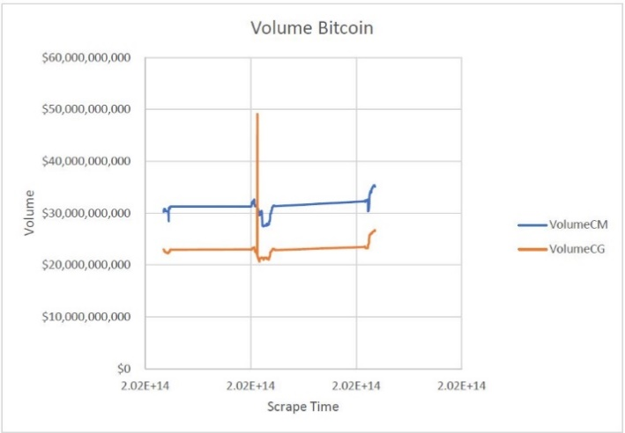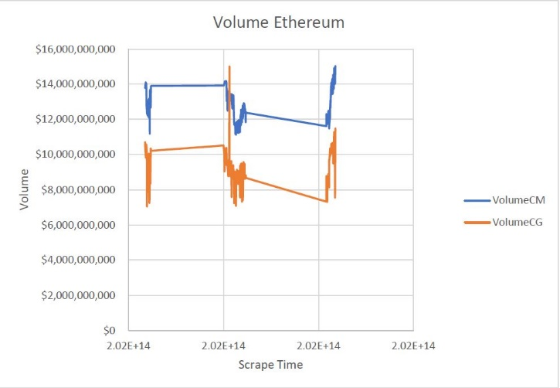

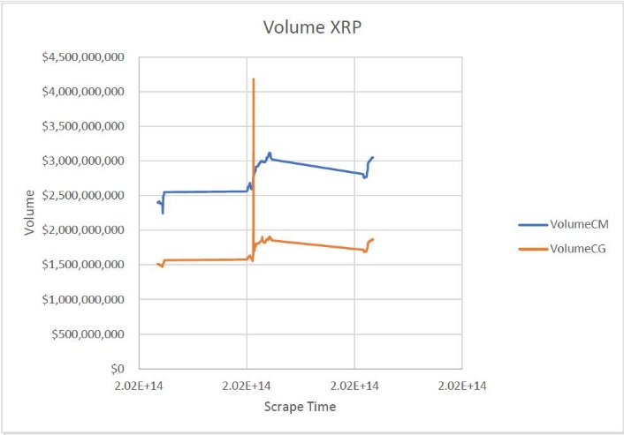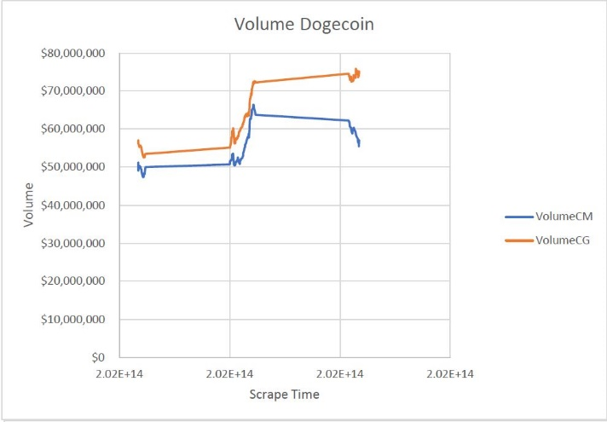

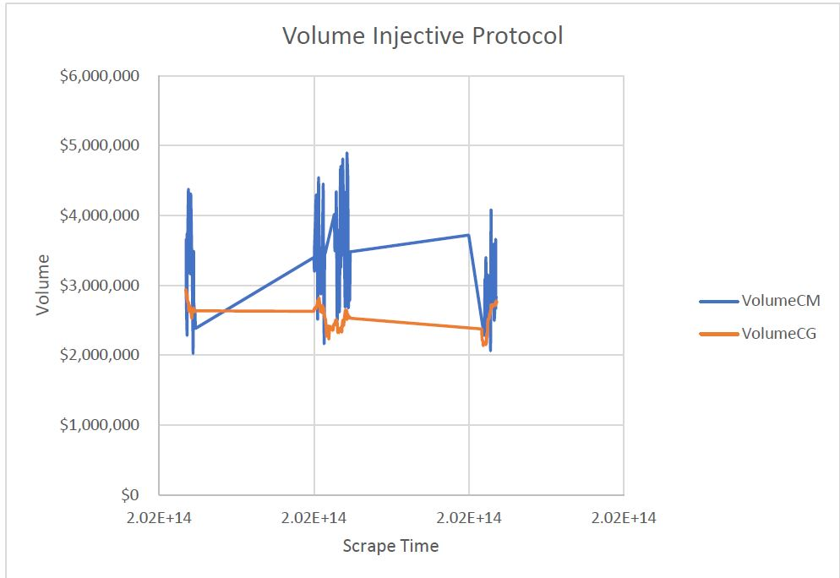

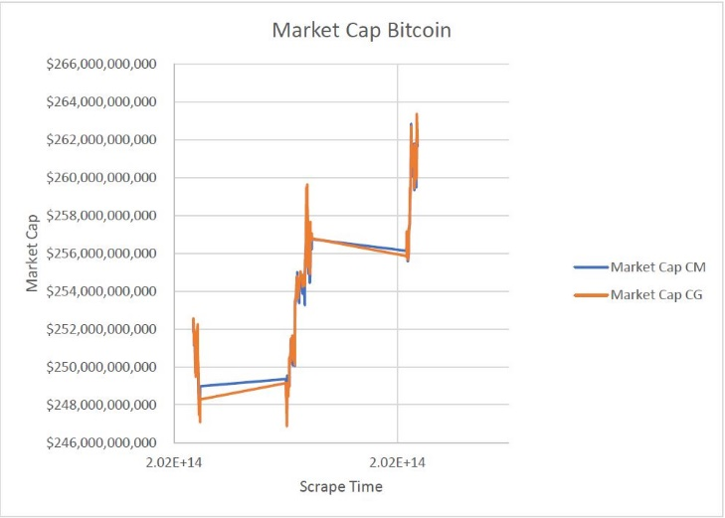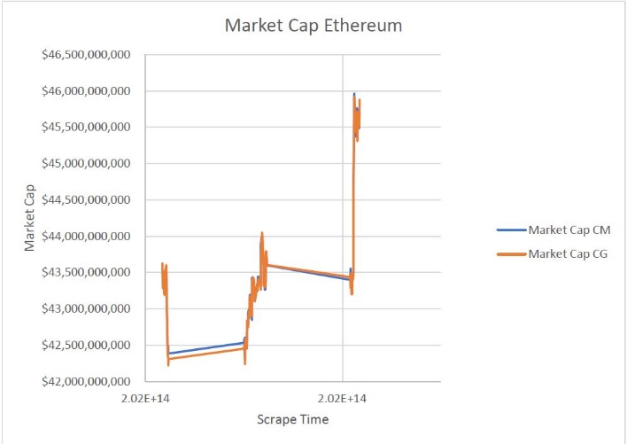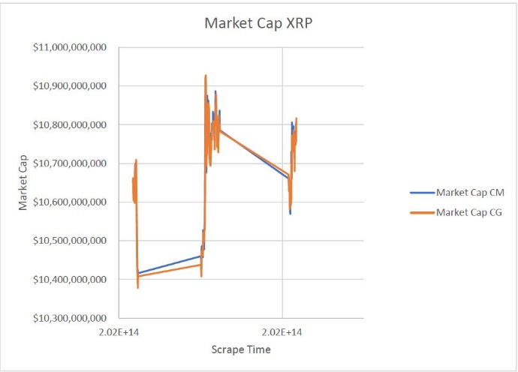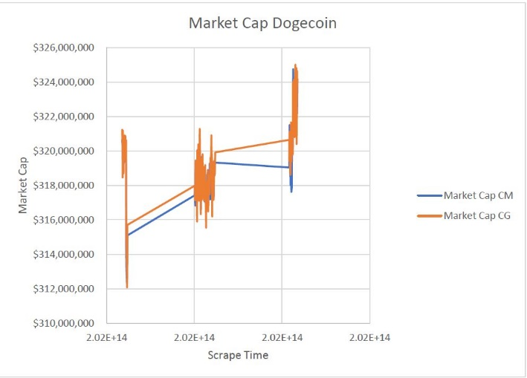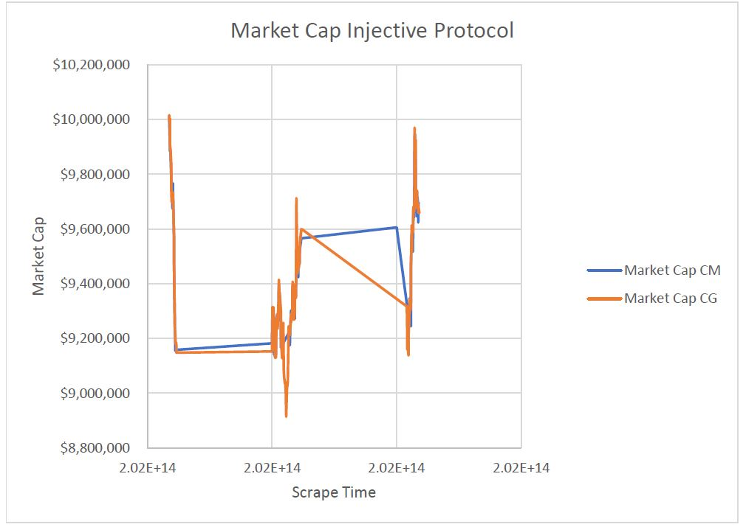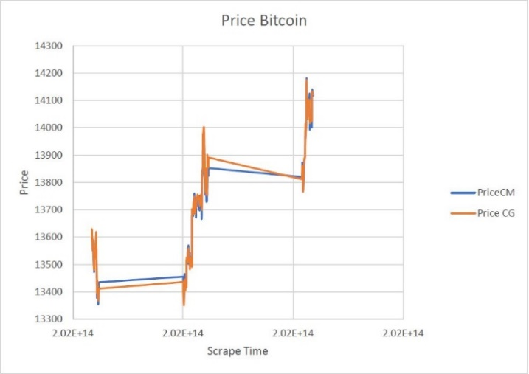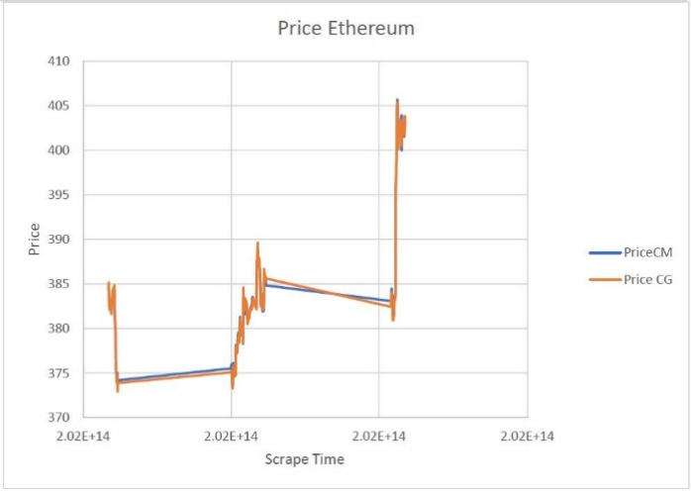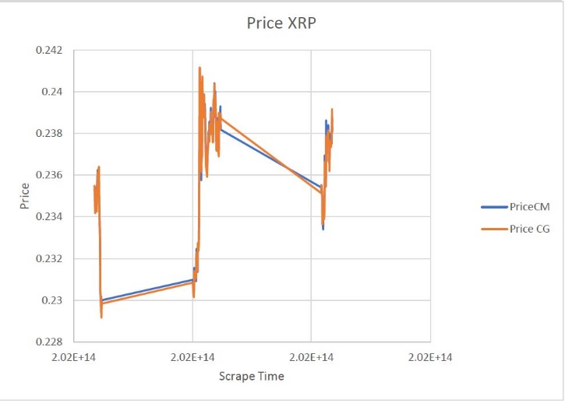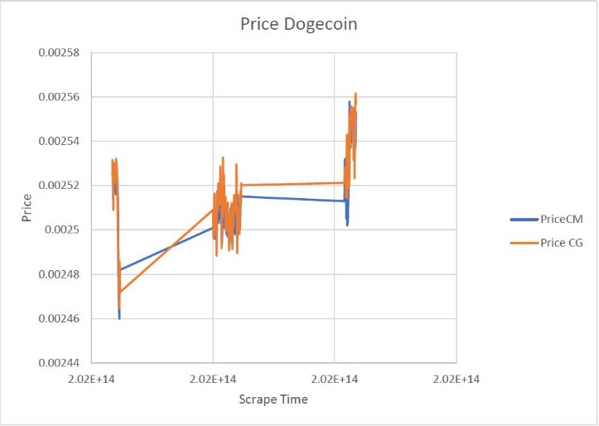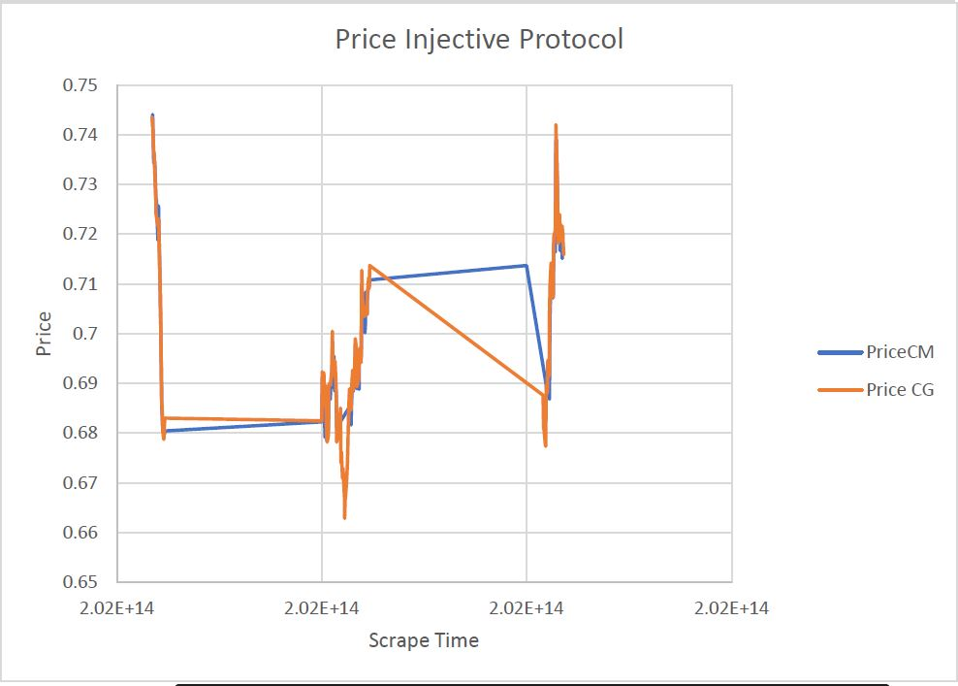

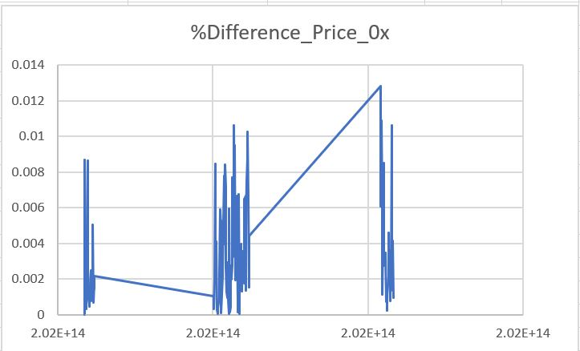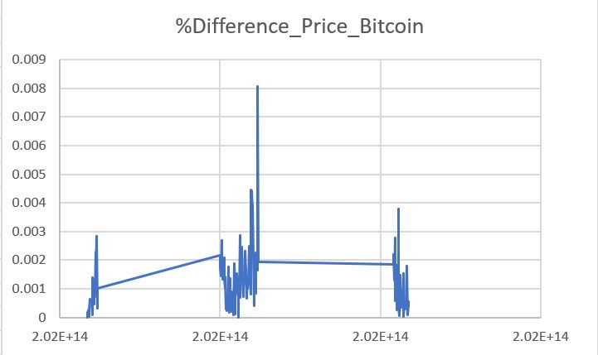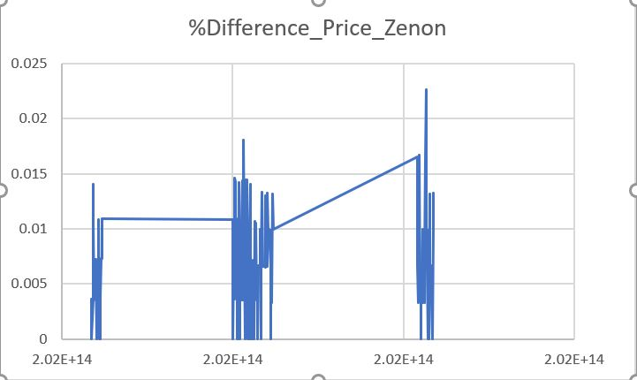 1% = .01

Works Cited

1. Jay May 22. (2020, May 9). Volume (Market Pair, Cryptoasset, Exchange, Aggregate). Retrieved November 10, 2020, from <https://support.coinmarketcap.com/hc/en-us/articles/360043395912-Volume-Market-Pair-Cryptoasset-Exchange-Aggregate->
2. Methodology. (n.d.). Retrieved November 10, 2020, from https://www.coingecko.com/en/methodology