

ENGLISH A1+
Coordinación de competencias lingüísticas
Unit 1: Storytelling
Topic 1: Telling Stories with the Past Perfect

Name: Lenin Lopez
Date: 26042026
Major: Data Science and IA
Academic term: 2026-1S
level: 4th

Script
Photo 1
In this photo, I’m at home first thing in the morning. I looked a little tired because I hadn’t slept well the night before. I’d been studying for an important exam, so I was feeling stressed and unmotivated. Even before that moment, I’d already decided it was going to be a long, difficult day.

Photo 2
Here I was on my way to work. I was listening to music to relax. Before leaving home, I had forgotten to eat breakfast, so I started to feel a little weak. I had also reviewed my notes one more time before leaving, but I still felt nervous about the exam.

Photo 3
This photo shows the moment right after my work exam. I looked more relaxed because I had already finished it. Before that, I was very worried, but during the exam I realized I had studied enough. I remembered most of the topics, so I felt more confident.

Photo 4
In this picture, I was with some coworkers. We were talking and laughing. Before meeting up with them, I felt very stressed, but spending time with them helped me feel better. I had forgotten my worries for a while.

Photo 5
Finally, in this photo, I was back home, relaxing. I felt calm and satisfied. Before going to sleep, I had reflected on my day and realized that I had handled everything better than I expected. It wasn’t a perfect day, but it taught me that I can manage stress and keep moving forward.

The end
Thanks you, I hope you enjoy my story.

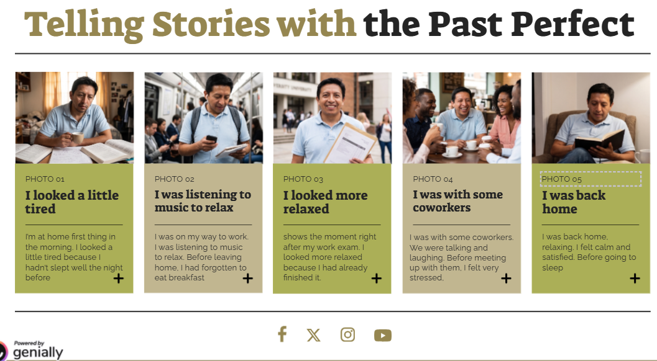

presentation https://view.genially.com/69eed56b4fb4ca2096e0f256
video https://youtu.be/y_KhAPRNLM4

