# **AMAZON LEADERSHIP PRINCIPLES**

<https://leetcode.com/discuss/interview-question/437631/Amazon-Leadership-Principle-(Behavioral)-Questions>

<https://managementconsulted.com/amazon-leadership-principles/#:~:text=Amazon%20Leadership%20Principles%20Interview%20Questions%20Examples%3A,-Tell%20me%20about&text=Tell%20me%20about%20a%20time%20when%20you%20raised%20the%20bar,your%20way%20to%20improve%20it>.

**Amazon Leadership Principles** are set of 14 concepts that Amazon uses as a mission’s statement.

The most frequently asked at Amazon’s interviews are:

* Customer Obsession
* Ownership
* Bias for Action
* Have Backbone; Disagree and Commit

*Amazon keeps customers first and goes above and beyond to satisfy customers in every possible way*.

Note: try to use examples when you were IBM DataStage trainer and develop DataStage practice at EPAM(as you greatest achievement)

|  |  |  |  |
| --- | --- | --- | --- |
| ID | Principle | Description | Example |
| 1 | **Customer obsession** | Leaders start with the customer. They work to earn and keep customer trust.  1. Leaders care about the customer and work to receive a constant feedback.  2.Customer obsession stands on understanding the customer and receiving a feedback  3. It is true customer often does know what exactly want and it is important to work closely with a customer to understand predict customer needs.  4. Customer obsession is strategical approach compared to customer focus and you anticipate customer needs and invent new services that customer is not aware yet | 1. Wrong planning 2. Maintains affected customer in different time zones 3. Datamart for each customer to avoid bad impact 4. Overlapped deployments of the same features and make them reusable 5. SLA |
| 2 | **Ownership** | Leaders are owners and they do not sacrifice long-term goals by short term result. They never say “it’s not my job” and spend efforts to solve they problem. It means they take care of all dependencies to get a job done   * ignore boundaries between department to complete a task or your project * take care of all dependencies to get a job done. No excuses it is not my job | 1. Take over responsibilities of sicked colleague (it increased of my workload by %25, but it I took an ownership) 2. Fix IBM DS issue with [truncate] reaching out IBM vendor 3. Was proactive to play BA on a project (because no budget to hire assigned person. it increased of my my workload by %25, but it I took an ownership) |
| 3 | **Invent and simplify** | Leaders always require innovation and invention from their team and find a way to simplify things | 1. Pandas framework (the most innovative thing) 2. Help users to automate their process – replace excel by database solution 3. Automate deployment (DataStage and DB) 4. Proposed do developer when I was SA on a project (think out of box) |
| 4 | **A right, a lot** | Leaders are right a lot. They have strong judgment and good instincts.  Amazon has a high degree of tolerance for mistakes, but Amazon does not tolerate if make the same mistakes over and over | 1. Mistake – did not commit changes into repo 2. I was wrong with a design pattern for ETL that was supposed to be a template for may ETL jobs (update issue) . I accepted the fault 3. Conflict with Pasha 4. Back and forth communication about requirements without delivery (Give me an example of making an important decision in the absence of good data) |
| 5 | **Hire and Develop the best** | Leaders raise a performance bar for each hire and promotion. They recognize exceptional talents and willing move through the organization.  in a lot of companies’ good performers left alone because they are already doing good job. Amazon is called “top performance management culture” and here Amazon believes top performers need more attention and guidance they provide their best to Amazon. Amazon believes that spending time on top performers is one of the best uses of a leader’s time, do not say that you spend an equal amount of time mentoring all of your employees, whether they’re top performers or not | 1. (Tell me about the best/tough hire of your career). Candidate was good, but asked a lot of questions |
| 6 | **Insist on the hire standards** | Leaders have high standards and are continuingly risings bars, driving team to deliver high quality standards  Standards are measured by SLA on a project | 1. Innovated TDD and unit test (What measures have you personally put in place to ensure performance improvement targets and standards are achieved? ) 2. Innovate SLA on a project, because number of customers increased 3. have you raised a bar to increase a quality of product? Innovated:  * discuss a high-level design before implementation * review of code for a team and.  1. Sometimes customer is not tech and can not measure quality of work. However I always aim to deliver a high quality products and make sure it is   (What measures have you personally put in place to ensure performance improvement targets and standards are achieved?) |
| 7 | **Think big** | Thinking big means, you come with a strategy and vision | 1. Replace a person who was not interested at the project. He came from a bench and I proposed a rotation for him 2. Bring shadow developers |
| 8 | **Bias for Action** | Speed is matter in business. Sometimes people do too much planning, estimations, clarification without real actions  Bias for action means you are not afraid to make decision and take actions | 1. fix in a PROD (team did not have access to prod and could nor reproduce error in dev due to diff in data between prod and dev) - Tell me about a time when you made a decision too quickly and what you would have done differently.” About 2. At ome assigenment proposed to replace Waterfall by Agile |
| 9 | **Frugality** | Accomplish more with less. There are no points for growing budget size or a headcount. With frugality you try to save money | 1.shadow position to hire, because a client did not have allocated budget for now  2. After speaking with customer and reviewing requirements it turned out it is a usual request |
| 10 | **Learn and be curious** | Leaders are never be done learning and seek opportunities to improve your self | 1. How do you find inspiration to learn.” About competition on a market” 2. Example about English to relocate to USA |
| 11 | **Earn trust** | Leaders listen attentively, treat others respectfully   * You need show engagement to a customer to earn trust * True collaboration in only possible way tin atmosphere of trust   Leaders at Amazon keeping trust by:   * Making good decision * Following commitments * Admitting failures * Treating people with respect and listening their ideas | 1. I have been proposed to take a tech lead role at Chevron. I had to earn trust. I showed my engagement   (How did you quickly earn your client’s trust?) |
| 12 | **Deep dive** | Leaders pay attention to all levels and stay associated with details |  |
| 13 | **Have a backbone; disagree and commit** | Leaders are obligated respectfully challenge decisions when they disagree. They do not compromise for a sake of social cohesion. They only commit, once a decision is determined | 1. Disagree about customer technical proposal to solve a problem. Customer solution did not work for all cases 2. Disagree to hire unmotivated person from a bench 3. Disagree with customer Architecture Team about one architecture pattern. It was easy to do [db link in oracle= from source to customer oracle db] instead of putting it to DWH, as well |
| 14 | **Deliver result** | Eventually, it is all about result and performance. You have to show your result | 1. Run a project at Chevron 2. Created DataStage practice at EPAM 3. Run a project alone at Penske |
|  |  |  |  |

Ownership. Leaders are owners and they do not sacrifice long-term goals by short term result. They never say “it’s not my job” and spend efforts to solve they problem. It means they take care of all dependencies to get a job done

* ignore boundaries between department to complete a task or your project
* take care of all dependencies to get a job done. No excuses it is not my job

# **#1. CUSTOMER OBSESSION - LP**

Leaders start with the customer. They work to earn and keep customer trust.

* **Customer obsession stands on a principle of understand a customer need and getting constant feedback**
* It means the customer is the number 1 priority.
* Collect data and deeply understand customer needs.
* It is true that quite often customer does not know what exactly he wants. Therefore, it is important to work closely with customer to predict his needs

**Customer focus vs customer obsession**. **= meeting needs vs anticipating needs**

* **Customer focus** – team listens what customer say and follow
* **Customer obsession** – team collects feedback and try to predict customer needs and invent new services that customer is not aware yet

Customer focus means meeting needs and it is more tactical approach

Customer obsession means anticipating needs and it is more strategical approach

Examples, to answer:

*I try to do beyond to server a customer*.

Example 1.1 . (bad planning and new tasks in the middle of sprint)

“*Problem: when I was assigned as a technical lead to one of Chevron DWH project, the group of customers were not satisfied with often delays of our delivery and poor estimation.*

*the project had a group of product owners and they gave us tasks. Those tasks often came during already started sprint and often new tasks had the highest priority*

*I figured out the main problem was a lack of customer trust and messed up during planning.*

*Action:*

* *I set up a few meeting with a group of product owners and we agreed we need to have two weekly planning meeting to define scope of work and set up of priorities of the. If there were a few priority tasks we asked a senior product owner to set up priorities.*
* ***In addition, to this I came up with the proposal to have a mandatory retrospective meeting to get a feedback from the customer about our delivery, passed sprint and hear ideas how improve our performance and the delivery****.*

*Result: in a few months we could improve planning, avoid delays in the delivery and gain the customer’s trust*”.

Example 1.2. (customer in different time zone and our maintains affected their job)

“*Problem. When I worked for DWH project in the beginning of project the customer was only in one time zone. Later, a few new customers from different time zone across a world joined our team and consumed data from DWH. It meant customer accessed our system around the world. Our team had some maintains task when the system had downtime or it had effect on a common’s performance of the system (like nightly batch load of data from SOR, backup, refreshing, materialized tables)*

*That maintains work had the impact on customer’s performance and they had complains about our application*

*Action. There were not an official SLA or maintains schedule between DWH team and customers. We started to meet with customer to discuss their schedule’s of work, our mainstans schedule and did the following actions:*

*Could agreed on the planning maintains schedule and deployment notification time*

*Notification system when: the system is down, is back and contact person*

*Result: it really improved communication between our team and customers and we could avoid situation when our work overlaps*

”

Example 1.3. (DWH. Come up with data mart for each group of customers)

“

*Problem: in the beginning of project DWH app had a few customers. Later, we received new customers with different departments. Each group of people had different needs, but work on pretty the same group of tables (dimension and fact). It caused changes for one group of people affected the rest of consumers and algo gave downtime of the system . It caused a lot of problems*

*Action: to solve this issue we came up with idea to create Data Mart area in DWH to keep specific tables for each group of people that does not overlap.*

*Result: Our improvement took some time, but, finally, it could make our customer’s independent on using data from our application*

“

Example 1.4. (Overlapped deployments)

“*Problem:*

*DWH project had a lot of consumers and sometimes happened that task with the same business logic was implanted in a different way and gave different result. For example, business logic of task can have different understanding by different departments, or not all input parameters can be used for calculation. It caused the same features could have different result.* ***And those features can not be reusable for all***

*Action: to avoid such confuses we set up a communication line and shared meeting between different teams during planning and deployment*

*Result: innovated communication helped to understand what is going in closed teams and avoid different result for the same features or formulas*

“

Example 1.5. (SLA

“*Problem. There were not SLA agreement between DWH team and consumers. It caused a lot of issues and complains, because there were not agreed time durarion to fix the issue*

*Action:*

*We classified possible issues by level of error and impact and set up approximate time to fix it*

*In addition, we set up 24/7 customer service from dev ops team, because consumers were in different time zones like USA, Asia, Europe*

*Result: we gained a lot of trust from the customers and it help us to stabilize work of our system*

“

Result: I believe the best customer service is when there is no incoming calls from customer, because everything works fine”

Set up SLA agreement between DWH team how to reply

# **#2. OWNERSHIP – LP**

Ownership. Leaders are owners and they do not sacrifice long-term goals by short term result. They never say “it’s not my job” and spend efforts to solve they problem. It means they take care of all dependencies to get a job done

* ignore boundaries between department to complete a task or your project
* take care of all dependencies to get a job done. No excuses it is not my job

**Example 2.1. (Describe a time when you went above and beyond for a customer)?**

**A colleague of mine got sick**

“Problem: A colleague of mine committed to complete a task, but he got ill and was on a sick leave and did not notified customer. As a result, the task was not complete in a time manner. I estimated a task and it would add 25% extra of my time load to complete a task. A PM approved this worked and asked to complete it asap.

Action: I contacted the customer, explained the case and promised to take over the task and complete it asap. I had a few overtimes to complete this task.

Result:

When I finished it and reached out the customer, he was happy, and we also could remain good relationship with the customer. I showed an ownership and did not give away. “

**Example 2.2. (IBM DataStage connector. [Truncate] operation worked as [Delete])**

“Problem: my team is extensively used ETL tool IBM data stage and others connected, because we had mature and certified developers. Once, I have been connected by a colleague from separate team to discover an issue. One of Oracle feature in Oracle connector of DataStage worked in a different way compared to documentation

Action: I contacted directly IBM support team and they had confirmed this issue and in a few weeks sent us an installation a patch. I took action to install path and the issue has gone

Result: I took an ownership of the problem, reached out the vendor and took actions to fix the issue. I was recognized by the other team and this fix could help them in their ETL’s implementation”

**Example. 2.3. Took a role of BA “Tell me about a time when you took on something significant outside your area of responsibility. Why was it important? What was the outcome?**

“Problem: the team did not have BA, DA on the project and my team of developers worked directly with product owner. The PO had strong business knowledge, but did not have a technical background. As a result, there was a lack of communication and a gap between PO and devs.

Action: The project did not have a budget to hire BA and I became a proactive and in addition to my responsibilities started to play a role of BA to clarify business requirements and create mapping for developers

Result: it was grueling time to play a few roles on the same time, however, it really helped to increase a performance of the project, eliminate gaps and gain trust of the customer

”

# **#3. INVENT AND SIMPLIFY - LP**

Leaders require innovation and invention from their teams and always find a way to simplify things.

Example. 3.1. (Proposed to use normalize method from pandas to simplify parsing of geojson file). What is the most innovative thins you’ve worked on?

“Problem: we had data on geo json format with a lot of nested levels. We used a complicated code in PySpark top parse all levels and normalize. It was hard to support when a new file came or a structure of existing file changed

Action: I proposed and implemented a new feature to use embedded method [normailize] from Pandas framework to easily parse multi-level hierarchy:

Result: this solution improved support of a solution and did a code reusable”

<https://pandas.pydata.org/docs/reference/api/pandas.json_normalize.html>

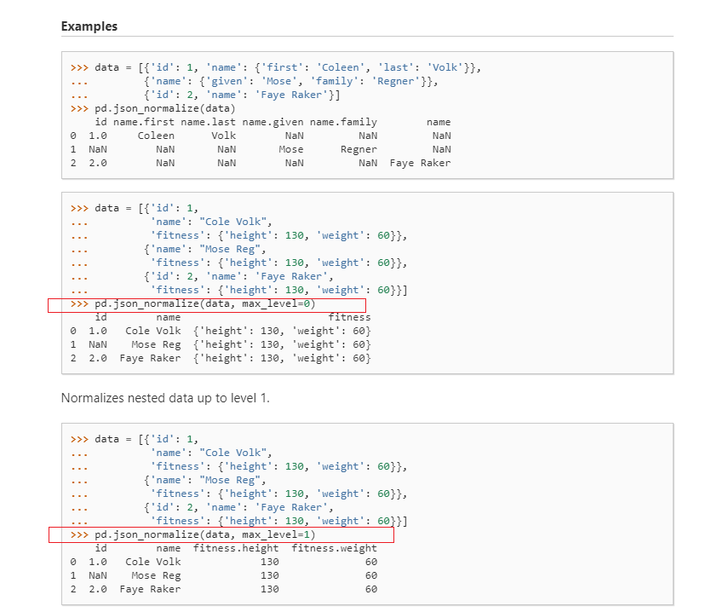

Example. 3.2. (Replace Excel solution by SQL)

“*Problem: business analyst spend a lot of time to join, aggregate data in excel. She received data in different excel sheets. Moreover, this manual work was prone on a human error.*

*Action: I proposed to simplify and automated this solution on db level and also add quality checks*

*Result: this solution became automated, saved time*”

Example. 3.3. (Automate deployment CI process of DWH: ETL - SQL)

“*Problem project had ETL and database code.*

*A deployment was semi-manual. Changes from DB and etl extracted manually*

*Action: I code a script in bash how automatically to extract changed objects from database and etl and commit changes into branch*

*Result: CI process became automatic*”

**Example. 3.4. “Tell me about a time you had to think outside the box”**

**Took over development part, because developers were assigned to another projects**

“*Problem. I was assigned as a Solution Architect for upcoming DWH project. My goal was to gather non-functional requirements for a system, propose design and propose technologies. The problem was all assigned developers were reassigned to another project and ,as a result team did not have developers, to implement my design for POC. It would cause a delay of starting a project for a couple of month.*

*One more concern, client did not have cross functional team. SA did SA work and did not do development*

*Action. I became a proactive and proposed to do implementation of POC. I did ETL, DB stuff and POC has been accepted by customer*

*Result. POC met the deadline, customer was happy and POC has been converted to a real project*”

# **#4. ARE RIGHT, A LOT - LP**

Leaders are right a lot. They have strong judgment and good instincts.

Amazon has a high degree of tolerance for mistakes, but Amazon does not tolerate if make the same mistakes over and over

Example 4.1 Did a mistake. Did not commit changes a repo

“*Problem. When I worked as a developer for one of project I was assigned for a task. I developed it for a week, but did not commit changes into repo and save coded on my local machine to speed up my development process. Once, my laptop crashed and I lost all my worked. Id had impact on a team and timeline of release*

*It was a good lesson for me. Since that all my changes I commit into repo*

”

**Example 4.2 “Tell me about a time you disagreed with a colleague. What is the process you used to work it out”. Example about Pasha**

“Problem. When I was a tech lead a new developer was assigned to our team. He was a star developer. He was mature worked for different project, but he had cons – he did not have a team spirit, was relucatant, act always invidually, often argued with a team and customer on stand up. It caused not friendly communication in a team and customer asked what was going on

Action.

I spoke with him once and said hie behavioral has impact on feedback and on his as a result we will not receive good annual bonuses and promotions. I proposed to work well in order to provide good deliver, earn nice feedback and at the end of year find him another project.

Result. This talk was very helpful, and we get rid of conflicts in a team

”

**Example 4.3.” Give me an example of making an important decision in the absence of good data.” Was back and forth emails and no result**

*“Problem. There were back and forth emails between development team and customer about uncertain of requreiemnts. It caused a delay for a two month without decision and no delivery.*

*Action: I took action and propose to separate clear and unclear requirements and do delivery for a minimum part. And in future do incremental deployment feature by feature*

*Result: it could produce minimum feature of application and make SDLC process*

*”*

# **#5. HIRE AND DEVELOP BEST**

Leaders raise up a performance bar with each hire and promotion. They recognize exceptional talents and willing move them through the company.

Important note: in a lot of companies left good performers alone, because they are already doing good job. Amazon is called “top performance management culture” and here Amazon believes top performers need more attention and guidance they provide their best to Amazon. Amazon believes that spending time on top performers is one of the best uses of a leader’s time, don’t say that you spend an equal amount of time mentoring all of your employees, whether they’re top performers or not.

Of course you want to keep the best performers

**Example 5.1 “Tell me about the best/tough hire of your career”. Candidate was good, but asked a lot of questions**.

*“Problem. I was assigned for a technical interview to hire people. One candidate was seasoned, good, but asked a lot of questions. He wanted to meet with people in the team, asked about customer and wanted to know a lot of details. This process took time and I was in question whether it worth to invest my time in so long hiring process. I asked about it from a colleague of mine and he said ,usually, if candidate asks good questions and many question he would be ready for long term commitment and will be a good performer*

*Action. I followed this advise and we hired that candidate*

*Result. That candidate became one of the best in our team and we have never regret about invested time”*.

# **#6. INSIST ON THE HIRE STANDARTS – LP**

Leaders have high standards and are continuingly risings bars, driving team to deliver high quality standards.

At Amazon standards are measured by SLA. It means everything is doing to meet SLA.

**SLA** (System Level Agreement) defines a level of services that expected by customer from a vendor/supplier, with timelines, penalties.

The SLA should include components in two areas: services and management.

Example 6.1. What measures have you personally put in place to ensure performance improvement targets and standards are achieved? Innovated TDD and unit test

“Problem. There was long time to get a feedback from customer. We did and then deployed. There were some issues, checks that could be checked by themselves

Action. I innovated TDD approach for ETL and also a new standard an a project to cover test by unit tests and include them in a delivery

Result. It saved time of our delivery, minimize a number of mistakes and improved a quality of our product”

**Example 6.2. have you raised a bar to increase a quality of product**

Innovate:

* discuss a high-level design before implementation
* review of code for a team and.

**Example 6.3. “What measures have you personally put in place to ensure performance improvement targets and standards are achieved?” Sometimes customer is not tech and can not measure quality of work. However I always aim to deliver a high quality products and make sure it is**

* Supportive
* Comparatively easy to extend current functionality
* Code covered by unit-tests
* Deployable

|  |  |
| --- | --- |
| Think big | Thinking big means you come with a strategy and vision |

# **#7. THINK BIG**

Think big means you come with a strategy and vision

**Example 7.1. “Replace a person who was not interested at the project. He came from a bench and I proposed a rotation for him.”**

“Problem. A new position was opened at the project and team was looking for a new team member. EPAM retains people on bench and they have a hire priority to be hired. After interview we hired this person for ETL/DB position

He was matured, experienced, but was not excited about technologies, project and not motivated.

Action

After a few month I spoke with him, found out what is going and proposed to create a rotation plan and find him a new project in a few month. The plan was approved by customer and EPAM leadership

Result.”

# **#8. BIAS FOR ACTION – LP**

Speed is matter in business. Sometimes people do too much planning, estimations and clarification without real action

Bias for action means you are not afraid to make decision and take actions

**Example 8.1. “Tell me about a time when you made a decision too quickly and what you would have done differently.” About fix on a production (team did not have access to prod)**

“Problem. I was a developer and did not have access to prod. The feature was developed by myself and I took a lot of time due to requirement’s changes. A policy was developers can not have access to prod and need to fix issue in dev and then deploy to prod. Based on logs I could not reproduce error, because dev had just a snippet of data

Action: I reached to PM, product owner and asked to get a tentative access to prod to fix

Result: I fixed the issue and deployment carried out successfully and I sync changes with lower env. I did not follow deployment policy, but quick exceptional decision could save time and money”.

# **#9. FRUGALITY – LP**

Frugality. Complete more with less. There are no points for growing budget size or headcount

With frugality you try to save money

Example 9.1. “Shadow positions”

“Problem. Customer asked to implement a new feature that requires a few more developers assigned to this task. Everyone was assigned to diff tasks and it required to extend a budget for a new sources. The customer could review a budget until new year. At new year they revie and allocate budget for a next year.

Action. We wanted to keep a good relationship with customer and I proposed to take a few shadow developers with the agreement. If they are efficient and do well job, the customer will hire them after budget revieing.

Result. It happened. Team increased and the EPMLOYER could earn more money

”

Example 9.2. “After speaking with customer and reviewing requirements it turned out it is a usual request”

“Problem. A new customer requested to keep info for all history and display data in near real time.

The requirements were not enough clear and initially it requires to keep a history of data for 20 years for their system and do kind of near real time compared to current budget. It required budgeting for new infrastructure, new technologies and possibly to new hires, because team did now work with events

Action. We meet a few times with customer and direct users of data and after clarification it turned out it is usual batch data load without evening and keeping a history just for one year

Result. Could save money and time to the customer”

# **#10. LEARN AND BE CURIOUS – LP**

Leaders are never done learnings and seek opportunities to improve themselves.

**Example 10.1. “How do you find inspiration to learn.” About competition on a market**

“The IT is very competitive market and a lot of skills require to find a decent job.

Tell example about Chevron and that worked with outdated skills for a few years”

# **#11. EARN TRUST – LP**

Leaders listen attentively and treat others respectfully.

You need show engagement to a customer to earn trust

Leaders at Amazon keeping trust by:

* Making good decision
* Following commitments
* Admitting failures
* Treating people with respect and listening their ideas

True collaboration in only possible way tin atmosphere of trust

**Example 11.1. How did you quickly earn your client’s trust? (**I have been proposed to take a tech lead role at Chevron. I had to earn trust. I showed my engagement**)**

“Problem. I have been proposed to take a tech lead role at Chevron. This position required a relocation from Ukraine to USA. Apart from coding, I had to communicate with customer, clear requirements, provide high level design of tasks. It was a new and challenging work for me.

I had to ern trust, because without it is impossible successfully running a project

Action. I showed my engagement and ownership. I took customer problems and issues as my own. I wanted to show I really care about customer’s problems and here to solve them

**Example 11.2 “Worked to earn trust of a team when I was a tech lead**

Was transparent with a team

Everyone understood strategy, short-term, long-term goals and personal goals

Understand people career goals

”

# **#12. DEEP DIVE – LP**

Leaders works on all levels and stay associated with details.

Question:

Tell us about something that you learned recently in your role?

Give us two examples of when you did more than what was obligatory in any job experience?

Tell us about the most complicated problem you’ve ever worked on?

Tell us about a time when understanding the details of a situation helped you arrive at a solution?

Tell us about a time you utilized in-depth data to come across a solution?

# **#13. HAVE A BACKBONE; DISAGREE AND COMMIT – LP**

**Leaders are obligated respectfully challenge decisions when the disagree. They do compromise for the sake of social cohesion. They commit, once a decision is determined**.

Example 13.1 Disagree about customer technical proposal to solve a problem. Customer solution did not work for all cases.

“Problem: Once I worked with the customer who had a technical background and from time to time gave advises how to improve SQL code. He recommended to add hints in sql in order to make sure sql execution plan is the best. Unfortunately that solution was not the best and did not work for all case

The problem was I did not know who exactly tell the customer that his solution is not the best

Action: after carefully thinking this case I did a POC using customer’s recommendation and showed pros and cons of his proposal and noted cases when the solution does not work

Result: the customer appreciated me for the deep analysis, accepted our solution and later left very nice feedback about my performance”

Example 13.2 Disagree to hire unmotivated person from a bench

Example 13.3 Disagree with customer Architecture Team about one architecture pattern. It was easy to do [db link in oracle= from source to customer oracle db] instead of putting it to DWH, as well

Customer obsession questions:

**Q1. Explain a situation when you had a challenging interaction with a customer?**

* A: We received an urgent request from a customer in email inbox and forgot to respond.

When the customer called, he was unhappy about the service and ignoring his request. I was on a call and was remaining calm. I apologized and said his request we would be take cared asap.

* When the request was completed I gave him call ask if it is that he expected and said him thank you that he could improve our service
* In addition, we summarized the negative experience in the team and learnt lesson how to avoid this case in a future

**Q2. Describe a situation when you refused a customer’s request?**

A: I worked on a customer feature from backlog and we agreed a few times on requirements. When the feature was developed and we deployed it to QA env. One day before a production deployment the customer asked to modify again changes. I had refused his new changes and proposed him to include new change in a new release.

**Q3. How would you define good customer service?**

A: You provide a service in time

* Try to impress the customer by quality of service and time
* Provide opportunity to leave a feedback and recognize what can improved to go beyond his expectations.
* Follow customer obsession approach – anticipate customer needs

**Q4. Tell me a time when you responded to feedback from a customer?**

A: BI reports took some time to run when a customer clicked on a report.

Reports was based on a multiple tables and “join” of tables took some time. We created materialized we what have already been run and report started to work much faster.

**Q5. Tell me a time when you made changes to customer service standards?**

A:

* Customer did not have standard for ETL tool. I created a template of standard ETL jobs that could be reusable
* Invent ETL name convention and PL/SQL: name convention to call jobs, stored procedure, variables. It has been approved by architecture team.

**Q6. Whilst dealing with a customer, what should you consider?**

A:

* **Listening** – is very important
* Customer feedback

**Q7. Give me some examples of outstanding customer service?**

* Service in time
* Impress and go beyond expectation
* Anticipate needs
* The best outcome when your customer recommends your service to someone else

**Q8. Why do you want to work in customer service?**

A: I like to work for a customer service, because I like to meet new people, address their needs and finally, it helps to build great community. Finally, the great customer service can help expand your business, because satisfied customer will recommend you to their friends.

**Q9. What skills are needed to excel from a customer service perspective?**

Excel = превосходить, превышать; быть лучше

Required skills:

1. Good listener
2. Respond to customer service and problems in a timely manner
3. Deal with customer complaints
4. Knowledge of a product and service
5. **Continuously improve and develop**

**Q10. If you received a customer complaint, how would you deal with it?**

A:

* Reach out the customer, apologies and carefully listen the complaint
* Take actions to solve the complaint as soon as possible and provide an estimate to the customer.
* When the issue is solved reach out the customer, ask if he satisfied and again apologies.
* Ask about customer’s experience.
* Did a research in the team why the complaint happened and take actions to avoid it in future

**Q11. Explain a situation when you provided great service to a customer?**

A:

“Problem: A colleague of mine committed to complete a task, but he got ill and was on a sick leave and did not notified customer. As a result, the task was not complete in a time manner. I estimated a task and it would add 25% extra of my time load to complete a task. A PM approved this worked and asked to complete it asap.

Action: I contacted the customer, explained the case and promised to take over the task and complete it asap. I had a few overtimes to complete this task.

Result: When I finished it and reached out the customer, he was happy, and we also could remain good relationship with the customer. I showed an ownership and did give away

“

**Q12. What’s the difference between customer service and customer support?**

**Customer support** – team is focused on a product and answers question and complaints about the product.

**Customer service** – is focused on a customer and helps the customer to gain value from the product.

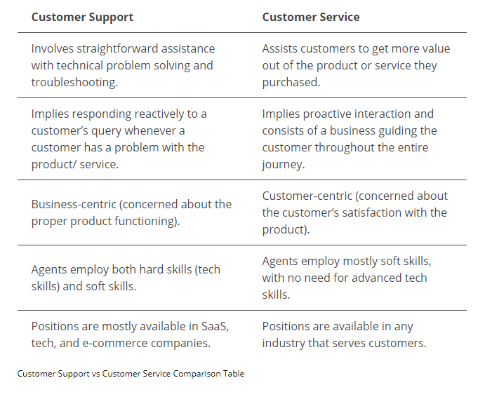

* Share an example of a time when you did not meet a client’s expectation. What happened, and how did you attempt to rectify the situation?
* Tell us about a time you handled a difficult customer?
* Tell us a story of the last time you had to apologize to someone.
* When do you think it’s ok to push back or say no to an unreasonable customer request?
* How do you develop strong client relationships?
* Most of us at one time have felt impatient when dealing with customers. Can you tell me about a time when you felt this way and how you dealt with it?
* Tell us about a time you used customer feedback to change the way you worked.
* Tell us about a time you had to compromise in order to satisfy a customer.
* How do you get an understanding of what the customer’s needs are?
* How do you anticipate your customer’s needs?

**Q13. When have you bent the rules to help a customer? What happened and why did you bend the rules?**

A:

1. Fix on a production environment after deployment (preliminary agree with a PM and product owner)

2. develop features in test environment, because DEV did not enough data to cover all business data

# **STAR METHOD**

**S**ituation –

**T**ask –

**A**ction -

**R**esult -

# **AMAZON FLYWHEEL**

[Customer experience] -> [traffic (more users)] -> [sellers] -> [selection]

At the same time

You invest into infrastructure: [lower cost structure] -> [lower prices]

[seller] is third party.

* Why amazon allows third parties to sell items. Why Amazon does not monopolize? Because, Amazon monopolize customer experience
* in order to, lower prices Amazon uses idea of flywheel

increasing each component will increase customer experience and finally decrease a price

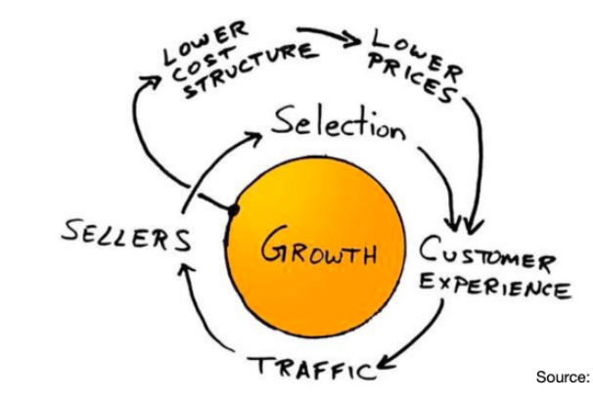

# **IMPORTANT QUESTIONS**

Jeff Bezos – the founder of Amazon

1. **A: Why should we hire you?**

* A: I am a hard working and passionate employee.
* I believe my experience and skills match for the applied position and I will add value to your company and perfectly fit to your cultural standards.
* Quick learner
* I have a teammate spirit and able to work under the pressure and in strict deadlines.

1. **A: Last word at the interview.**

Q: ***I just want to say thank you for the inviting to be interviewed today. I really enjoyed todays call and hope can show what I can do at work and contribute to your company*** .

1. **A. Why are you leaving your employer?**

Q. My current employer is brilliant, but I am ready for a new challenge and want to work for good company where my experience and skills match and I will contribute.

1. **Describe a time when you went above and beyond for a customer?**

A1. “

Problem:

A colleague of mine committed to complete a task, but he got ill and was on a sick leave and did not notified customer. As a result, the task was not complete in a time manner. I estimated a task and it would add 25% extra of my time load to complete a task. A PM approved this worked and asked to complete it asap.

Action:

I contacted the customer, explained the case and promised to take over the task and complete it asap. I had a few overtimes to complete this task.

Result:

When I finished it and reached out the customer, he was happy, and we also could remain good relationship with the customer. I showed an ownership and did give away. “

A2.: The data lake had a few sources and the customer did not what exactly know about all SOR and was not unsure about data

I helped to communicate with other teams about existing business domain and based on this info we could clarify existing requirement and be more specific.

Links:

<https://interviewgenie.com/blog-1/2017/11/28/how-to-answer-amazon-leadership-principle-customer-obsession-interview-questions>