**WAYFAIR**. Phone interview.2020-Oct -08

Position: Data Engineer in Boston, MA

Interviewer: Kaitlin Bohon (Senior Manager)

<https://app.codility.com/c/run/CL-AU3PSY-4CV/>

**Solution:**

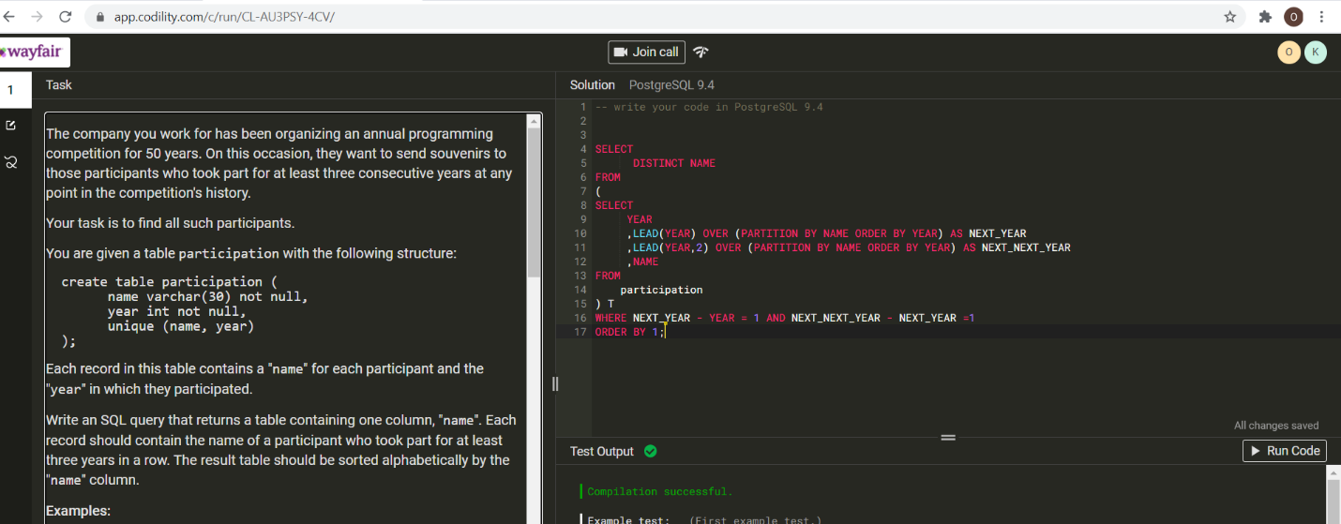

**Task. Screen1**

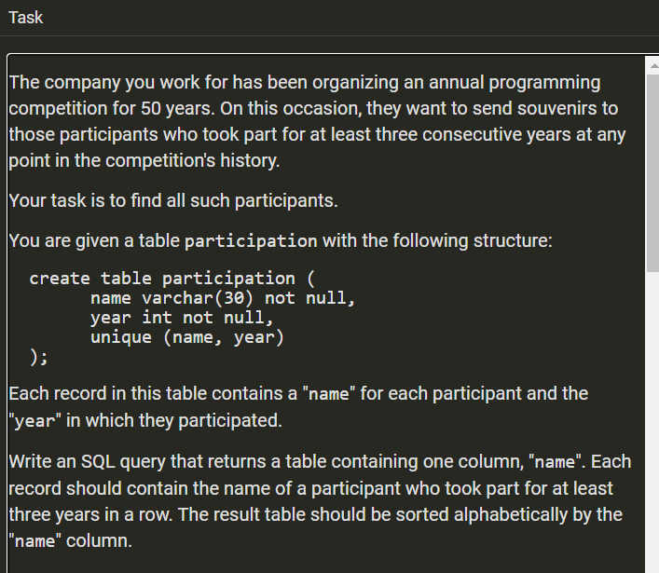

**Task. Screen2**

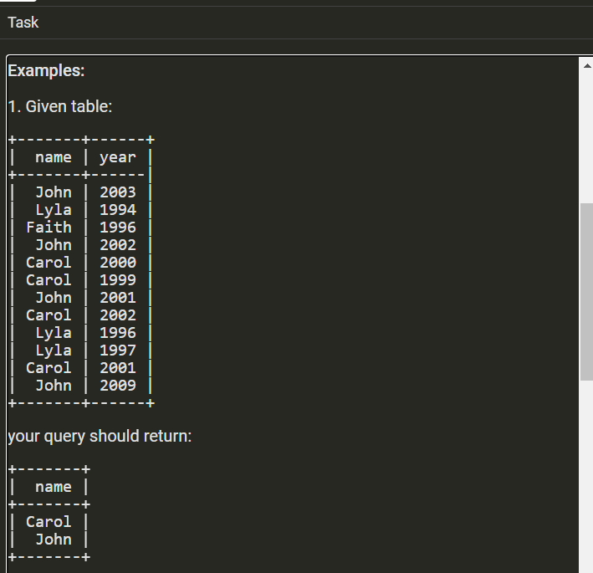

**Task. Screen3**

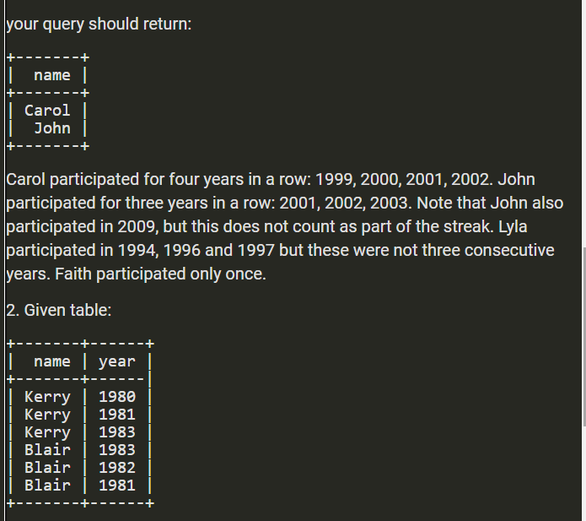

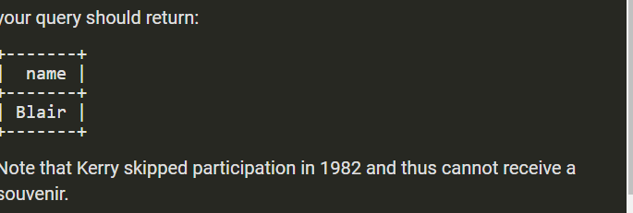

**Task. Screen4**

