## **SLIDING WINDOW**

[sliding window] problems can be solved in

Problems that can solved using [sliding window]

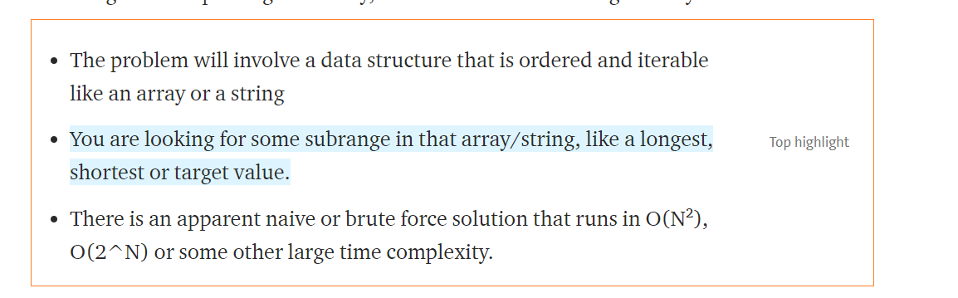

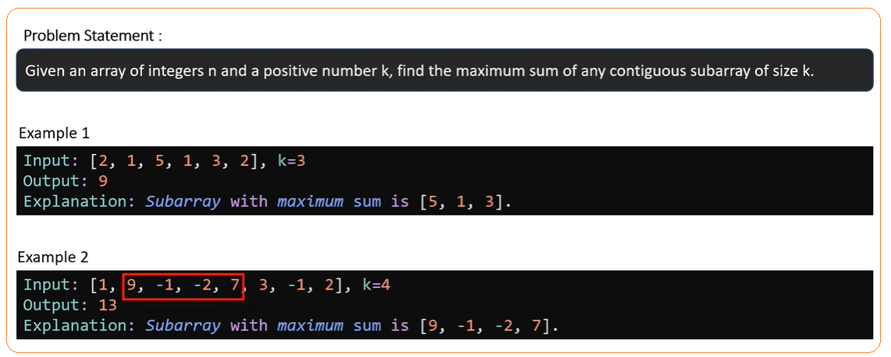

# **BRUTE FORCE APPROACH**

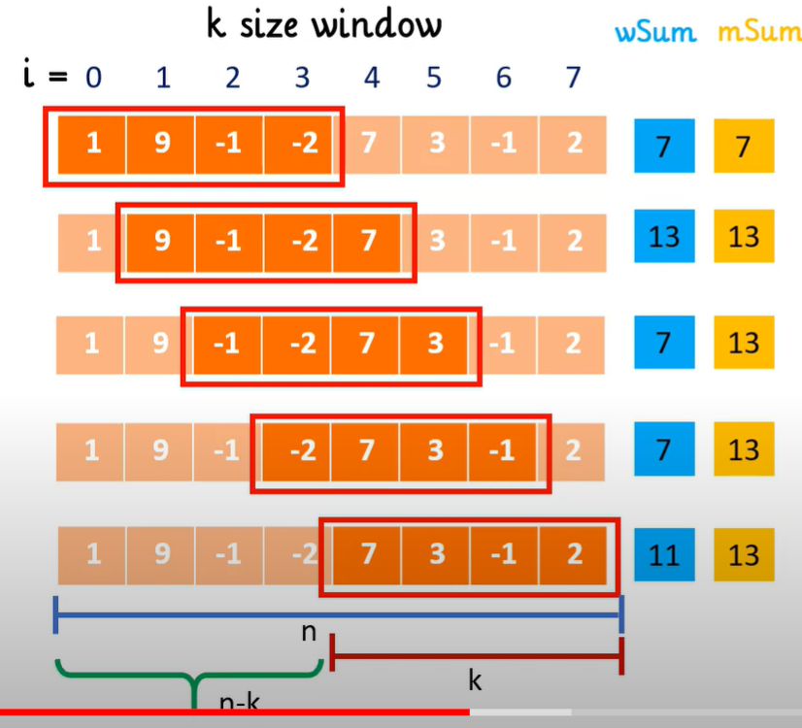

**Time Complexity = O(n*k);**

because there is a nested loop: out loop has [n] operations in the worst case

nested loop has [k] operations in the worst case

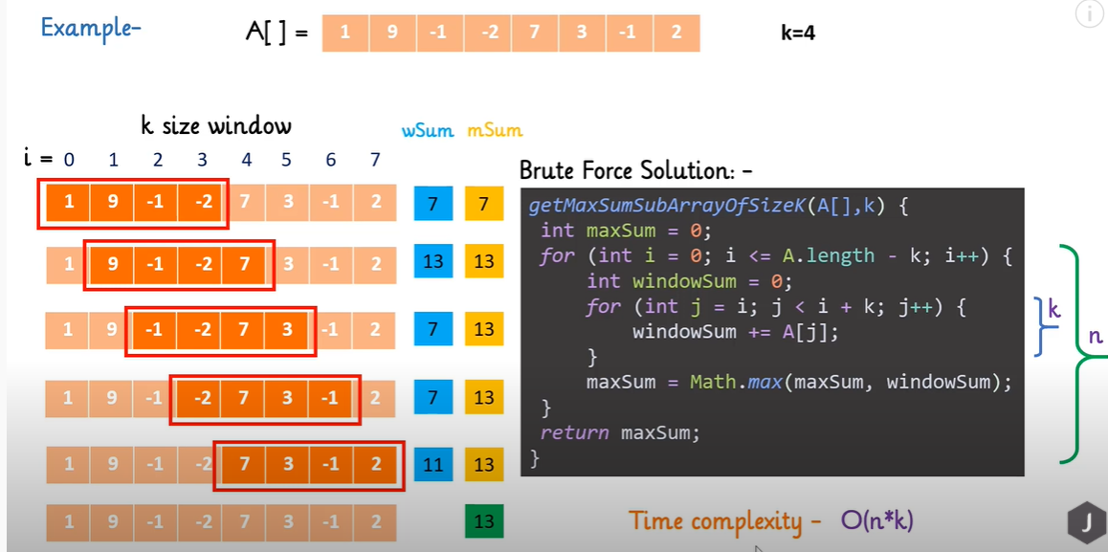

# **SLIDING WINDOW APPROACH**