# **PATTERN TWO POINTERS**

# **#TASK1. REMOVE DUPLICATES WITH EXTRA SPACE**

**Not optimal solution**.

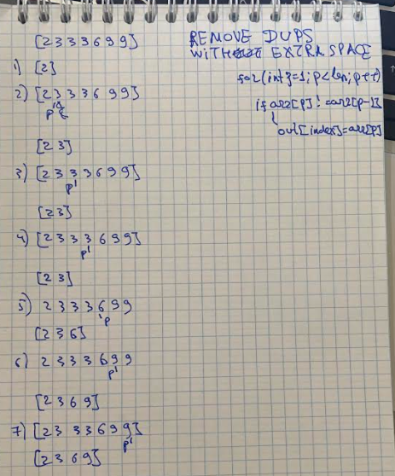

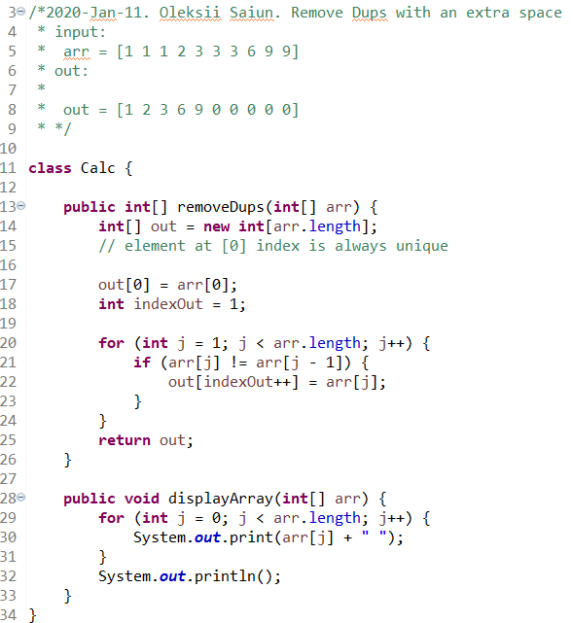

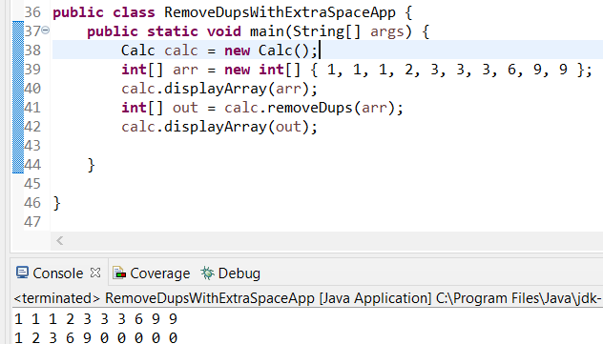

# **#TASK2. REMOVE DUPLICATES WITHOUT EXTRA SPACE**

**Optimal solution**.

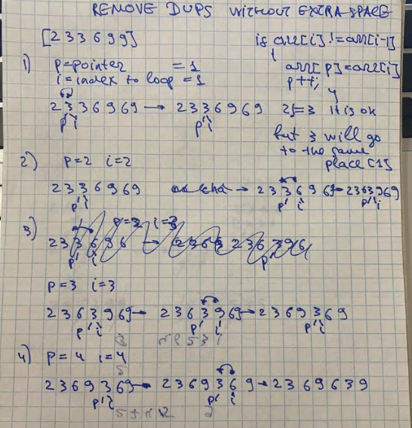

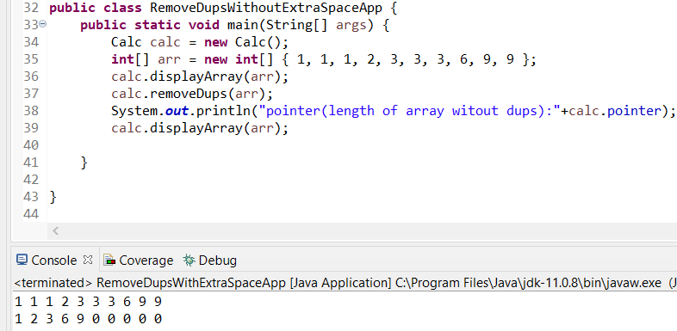

# **#TASK3. REMOVE ALL INSTANCES OF ELEMENT IN ARRAY**

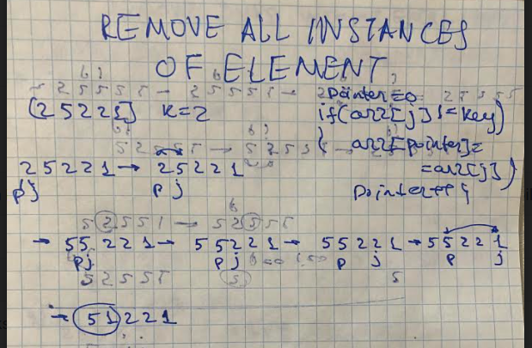

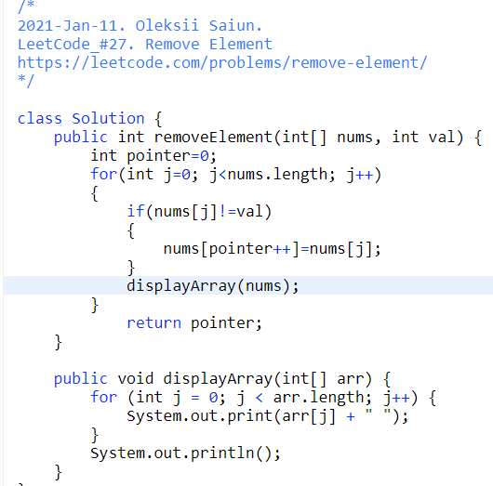

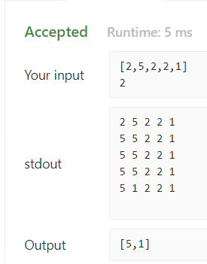

# **#TASK4. TWO POINTERS**

**896. Monotonic Array**

