# **LONGEST COMMON SUBSEQUENCE**

**Difference between subsequence and substring:**

Substring – is a contiguous part of string while in subsequence a subsequence symbols can be not contiguous

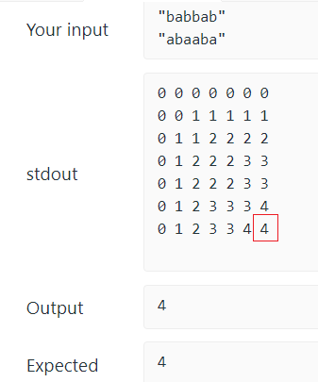

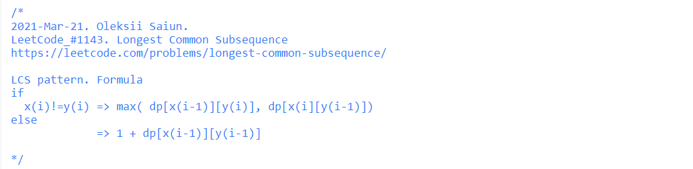

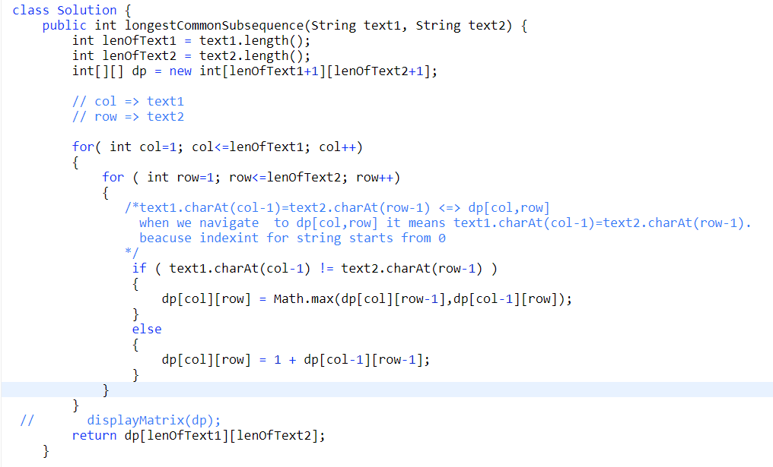

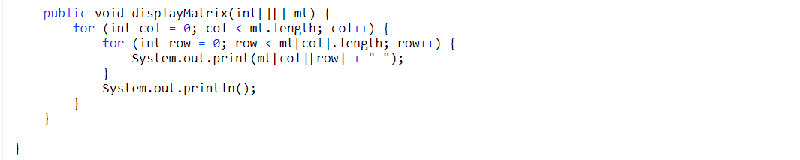

## **LONGEST COMMON SUBSTRING**

Longest Common Substring is a partial case of [Longest Common Subsequence] problem

1. I can be calculated by formula

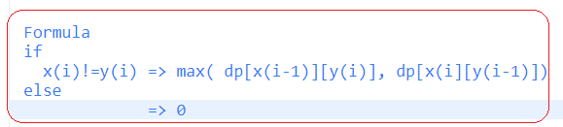

1. We need take a max for each step. This max will the result