GRAPH

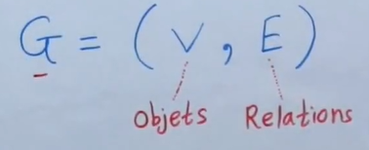

V- set of vertices (objects)

E- set of edges

**Order of graph** – is number of vertices (objects, elements)

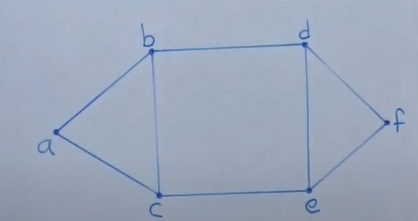

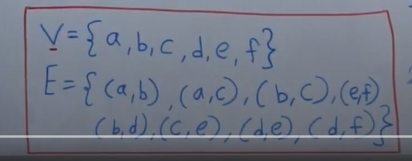

If consider an example of social network

(a,b), (a,c) -are friends, but (a,f) are not friends

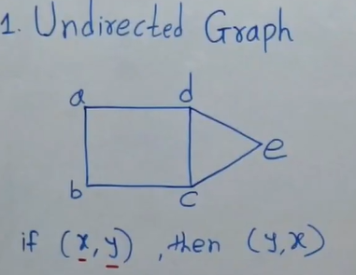

Undirected graph: if there is an edge between (a,b) => there is also an edge between (b,a). For example,

If [a] is a friend of [b], then [b] is also a friend of [a]

It is called **sibling relation**.

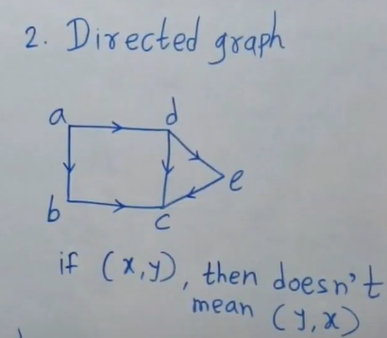

For example, it like a follower relation. If [a] follows [b], it does not mean [b] is also a follower of [a]

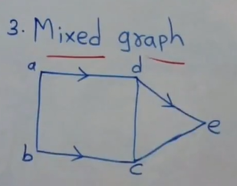

Example, of job scheduler

# **GRAPH PRESENTATION**

Graph can be present as:

* Adjacency matrix
* Adjacency list

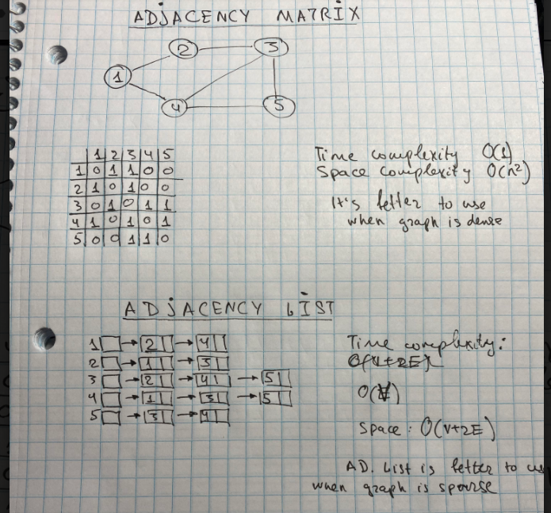

DFS vs BFS

DFS and BFS is has a goal to search relations. It ‘s not only about graph, it a general term. It can be used to find a distance in a string.

**DFS** it is goes first deep and then goes back

Stack (LIFO) is used

**BFS** – goes wide

Queue (FIFO) is used