# **MATH**

# **PRIME NUMBER**

**Prime numbe**r is a number that has two dividers - one and itself. Prime numbers starts from 2

Example: 2, 3, 5, 7, 11

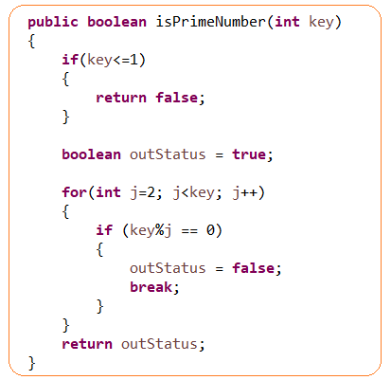

# **SIEVE OF ERATOSTHENES**

SIEVE OF ERATOSTHENES – the ancient method of finding prime numbers

1. We generate a range of numbers what we want to checks

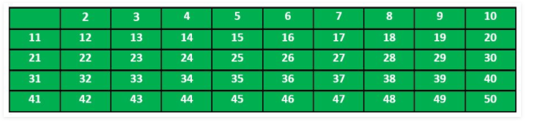

1. Divide all numbers by 2. Those which are not dividable (n%2 != 0) will leave as not touchable

2*2=4, 2*3=6, 2=8, 2*5=10, 2*6=12

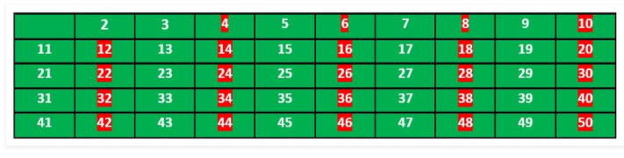

1. Repeat the same for 3

3*3=6, 3*4=12, 3*5=15, 3*6=18

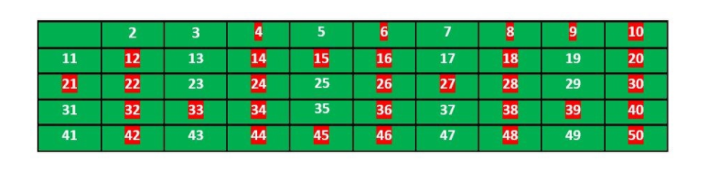

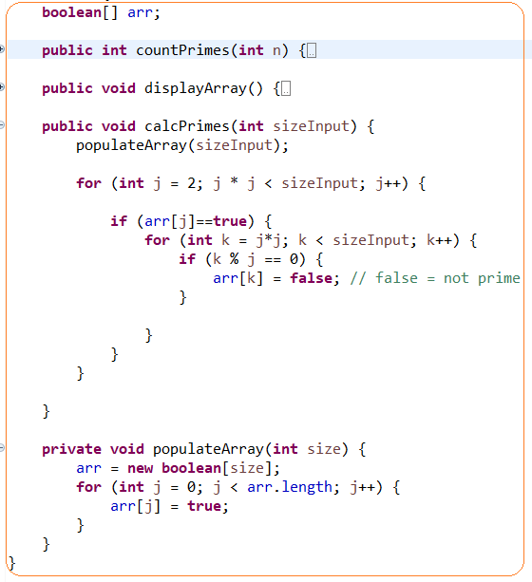

# **CONVERT_BINARY_TO_DECIMAL**

**Binary number**: A binary number is a number expressed in the base-2 numeral system or binary numeral system. This system uses only two symbols: typically 1 (one) and 0 (zero).

**Decimal number:** The decimal numeral system is the standard system for denoting integer and non-integer numbers. It is also called base-ten positional numeral system.

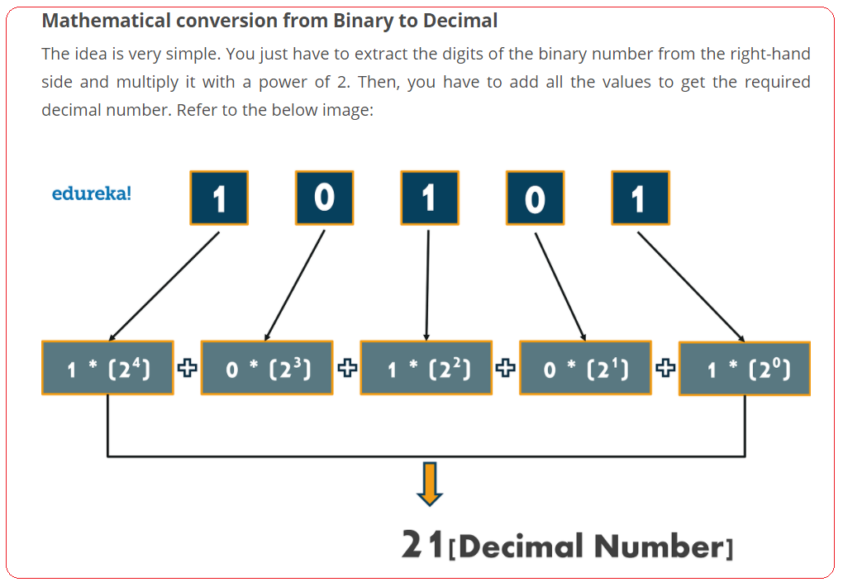

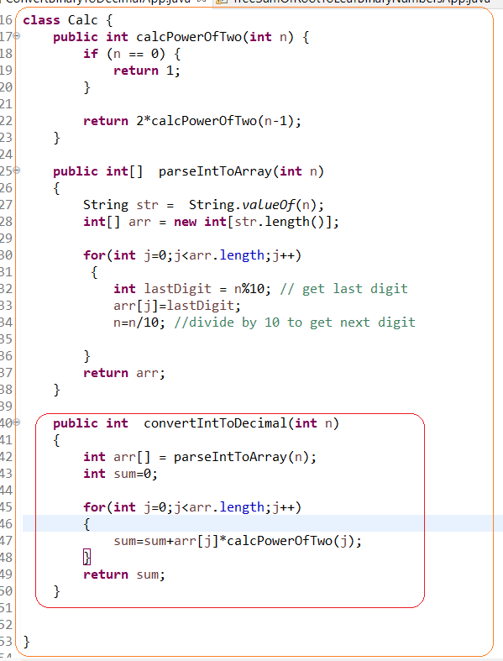

# **CONVERT INTEGER TO ARRAY OF INTEGERS**

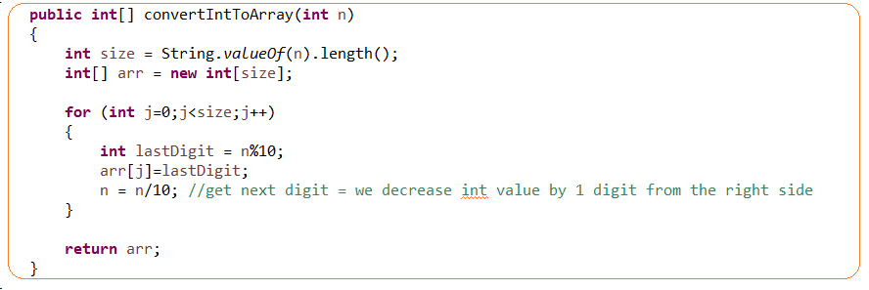

## **CATALAN NUMBER**

<https://coldfunction.com/mgen/p/3r>

**Catalan number** is a sequence of numbers that can be calculated by formula. It is used in many problems. One of them is count all possible unique binary trees

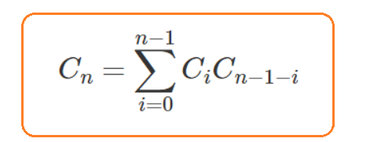



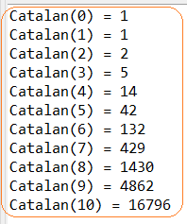

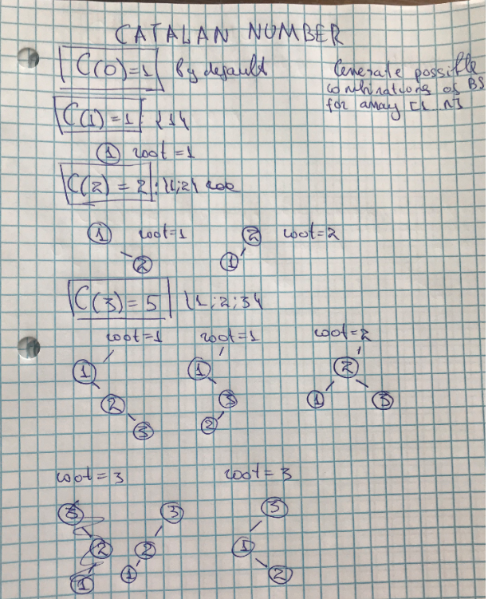

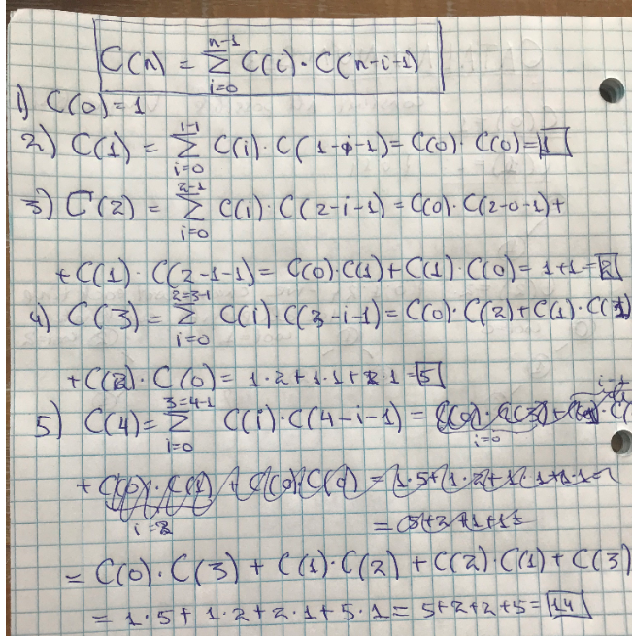

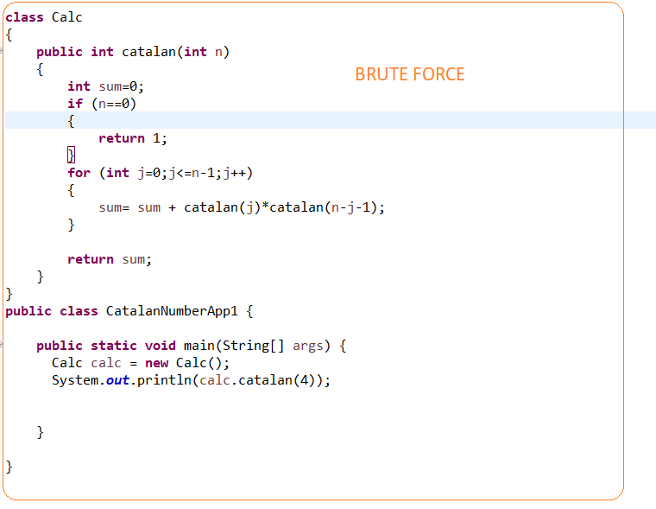

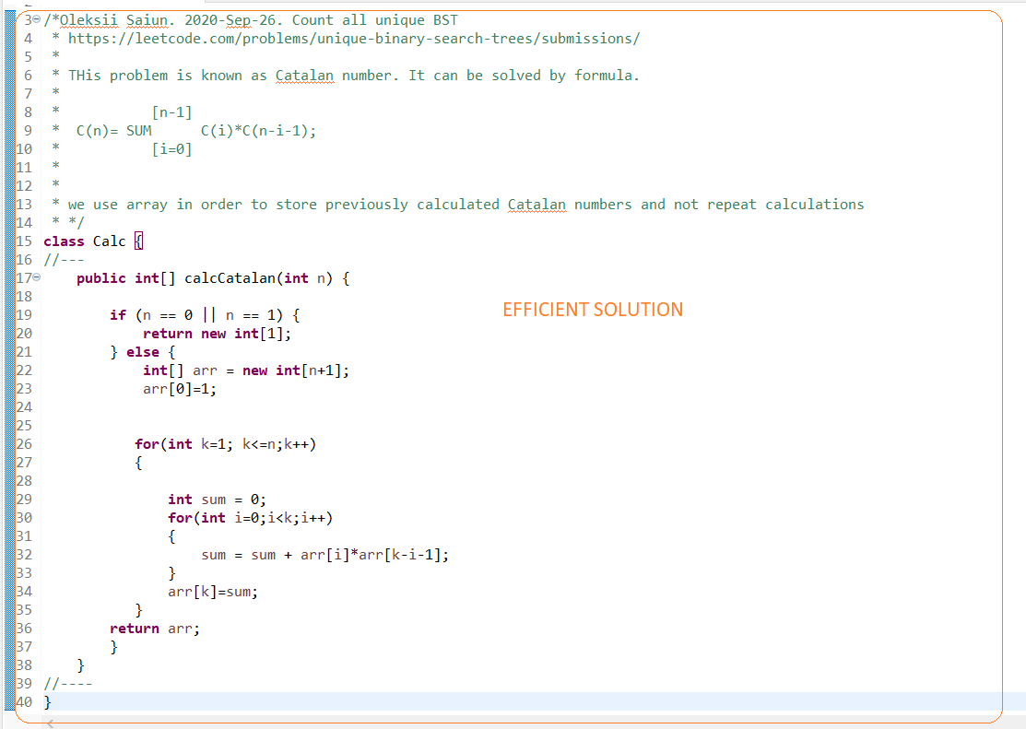

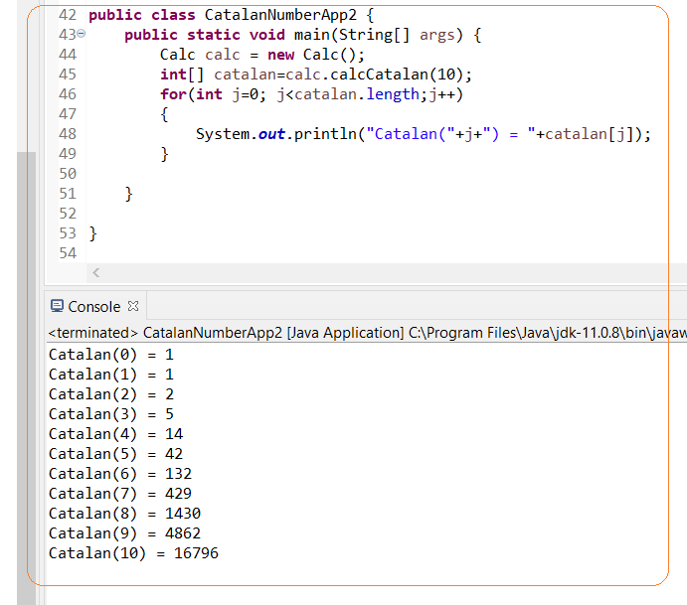

## **SUM OF ALL NUMBERS 1..N**

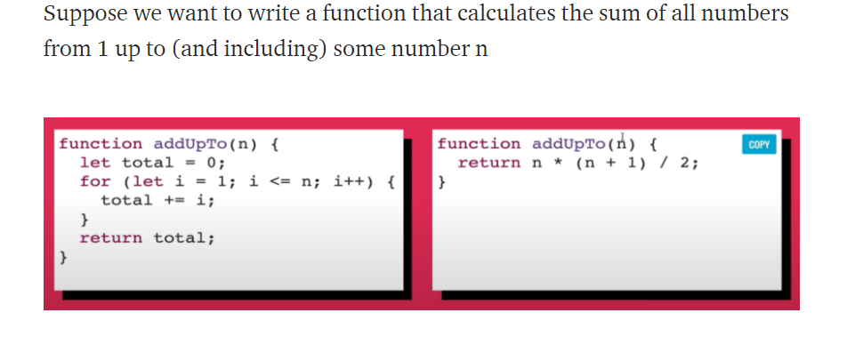

## **LOGARITHM**

Logarithm of number [Y] base [B] is equal to [X]

**BY = X ⬄ logBY=X**

**23 = 8 ⬄ log28=3**

**Logarithm** (BY = X ⬄ logBY=X) is exponent that we need to raise base B to power Y to get number X.

In computer science log2Y = logY – base 2 disregards and everything is considered as logarithm base 2 by default.

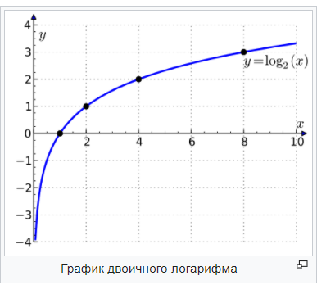

**2y = x ⬄ log2y=x**

|  |  |
| --- | --- |
| Y | X |
| 0 | 1 |
| 1 | 2 |
| 2 | 4 |
| 3 | 8 |
| 4 | 16 |

## **FORMULAS**

