# **ARRAY**

# **CONVERT INTEGER TO ARRAY OF INTEGERS**

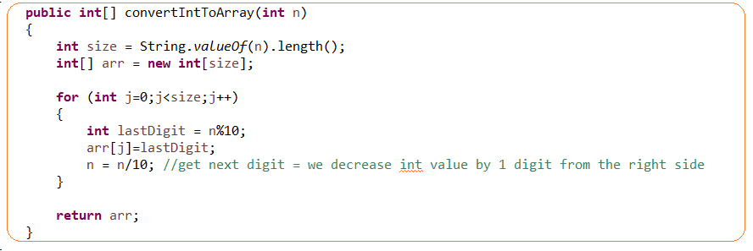

# **HOW TO COPY ONE ARRAY TO ANOTHER IN JAVA**

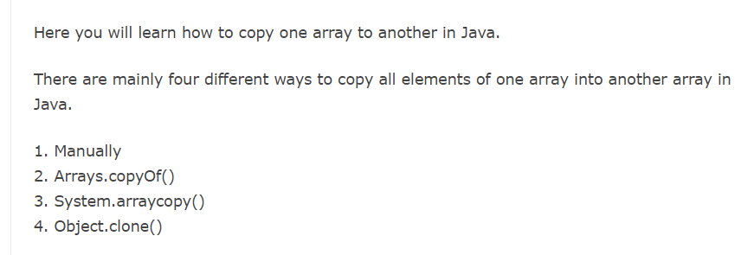

**Not correct approach – it copies only reference, not values**

Int[] a = new int[]{1,2,3};

Int[] b =a;

# **#TASK1. MERGE SORTED ARRAY**

I use the approach of two pointers to solve it(a high level idea as for a merge sort)

