# **STRINGS**

# **1.PARSING SENTENSE INTO ARRAY**

String[] str = s.split("\\W+");

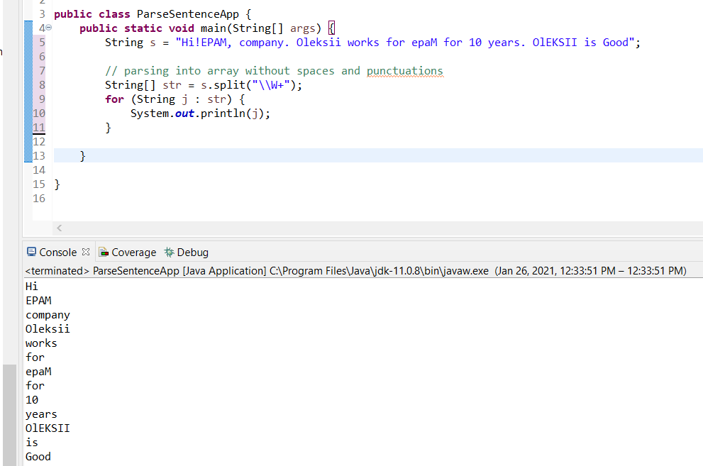

# **2.METHOD Character.isLetterOrDigit(val)**

There are very useful nmethods:

* **Character.isLetterOrDigit(val)**
* **Character.isLetter(val)**

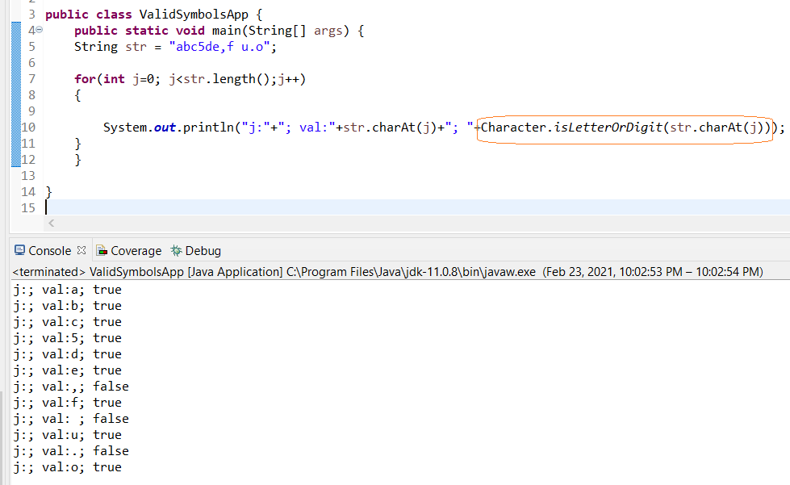

# **3.Replace all punctuation symbol**

String strOut = str.replaceAll("[^a-zA-Z0-9]", "");

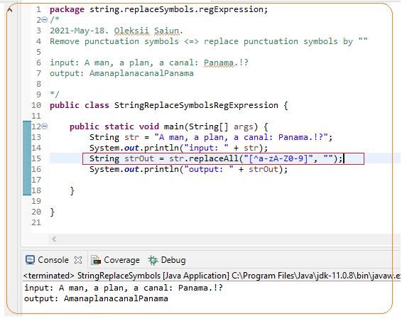

# **4.METHOD Character.toLowerCase(val)**

There are very useful methods:

* **Character.toLowerCase(val)**
* **Character.toUpperCase (val)**

[String] type has also these methods

However, it is useful to know there are similar methods for [Character]

But [char] primitive data type does not have it

