# **LINKED LIST**

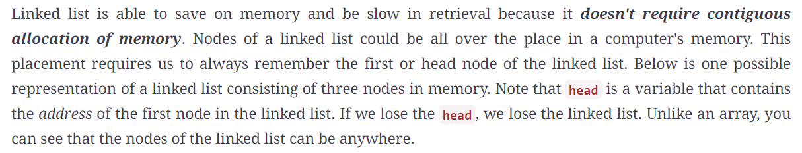

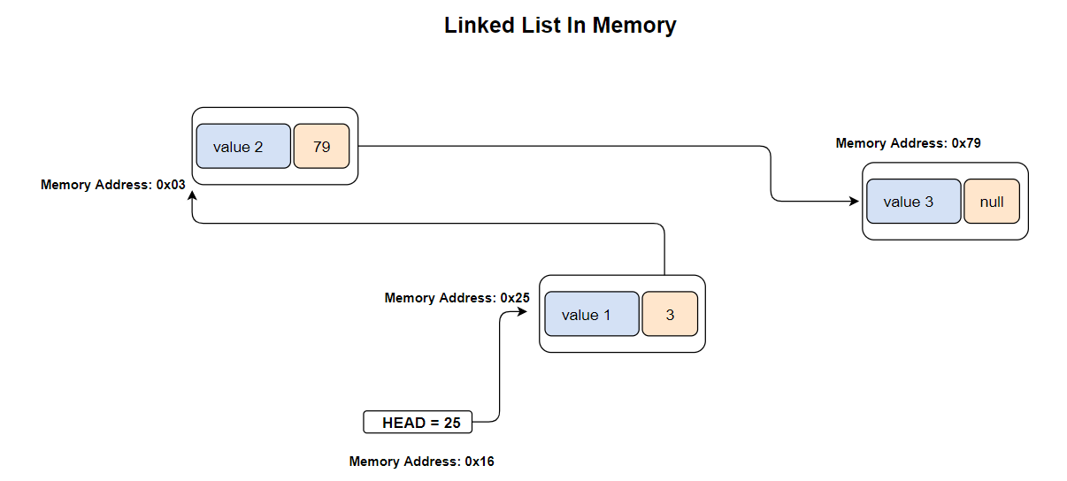

# **SINGLE CIRCULAR LINKED LIST**

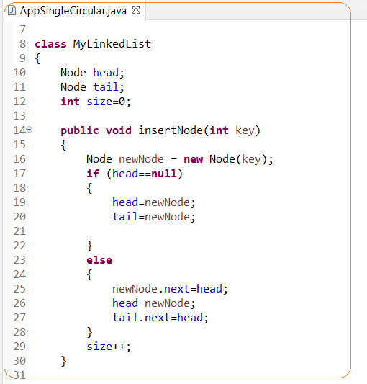

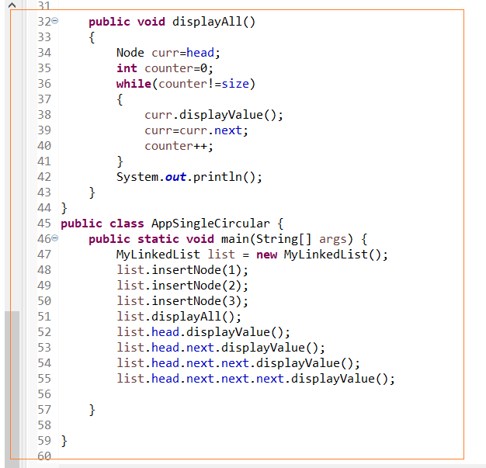

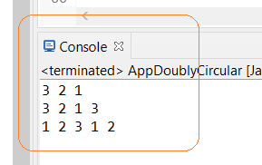

# **CIRCULAR DOUBLY LINKED LIST**

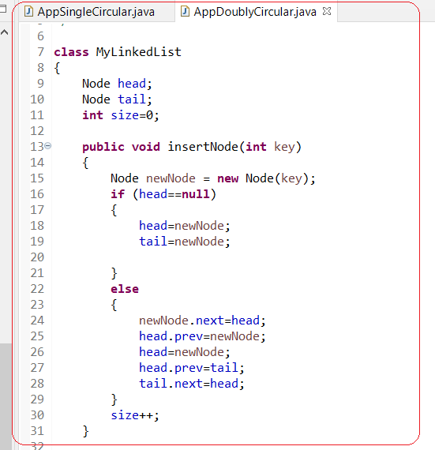

# **LRU CACHESINGLE CIRCULAR LINKED LIST**

**LRU (least recently used cache)** - doubly linked list is combined with a hash table to create a more advanced data structures called a least recently used cache or LRU cache.