# JAVA OOP

Purpose or OOP languages is to implement real word entities

OOP language over procedural

* It’s easy to develop and support applications over procedural language
* OOP provides data hiding. Whereas in procedural language global data can be accessed anywhere
* Make code reuale

**CLASS** is blue print from which you can create [objects]

Class is logical entity

**OBJECT** is runtime entity that has state and behavior. Object is created from the class or instance of class. Everything that surrounds us is ab object (pen, table, chair, car)

For example, dog is an object.

* It has state - color, name, whiskers
* It has behavior – barking, eating, wagging tail

Object has address to the memory and therefore it takes up some space

Object is physical entity

Object has:

* **state** - represent data (value) of an object
* **behavior** – represents functionality (deposit, withdraw)
* **identity** – is ID. It is not visible to external users. It’s used internally by JVM to identify each object uniquely

[**new**] keyword is used to allocate memory at runtime. All objects get memory in [Heap memory] are

**Declaration -> Instantiation-> Initialization**

**1.Declaration** assign type to the variable

Person p;

**2.Instantiation** means to creating new object. It means allocation memory at runtime in [Heap] memory ] area

Person p = new Person();

Person p = new Person(“Alex”);

**3.Initialization** – passing parameters to constructor to define (=*storing data in Object*)

public class Person

{

private String name;

private String color;

public Person(String name)

{…}

public Person(String name, String color)

{…}

}

# INITIALIZE OBJECT

There are 3 ways to initialize object:

1. **by reference variable**

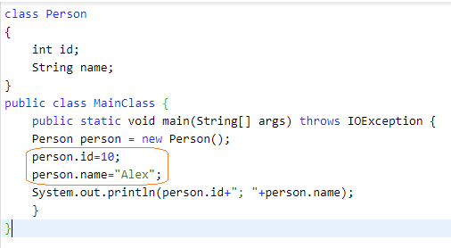

1. **by method**

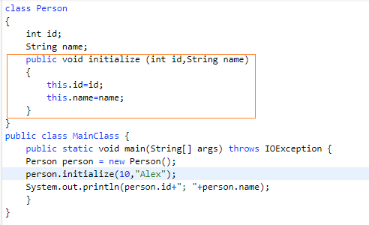

1. **by constructor**

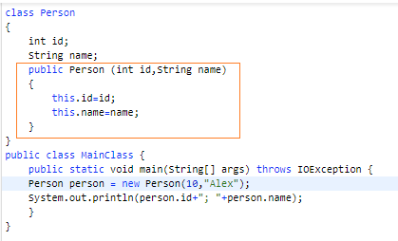

# INSTANTIATE OBJECT

It means allocation memory at runtime in [Heap] memory

There are 5 ways to do it:

* By [new ] keyword
* By [newInstance()] method
* By [clone] method
* By deserialization
* By factory method

# CONSTRUCTOR

Constructor can not be:

* status
* final
* synchronized

Constructor *overloading* is allowed in Java. Overloading is just have constructor with different parameters

|  |  |
| --- | --- |
| CONSTRUCTOR | MEHTOD |
| *Constructor is used to initialize the state of Object* | Method is to make some behavior |
| It does not have return type | It must have return type |
| Constructor is invoked implicitly | method is invoked explicitly |
| Java provides default constructor | Method must be developed |
| Constructor name must match with class name | Any name |

public class Student

{

public Student()

{…}

public Student(String name)

{…}

public Student(int id, String name)

{…}

}

# STATIC

Static relates to class than instance.

Static can be

* **variable** - it is used for cases when variables is used across all object. For example, SK, company name, university name. Static variable **gets memory only once**.
* **method** -
* static block – this block executed when class is loaded in the memory. It’s used to initialize static data
* nested class -

note: is it possible to execute java program without main method? It was possible in static bloch till JGK 1.6. After it’s not possible

# INHERITANCE

**INHERITANCE** – is OOP concept. When one object acquires all the properties and behaviors of parent class it’s called inheritance.

It’s used to achieve [runtime polymorphism]

# POLYMORFISM

**POLYMORFISM** is when task can be performed in different ways

**POLYMORFISM** is the ability of object takes different forms

Polymorphism:

* static binding
* dynamic binding

# ADBSTRACTION

**ABSTRACTION** is hiding details and showing only functionality

# COUPLING

**COUPLING** refers to dependency to another class. You can use interface to achieve weakly coupling, because it does not have concrete implementation.

# COHESION

Weakly cohesive method will split the task into separate parts

# ASSOCIATION

**ASSOCIATION** represents relationship between objects:

* 1:1
* 1:n
* n:1
* n:n

# AGGREGATION

**AGGREGATION** (**HAS-A**) is a way to achieve association.

**AGGREGATION** (**HAS-A**) represents the relationship where one object contains others as a part of its own state. It represents a **weak relationship** between objects

represents re

# COMPOSITION

**COMPOSITION**(**IS-A**) is also way to represents the relationship where one object contains others as a part of its own state. It represents a **strong relationship** between objects

# [this] keyword

[this] can be used to refer to instance variable of current class

[this] can be used to invoke current class method

[this] can be used to invoke current constructor method

[this] can be used to pass argument to the method

1.[this] can be used to refer to instance variable of current class

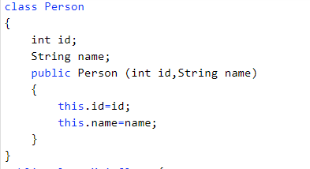

2.[this] can be used to invoke current class method

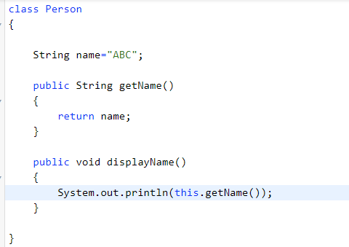

3.[this] can be used to invoke current constructor method

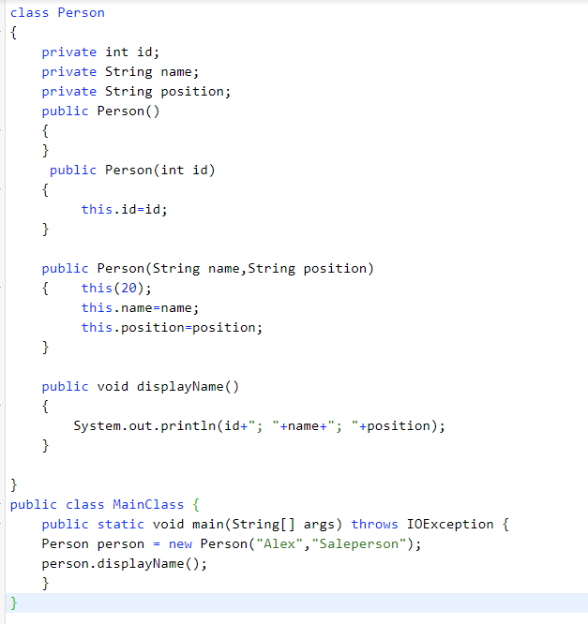

4.[this] can be used to pass argument to the method

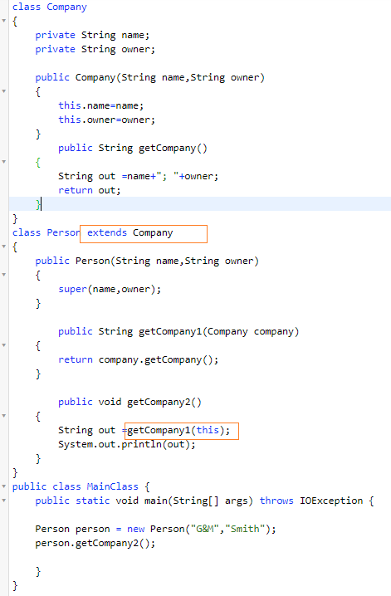

|  |  |
| --- | --- |
| **HOW ACHIEVE CONCEPT** | **DESC** |
| abstraction | Using abstract class and inheritance |
| runtime polymorphism | Inheritance (reference variables) |
|  |  |
|  |  |

Links:

<https://www.javatpoint.com/this-keyword>