JAVA COLLECTIONS FRAMEWORK

**Java Collection Frameworks** is a collection of classes and interfaces that helps in storing and processing data efficiently

**List Interface** – ordered data.

* Data can have duplicates
* Data can be accessed by index

**ArrayList** class implementation

* Can dynamically grow and shrink when elements are removed compared to Array
* ArrayList grows 50% of its size each time
* ArrayList should be preferable when there are often get and set operations
* ArrayList should be preferable when there is no often add/remove operations

**LinkedList** is implemented by 2 interfaces <List> and <Deque>(**as double linked list**)

* It’s good performance on add and remove elements compare to ArrayList, but worse on get and set element
* LinkedList should be preferable when there is no often get and set operations
* LinkedList should be preferable when there are often add/remove operations

4 ways how LinkedList can be looped

1. For loop
2. ForEach loop
3. Iterator
4. While loop

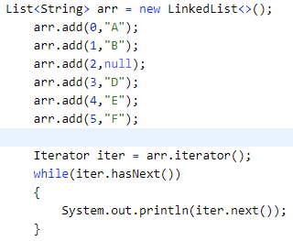

**Vector** is similar with ArrayList but synchronized. It means it is a thread safe

Vector implements <List> interface. It’s a thread safe. Because it’s synchronized it gives poor performance.

* ArrayList grows 50% of its size each time
* Vector grows 2 times of its size each time

**Set Interface** – ordered data.

Links:

<https://beginnersbook.com/java-collections-tutorials/>