## 1.OOP

## 2.COLLECTIONS

1. Q:How remove elements in Array List

A:

* [Remove(index)]
* [Remove(object)]
* [clear]

2. Q: How add elements in ArrayList using explicit index

A:

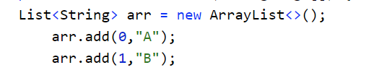

3. Q: if you use sparse indexes (0,1,..,3) to add data what happens

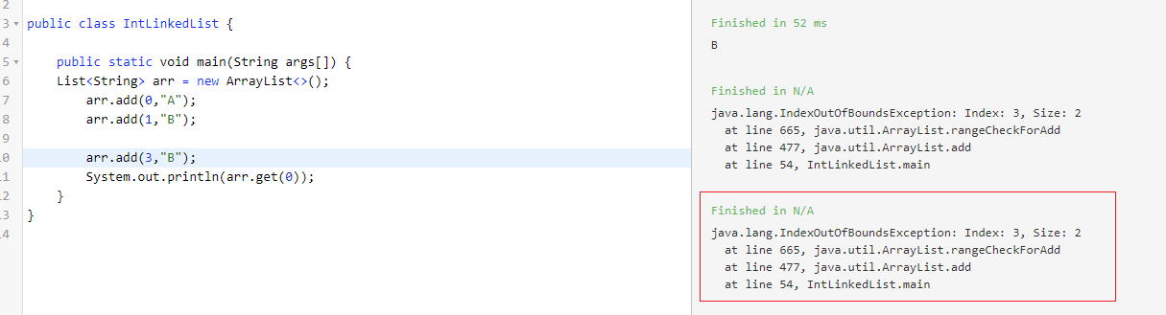

4. What is difference between Collections and Collection?

* **Collections** – is utility class
* **Collection** - is a top level interface of java collection framework

5. Performance

