# EXCEPTIONS

1.**Exceptions** – event that occurs in app

* **checked exceptions** – all exceptions other than Runtime Exceptions. If these exceptions are not handled/declared in the program, you will get compilation error. For example, SQLException, IOException, ClassNotFoundException.
* **unchecked exceptions** – it is runtime exceptions. These exceptions are not checked at compile-time so compiler does not check whether the programmer has handled them or not but it’s the responsibility of the programmer to handle these exceptions and provide a safe exit. For example, ArithmeticException, NullPointerException, ArrayIndexOutOfBoundsException

*They are called [unchecked exceptions], because it is not feasible to define until program runs*.

2. **Errors** – indicates severe error happened and app will crash. For example, StackOverflowError is a runtime error in java. It is thrown when the amount of call stack memory allocated by JVM is exceeded

Note: most of the time you will work with checked exceptions

|  |  |
| --- | --- |
| Checked | Unchecked |
| * SQLException * IOException * ClassNotFoundException | * ArithmeticException * NullPointerException * ArrayIndexOutOfBoundsException |

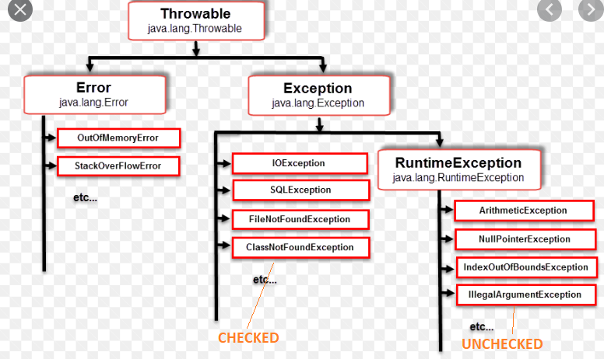

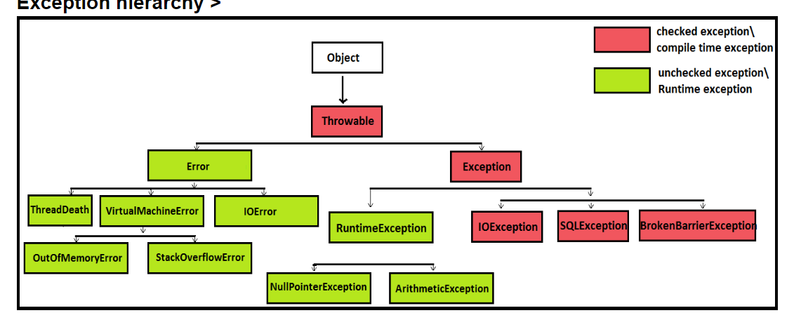

**UNCHECKED EXCEPTIONS**

