MRI Table Kinect : A multi-surface application for exploring volumetric medical imagery

Abstract

Copyright is held by the author/owner(s).

CHI’13, April 27 – May 2, 2013, Paris, France.
ACM 978-1-XXXX-XXXX-X/XX/XX.
Medical imaging is an important part of diagnostics and treatment planning. Traditional approaches for exploring medical imaging data typically involve physical media or keyboard and mouse based interactions. However, commodity digital tabletops and tablets are now available and affordable. Such technologies enable new approaches in visualizing medical data. In this paper we present an application with a novel interaction technique for visualizing volumetric MRI imagery. With our application users can slice into this volumetric dataset by moving a tablet in the physical space above a tabletop. An image corresponding to the plane of the slice is displayed on the tablet. We believe that this interaction technique is useful and might have benefits in diagnostics, treatment planning, and medical education.
Teddy Seyed
Dept. of Computer Science
University of Calgary
Calgary, AB Canada
teddy.seyed@ucalgary.ca

Chris Burns
Dept. of Computer Science
University of Calgary
Calgary, AB Canada
chris.burns@ucalgary.ca

Patrick King
Dept. of Computer Science
University of Calgary
Calgary, AB Canada
patrick.f.king@gmail.com

Francisco Marinho Rodrigues
Dept. of Computer Science
University of Calgary
Calgary, AB Canada
fm.rodrigues@ucalgary.ca

Mario Costa Sousa
Dept. of Computer Science
University of Calgary
Calgary, AB Canada
smcosta@ucalgary.ca

Frank Maurer
Dept. of Computer Science
University of Calgary
Calgary, AB Canada
frank.maurer@ucalgary.ca

Author Keywords
Multi-surface systems, Medical Image Visualization

ACM Classification Keywords
H.5.2. Information interfaces and presentation: User Interfaces – input devices and strategies.

Introduction
Imaging has been an important component of medicine for several decades. Imaging technologies (e.g. Medical Resonance Imaging (MRI), Computed Tomography (CT), X-Rays and Angiograms) provide the basis for informed decisions on healthcare, such as diagnosing health problems, planning of medical treatment and assessing surgery risks.
For the most part, physicians and researchers have accessed this data via conventional keyboard and mouse driven computer interfaces. Recent years have seen new input methods reach the market. These include sensor technologies, ranging from the small and inexpensive Leap Motion sensor to the more expensive Vicon camera system; and touch technologies, including tablets such as the Apple iPad, and touch tabletops such as the SMART digital tabletop.
Applying these technologies to the medical domain opens new opportunities for exploring medical imaging data, particularly volumetric imaging data. We present a novel system to visualize volumetric medical data which maps the dataset to a physical space, and which enables navigation through it with tablet computers and the Microsoft Kinect sensor. In this paper, we present this approach, details about the implementation of the system, and additional planned work.

Background & Related Work

Medical Data on Tabletops
Tabletops have been used in to display medical imaging data in a variety of ways. Volumetric data can be rendered directly on the tabletop, and then rotated and explored using multi-touch interactions [1]. Other work presents a system where a ‘world in miniature’ can be manipulated on a tabletop to control a detail view on a wall mounted display, while global context is provided by a 3D rendering of the data via a stereoscopic display system [2].

Slicing & Lenses
Previous work has considered the idea of lensing where two displays are layered one on top of the other, so that one display can augment information displayed beneath it. This has been implemented by projecting a display onto a lens or board held by a user. This approach has been used to explore horizontal layers of data such as different views of a map [3] and to provide a multi-dimensional exploration of medical visualization data [4]. This approach requires the use of cumbersome tracking systems that are not widely available or affordable.

Implementation
Our application is composed of three separate hardware components. We use a SMART digital tabletop to display a reference image encompassing the entire area scanned (for example, the reference image for an MRI scan of a person is an image of the human body). We display planes of the MRI data on an Apple iPad tablet. Adjacent to the tabletop is a Microsoft Kinect sensor which tracks the spatial position of the tablet over the tabletop, and which determines which data appears on the tablet.
We created custom applications to track the position of the tablet, select a plane through the data, and finally display the plane for users of the system. To manage communication between each of the component devices we employed a device discovery and communication library called IntAirAct.

Slicing Interaction
Our system creates a correspondence between the physical space above a digital tabletop and the volumetric dataset itself. To explore a specific area of the MRI volume, the user moves their hand or a tablet computer to the area of interest over a reference image which covers the entire area scanned. The hand or tablet is detected by the Kinect sensor, a marker indicating the selected plane through the data is displayed on the tabletop, and the data itself is displayed on the tablet or other external display.

Slicing with a Tablet
When using a tablet to explore the volumetric data set the slice is displayed directly on the tablet (figure 1). This integrates the tablet into the space mapped to the scan, as moving the tablet moves the display through the corresponding portion of the data. This interface is highly intuitive, though smaller tablets are preferred to minimize fatigue.

Slicing with a Hand
The hand is held vertically to form a plane over an area of interest (figure 2). The corresponding slice of the scan is shown on another display. While this lacks the immediacy of the tablet-based interaction, it is less tiring over time than holding a tablet and just as intuitive to use. This mode of interaction could be applicable in clinical settings where sterility is a requirement.

Figure 1. Slicing with a tablet computer.
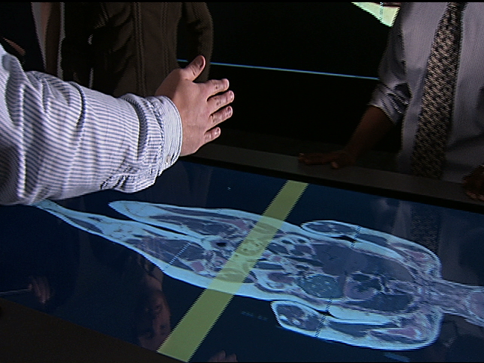
Figure 2. Slicing by hand.

Future Work
We intend to expand this work in several directions. In order to justify the validity of this interaction technique, we would like to conduct detailed usability studies with physicians and imaging analysts. This would allow us to assess whether or not this technique is useful in a clinical environment.
Currently the application can only provide slices along a single axis. We would like to extend our system to allow multi-dimensional slicing. This could be achieved by accessing information from the gyroscope to determine the physical orientation of the tablet, or by implementing rotation of the reference image on the tabletop.

Conclusion
MRI Table Kinect provides a novel visualization approach using touch tabletops and spatial tracking for exploration of volumetric medical data with relatively inexpensive consumer grade hardware. While this approach has not yet been evaluated in clinical settings, we believe that it has potential advantages over traditional approaches, such as providing intuitive interactions, offering a touch-free interface, and reducing hardware costs. We aim to follow up this work by validating the interactions presented and expanding the capabilities of the system.

References
- Lundstrom, C., Rydell, T., Forsell, C., Persson, A., Ynnerman, A., Multi-Touch Table System for Medical Visualization: Application to Orthopedic Surgery Planning. IEEE Transactions on Visualization and Computer Graphics. Vol. 17, No. 12 (December 2011), 1775-1784.
- Coffey, D., Malbraaten, N., Le, T. B., Borazjani, I., Sotiropoulos, F., Erdman, A. G., Keefe, D. F. Interactive Slice WIM: Navigating and Interrogating Volume Data. Sets Using a Multisurface, Multitouch VR Interface. IEEE Transactions on Visualization and Computer Graphics. Vol. 18, No. 10 (October 2012). 1614-1626.
- Spindler, M., Stellmach, S., Dachselt, R. PaperLens: Advanced Magic Lens Interaction Above the Tabletop. In: Proceedings of Interactive Tabletops and Surfaces (2009).
- Spindler, S., Dachselt, R., Exploring Information Spaces by Using Tangible Magic Lenses in a Tabletop Environment. CHI 2010, ACM Press (2010), 4771–4776.

http://arlol.github.com/intairact.html

