The Accuracy of Human and AI SOC Analysts

Leilani Leon
Department of Cybersecurity, Metropolitan State University of Denver
CYB-4990-002: Capstone Seminar in Cybersecurity
Dr. Meg Bertoni
December 11, 2025

The Accuracy of Human and AI SOC Analysts
With the rise in complexity, sophistication, and frequency of cybersecurity threats, organizations tasked with identifying and defending against these incidents face significant risk of fatigue and strain. Security Operations Centers (SOC) often serve as the frontline defense against these threats and are where analysts monitor, detect, and respond in real time. Their role in this ever-evolving threat landscape is crucial in safeguarding critical infrastructure, yet they are increasingly hindered by alert fatigue, information overload, and the growing complexity of modern attack vectors. As a result, organizations are exploring the use of artificial intelligence (AI) to support automation, augment SOC operations, and help process the increasing number of alerts in all attack vectors. As I worked through this project, it became increasingly clear why many SOC teams struggle with alert fatigue, as modern systems simply generate too much noise for humans to keep up with without some form of automation.
AI tools promise to transform the detection and response process through leveraging pre-trained machine learning and data analytics techniques to identify anomalies, event correlation, and reduction in time of detection. Scholars like Edris (2025) argue that AI and cybersecurity capabilities can create a symbiotic relationship in which AI can enhance both efficiency and applicability. This, however, raised the question of whether or not these systems can achieve the same level of accuracy, contextual awareness, pattern recognition, and reliability as a human SOC analyst.
This capstone project focuses on implementing a functional, AI-supported Security Operations Center (SOC) environment using Wazuh, OpenSearch, Filebeat, and a custom AI triage model through a virtual cloud environment hosted by Oracle. The objective is to compare the performance of human SOC analysts against an automated AI-driven analysis system that utilizes controlled and simulated cyberattack scenarios such as an SSH brute force attack, sudo privilege escalation, and FIM tampering. The study evaluates both AI-assisted and human SOC triage performance through triage accuracy and incident classification quality, misclassification rates that include false escalations (false positives) and missed critical events (false negatives), and the efficiency in response measured by time-to triage and incident consolidation. This study also implemented a working AI triage pipeline that was integrated with both the Wazuh Dashboard and OpenSearch, which enabled a direct comparison between AI-driven incident classification and human SOC analysts across the three controlled attack scenarios. Throughout the course of this project, the setup has required substantial configuration, troubleshooting, and system validation.

Literature Review
AI is emerging as one of the most transformative forces in cybersecurity due to its ability to process large quantities of data at impossible speeds for humans. Edris (2025) highlights the support these AI tools can offer when it comes to enhancing security outcomes through acting as a multiplier for preexisting cybersecurity tools, which allows them to become adaptive to more dynamic threats. This is further emphasized by Kshetri (2025), who highlights the potential of agentic AI, autonomous systems capable of proactively identifying and mitigating attacks without direct human oversight. This would suggest a shift from a reactive role to a more proactive defense model, where AI increasingly acts as an independent security agent rather than simply assisting human analysis.
Despite these advances, however, organizational adoption of AI also introduces complexities. Jada and Mayayise (2024), through review, have found that AI significantly strengthens cybersecurity resilience but raises concerns regarding overreliance, transparency, and explainability.
Evaluating any SOC performance requires well-defined and measurable criteria. Forsberg and Frantti (2023) argue that traditional qualitative assessments of SOC effectiveness are insufficient, and they propose a series of quantitative performance methods. These include mean time to detection (MTTD), mean time to response (MTTR), and the ratio of true positives to false positives. These metrics provide a means of comparing human analysts and AI tools to ensure that evaluations are based on objective measurable performance rather than subjective assessments.
Rosso et al. (2020) introduced SAIBERSOC, a framework that uses synthetic attack injections to benchmark SOC performance. By generating these controlled attack scenarios, SAIBERSOC enables the users to establish “ground truth” conditions against the effectiveness of analysts and systems in a way that can be measured. This approach is valuable in experimental studies as it allows for direct head-to-head comparisons of AI and human performance in simulated SOC environments.
AI-driven intrusion detection has demonstrated significant progress through research in recent years. Salem et al. (2024) provides a comprehensive review of AI-based detection methods that particularly focus on machine learning and deep learning. The findings highlight how AI systems often outperform traditional signature-based approaches by detecting previously unseen threats and adapting to new attack strategies. The review, however, also identifies the ongoing challenges of explainability, dataset generalization, and the reduction of false positive rates. These issues directly impact trust and usability.
Sarhan, Laueghy, and Portman (2021) stress the importance of explainability in AI models for network intrusion detection. They note that while high accuracy is essential, building trust in AI recommendations is equally important for adoption in SOC environments. AI must not only perform accurately but also provide sufficient reasoning or justification for the decisions made to be effectively integrated into SOC workflows.
Recent studies indicate that AI may be most effective in augmentation rather than a replacement for human analysts. Singh et al. (2025) conducted a study of SOC analysts using large language models (LLMs) in operational contexts. Their research revealed that AI tools helped significantly improve the speed of querying and triage tasks, but human oversight was essential for nuanced interpretation, contextual decision making, and escalation. This finding suggests that hybrid models, where AI filters and prioritizes alerts for humans to provide contextual judgement, may offer the best balance of efficiency and accuracy.
This resonates with the aforementioned organizational concerns raised by Jada and Mayayise (2024) when it comes to overreliance of AI. By retaining that human oversight, organizations can mitigate risks associated with AI misclassifications while still reaping the benefits of the provided automation. The implication is rather than replacing SOC analysts, AI could shift their role toward more higher-level analysis and decision making, which could reduce the cognitive burden that is brought upon by alert fatigue, information overload, and the growing complexity of modern attack vectors.

Methods
This study employed a comparative evaluation design in order to compare the performance between a human SOC analyst and an AI-based SOC triage model. The goal was not to assess raw detection capabilities, but rather the triage performance itself, which includes:
- Triage accuracy and incident classification.
- Misclassification patterns such as false positives and false negatives.
- Response efficiency, measured through time-to-triage.
This design is consistent with recommended SOC evaluation methodologies (Forsberg & Frantti, 2023; Rosso et al., 2020), who emphasizes that meaningful SOC evaluation must examine detection correctness, escalation decisions, and timeliness. This experiment was conducted within a controlled Wazuh-based SIEM environment using real alert data from simulated cyberattacks. Synthetic attack scenarios were selected in accordance with Rosso et al. (2020), who highlighted the importance of ground-truth benchmark datasets for SOC performance research.
Three entry-level SOC analysts with prior experience in using SIEM or IDS tools participated in this study. All participants completed Scenario 1, while two completed Scenario 2 and Scenario 3. Variation in the scenario completion reflects realistic operational constraints such as workload and analyst availability. No personally identifiable information (PII) was collected, and all participation was voluntary.

System Environment
The entire system was deployed and hosted on Oracle Cloud Infrastructure using Docker Compose for container orchestration and configuration. The resulting single-node SOC environment consisted of:
- Wazuh Manager for alert generation and log collection.
- Wazuh Indexer/OpenSearch for backend search and analysis.
- Filebeat as the log forwarding agent.
- A custom-built AI Triage Container integrated with the OpenAI API.
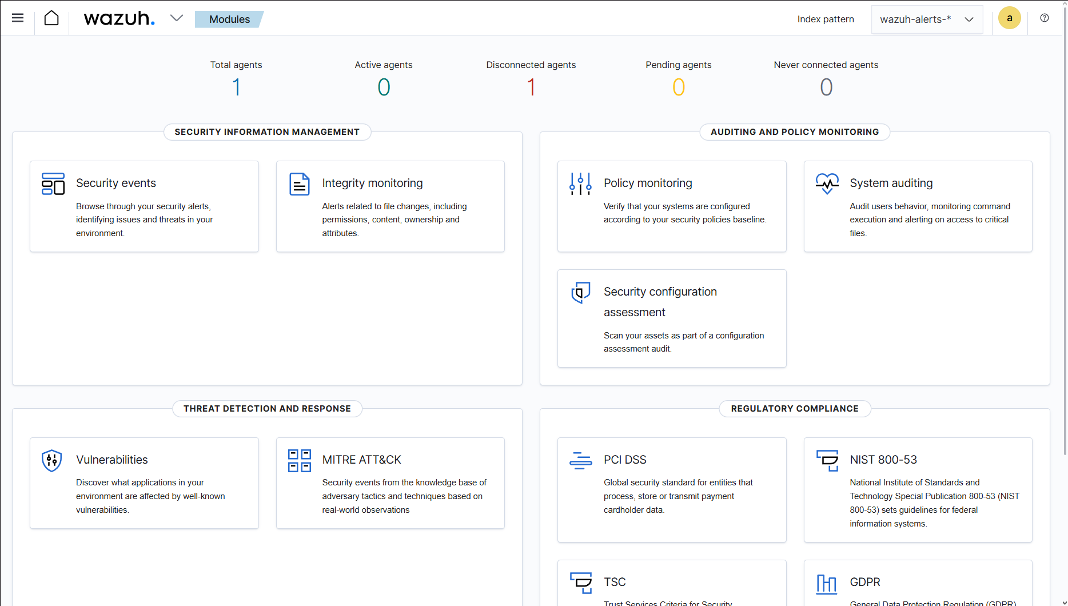
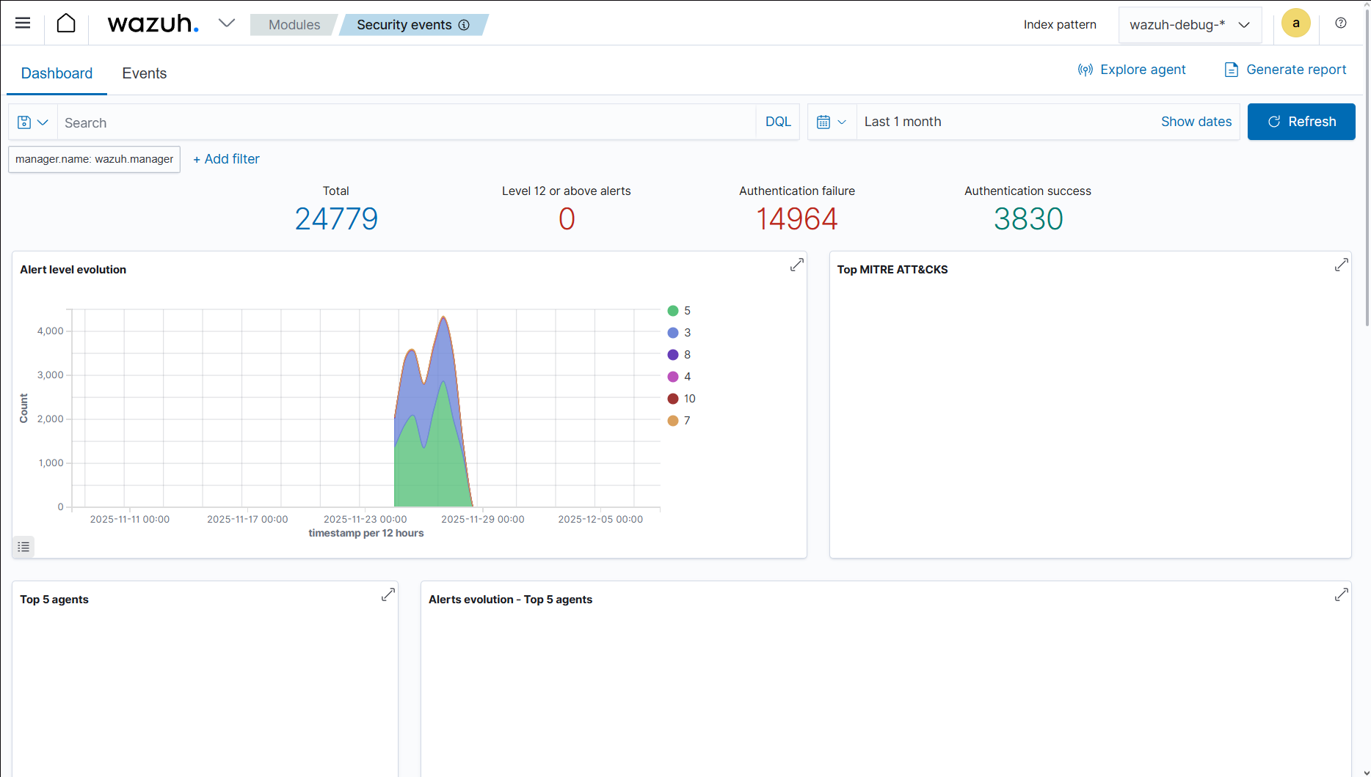

Troubleshooting, Configuration, and System Validation
Substantial troubleshooting and configuration were required before any experimentation could be conducted. This included SSL and Certificate Issues such as incorrectly named certificate files, improper file permissions, and OpenSearch refusing TLS negotiation. These configuration issues affected external analyst access to the Wazuh Dashboard.
Other troubleshooting and configuration included:
- OSSEC configuration failure.
- Wazuh Dashboard authentication failures.
- Missing environment variables in the AI container.
- Failed Cloudflare tunnels.
- SSH-based port forwarding adopted for remote analyst access.
Due to the persistent certificate and TLS negotiation failures, remote analysts were unable to authenticate and connect directly into the live SIEM interface. As a result, all human analysts were provided with the exported alert datasets in the form of a JSON file for each scenario rather than conducting their triage through the dashboard. This adaptation ensured that human evaluations remained consistent, controlled, and comparable across participants despite this limitation in access. This overall troubleshooting phase also informed how I understood the limitations of real SOC environments.

Attack Scenario Generation
Three controlled attack scenarios were executed within the Wazuh environment to create ground-truth alert data. These scenarios were chosen because they both represent common adversarial behaviors and a realistic progression across authentication, privilege escalation, and post-exploitation file tampering. Scenario construction follows the synthetic attack approach recommended by Rosso et al. (2020) to enable consistency and SOC benchmarking measurability. Scenario 1 simulated SSH Brute Force (Rule 5710) and generated approximately 4,700 authentication failure alerts by simulating repeated attempts to log in through nonexistent user accounts. Scenario 2 simulated Sudo Privilege Escalation (Rule 5402) and generated approximately 17,797 alerts through repeatedly executing commands that escalated privileges from a user account to root. Scenario 3 simulated File Integrity Tampering (Rule 554) and unauthorized configuration changes, which generated approximately 24 alerts through repeatedly modifying a monitored configuration file in /etc/. To standardize the human review, each scenario was reduced to a curated dataset of 50 alerts for the first two scenarios and 24 alerts for Scenario 3. AI processed the full alert set, meanwhile humans used curated subsets.

Human Analyst Triage Procedure
Human participants were provided with the exported JSON datasets and asked to evaluate each alert independently. Analysts recorded for each:
- Severity level (low, medium, high).
- Maliciousness (malicious, benign, uncertain).
- Escalation Decision (escalate, monitor, dismiss).
- 1-2 Sentence Summary (optional).
- Total time taken to determine time-to-triage.
Participants completed the scenarios independently and did not have access to one another’s responses to ensure each response was unbiased and individualized in terms of decision making. Despite the alerts being reviewed outside of the Wazuh Dashboard, all datasets were identical across participants to preserve experimental consistency.
Providing only the attack vector to the analysts mirrors SOC workflows in which they are aware of the general category of an alert, but must determine meaning, severity, and escalation based on the log content alone. This design remains consistent and aligns with evaluation approaches described by Singh et al. (2025), which emphasizes human reasoning and context interpretation under limited guidance.

AI Triage Procedure
The AI triage system processed alerts automatically and the procedure consisted of
- Polling the Wazuh Indexer for any alerts matching the current scenario’s index pattern.
- Sending alert batches to the OpenAI API, using the configured model and API key.
- Receiving model-generated triage outputs, including:
  - ai.score (Severity estimation).
  - ai.summary (Narrative description).
  - triage.status (incident-level classification).
- Clustering and storing incidents in dedicated OpenSearch index (ai-incidents).
This configuration allowed for a direct comparison between the machine-generated triage decisions and human analyst responses. During the system validation, all alerts were confirmed to be ingested and processed by the AI container, which then surfaces in the wazuh-debug output. This verified that the pipeline was successful in receiving data even when the classification results were not produced. This ensured that failures observed in later scenarios, such as Scenario 3, reflected model-level limitations rather than any ingestion or connectivity issues.

Measures
Three primary categories of performance metrics were used: triage accuracy, misclassification rates, and response efficiency. Triage accuracy is defined as how well human or AI classifications aligned with ground-truth scenario behavior. Accuracy included:
- Correct classification of malicious vs. benign activity.
- Correct severity assignments.
- Appropriate escalation decision.
- Ability to consolidate multiple alerts into a single incident.
Misclassification rates follows Forseberg and Frantti (2023) and were grouped as:
- False positives: Over-escalation or incorrect classification of benign/uncertain events.
- False negatives: Missed malicious activity or failure to escalate
- Critical AI FN case: In Scenario 3. AI generated 0 incidents despite all alerts being malicious.
Response efficiency was measured using:
- Human time-to-triage (start-to-end timing).
- AI processing latency (near-instant).
- Incident reduction ratio (alerts-incidents).
- Consolidation effectiveness.
These metrics correspond to widely adopted SOC performance measures such as timelines, clarity of classification, and escalation quality.

Data Analysis
Human responses were coded into structured variables and compared across participants. AI incident data were exported from the OpenSearch index and analyzed alongside human results. Comparison criteria included:
- Incident count differences.
- Severity and maliciousness trends.
- False positive/false negative patterns.
- Human variability across participants.
- AI consistency across scenarios.
Given that the study involved a small participant pool and exploratory objectives, analyses were descriptive rather than inferential.

Ethical Considerations
This study involved simulated data only. No real user, organizational, or customer information was used. All participants provided informed consent and voluntarily contributed to the research. Data were anonymized, and no identifying information was collected. The simulated SOC environment and non-sensitive datasets qualified the research as minimal-risk.

Results

Scenario 1: SSH Brute Force (Rule 5710)
A total of approximately 4,700 raw Wazuh alerts were generated during Scenario 1. The AI triage system processed the full alert stream and produced 3,098 incidents, each containing an ai.score (M ≈ 0.20), ai.summary, and triage.status of open. The AI system did not consolidate alerts into a single campaign, but rather generating thousands of distinct individual incidents representing repeated invalid authentication attempts.
All three human analysts completed Scenario 1 using the curated 50-alert dataset.
- Participant 1 identified 49 of 50 alerts as malicious, escalating all but one event, and consolidating the dataset into one brute-force attack campaign. They noticed the pattern at the very beginning of the scenario and reported accordingly. Time-to-triage was 15 minutes.
- Participant 2 initially identified many events as uncertain and escalated malicious activity later in the dataset. They demonstrated the slowest escalation threshold and completed the scenario in 35 minutes.
- Participant 3 marked events 1-9 as medium severity and uncertain, then escalated all remaining alerts as malicious beginning at event 10. They noted repeated thresholds (events 10, 20, 30, etc.) as escalation milestones. Time-to-triage was 22 minutes.
All three human analysts correctly consolidated the scenario into one attack, while the AI generated thousands of individual incidents and lacked pattern recognition. The AI did not produce false negatives, detecting brute-force behavior across hundreds of attempts, but produced significant false-positive fragmentation by classifying each attempt as a separate incident. Human analysis varied; Participant 1 produced no false negatives, Participant 2’s heavy use of “uncertain” introduced possible FN risk early in the triage, and Participant 3’s delayed malicious labeling until the 10th attempt represents another FN-adjacent delay.
Table 1
Scenario 1: Time-to-Triage and Incident Consolidation
Analyst/AI | Time-to-triage | Consolidation output
AI | Seconds | 3,098 incidents
Participant 1 | 15 minutes | 1 incident
Participant 2 | 35 minutes | 1 incident
Participant 3 | 22 minutes | 1 incident

Scenario 2: Sudo Privilege Escalation (Rule 5402)
The scenario generated 17,797 raw alerts representing successful privilege escalations to root. The AI triage system produced 446 incidents with an average ai.score of approximately 0.36, which suggests that the model recognized elevated severity, but not strongly. AI summaries were brief and lacked contextual narrative.
Two human analysts completed this scenario using the curated 50-alert dataset.
- Participant 1 recognized the multistage privilege escalation sequence, identifying connections between earlier SSH service restarts and later root-level commands. They escalated 47 of 50 events as malicious and consolidated the dataset into one privilege escalation incident. Time to triage was 20 minutes.
- Participant 3 demonstrated threshold-driven analysis, labeling events 1-4 as benign to account for potentially real admin access, events 5-14 as uncertain, and escalating 15-50 as malicious. They escalated at consistent numeric intervals (15, 20, 30, 40, 50). Time-to-triage was 15 minutes.
Both human analysts correctly identified the scenario as a single privilege escalation campaign, meanwhile the AI showed partial understanding of severity. It produced 446 fragmented incidents instead of a unified event. The AI demonstrated no direct false negatives, as it recognized all events as requiring open triage status. It substantially over-segmented the data, however, and resulted in a very high false-positive equivalent rate. Humans produced no major false negatives, although Participants 3’s early “benign” labels demonstrate delayed recognition of malicious behavior in the dataset.
Table 2
Scenario 2: Time-to-Triage and Incident Consolidation
Analyst/AI | Time-to-triage | Consolidation output
AI | Seconds | 446 incidents
Participant 1 | 20 minutes | 1 incident
Participant 3 | 15 minutes | 1 incident

Scenario 3: File Integrity Tampering (Rule 554)
This scenario generated 24 alerts from repeated unauthorized modifications to a monitored configuration file. Although alerts were successfully ingested into the AI container (verified via Wazuh debug logs), the model produced zero incidents and did not generate any triage classifications, despite all alerts being malicious. This constitutes a critical false negative, indicating a failure to process or recognize low-volume but high-severity events.
Two participants completed the scenario.
- Participant 1 marked all alerts as high severity and malicious, consolidating the dataset into one configuration tampering incident. Time-to-triage was 31 minutes.
- Participant 3 marked all alerts as high severity, initially uncertain on maliciousness, but escalated at event 24 after reaching their threshold. They recommended breach containment steps. Time-to-triage was 8 minutes.
Both human analysts correctly identified the scenario as a single malicious configuration-tampering event, while the AI produced no classification and resulted in a complete triage failure. The AI resulted in a critical false negative and failed to detect any malicious activity. Humans had no false negatives and escalation behavior was consistent across both participants.
Table 3
Scenario 3: Time-to-Triage and Incident Consolidation
Analyst/AI | Time-to-triage | Consolidation output
AI | Seconds | 0 incidents
Participant 1 | 31 minutes | 1 incident
Participant 3 | 8 minutes | 1 incident

Cross-Scenario Summary
The AI demonstrated:
- High-speed processing but poor consolidation
- Strong pattern recognition in high-volume scenarios
- Failure in low volume high-severity detection (as seen in Scenario 3)
- Limited narrative understanding in all outputs
Humans demonstrated:
- High accuracy and campaign-level reasoning
- Slower triage than AI, but more reliable
- Individual variability in maliciousness labeling and escalation thresholds
- Superior contextual interpretation, especially in Scenarios 2 and 3.

Discussion
The purpose of this study was to compare the triage performance of human SOC analysts and an AI-driven incident classification model across three controlled attack scenarios. The findings of this study reveal a number of significant differences in accuracy, misclassification patterns, contextual reasoning, and response efficiency between the AI system and the human analysts. The results suggest that while AI can rapidly process high volumes of alerts, it lacks the contextual understanding, pattern recognition, and consolidation ability demonstrated by human analysts. This only reinforces the importance of hybrid human-AI SOC models should an AI-driven incident classification model be implemented.
Across all scenarios, the AI triage model demonstrated substantial processing speed as it completed triage tasks in seconds regardless of the alert volume. This aligns with Jada and Mayayise (2024), who highlights AI’s ability to scale rapidly within data-intensive environments. During testing, I found myself surprised at how quickly the AI produced results compared to how long humans needed to interpret them. The AI also showed strong sensitivity to repeated or high-volume patterns, as evidenced in both Scenario 1 and Scenario 2 where it recognized malicious activity across thousands of alerts.
But the AI system exhibited major weaknesses in its consistent failure to consolidate alerts into coherent incidents. Its production of 3,098 incidents in Scenario 1 and 446 for Scenario 2 highlighted this and emphasized the human analysts’ consistent identification of one single attack campaign for each scenario. This fragmentation mirrors concerns expressed by Salem et al. (2024), who argued that AI-based detection systems often struggle with event correlation and contextual interpretation.
The most crucial limitation was seen in Scenario 3 where the AI failed to generate any incidents despite all alerts being malicious. This complete false negative aligns with documented challenges in AI systems operating on low-volume or irregular datasets (Salem et al., 2024). It also underscores the current gap between LLM-based SOC augmentation tools and the more advanced, autonomous security capabilities envisioned by Kshetri (2025). Within this study, the AI demonstrated no agentic behavior. Instead, it failed to detect high-severity attacks that both human analysts immediately escalated.
Human analysts, on the other hand, consistently outperformed the AI in terms of accuracy, contextual understanding, pattern recognition, and correct incident consolidation. One thing that stood out during testing was how differently each analyst approached the exact same dataset. This was especially noticeable as I watched how AI over-segmented alerts that every human immediately grouped together. Every participant recognized that the three scenarios represented single multistage attacks, whereas the AI over-fragmented outputs or failed entirely. This confirms findings by Singh et al. (2025), who demonstrated that while AI can accelerate query and triage tasks, human analysts remain essential for more nuanced interpretation, pattern recognition, and escalation decisions.
Human participants did, however, demonstrate meaningful variability and reflects real SOC environments. Participant 1 consistently produced fast, decisive triage with clear recognition of malicious patterns. Participant 2 exhibited a more cautious approach with slower escalation thresholds and resulting in a longer triage time. Participant 3 applied a threshold-based escalation strategy, marking distinct milestone events before formally declaring malicious activity.
This variability aligns with literature describing differences in analyst experiences, cognitive processing, and risk tolerance (Forsberg & Frantti, 2023). The human results reinforce that SOC work is not uniform as analyst decision-making is shaped by personal heuristics and interpretation styles. Yet, despite these individual differences, all analysts reached overall correct conclusions. This indicates that human cognitive strengths compensate for individual methodological variation.
These findings strongly support a hybrid approach model in which AI augments SOC operations rather than replace human analysts. While AI excelled at rapid processing, broad pattern recognition in high-volume scenarios, and reducing overall alert fatigue by pre-filtering large datasets, it is unreliable for incident classification and showed poor correlation between raw alerts and contextual events. This demonstrated an inability to reason about attacker intent or campaign structure.
This lines up with Edris’s (2025) argument that AI and cybersecurity capabilities should operate symbiotically, with AI enhancing speed and efficiency while human analysts apply judgement, reasoning, and contextual evaluation. The study also echoes Jada and Mayayise’s (2024) concerns about organizational overreliance on AI tools. Scenario 3 illustrates the potential danger in relying solely on AI as it completely failed to classify a malicious high-severity act.
A hybrid approach, where AI accelerates routine triage and humans oversee contextual interpretation, appears supported by both the data and prior research. This structure mitigates risks from AI misclassification while leveraging its strengths in data processing and repetition detection.
Given all of this, several limitations affect the generalizability of these findings. The sample size of human analysts was small, and not all participants completed all three scenarios. While this variability reflects real-world SOC conditions, a larger and more diverse analyst pool would yield improvements in statistical validity. The necessity of providing analysts with exported JSON files, rather than the intended access to the live Wazuh Dashboard, may have altered the natural triage workflow. Given the amount of troubleshooting required just to reach a working pipeline, these performance limitations were noticeable in real time during testing.
Additionally, while the AI was validated to ingest all alerts, its failure to classify Scenario 3 indicates that prompt design, index mapping, or feature extraction may require refinement. This suggests that technical implementation, not only model capability, plays a role in SOC-AI performance. Future research should explore:
- Fine-tuning or customizing AI models for SOC-specific vocabulary, fields, and triage patterns.
- Increasing the number of human participants to better quantify analyst variability.
- Improving AI feature extraction to reduce false negatives in low-volume scenarios.
- Testing hybrid workflows where analysts review AI-prioritized incidents.
- Conducting longitudinal evaluations to measure learning effects and analyst adaptation.
Automating the deployment of SIEM and AI components through Infrastructure-as-Code may also reduce the troubleshooting burden observed during this study and improve reproducibility in future experiments.

Conclusion
This capstone set out to evaluate and compare the accuracy, misclassification patterns, and response efficiency of human SOC analysts compared to an AI-based triage model within a controlled Wazuh SIEM environment. Across three simulated attack scenarios, the results demonstrated clear differences in how humans and AI systems interpret, classify, and escalate malicious activity. While the AI triage model processed large alert volumes within seconds, it consistently failed to consolidate related alerts into coherent incidents and, in the case of the third scenario, did not generate any classification at all. These findings highlight the current limitations of general-purpose AI systems when applied to nuanced SOC triage tasks that require contextual awareness and pattern reasoning.
Human analysts, despite the variability in decision-making styles and time-to-triage, consistently identified the correct attack structure and pattern in all three scenarios. Their ability to combine alert content, behavioral context, and prior knowledge enabled accurate incident consolidation and escalation decisions that the AI system could not replicate. These results align with prior research suggesting that AI tools are most effective when taking on the role of augmentation rather than replacement (Singh et al., 2025). The human analysts’ performance further reinforces concerns in the literature regarding AI overreliance, transparency, and misclassification risk (Jada & Mayayise, 2024).
The technical challenges encountered during the deployment, particularly certificate configuration, dashboard access, and container interoperability, also underscores the complexity and difficulty of building reliable and scalable SOC environments. These challenges are themselves a reflection of the constraints of real SOC operational constraints, where infrastructure reliability can directly influence detection and response outcomes. Working through the troubleshooting, and constant pipeline adjustments helped me understand how many technical and procedural details go into setting up AI-driven SOC tools.
Overall, this study demonstrates that, while AI offers speed and scalability, it lacks the interpretive depth required for independent SOC triage. Human analysts remain essential and crucial in contextual classification, incident consolidation, and accurate escalation. These findings support a hybrid SOC approach in which AI performs high-volume processing while humans guide any final decision making. Future work should focus on fine-tuning the AI models for more security-specific domains, improving dataset feature extraction, expanding participant samples, and evaluating real-time hybrid workflows to further understand how AI can reliably augment human-led cyber defense. This project ultimately showed me how AI can assist, but not yet replace, the human element in cybersecurity operations.

References
Edris, E. K. K. (2025). Utilisation of artificial intelligence and cybersecurity capabilities: A
symbiotic relationship for enhanced security and applicability. Electronics, 14(10). https://doi.org/10.3390/electronics14102057
Forsberg, J., & Frantti, T. (2023). Technical performance metrics of a security operations center.
Computers & Security, 135. 103529 https://doi.org/10.1016/j.cose.2023.103529
Jada, I., & Mayayise, T. O. (2024). The impact of artificial intelligence on organisational cyber
security: An outcome of a systematic literature review. Data and Information Management, 8(2). https://doi.org/10.1016/j.dim.2023.100063
Kshetri, N. (2025). Transforming cybersecurity with agentic AI to combat emerging cyber
threats. Telecommunications Policy, 49(6). https://doi.org/10.1016/j.telpol.2025.102976
Rosso, M., Campobasso, M., Gankhuyag, G., & Allodi, L. (2020). Saibersoc: Synthetic attack
injection to benchmark and evaluate the performance of security operation centers. arXiv. https://doi.org/10.48550/arXiv.2010.08453
Salem, A. H., Azzam, S. M., Emam, O. E., & Abohany, A. A. (2024). Advancing cybersecurity: A
comprehensive review of AI-driven detection techniques. Journal of Big Data, 11(1), 105. https://doi.org/10.1186/s40537-024-00957-y
Singh, R., Tariq. S., Jalalvand, F., Chhetri, M. B., Nepal, S., Paris, C., & Lochner, M. (2025)
LLMs in the SOC: An empirical study of human-ai collaboration in security operations centres. arXiv. https://arxiv.org/html/2508.18947v1

