HOME

Hi I’am Araceli

Research, Design, Develop.

I’m a designer

Easy to use, fast, responsive, intuitive UX/UI.

I’m a {coder}

Front-end/Back-end Web Development

<ul class="off-canvas-social-links line-shown">

<li style="transform: scale(1, 1);"><a target="_blank" href="https://www.linkedin.com/in/josueespinosa"><i

class="fa fa-linkedin"></i></a></li>

<li style="transform: scale(1, 1);"><a target="_blank" href="https://github.com/josueespinosa"><i

class="fa fa-github-alt"></i></a></li>

<li style="transform: scale(1, 1);"><a target="_blank"

href="http://stackoverflow.com/users/1757401/josue-espinosa"><i class="fa fa-stackexchange"></i></a></li>

</ul>

ABOUT

I am full stack developer with a passion for thoughtful UI design, localization, and documentation.

I'm a seasoned web designer & full stack developer with a passion for thoughtful UI/UX design and web development. I also have skills in other fields like SEO, copywriting, localization or technical writing.

When the time for keeping pixels and code on the right path is over, I love cooking, forest wandering and dancing.

I'm interested in all kinds of visual communication, but my major focus is on designing web, mobile & tablet interface

*Mission-driven full stack developer with a passion for thoughtful UI design, collaboration, and teaching.*

I'm a Front-End Developer for [ChowNow](http://www.chownow.com) in Los Angeles, CA.   
I have serious passion for UI effects, animations and creating intuitive, dynamic user experiences.

WHAT I DO? HERE ARE SOME OF MY EXPERTISE

I specialize in creating software for clients ranging from individuals and small businesses to large corporations.

I have designed, developed and launched numerous projects from the beginning, carrying the development of its' back-end and front-end codebases, also assisting with all the aspects of the project.

|  |  |  |
| --- | --- | --- |
| front-end  I develop modern high-converting designs: bootstraping, refactoring, improving the structure, reliability, build setup.  I program the frontend layer considering standards, compatibility between browsers and mobile devices.  I write reusable code and libraries.  Have great experience in JS ecosystems. | back-end  I have a solid experience with PHP, Python, Java and Node.js  Strong skills on back-end components, including large-scale databases, data processing optimization and real-time messaging frameworks.  Collaboration with APIs, remote data synchronizations, cloud servers. | Database  Skilled with SQL and MySQL tools and technologies environment.  Creation and management of database schema objects, including tables, indexes, views, stored procedures and triggers.  Handling client requests from various sources.  Creating backups and maintaining recovery procedures. |
| mobile app  I design the architecture of mobile applications with clean code.  I build seamless and butter-smooth user interfaces across mobile platforms.  Share code between a React-Native app and a ReactJS website. | UI/UX design & SEO  I plan the user experience from the ground up, from research and discovery to visual designs.  Great at improving Google rankings with SEO, increasing engagement, building brand and influence. | Testing & writing  I write solid unit and E2E tests.  Thorough at launching, deployment and monitoring the app after the release.  I authored a series of manuals for clients and employees giving them access to clear and concise information about the launched app. |

Over the past ten years, I have completed over 100 software projects including iOS/Android apps, Mac/Windows programs, Unity/Unreal video games, and web apps.

comprehensive research, wireframing, design & development.

SKILLS

Single page web applications (frontend and backend), ensuring cross-platform optimization for mobile phones and responsiveness of applications, seeing through a project from conception to end, designing and developing APIs, research and implementing solutions using new technologies but also integrating past ones, staying abreast of developments in web applications and programming languages.

EDUCATION

EXPERIENCE

WORK

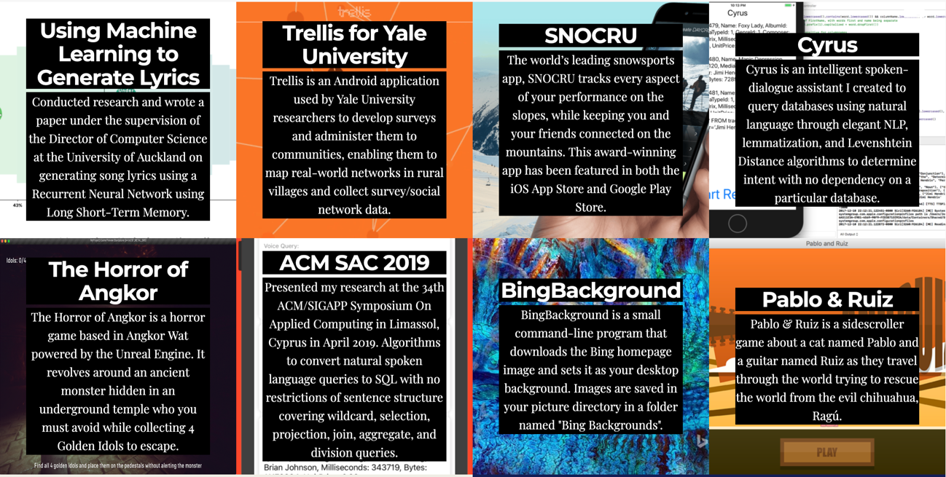

<https://ejosue.com/>

BLOG

Medium? O creas artículos en la misma página? <https://www.adhamdannaway.com/blog>

|  |  |  |
| --- | --- | --- |
| HTML5 | CSS3 | Bootstrap | LESS| SASS | 90  4 | JavaScript | ES6 | Ajax | jQuery |
| PHP | Laravel | 85  1 | Python | Django | MySQL | SQL |
| React | Redux | React Native | 80  6 | Photoshop | XD prototyping |
| GIT | GRUNT | GULP | Postman | 75  3 | Web services (REST, SOAP, WSDL, XML, XSL/XSLT, JSON) |
| WordPress | PrestaShop | SEO | 70  5 | Node.js | Express.js | Passport.js |
| Google APIs | Facebook APIs | 60  2 | MongoDB | Mongoose OMD |

Font End  
~~HTML5 | CSS3 | Bootstrap4 | LESS| SASS | JavaScript | ES6 | Ajax | Angular | Vue | jQuery |~~ React | Redux | SOA | Webservices (REST, SOAP, XML, XSL/XSLT, JSON)  
  
Back End  
~~PHP | Laravel | Symfony | Python~~ | ~~MySQL | SQL | SQL Server~~ | ~~Apache | Node.js | Express.js | Passport.js | OAuth~~ | ~~MongoDB | Mongoose OMD~~  
  
Tools  
~~GIT | GRUNT | GULP | Postman |~~ ~~Google APIs | Facebook APIs~~  
~~Adobe Photoshop | Adobe XD prototyping~~  
~~Video conference| File Sharing | Virtual office environments~~  
  
CMS  
~~WordPress | PrestaShop~~  
  
Mobile  
~~C++| Java | React Native~~