Steve.

Here is a brief explanation about the symbols I used for the plots as the one shown in figure 1.

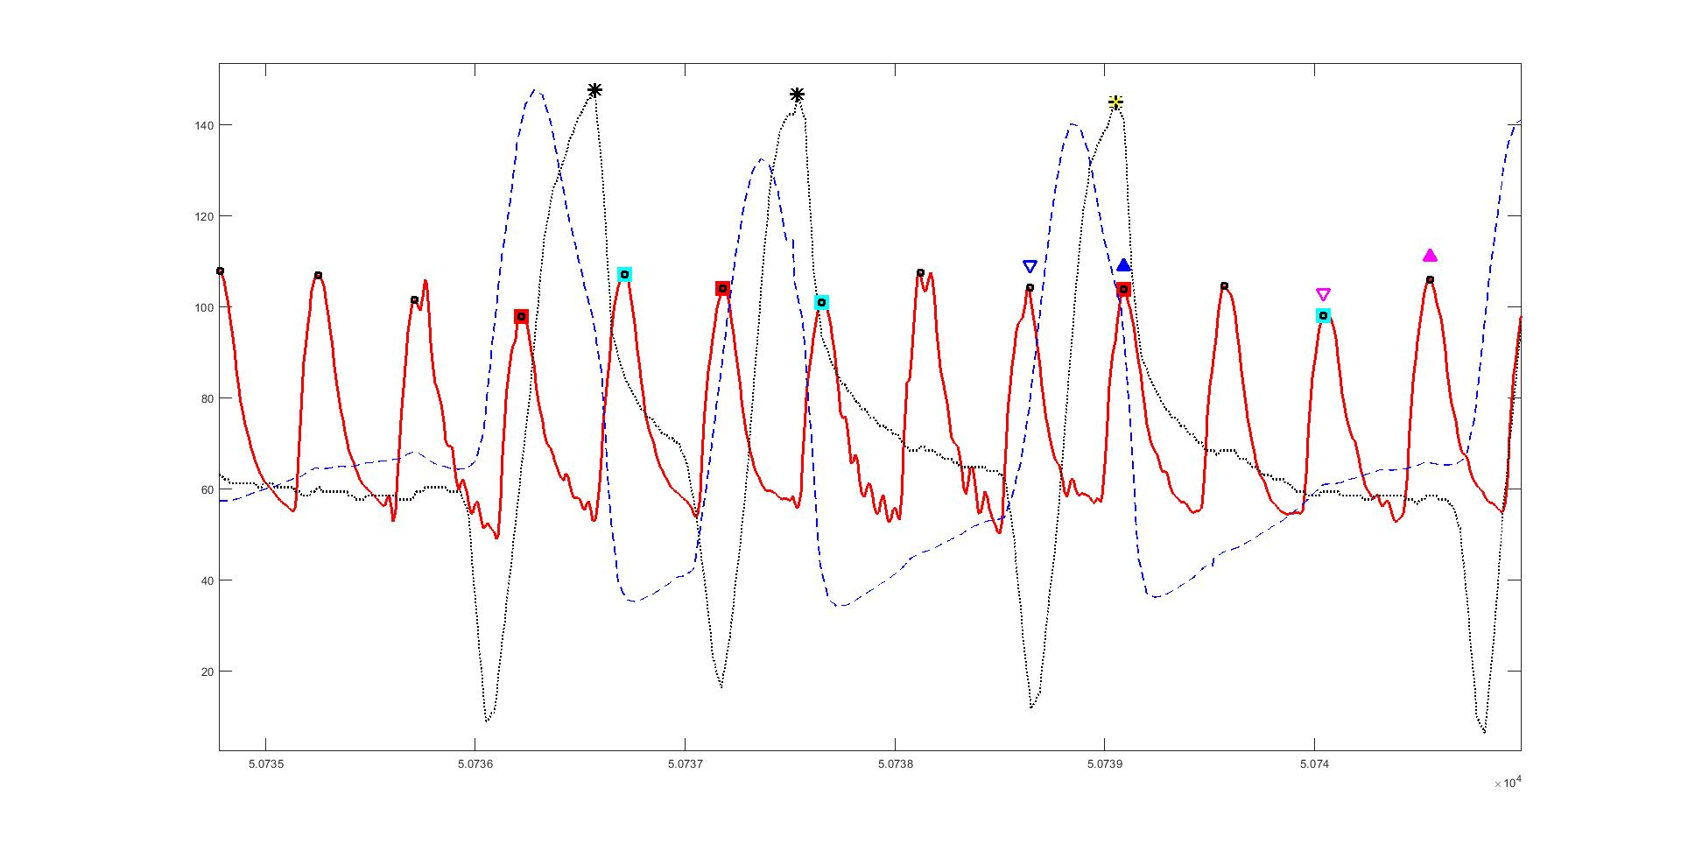

Figure 1.

Starting with the lines, the solid red line corresponds to the arterial pressure signal, the dotted black line corresponds to the scaled airway pressure, and the dashed blue line corresponds to the scaled airway flow signal. The airway pressure was multiplied by a factor of 9, and the airway flow was multiplied by (1/20) and then 70 units were added.

In regards to the symbols, let’s start with the data from the previous code. The maximum and minimum systolic arterial pressure, measured during inspiration are shown with blue upwards and downwards triangles, respectively. The maximum and minimum systolic arterial pressure, measured during expiration are shown with magenta upwards and downwards triangles, respectively. All triangles are shifted so they lie above the arterial pressure signal. The yellow cross indicates the maximum airway pressure that corresponds to each set of triangles time gap.

The squares and asterisks shown in figure 1 correspond to the new code. The systolic pressure or maximum systolic pressure, measured during inspiration is shown with red squares. Conversely, the systolic pressure or minimum systolic pressure, measured during expiration is shown with light-blue squares. The little black squares show all systolic pressures, and the black asterisk indicates the maximum airway pressure that corresponds to each set of squares time gap.