Fysiologisk og biomekanisk modellering

Compartmental modelling of the circulation system

Exercise: Using Matlab, built a compartmental model of a ventricle that pumps from a low pressure (P₁) to a high pressure (P₃). The end results should be a plot showing variations in volume (V), pressures (P1, P2 and P3) and flows (Q1 and Q2).
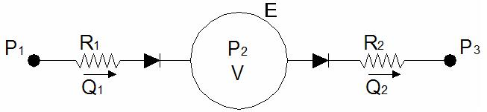

Governing equations:

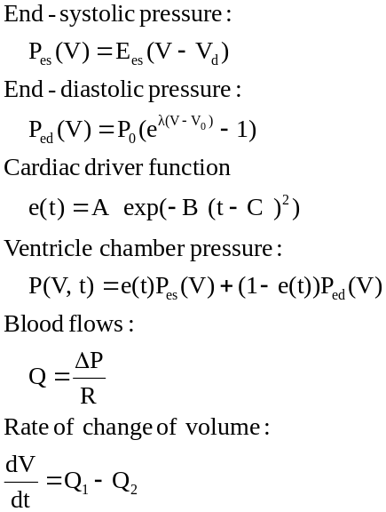
Parameters:

Ees = 100x10⁶N/m⁵
V_{d} = 0 m³
V₀ = 0 m³
λ = 33000 m⁻³
P₀ = 10 N/m²

R₁ = 6 x10⁶ Ns/m⁵
R₂ = 6x10⁶ Ns/m⁵

A=1
B=80secs⁻²
C=0.27secs

P₁ = 1000 N/m²
P₃ = 2000 N/m²

Tips for writing the solver:

Start with an initial condition of V(0) = 2x10⁻⁴.

Don’t forget to add valves so flow through the valves can only be positive.

Use the rem function to make the cardiac driver function repeat every 0.6 seconds.

Example code:
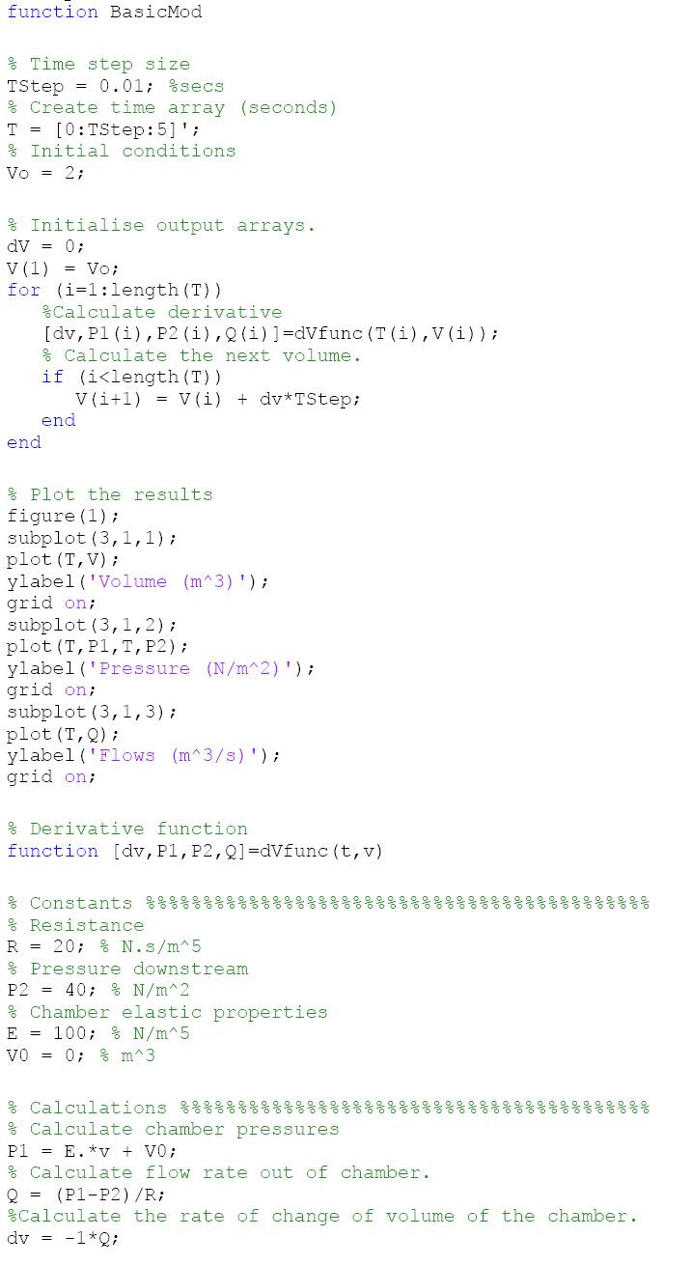

Example output:
