ENSC 833-3: NETWORK PROTOCOLS AND PERFORMANCE
CMPT 885-3: SPECIAL TOPICS: HIGH-PERFORMANCE NETWORKS

Adaptive Gossip-based

Ad Hoc Routing Algorithm

Spring 2003

Final Project

Hong Shen & Zhongmin Shi
www.sfu.ca/~hshen/885website/index.html
{hshen, zshi1}@sfu.ca

Instructor: Ljiljana Trajkovic

INDEX

ABSTRACT………………………………………………………………………………………. 1
1. Introduction 1
2. AODV+G and AODV 3
2.1. Overview of AODV 3
2.2. Gossip-based AODV 4
2.3. Comparison 4
2.3.1. Simulation Environment & Scenarios 4
2.3.2. Evaluation metrics 5
2.3.3. Implementation 5
2.3.4. Experiment Results and evaluations 7
3. Adaptive Gossip-based Ad Hoc Routing (AGAR) 9
3.1. Problems of GOSSIP3 9
3.2. Solution 10
4. AGAR and AODV+G 11
4.1. Simulation Environment and Scenarios 11
4.2. Implementation 12
4.3. Experiment results and evaluations 12
5. Conclusion and Future work 14
6. References 15
7. Appendix: Codes 16
7.1. C++ programs 16
7.1.1. aodv.h 16
7.1.2. aodv.cc 16
7.1.3. god.h 19
7.1.4. god.cc 20
7.2. Otcl codes 21
7.3. Parsing codes 25

Abstract

A mobile ad hoc network (MANET) is a system of wireless mobile nodes that does not rely on any base station or fixed infrastructure. It poses difficult challenges on routing protocols due to multi-hop wireless connectivity, frequently changing network topology and the need for efficient dynamic routing protocols. Gossip-based technique recently employed in Ad Hoc routing algorithm has achieved significant improvement on network overhead, routing efficiency and reliability. We studied Ad Hoc On-Demand Distance Vector Routing (AODV) [6] and an existing gossip-based Ad Hoc routing algorithm implemented in AODV (AODV+G) [4], and found some problems of this gossip-based approach. These problems can be solved in order to further improve the overall network routing performance. An new algorithm, AGAR, is introduced, simulated and compared with AODV+G and achieves significant performance improvement not only on network overhead, efficiency and reliability, but also on scalability, adaptability and maintainability. We expect that AGAR would achieve even more significant improvement in larger scaled networks.

Introduction
Mobile hosts and wireless networking hardware are becoming widely available, and many researches have been done in integrating these elements into traditional network such as Internet. However, sometimes, mobile users cannot access those fixed wired infrastructures due to lack of such infrastructures or unexpected situations, while they want to hook up the network. A collection of mobile hosts with wireless networks may form a temporary network without the aid of any established infrastructure. This type of wireless network is known as an ad hoc network. Nodes in this network model share the same random access wireless channel. They cooperate friendly to engage in multi-hop forwarding. Each node functions not only as a host but also a router. Routing in ad hoc network faces extreme challenges from node mobility, potentially very large number of nodes, and limited communication resources. The routing protocols for ad hoc networks have to adapt quickly to frequent and unpredictable topology changes and must be parsimonious of communications and processing resources. Hence designing efficient routing algorithms for such network have been an active research topic in the last few years.
Researchers found that many routing messages are propagated unnecessarily in routing protocols. Instead of flooding those messages, gossiping, essentially, tosses a coin to decide whether or not to forward a message, which can be used to reduce the number of routing messages sent significantly. Actually gossiping can be applied to any routing algorithms that use flooding to update routing information. However, we will only focus our attention on the on-demand routing algorithms AODV, since it is the one much suited for ad hoc network.
By the percolation theory, gossiping exhibits a certain type of bimodal behavior. Let the gossiping probability be p. Then in sufficiently large “nice” graphs, there are fractions θ^{S}(p) and θ^{R}(p) such that the gossip quickly dies out in 1- θ^{S}(p) of the executions and, in almost all of the fraction θ^{R}(p) of the nodes get the message. Moreover, in many cases of interest, θ^{S}(p) is close to 1. Thus, in almost all executions of the algorithm, either hardly any nodes receive the message, or most of them do [4]. The basic gossiping protocol is simple. A source sends the route request with probability 1. When a node first receives a route request, with probability p it broadcasts the request to its neighbors and with probability 1 – p it discards the request; if the node receives the same route request again, it is discarded. Thus, a node broadcasts a given route request at most once. This protocol is called GOSSIP(p). [4] shows that gossiping can save 35% message overhead other than flooding and also it can be used in almost any routing algorithm. Based on GOSSIP(p), [4] proposed several heuristics to improve the performance of gossiping. We will introduce three of them that are relevant to our work. They are GOSSIP1 – First k hops, GOSSIP2 – Two-threshold scheme, GOSSIP3 – Preventing premature gossip death.
GOSSIP1(p,k) – First k Hops, the problem of GOSSIP(p) is that if the source has relatively few neighbors, there is a chance that none of them will gossip, and the gossip will die. To make sure this does not happen, researchers gossip with probability 1 for the first k hops before continuing to gossip with probability p [4].
GOSSIP2(p₁,k,p₂,n) – Two-threshold Scheme, in random network, a node may have very few neighbors. In this case, the probability that none of the node’s neighbors will propagate the gossip is high. Thus if a node has few neighbors, it can gossip with higher probability will be better. To show the effect of this, we consider a protocol with four parameters, p₁, k, p₂, n. As in GOSSIP1, p₁ is the typical gossip probability and k is the number of hops with which we start gossip probability 1. The new features are p₂ and n; the idea is that the neighbors of a node with fewer than n neighbors gossip with probability p₂ > p₁. That is, if a node has fewer than n neighbors, it instructs its immediate neighbors to broadcast with probability p₂ rather than p₁ [4].
GOSSIP3(p,k,m) – Preventing premature gossip death, the real problem with gossiping is that, if we gossip with too low a probability, the message may “die out” in a certain fraction of the executions [4]. Intuitively, if the message does not die out, the node can expect that all its neighbors would get the same message as well, and thus, if the gossip probability is p, it should get roughly m (m <= pn) messages from its neighbors. This suggests that if a node with n neighbors receives a message and does not broadcast it, but then does not receive the message from at least m neighbors within a reasonable timeout period, it broadcasts the message to all its neighbors [4]. Based on the experiments from [4], set m = 1 will get the most significant performance improvement.
We ask the AODV+G program [5] from the authors and move the gossip part into current version of ns-2.1b9a [9], since the AODV module is not compatible within different version of ns. We also partially implemented some methods to get AODV+G work in the current version ns. Also, we set the simulation environment in terms of [4] and compare AODV+G with AODV at Section 2. Next, we propose an improved approach AGAR, Adaptive Gossip-based Ad hoc Routing algorithm, based on AODV+G at Section 3 and compare it with AODV+G at Section 4. Section 5 summarizes the report and outlines some interesting directions for future research.
The contribution of each individual member to this project is listed as follows. Hong Shen is responsible for:
Asking the AODV+G module and moving gossiping part from old version AODV into current version of AODV in ns-2.1b9a.
Building course project web site.
Writing interim report, proposal, and partial presentation slides related on basic theory of AODV, gossiping and gossip-based AODV.
Writing Section 1, 2.1 and 2.2 of the final report.
Zhongmin Shi is responsible for:
Designing the algorithm AGAR
Programming that includes
fixing bugs in AODV+G and enabling Gossip2 and 3 modules to work.
implementing AGAR in ns.
Otcl programs to set simulation environments, create traffic patterns and mobility movement scenarios.
parsing and analyzing simulation trace file using Java.
Experiments, comparison and evaluation of AODV and AODV+G.
Experiments, comparison and evaluation of AGAR and AODV+G.
Updating the project proposal, writing partial presentation slides related to the description of AGAR, network simulations, algorithm comparisons and conclusion.
Preparing demo, including slides and programs.
Writing abstract, Section 2.3, 3, 4, 5, 6, and 7 of the final report.

AODV+G and AODV

Overview of AODV
Since channel bandwidth is at a premium, on-demand routing algorithm was proposed. On-demand algorithms build or maintain only the routing paths that have changed and are needed to send the data packets currently in the network. Many performance comparisons show that on-demand routing algorithm is better suited for mobile and ad hoc network environments [2].
Among of them, the most typical one is called Ad Hoc Distance Vector Algorithm (AODV), which is based on Distance Vector algorithm. AODV is reactive, as opposed to proactive protocols like DSDV. AODV requests a route only when needed and does not require nodes to maintain routes to destinations that are not actively used in communications. AODV uses expanding ring search in Route Discovery and route validation in Route Maintenance [6].
Route discovery A node broadcasts a request when it determines that it needs a route to a destination and does not have one available. This can happen if the destination is previously unknown to the node, or if the destination is previously valid route to the destination expires. To prevent unnecessary broadcasts of requests the source node uses an expanding ring search technique as an optimization. In the expanding ring search, increasingly larger neighborhoods are searched to find the destination. The search is controlled by the time-to-live (TTL) field in the IP header of the request packets. If the route to a previously known destination is needed, the prior hop-wise distance is used to optimize the search [6].
Route Maintenance Every routing table entry maintains a route expiry time, which indicates the time until which the route is valid. Each time the route is used to forward a data packet, its expiry time is updated to be the current time plus ACTIVE_ROUTE_TIMEOUT. A routing table entry is invalidated if it is not used within such expiry time. AODV uses an active neighbor node list for each routing entry to keep track of the neighbors that are using the entry to route data packets. These nodes are notified with route error packets when the link to the next hop node is broken. Each such neighbor node, in turn, forwards the error packet to its own list of active neighbors, thus invalidating all the routes using the broken link [6].

Gossip-based AODV
AODV is a very typical on-demand routing algorithm that very suited for mobile nodes routing in ad hoc network. Those mobile nodes are very sensitive to the resource allocation, such as limited bandwidth and transmission speed. Reducing unnecessary traffic will effectively improve the efficiency of those mobile nodes in such network. That is the major reason why [4] chose AODV as its base platform for gossiping.
In AODV+G, if the expanding-ring search with a smaller radius fails, rather than flooding to the whole network, we use GOSSIP3(.65,1,1). (We use these parameters since they gave good performance in the particular scenarios we consider based on [4].) The timeout period of GOSSIP3 should be big enough to allow neighboring nodes to gossip. The NODE_TRAVERSAL_TIME parameter of AODV is a conservative estimate of the average one hop traversal time for packets that includes queuing delays, interrupt processing times and transfer times. Note that we do not use GOSSIP3 in the expanding-ring search with a smaller radius, since flooding is more efficient than gossiping for a zone with small radius because of the back-propagation effects [4]. We call the variant of AODV that uses GOSSIP3 AODV+G.

Comparison
To evaluate the performance of gossip-based routing algorithm, we requested the C++ source code of AODV+G [5] from one of authors of [4], implemented it in our ns simulator, and compared it with AODV, which has been integrated in ns since the version 2.1b9a.

Simulation Environment & Scenarios
The simulation model and application environment we initially used are exactly the same as that in [4], which uses IEEE 82\02.11 as the MAC layer protocol, and Lucent’s WaveLAN [10] as radio model, with a nominal bit rate of 2Mb/sec and a nominal range of 250 meters. The Application traffic is CBR (constant bit rate). The source destination pairs (connections) are chosen randomly. For mobility, the random waypoint model [7] is adopted in a rectangular field. The simulation scenarios are as follows: 150 nodes are randomly placed in a grid of 3300m×600m.The application packets are all 512 bytes. The packet sending rate and number of connections are assumed as of 2 packets/second and 30 connections; simulation time is 525 seconds; each node moves with a randomly chosen speed (uniformly chosen from 0- 20 m/sec), then pauses for τ seconds after reaching a randomly set destination. The pause time is varied to simulate different mobility scenarios. Each data point represents an average of six runs using the identical traffic model, but with different randomly generated mobility scenarios. To preserve fairness, identical mobility and traffic scenarios are used for both AODV and AODV+G [4].
However, this simulation model took us more than 1GB space and about 10 hours to generate the trace file for one mobility scenario, which are not affordable for this course project. Therefore, we change the following settings in order to provide a smaller scale network model suitable for the simulation of this project.
75 nodes, 2200m X 400m, 15 connections
Node speed: randomly chosen from 0 ~ 10m/sec
Pause time: 0, 50, 100, 150, 200, 250 seconds
Simulation time: 275 seconds
The experiments in [4] show that the most significant performance of GOSSIP3 is achieved by taking p=0.65, k=1 and m=1. Therefore, all experiments in our project are using GOSSIP3(0.65, 1, 1).

Evaluation metrics
We study the performance of the following three metrics, which were also studied in [1] and [4]:
“The packet delivery fraction represents the ratio of the number of data packets successfully delivered to the number of data packets generated by the CBR sources.
The average end-to-end delay of data packets includes all possible delays caused by buffering during routing discovery, queuing at the interface queue, retransmission at the MAC layer, propagation, and transfer time.
The normalized routing load represents the number of routing packets transmitted per data packet delivered at the destination. Each hop-wise packet transmission is counted as one transmission.” [4]

Implementation

C++
The C++ source program [4] requested from authors of [4] are two files, aodv{.cc, .h}, which are the same names with files of AODV protocol in ~ns/aodv. [4] implements Gossip1, 2, and 3 in AODV protocol. However, only gossip1 module in [4] works. The coding of Gossip2 and 3 modules has not been finished in [4]. The following is a list of major problems in [4] we have found and fixed.
In files aodv{.cc, .h}:
The return of AODV::getIndex() has wrong data type, int. We changed it to nsaddr_t, a data type of address defined in ns.
In ppgdTimer::handle(Event*) function, the AODV request (hdr_aodv_request) should be referred from the function HDR_AODV_REQUEST(Packet*), instead of agent->getAODVRequest(Packet*).
The data type of the first parameter of the function agent->forward() should be aodv_tr_entry, instead of rt_entry.
We enabled Gossip 2 and 3.
To enable AODV+G, we simply replace two files, aodv.cc and aodv.h, in ~ns/aodv/ with two modified with as described above.
In files god{.cc, .h}:
In function God::IsNeighbor(int, int), energy_model() of nodes could be NULL, therefore we added an condition statement to detect this situation.
The function God:: numNbrs(nsaddr_t) is called by aodv.cc but is not provided in [5]. We created this function, which counts the number of neighbors.
We directly modified god{.cc, .h} in ~ns/god. The above modifications are effective only if ns is re-compiled by run “make” under home directory of ns.

Otcl
Otcl programs consist of 3 tcl files: the main file, traffic connection pattern file and node movement file.
The main tcl file defines the settings of simulation environment, including wireless channel, propagation, wireless protocols, antenna, wireless physical identification, some of traffic pattern parameters, node configurations, starting, tracing and ending the simulation, etc. The packets are traced on agent and router levels.
The random traffic connection patterns between mobile nodes by a traffic-scenario generator script, which is called cbrgen.tcl available under ~ns/indep-utils/cmu-scen-gen. The following is an example to generate the traffic pattern for one of our experiments:
~ns/indep-utils/cmu-scen-gen/cbrgen.tcl -type cbr -nn 75 -seed 1.0 -mc 15 -rate 2.0.
The reference to the meaning of each parameter is in [9]. The node movement file can be generated by The node movement generator, setdest{.cc,.h}, which is available under ~ns/indep-utils/cmu-scen-gen/setdest directory. The following is an example to generate node movement file for one of our experiments.
~ns/indep-utils/cmu-scen-gen/setdest/setdest -n 75 -p 0 -s 10 -t 275 -x 2200 -y 400.
Please refer to [9] for the meanings of parameters above.
Each simulation generates a trace file, which records traffic and movement information.

Parsing
The trace file needs to be parsed to extract the information needed to calculate the three evaluation metrics. Corresponding to definitions of three metrics, the regular expressions for parsing and calculation methods are described as following. For easy understanding, all regular expressions are in form of those in Perl [11].
The packet delivery fraction (PDF):
Calculate the number of sent packets, s, by counting the number of packet delivering information that matches the following regular expression in the trace file.
/^s *- Nl AGT.*-Is (\d{1,3})\.\d{1,3} -Id (\d{1,3})\.\d{1,3}.*-It cbr.*-Ii (\d{1,6})/ [3]
Similarly, the number of received packets, r, is calculated corresponding to this regular expression:
/^r -t (\d{1,3}\.\d{9}).*-Nl AGT.*-Is (\d{1,3})\.\d{1,3} -Id (\d{1,3})\.\d{1,3}.*-It cbr.*-Ii (\d{1,6})/ [3]
So, PDF = s / r * 100.

Average End-End packet delivery:
Average end-end packet delivery is calculated in the way that, for each packet with id (Ii) of trace level (AGT) and type (cbr), calculate the send(s) time (t) and the receive (r) time (t) and average it [3].
Normalized routing load (NRL):
The regular expression for calculating the number of send routing packet (SRP) is:
/^[s|f].*-Nl RTR.*-It AODV| -Il (\d{1,4})/ [3]
Therefore, NRL = SRP / r.
We chose Java SDK 1.4.1 as the platform of parsing program.

Experiment Results and evaluations
We simulated both AODV and AODV+G with same network environment settings and calculated three evaluation metrics as described above. All experiments were performed on a Pentium III PC with 733 MHz clock speed, 512 MB of main memory and Redhat 7.3 operating system. The experimental results show that performance of AODV is slightly better than AODV+G on average, which seems contradict to the conclusion in [4]. However, an analysis by comparing the gossiping and flooding techniques addresses that this situation is quite common for very small network mode like we created. On one hand, the smaller scale the network model, the less broadcasting happens, thus the less the advantage of gossiping over flooding. On the other hand, since gossiping does not guarantee 100 percent successful transmission, the transmission failure in smaller network would be more significant than the improvement on overhead decrease. Therefore, the reason of the contradiction of our experiments with those in [4] is our network model is too small-scaled. Since we cannot afford simulations on larger network model, we refer the experiment and evaluation results in [4] and do not exhibit our experiment results of AODV and AODV+G.
Figure 1 illustrates that AODV+G has significant improvements over AODV on three evaluation matrices. I.e., Gossiping technique can significantly improve the network performance [4].
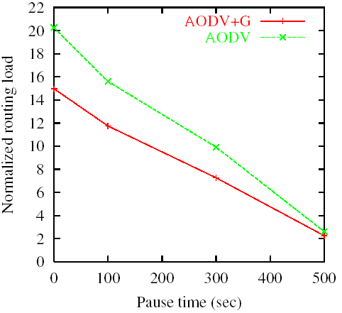
(a) Normalized routing load
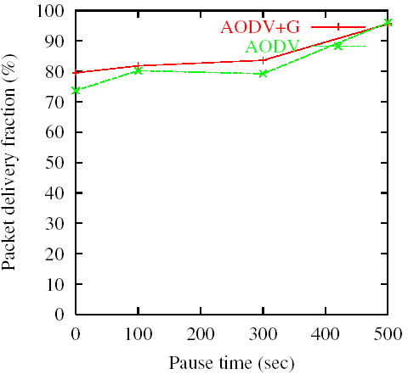

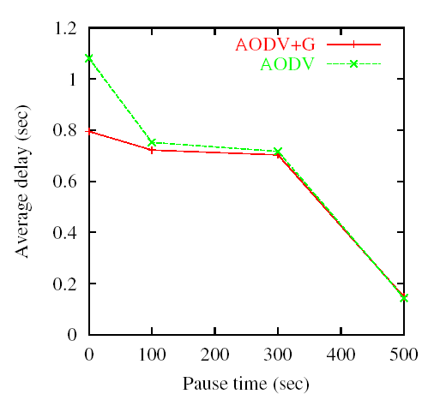
(b) Packet delivery fraction

(c) Average end-to-end delay
Figure 1 Performance Comparison of AODV with AODV+G

Adaptive Gossip-based Ad Hoc Routing (AGAR)
The objective of our project is to study the gossiping technique and try to improve its performance. This section points out the problems of GOSSIP3 and introduces our proposed solutions.

Problems of GOSSIP3
As introduced in Section 1, whether a node broadcasts or not is determined by the follows (assuming with GOSSIP3(0.65, 1, 1) ):
The first “toss” with broadcasting probability 0.65.
If the node does not broadcast (with probability 0.35), after the timeout period, it broadcast or not depending on if n >0, where n is the number of requests, which the node have received within the timeout period, with same request ID as that of the original request from its neighbors.
Therefore, the overall probability P that a node broadcasts a request is:
0.65 + 0.35 *1 = 1, if n=0;
0.65 + 0.35 *0 = 0.65, otherwise.
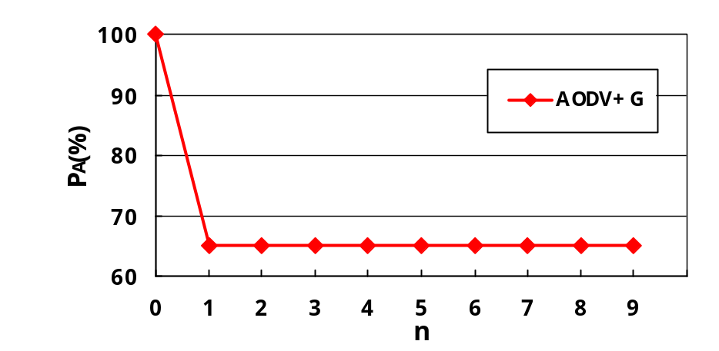Figure 2 shows the relation of P_{A} and n using GOSSIP3(0.65,1, 1).
An observation on the relation of P_{A} and n addresses two problems of GOSSIP3.
Figure 2 Overall probability P_{A} of AODV+G with GOSSIP3(0.65, 1, 1)

When n=0, P_{A} = 100%, which is just what the gossip technique tries to avoid. Since at least its neighbor who sent out the original request may broadcast with very large probability, the node with P_{A}=100% most likely results in significant overhead.
When n=1, P_{A} dramatically changes from 100% to 65%, thus the network performance may drop rapidly at this point. This situation is called Ungraceful Degradation, which means a little variation invokes the dramatic change of the system performance.

Solution
Any method that addresses itself to the problem of Goosip3 must be of simplicity, which is one of the most important requirements for routing algorithms. Our solution is: when a node receives a request with a new request ID and decides not to broadcast (with probability 1-p), after reasonable timeout period, it broadcast with probability p/(n+1). Figure 3 shows how our approach works comparing to AODV+G.
recvRequest
hop_count <= k
OR
Random(0,1) <= p
wait(SLEEP_TIME)
n < 1(m) ?
Insert ID in
LOOKUP_TABLE
drop request
packets
Broadcast
Y
Y
N
N

(a) AODV+G with GOSSIP3(p, k, 1)
recvRequest
hop_count <= k
OR
Random(0,1) <= p
wait(SLEEP_TIME)
Random(0,1)
<= p/(n+1) ?
Insert ID in
LOOKUP_TABLE
drop request
packets
Broadcast
Y
Y
N
N

(b) Our solution

Figure 3 Comparison on how AODV+G and our solution work

The overall probability P_{A} of our solution is (assuming p = 0.65):
P_{A} = 0.65 + 0.35*0.65/(n+1) = 0.65 + 0.2275/(n+1).
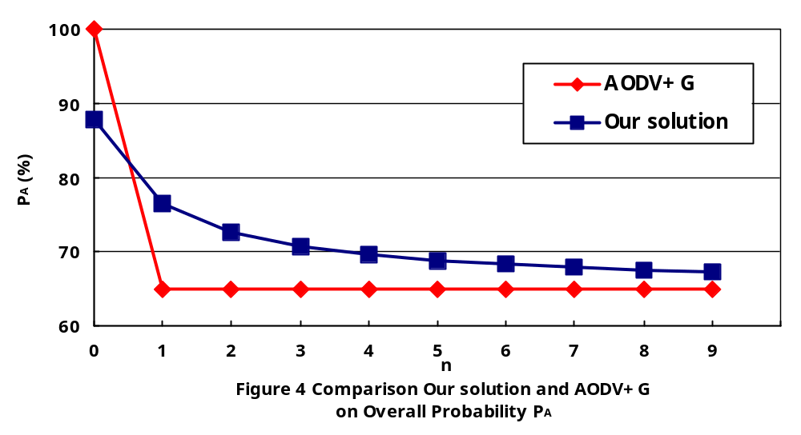Figure 4 illustrates the comparison of our solution with AODV+G on P_{A}. Comparing to the problems of GOSSIP3, our approach exhibits following advantages:
When n=0, it avoids 100 percent broadcast. Now the node has P_{A} = 87.75%, which seems not large enough in case that no neighbor responds thereafter. However, considering both the current node and its neighbor who sent out the original request, the overall probability of at least one of them broadcasting is:
1 – (1 – 0.8775)^2*100% = 98.5%.
Therefore, our solution provides high probability of broadcasting by a node and its neighbors, and decreases overhead at the same time as described in Section 4.
Our solution also provide a smoothly decreased P_{A} when n increases, thus successfully achieves graceful degradation, which is an essential to a system with respect to maintenance, scalability and adaptability. We introduce these points in Section 5.
For easy reference, we name our solution as Adaptive Gossip-based Ad Hoc Routing (AGAR).

AGAR and AODV+G
We implement AGAR by modifying AODV+G described in Section 2.3.3, simulate both AGAR and AODV+G in the same simulation environments and scenarios, and evaluate them by three evaluation metrics introduced in Section 2.3.2.

Simulation Environment and Scenarios
The settings of simulation environment are exactly the same as those listed in Section 2.3.1.

Implementation
To implement AGAR, the major modifications of AODV+G are in ~ns/aodv/aodv{.cc, .h}.
Rewrite AODV::id_lookup(nsaddr_t, u_int32_t) function to count the number of requests with same request ID in the request ID lookup table, which stores all requests from neighbors within recent timeout period.
In the function AODV::recvRequest(), we adjust the probability of broadcast for the incoming request according to the calculation introduced in the Section 3.2.
The function ppgdTimer::handle(Event*) is called by the function Scheduler::instance().schedule() after a timeout period, and is actually a new thread to enable the node to determine again whether to broadcast or not. We adjust the probability of broadcast in the function according to the calculation in the Section 3.2.
We use the same tcl script and parsing programs described in 2.3.3 to simulate AGAR and AODV+G.

Experiment results and evaluations
The pause timeτis set as 0, 50, 100, 150, 200, 250 seconds to simulate different scenarios respectively. These six scenarios are organized as one simulation group. Since both AGAR and AODV+G work with some random procedures, for instance, the randomly chosen source-destination pair, random node moving speed, randomly decided broadcast with specified probability, the simulation results with unlike scenarios could be quite different. For the fair comparison, we simulate both AGAR and AODV+G with six simulation groups, each of which is associated with re-generated traffic connection pattern and mobile movement files.
Figure 5 illustrates the simulation results of AGAR and AODV+G with respect to three evaluation metrics. We conclude that the overall performance of AGAR is better than that of AODV+G. In general, the experiments with less pause time, which indicates heavier network traffic, roughly show more significant improvement. This observation may be an indication that the advantage of AGAR would be more significant with larger scaled networks and more complex traffic patterns.
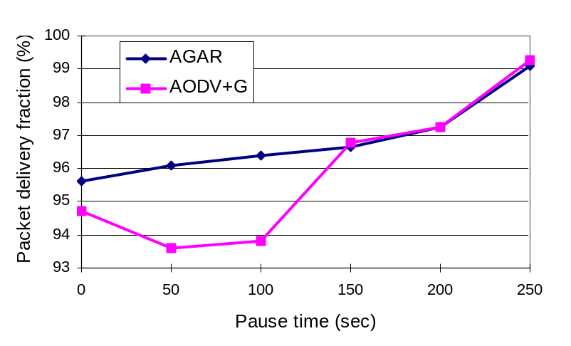

(a) Packet delivery fraction
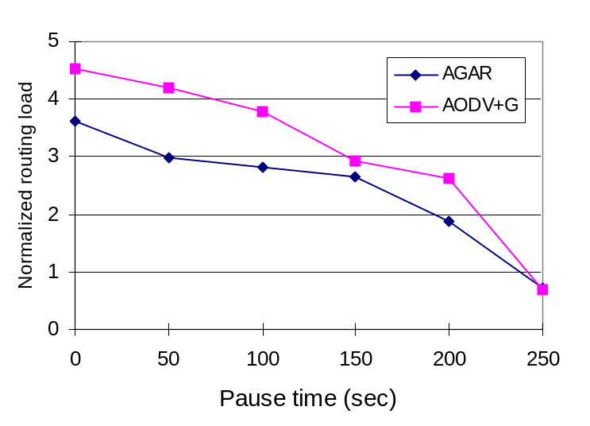
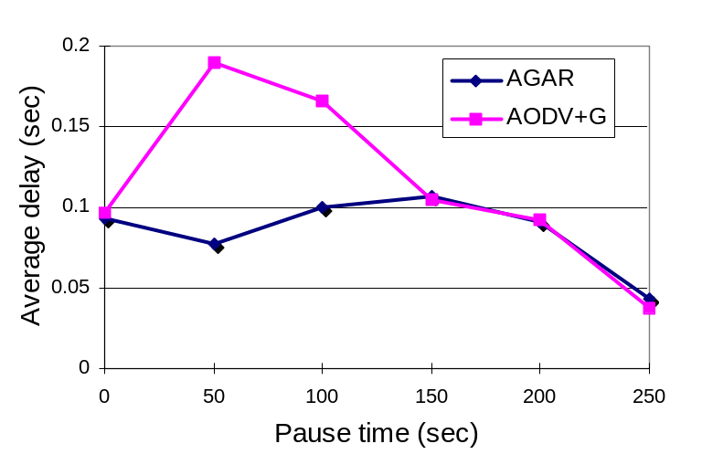 (b) Normalized routing load

(c) Average end-to-end delay
Figure 5 Performance Comparison of AGAR and AODV+G

Conclusion and Future work
This project report describes a study on gossiping techniques. The major contribution of our project lies in the proposal of improved algorithm, AGAR, which can significantly enhance the overall performance of mobile network over an existing gossip technique. The most challenges of this project are finding out the problem of the existing algorithm and designing our own solution. Understanding programs from other people and combining our own codes into them also took considerable effort and time. The follows summarize the important features of our approach.
Complexity. AGAR modifies AODV+G by adding a very simple calculation as introduced in the Section 3.2. It almost changes nothing on both time and space complexities, which are essential requirements to the wireless routing algorithms, while achieving significant improvement over its competitor.
Reliability. Comparing to AODV+G, AGAR performs with larger packet delivery fraction, which indicates higher reliability of packet transmission on networks.
Efficiency. AGAR achieves better efficiency than AODV+G does by transmitting the packets with smaller end-to-end delay.
Overhead. AGAR also exhibits less transmission overhead that AODV+G does as a result of its smaller normalized routing load.
Graceful degradation. As discussed in the Section 3.2, AGAR successfully achieves graceful degradation, which avoids the sharp drop-off in performance as conditions worsen [8].
Scalability. Scalability requires that the network performance does not drop dramatically as the number of nodes grows. As shown by Figure 3, when the network grows with n increasing, P_{A} of AODV+G would decrease sharply at some point and may largely affect the network performance; while AGAR always maintains a smooth change on P_{A}. Therefore, AGAR has better scalability over AODV+G.
Adaptability. For the same reason in the previous item, AGAR exhibits better adaptability, which means that the network performance would drop dramatically when a node fails or is recovered. This performance also indicates good maintenance.
Finally, We outline a few directions for future research. We would do more experiments with larger network models and different traffic patterns, with the expectation that AGAR may perform more significantly in larger scaled networks. Furthermore, since the performance of gossip techniques largely depends on the probability p, an intelligent system that can automatically choose the value of p would be an interesting topic for further research.

References
[1].Samir R. Das, Charles E. Perkins and Elizabeth M. Royer. Performance comparison of two on-demand routing protocols for ad hoc networks. INFOCOM, pp. 3-12, March 2000. Tel Aviv, Israel.
[2].T.D. Dyer and R.V. Boppana, A Comparison of TCP Performance over Three Routing Protocols for Mobile Ad Hoc Networks, ACM Mobihoc, October 2001.
[3] Sharad Gupta. Performance Evaluation of Ad-Hoc network routing protocols. Available at: http://www.cs.utk.edu/~gupta/Adhoc.doc.
[4] 1.Z. J. Haas, J. Halpern, L. Li, Gossip-based Ad Hoc Routing, unpublished. citesser.nj.nec.com/hass02gossipbased.html.
[5].Z. J. Haas, J. Halpern, L. Li. C++ source codes of gossip-based AODV, requested from authors on Feb. 11, 2003.
[6].C. E. Perkins, Ad-hoc on-demand distance vector routing, in MILCOM '97 panel on Ad Hoc Networks, Nov. 1997.
[7].E. M. Royer and C. E. Perkins, Multicast operation of the ad-hoc on-demand distance vector routing protocol, MOBICOM, pp. 207-218, Aug. 1999.
[8] Stuart Russell, Peter Norvig. Artificial Intelligence: A Modern Approach. Prentice Hall. Upper Saddle River, NJ, 07458. 1995.
[9] The VINT project. The ns Manual. Available at: http://www.isi.edu/nsnam/ns/doc/.
[10] Bruce Tuc. Development of WaveLAN, an ISM band wireless LAN. AT&T Technical Journal, 72(4): 27-33, 1993.
[11] Larry Wall, Tom Christensen, and Randal L. Schwartz. Programming Perl. O’Reilly & Associates, Inc., second edition edition, September 1996.

Appendix: Codes

C++ programs
The C++ coding part of this project involves aodv{.cc, .h} and god{.cc, .h}. Since these 4 files are notl programs, totally about 3,500 lines, and we just modified the algorithm and produced very small portion comparing to these files, it may not be appropriate to print them all in this report. Therefore, only our own codes and modified parts are listed as follows. Please refer to submitted electrical copy.

aodv.h
…

ifdef PPGD
public:
int hmHeard; // How Many of this bid has Heard, 1/14/2001
// 03/21/03 Zhongmin: private->public
#endif

…

#ifndef PPGD
bool id_lookup(nsaddr_t id, u_int32_t bid); // not touched
#else
BroadcastID* id_lookup(nsaddr_t id, u_int32_t bid);
nsaddr_t getIndex() {return index;} //03/21/03 Zhongmin: int -> nsaddr_t
int len_lookup(); //03/23/03 Zhongmin: get length of lookup table
#endif

…

aodv.cc
…
void ppgdTimer::handle(Event* p)
{
struct hdr_cmn *ch = HDR_CMN((Packet*)p);
struct hdr_aodv_request *rq = HDR_AODV_REQUEST((Packet*)p);
// 03/21/03 Zhongmin :agent->getAODVRequest((Packet*)p);

BroadcastID* tmpb = agent->id_lookup(rq->rq_src,rq->rq_bcast_id);
int nnbrs = God::instance()->numNbrs(agent->getIndex());

if (tmpb==NULL) {
Packet::free((Packet*)p); //sth is wrong!
} else { // if 1 < 0.5*4 , < 0 test if equivalent to no PPGD, YES IT IS!
// Grid: GOSSIP1(.62,4) with hmHeard<1 doesn't work well!

// 03/22/03 Zhongmin: adjast gossip with prob = gsprob_/tmpb->hmHeard
if (tmpb->hmHeard!=1) fprintf(stderr, "***** gspProb: %f hmHeard: %d tuned_gspPrb: %f \n", agent->gspPrb_, tmpb->hmHeard,agent->gspPrb_/tmpb->hmHeard); //--------

if( Random::uniform(0.0, 1.0)<= agent->gspPrb_/tmpb->hmHeard) {

//if ( (double)tmpb->hmHeard < 1 ) {//3 //2
// (floor)(agent->gspPrb_*nnbrs) 03/22/03 commented by Zhongmin

// 1/14/2001: need to keep track of the number of messages sent
// no need to add "FwdNode...", since it has already
// spilled out the first time we received this
// message; we just chose not to gossip it.
agent->gspNumMsgs_++;
fprintf(agent->gspTraceFile,
"me:%d src:%d dst:%d gossiping %d-th routeRequest, %d messages sent
(nnbrs=%d)\tprevHop=%d\tt:%f\tppgdWakeUp:timediff=%f\n",
agent->getIndex(),rq->rq_src,rq->rq_dst,rq->rq_bcast_id,
agent->gspNumMsgs_,nnbrs, ch->prev_hop_, CURRENT_TIME,
CURRENT_TIME-rq->rq_timestamp); // added 1/14/2001:

agent->forward((aodv_rt_entry*) 0, (Packet*)p, DELAY);
//03/21/03 Zhongmin: rt_entry -> aodv_tr_entry
}
else Packet::free((Packet*)p);
}
}

…

BroadcastID* AODV::id_lookup(nsaddr_t id, u_int32_t bid){
BroadcastID *b = bihead.lh_first;

/* 03/22/03 Zhongmin: count the times of occurances
and return it by hmHeard
*/

BroadcastID *return_b=NULL;
int times=0;
//--------------------------------------------------

// Search the list for a match of source and bid
for( ; b; b = b->link.le_next) {
if ((b->src == id) && (b->id == bid)) {
return_b=b; //03/22/03 Zhongmin
return_b->hmHeard=++times; //03/22/03 Zhongmin
//return b; 03/22/03 commented by Zhongmin
}

}
return return_b; //03/22/03 Zhongmin: (BroadcastID*)NULL->return_b
}

…

/*
* 03/23/03 Zhongmin - get the length of lookup table
*/
int AODV:: len_lookup() {
int length=0;
BroadcastID *b = bihead.lh_first;
for( ; b; b = b->link.le_next) length++;
return length;
}

…

/* An improvement, nbr. always gossip
* Another improvement, less connected node forward with high
* probability and its nbrs.
*/

double tmpp = gspPrb_;
if( (rq->reserved[0] || nnbrs<=lowcnn) && highgPrb_>gspPrb_) tmpp = highgPrb_;
else tmpp = gspPrb_;
if(nnbrs<=lowcnn) rq->reserved[0] = 1;
else rq->reserved[0] = 0;

double tuned_gspPrb_=((tmpb==NULL)? gspPrb_ : gspPrb_/tmpb->hmHeard); //02/22/03 Zhongmin: adjust probability

// 1/17/01: only network wide flooding is replaced with gossiping!
if( (Random::uniform(0.0, 1.0)<= ((TWO_THRESH>0)? tmpp : tuned_gspPrb_)) // 03/21/03 Zhongmin: /tmpb->hmHeard))
|| rq->rq_hop_count<=kParam_
//|| (rq->reserved[1]==0) // if not network wide flooding
) {
gspNumMsgs_++;
fprintf(gspTraceFile,
"me:%d src:%d dst:%d %s %d-th %s %d %s (nnbrs=%d)\tprevHop=%d\tt:%f\n",
index,
rq->rq_src,
rq->rq_dst,
"gossiping",
rq->rq_bcast_id, "routeRequest,",
gspNumMsgs_, "messages sent",
nnbrs,
ch->prev_hop_,
CURRENT_TIME);
// Maximum sequence number seen en route
if (rt) rq->rq_dst_seqno = max(rt->rt_seqno, rq->rq_dst_seqno);
// not touched
forward((aodv_rt_entry*) 0, p, DELAY); // not touched
}

…

god.h
…

// Added by Zhongmin Shi 3/20/03
int numNbrs(nsaddr_t);

…

god.cc
…

bool God::IsNeighbor(int i, int j)
{
assert(i<num_nodes && j<num_nodes);
// 03/23/03 Zhongmin: energy_model() of nodes could be NULL
if (mb_node[i]->energy_model()==NULL ||
mb_node[j]->energy_model()==NULL ||
mb_node[i]->energy_model()->node_on() == false ||
mb_node[j]->energy_model()->node_on() == false ||
mb_node[i]->energy_model()->energy() <= 0.0 ||
mb_node[j]->energy_model()->energy() <= 0.0 ) {
return false;
}

vector a(mb_node[i]->X(), mb_node[i]->Y(), mb_node[i]->Z());
vector b(mb_node[j]->X(), mb_node[j]->Y(), mb_node[j]->Z());
vector d = a - b;

if (d.length() < RANGE)
return true;
else
return false;
}

// 03/22/03 Zhongmin: count the numbers of neighbour
int God:: numNbrs(nsaddr_t index)
{
int count=0;
for (int i=0; i<num_nodes;i++) {
if (IsNeighbor(i, index)) count++;
}
return count--; //not count itself
}

…

Otcl codes
The main tcl script file, AGAR.tcl, is listed as follows.

#
# Adaptive Gossip-based Ad-hoc Routing Algorithm
# Author: Zhongmin Shi
# Spring 2003
#

# ======================================================================
# Define options
# ======================================================================

set opt(chan) Channel/WirelessChannel
set opt(prop) Propagation/TwoRayGround
set opt(netif) Phy/WirelessPhy
set opt(mac) Mac/802_11
set opt(ifq) Queue/DropTail/PriQueue
set opt(ll) LL
set opt(ant) Antenna/OmniAntenna

set opt(x) 2200 ;# X dimension of the topography
set opt(y) 400 ;# Y dimension of the topography
set opt(cp) "conn.tcl"
set opt(sc) "scen0.tcl"

set opt(progress) 4 ;# progress markers

set opt(ifqlen) 50 ;# max packet in ifq
set opt(nn) 75 ;# number of nodes
set opt(seed) 1.0
set opt(cn) 15.0 ;# number of connections
set opt(rate) 2 ;# packet generating rate

;# Traffic pattern parameter
set opt(stop) 275 ;# simulation time
set opt(tr) aodvg0.tr ;# trace file
set opt(nam) aodvg.nam
set opt(rp) AODV ;# routing protocol script
set opt(lm) "off" ;# log movement
set opt(energymodel) EnergyModel ;
set opt(initialenergy) 100 ;# Initial energy in Joules

LL set mindelay_ 50us
LL set delay_ 25us
LL set bandwidth_ 0 ;# not used
LL set off_prune_ 0 ;# not used
LL set off_CtrMcast_ 0 ;# not used

Agent/Null set sport_ 0
Agent/Null set dport_ 0

Agent/CBR set sport_ 0
Agent/CBR set dport_ 0

Agent/AODV set gspPrb_ 0.65 ;# p of Gossip(p,k)
Agent/AODV set kParam_ 1 ;# k of Gossip(p,k)
Agent/AODV set whichnw_ 0 ;# Network type: random

Queue/DropTail/PriQueue set Prefer_Routing_Protocols 1

# unity gain, omni-directional antennas
# set up the antennas to be centered in the node and 1.5 meters above it
Antenna/OmniAntenna set X_ 0
Antenna/OmniAntenna set Y_ 0
Antenna/OmniAntenna set Z_ 1.5
Antenna/OmniAntenna set Gt_ 1.0
Antenna/OmniAntenna set Gr_ 1.0

# Initialize the SharedMedia interface with parameters to make
# it work like the 914MHz Lucent WaveLAN DSSS radio interface
Phy/WirelessPhy set CPThresh_ 10.0
Phy/WirelessPhy set CSThresh_ 1.559e-11
Phy/WirelessPhy set RXThresh_ 3.652e-10
Phy/WirelessPhy set Rb_ 11*1e6
Phy/WirelessPhy set Pt_ 0.2818
Phy/WirelessPhy set freq_ 914e+6
Phy/WirelessPhy set L_ 1.0
Phy/WirelessPhy set bandwidth_ 11e6

# Initialize the 802.11 MAC
Mac set bandwidth_ 11e6

# ======================================================================
# Main Program
# ======================================================================

#
# Initialize Global Variables
#
set ns_ [new Simulator]
set topo [new Topography]
set god_ [new God]

#set namtrace [open $opt(nam) w]
set traceall [open $opt(tr) w]

$topo load_flatgrid $opt(x) $opt(y)
$ns_ use-newtrace
$ns_ trace-all $traceall
#$ns_ namtrace-all-wireless $namtrace $opt(x) $opt(y)

#$ns_ use-newtrace

#
# Create God
#
create-god $opt(nn)

#
# Create the specified number of nodes $opt(nn) and "attach" them
# the channel.
# Each routing protocol script is expected to have defined a proc
# create-mobile-node that builds a mobile node and inserts it into the
# array global $node_($i)
#

# Create channel #1
set chan_1_ [new $opt(chan)]

#global node setting

$ns_ node-config -adhocRouting $opt(rp) \
-llType $opt(ll) \
-macType $opt(mac) \
-ifqType $opt(ifq) \
-ifqLen $opt(ifqlen) \
-antType $opt(ant) \
-propType $opt(prop) \
-phyType $opt(netif) \
-channel $chan_1_ \
-topoInstance $topo \
-energyModel $opt(energymodel) \
-macTrace OFF \
-agentTrace ON \
-routerTrace ON \
-movementTrace OFF \
-rxPower 0.3 \
-txPower 0.6 \
-initialEnergy $opt(initialenergy)

for {set i 0} {$i < $opt(nn) } {incr i} {
set node_($i) [$ns_ node]
$node_($i) random-motion 1 ;# enable random motion
$god_ new_node $node_($i)
}

#
# Source the Connection and Movement scripts
#

puts "Loading connection pattern..."
source $opt(cp)

puts "Loading scenario file..."
source $opt(sc)
puts "Load complete."

#
# stopping the simulation
#

for {set i 1} {$i <= $opt(progress)} {incr i} {
set t [expr $i * $opt(stop) / ($opt(progress) + 1)]
$ns_ at $t "puts \"completed through $t secs...\""
}

proc stop {} {
global ns_ traceall namtrace
close $traceall
$ns_ flush-trace
exit 0
}

for {set i 0} {$i < $opt(nn) } {incr i} {
$ns_ at $opt(stop).000000001 "$node_($i) reset";
}

$ns_ at $opt(stop).00000002 "stop"

#
# Define node initial position in nam
#

for {set i 0} {$i < $opt(nn)} {incr i} {

# positions will be set by scenario
# The function must be called after mobility model is defined

$ns_ initial_node_pos $node_($i) 20 ;# whatever
}

puts "Starting Simulation..."
$ns_ run

Parsing codes
Parsing.java is the program to parse the simulation trace files and calculate the evaluation metrics.

/*
* Adaptive Gossip-based Routing Algorithm
* Parsing simulation trace files generated by ns-2.1b9a
* Author: Zhongmin Shi
*
* Input: agar?.tr
* Output: parseout.txt
*/

import java.util.*;
import java.lang.*;
import java.io.*;

public class parsing {

public static void main (String args[]) {

String line;
int j=0;
FileInputStream file_in;
FileOutputStream file_out;
file_inal int FILES = 6;
file_inal int MAX_PACKETS = 100000;

try {
// initialize variables

int i=0, sends=0, receives=0;
int drops=0,packet_id=0, highest_packet_id = 0;
int routing_packets=0, count=0;
float pdfraction, time=0, packet_duration=0, end_to_end_delay=0;
float avg_end_to_end_delay=0;
float start_time[] = new float[MAX_PACKETS];
float end_time[] = new float[MAX_PACKETS];
float sent_packets[] = new float[MAX_PACKETS];
float received_packets[] = new float[MAX_PACKETS];
String tokens[] = new String[100];

// initialize the start time

for (i=0; i<MAX_PACKETS ; i++)
start_time[i] = 0;

file_out =new FileOutputStream ("parseout.txt");
DataOutputStream op = new DataOutputStream(file_out);
for (int h=0;h<FILES;h++) {
j=h*50;
sends=0; receives=0; routing_packets=0;
highest_packet_id = 0;
end_to_end_delay=0;
for (i=0; i<MAX_PACKETS ; i++) {
start_time[i] = 0;
end_time[i]=0;
}
file_in = new FileInputStream ("agar"+j+".tr");
DataInputStream br = new DataInputStream(file_in);

while ((line = br.readLine()) != null) {
// scan it line by line
java.util.StringTokenizer st=new java.util.StringTokenizer(line," ");
i=0;
while(st.hasMoreElements())
tokens[i++]= st.nextToken();
if (tokens[0].equals("s") || tokens[0].equals("r")|| tokens[0].equals("f"))
{
// parse the time
if (tokens[1].equals("-t"))
time = Float.valueOf(tokens[2]).floatValue();
// parse the packet_id
if (tokens[39].equals("-Ii"))
packet_id = Integer.valueOf(tokens[40]).intValue();
/// calculate the sent packets
if (tokens[0].equals("s") && tokens[18].equals("AGT")&& tokens[34].equals("cbr"))
sends++;
// file_ind the number of packets in the simulation
if (packet_id >highest_packet_id) highest_packet_id = packet_id;
// set the start time, only if its not already set
if (start_time[packet_id] == 0) start_time[packet_id] = time;
// calculate the receives and end-end delay
if (tokens[0].equals("r") && tokens[18].equals("AGT") && tokens[34].equals("cbr")) {
receives++;
end_time[packet_id] = time;
}
else end_time[packet_id] = -1;
// calculate the routing packets
if ((tokens[0].equals("s") || tokens[0].equals("f")) && tokens[18].equals("RTR") && tokens[34].equals("AODV") )
routing_packets++;
}
}

// calculate the packet duration for all the packets

for (packet_id = 0; packet_id <= highest_packet_id ; packet_id++) {
packet_duration = end_time[packet_id] - start_time[packet_id];
if (packet_duration >0) end_to_end_delay += packet_duration;
}

// calculate the average end-end packet delay

avg_end_to_end_delay = end_to_end_delay / (receives );

// calculate the packet delivery fraction

pdfraction = ((float)receives/(float)(sends))*100;
System.out.println(" Normalized routing load: "+(float)routing_packets/(float)receives);
System.out.println(" pdfraction: " +pdfraction);
System.out.println(" Avg End-End delay: " +avg_end_to_end_delay);

op.writeBytes(""+j);
op.writeBytes(" " +sends);
op.writeBytes(" "+receives);
op.writeBytes(" "+ routing_packets);
op.writeBytes(" "+(float)routing_packets/(float)receives);
op.writeBytes(" " +pdfraction);
op.writeBytes(" " +avg_end_to_end_delay);
op.writeChar('\n');
}
}

catch (Exception e) {
e.printStackTrace();
}
}
}

