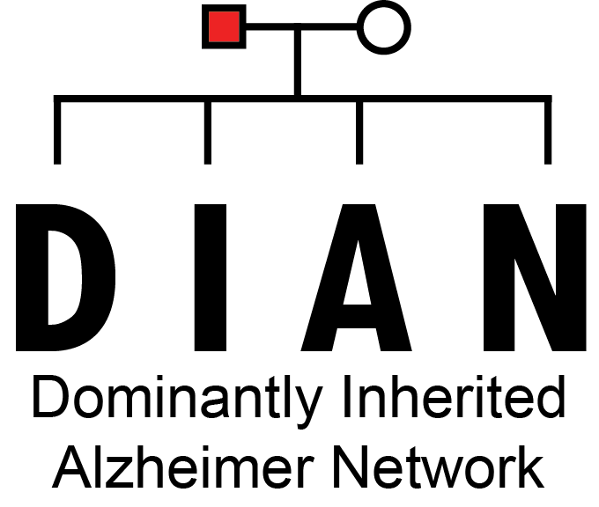

**DIAN DF11**

IMAGING CORE

Methods and Definitions

v1.0

November 2016

**Table of Contents**

Introduction and Contact Information 3

Data Archiving and Quality Control 4

Neuroradiological Interpretations 4

Data Distribution and Data Freezes 5

Recent and Upcoming Data Freeze Information: 6

DIAN DF7 May 2014 6

DIAN DF8 July 2014 (PET Unified Processing Pipeline) 6

DIAN DF9 April 2015 (PET Unified Processing Pipeline) 6

DIAN DF10 May 2016 (FreeSurfer v5.3) 6

DIAN DF11 November 2016 (White Matter Hyperintensity detection) 7

Definition of Positive Imaging Results 8

MRI Imaging and Processing 9

FreeSurfer: Quality Control Measures 9

Instructions for normalization of MRI Freesurfer-derived cortical volumes 11

FreeSurfer: Default Variables & Biostatistics Correlates 12

PET Processing Introduction 16

PET Processing Workflow 17

PiB and FDG data normalization 19

Mean Cortical PiB SUVR 19

PET Variable Nomenclature 20

PET Processing Variables & Biostatistics Correlates 21

Manual Region PET Processing Biostatistics Variables 26

For ANNE 26

SUVR and Binding Potential Cutoff Values 26

Processing References 27

# Introduction and Contact Information

The Dominantly Inherited Alzheimer’s Network (DIAN) Imaging Core works alongside the Administration Core and Clinical Core and has a primary role of acquisition and processing of imaging data. This Data Dictionary serves as a reference manual for researchers requesting or using imaging data generated by the Imaging Core.

Data are available for access in several permutations:

* Derived variables in spreadsheets (SAS or Excel)
* Source (DICOM) and derived data via web download from the
  + Central Neuroimaging Data Archive (CNDA) cnda.wustl.edu
  + Open Access Series of Imaging Studies(OASIS) www.oasis-brains.org
* ClinPortal synchronization project (in progress, contact Biostats core for further details)

Further resources, including updated copies of this Data Dictionary, are available online at our wiki site:

<http://kairmir.wikispaces.com/>

**Imaging Core Director:**

Tammie Benzinger, MD, PhD

[benzingert@wustl.edu](mailto:benzingert@wustl.edu)

**Regulatory Manager:** **Imaging Core Project Manager:**

Trish Stevenson Russ Hornbeck

[stevensonp@mir.wustl.edu](mailto:stevensonp@mir.wustl.edu) [russ@wustl.edu](mailto:russ@wustl.edu)

314-362-3613 314-362-6905

**Program Coordinator:**

Emily Gremminger

[gremmingere@mir.wustl.edu](mailto:dwyerd@mir.wustl.edu)

314-362-1558 314-362-1558

# Data Archiving and Quality Control

All imaging data are stored in the CNDA (Marcus, Olsen et al. 2007) portion of the DIAN database. DICOM-based transceivers at our scanners automatically send images to the CNDA within minutes of collection. The CNDA data are housed on a BlueArc Titan RAID-based system with 100% mirroring for disaster recovery and full back up. To facilitate data access, a web-based archive and visualization system (XNAT) has been developed and is now maintained by Informatics Core Director Dan Marcus, PhD (Marcus, Olsen et al. 2007). Before the CNDA makes the image data available for processing or extraction, the de-identified data must be matched with participant identifiers and undergo a series of quality control steps. The quality of the MRI data is assured by a rigorous quality assurance (QA) and preventative maintenance (PM) program that has been in operation for NIL Imaging Core Laboratory research scanners for over 12 years. QA/PM tests are performed by a combination of a dedicated Siemens field service engineer and the MRI and PET chief technologists. Quarterly phantom scans for longitudinal QC are obtained. At the scanner, the sequence parameters are verified by the study coordinator and images are reviewed for motion and repeated if needed, documented both on a study procedure form and captured electronically at the time of archiving. Multiple additional QC steps are then employed during each phase of the processing. Further details of this integrated workflow and QC for volumetric MRI and amyloid PET imaging are provided below. Post-processed data generated via CNDA processing (more details below) are also synchronized with the portion of the database residing in Biostatistics.

# Neuroradiological Interpretations

The first four MR sequences of the standard protocol allow us to quantify pathological changes due to small vessel disease, including assessment of white matter hyperintensity, microhemorrhage, and prior stroke. All MR studies acquired are interpreted by board-certified neuroradiologists on the faculty at Washington University. Upon receipt in the CNDA, an automated email notification is sent to the readers and the study is placed in a reading queue. Readers have the option of viewing the images directly using a built-in image viewer, or of downloading to a local workstation. Readings are entered directly into the CNDA by the radiologist. Abnormal findings are flagged and referred to the Imaging Core Leader (Dr. Benzinger) and study PI (Dr. Morris) for follow up. In cooperation with Barnes-Jewish Hospital, we have developed a HIPAA compliant workflow that allows for scans with abnormal findings to be added to the participant’s electronic medical record (if desired) and/or for a CD with an image viewer and interpretation to be provided to the participant and his personal physician (if outside our network).

# Data Distribution and Data Freezes

Data are shared with investigators by several mechanisms.

Requests for data (including raw imaging data) should be logged at the Knight ADRC website:

<http://alzheimer.wustl.edu/Research/ResourceRequest.htm>

Requests for DIAN data should be logged online at

<http://www.dian-info.org/resourcedb/Data/default.asp>

DICOM is available to outside investigators via the Open Access Series of Imaging Studies (OASIS) project.

www.oasis-brains.org

DICOM is available to engaged study investigators at Washington University via registration through the Central Neuroimaging Data Archive, or CNDA (cnda.wustl.edu). Requests for these data must also be approved by the Knight ADRC (<http://alzheimer.wustl.edu/Research/ResourceRequest.htm>).

Users of the CNDA may notice PET reconstructions utilizing a 128 size matrix (128mtx). This is a scan reconstruction specific to WU and should not be used when analyzing DIAN data.

Extracted (processed) data for volumetric MRI and amyloid PiB PET is available by request through the Knight ADRC and distributed by Biostatistics. In the future, this will be available through ClinPortal.

Extracted (processed) data for volumetric MRI and amyloid PiB PET is deposited on a regular basis. The contents of this manual describe the data deposited cumulatively for the DIAN project through 2013. For PET and MR imaging protocols please refer to the technical procedures manuals for each modality. To receive the DIAN imaging manuals, further clarification of the processing methods used, or if specialized processing is required, please contact a Core Leader or Co-Leader.

## Recent and Upcoming Data Freeze Information:

## DIAN DF7 May 2014

* Contains 510 MRI, 402 FS-PiB, 447 FS-FDG, 33 manual-PiB, 46 manual-FDG

## DIAN DF8 July 2014 (PET Unified Processing Pipeline)

* DIAN DF8 PET data has been (re)processed using the Imaging Core Laboratory’s PET Unified Processing pipeline (PUP). This pipeline allows for better target registration and reduction of motion artifact which will recovers imaging sessions whose ROI analyses could only be processed manually. Reprocessing with PUP yields superior longitudinal imaging data. PUP will also allow for di novo atlas registration and refined (template and manually drawn) ROI using the same engine.
* Contains 574 MRI, 487 FS-PiB, 515 FS-FDG, 28 manual-PiB, 41 manual-FDG
* Longitudinal Summary
  + ASL: 169 subjects with 1 scan, 18 subjects with more than 1 scan.
  + MRI: 193 with 1 scan, 161 with more than 1 scan.
  + FDG: 194 with 1 scan, 148 with more than 1 scan.
  + PIB: 192 with 1 scan, 139 with more than 1 scan.

## DIAN DF9 April 2015 (PET Unified Processing Pipeline)

* Contains 632 MRI, 492 FS-PiB, 522 FS-FDG, 78 manual-PiB, 35 manual-FDG
* FS statistics do not include intracranial volume (ICV) values due to known issues with FreeSurfer version 5.1 calculations of ICV.
* Longitudinal Summary
  + MRI: 201 with 1 scan, 172 with more than 1 scan.
  + FDG: 191 with 1 scan, 142 with more than one scan.
  + PIB: 187 with 1 scan, 131 with more than 1 scan.

## DIAN DF10 May 2016 (FreeSurfer v5.3)

* Imaging IDS will be anonymized
* FreeSurfer Cubic Spline Interpolation set to off (0) for fewer edits, reprocessing
* FreeSurfer v5.3 with all patches used for MRI statistics
* Corrected and restored Intracranial Volume values (ICV)
* PUP processing with scanner specific spatial filtering
* Longitudinal Imaging Summary (Scans Available)

|  |  |  |  |  |  |  |  |
| --- | --- | --- | --- | --- | --- | --- | --- |
|  | **v00** | **v01** | **v02** | **v03** | **v04** | **v05** | **v06** |
| **MRI** | 407 | 111 | 75 | 117 | 20 | 8 | 2 |
| **PiB** | 375 | 95 | 69 | 117 | 19 | 6 | 2 |
| **FDG** | 387 | 103 | 72 | 123 | 21 | 6 | 2 |

## DIAN DF11 November 2016 (White Matter Hyperintensity detection)

* An SPM based Lesion Segmentation Tool (LST) pipeline has been added to detect and segment T2 hyperintense lesions in FLAIR images. Originally developed for the segmentation of MS lesions, it has proven useful for the segmentation of brain lesions in Alzheimer's disease.
* FreeSurfer v5.3 with all patches used for MRI statistics
* Longitudinal Imaging Summary (Scans Available)

|  |  |  |  |  |  |  |  |
| --- | --- | --- | --- | --- | --- | --- | --- |
|  | **v00** | **v01** | **v02** | **v03** | **v04** | **v05** | **v06** |
| **MRI** | 426 | 112 | 83 | 124 | 24 | 20 | 11 |
| **PiB** | 394 | 97 | 78 | 124 | 22 | 21 | 8 |
| **FDG** | 406 | 104 | 77 | 130 | 25 | 21 | 8 |

## Definition of Positive Imaging Results

PiB+ (positive) is defined at Washington University as a mean cortical binding potential (MCBP) of 0.18 or higher (Mintun et al., 2006). Using the processing methods described in this Data Dictionary, this corresponds to a mean cortical standardized uptake value ratio (MC-SUVR) of 1.3. with PiB is referenced to ***cerebellar grey matter)***

As of July 2014 we have not completed our crossover study of PIB and florbetapir (AV45) amyloid PET. However, it appears that an MC-SUVR of 1.3 will likely be appropriate for those studies as well.

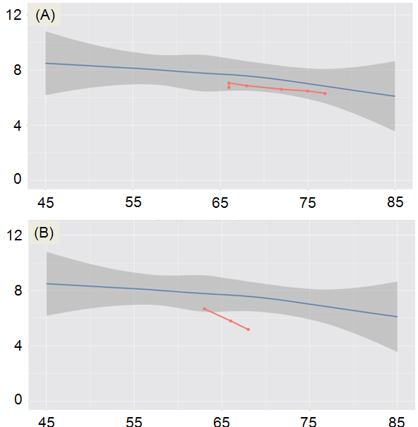Also under investigation, we are defining hippocampal abnormality, based upon individual longitudinal reports (ILR) (Fig. 1), where adjusted hippocampal volume is greater than one standard deviation from our Super-Norm cohort (cognitively normal and biomarker normal) (Table 1). Also using this Super-Norm cohort and a corresponding biomarker positive AD cohort we have defined a refined cortical signature (RCS) for cortical thickness (Fig. 2). These regions can be combined to evaluate for abnormal RCS for an individual compared to the Super-Norms. The ILR and RCS reports are available for specific participants upon request and may be useful for multicore conferences and case discussions.

**Figure 1:** Individual Longitudinal Participant (ILP) reports.x-axis is age (in years). y-axis is normalized hippocampal volume (cm3). (A) Example of a participant who first had imaging at age 66. Over the course of 6 visits, both clinical status and hippocampal volumes remained normal. (B) Example of a participant who was cognitively normal (CDR 0) at first visit, but who progressed to a diagnosis of AD (CDR 0.5) by the last imaging visit.

**Table 1**: “Super-Normal” cohort (CN and biomarker negative) and “True AD” cohorts. “NA” denotes cases where ApoE genotyping is not currently available (is in progress).

|  |  |  |  |
| --- | --- | --- | --- |
| **Demographic** | **Super-Normal** | **AD** | ***p*-value** |
| ***n*** | 106 | 64 | - |
| **Age (SD) years** | 71.84 (5.02) | 74.81 (5.10) | <0.001 |
| **Education (SD) years** | 15.35 (2.61) | 14.44 (2.82) | 0.038 |
| **% Male** | 47.2 | 48.4 | 0.874 |
| **APOE4 Status** | E4–=79, E4+ =23, NA = 4 | E4–=14, E4+=46, NA=4 | <0.001 |

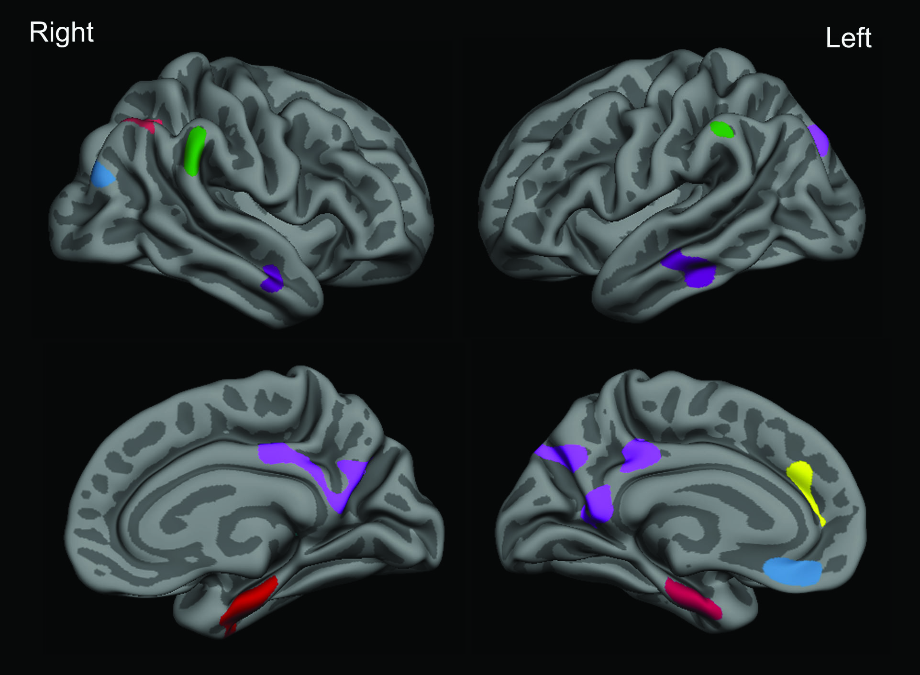

**Figure 2.** A refined cortical signature of AD. Cognitively normal (CN) and symptomatic AD participants were characterized using Aβ imaging using PiB, and cerebrospinal fluid (CSF) Aβ42. Vertex-wise comparisons were conducted between CN individuals (N=106) who were negative for all biomarkers and AD individuals (N=64) who were positive for either PIB or CSF Aβ42 using general linear model. Group difference map thresholded at p < 0.05 (corrected) identifies the regions showing reduced cortical thickness in AD participants. Color-coded labels derived from these regions are shown on the semi-inflated cortical surface of the FreeSurfer average brain with light gray regions representing gyri and dark gray regions representing sulci.

# MRI Imaging and Processing

***Note: The following paragraphs outline processing details useful for citation in manuscripts using DIAN Imaging Core data.***

Structural MRI acquisition was performed using the Alzheimer Disease Neuroimaging Initiative (ADNI) protocol (Jack et al., 2008, Jack et al., 2010). Participating sites were required to pass initial and regular follow-up quality control assessments to insure acquisition conformity. Each participant received an accelerated 3D sagittal T1-weighted MPRAGE on a 3T scanner. A high quality, whole-brain image with 1.1x1.1x1.2 mm voxels was acquired in approximately 5-6 minutes. Before analysis, images were screened for artifacts and protocol compliance by the ADNI imaging core.

All MRI sessions were processed through the FreeSurfer image analysis suite using Dell PowerEdge 1950 servers with Intel Xeon processors running CentOS 5.5 Linux. These scans were acquired with a Siemens BioGraph mMR PET-MR 3T scanner or Siemens Trio 3T MRI scanner [***FOR MANUSCRIPTS, SELECT ONLY THE SCANNER(S) FROM WHICH YOUR DATA WERE DERIVED***], and T1 weighted images were obtained for analysis.

FreeSurfer involves cortical reconstruction and volumetric segmentation, which is documented @ [http://surfer.nmr.mgh.harvard.edu/](https://nilmail07.wustl.edu/owa/redir.aspx?C=900bd19abc954827ae41e219837de85a&URL=http%3a%2f%2fsurfer.nmr.mgh.harvard.edu%2f). The technical details of these procedures are described in prior publications (Dale et al., 1999; Dale and Sereno, 1993; Fischl and Dale, 2000; Fischl et al., 2001; Fischl et al., 2002; Fischl et al., 2004a; Fischl et al., 1999a; Fischl et al., 1999b; Fischl et al., 2004b; Han et al., 2006; Jovicich et al., 2006; Segonne et al., 2004)). The processing pipeline includes motion correction and segmentation of the subcortical white matter and deep gray matter volumetric structures on T1 combined with T2 images (Fischl et al., 2002), intensity normalization, registration to a spherical atlas which utilizes individual cortical folding patterns to match cortical geometry across subjects (Fischl et al., 1999b), and parcellation of the cerebral cortex into units based on gyral and sulcal structure (Desikan et al., 2006). For each vertex on the cortical surface, thickness was calculated as the shortest distance from the gray/white boundary to the gray/CSF boundary (Fischl, 2012).

All 3.0T MRI imaging data have been processed using FreeSurfer 5.3 with all patches applied.

# FreeSurfer: Quality Control Measures

All individuals interacting with imaging data will be trained in the FreeSurfer quality control measures developed by the Imaging Core. Such measures include processing pipeline workflows, visual inspection of the data for erroneous sessions, and the correct applications of edits to the volumes when errors persist. Additional information surrounding the FreeSurfer quality control process may be found through the FreeSurfer website, <http://surfer.nmr.mgh.harvard.edu/fswiki/FsTutorial/TroubleshootingData>

Annual quality control testing ensures the reduction of drift between raters while simultaneously guaranteeing a rigorous data set. Interclass correlation (ICC) values between raters shall not fall below 90% agreement; if they do, retraining on test data sets will be required until agreement is reached.FreeSurfer: Correcting Subcortical Volumes for Head Size

It is suggested that all subcortical regions should be corrected for head size in order to have correct comparisons. There is no need to normalize for cortical thickness as it is not dependent on intracranial volume (ICV). It does not make a difference if you normalize left and right hemispheres separately or together, the sum will be the same. The normalization process applies to each individual ROI, and is sample specific.

***Note: Volume normalization must be repeated any time a subject is added or removed from the sample.***

An analysis of the intracranial volume estimate for each participant was performed on a longitudinal cohort (Figure 3). All participants had MRI scans using a 3T scanner and were processed with FreeSurfer 5.3. Within a participant, ICV can vary from the baseline scan more than 5% with a mean subject SD of 15.75 cm 3. This variance should be taken into consideration when correcting subcortical and cortical volumes.

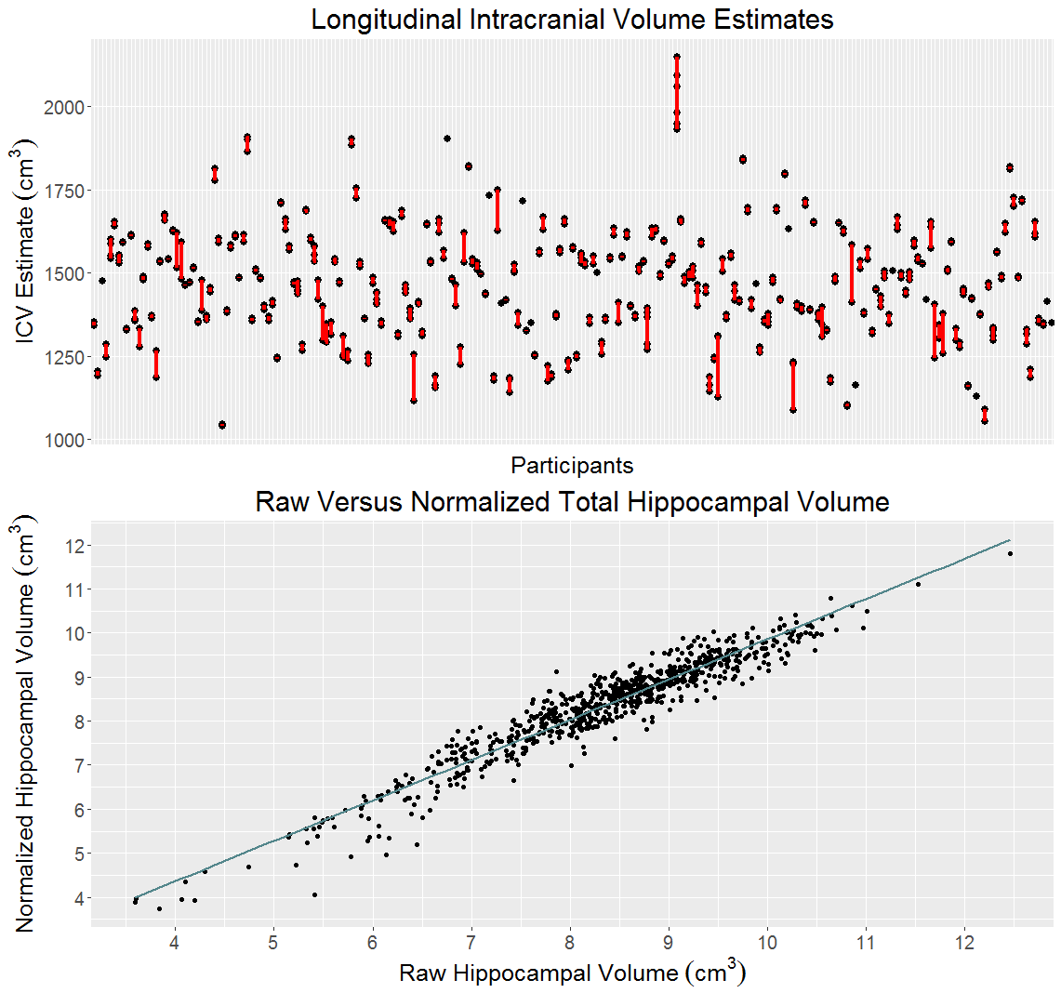

**B**

**A**

**Figure 3**. (A) ICV estimate for each participant in a longitudinal study. Each black circle represents an MR session and the red line represents a longitudinal participant. (B) The relationship between the raw hippocampal volume and the hippocampal volume normalized by ICV.

The relevant publication for the head-size correction is as follows:

**Neuroimage, 2004**

A unified approach for morphometric and functional data analysis in young, old, and demented adults using automated atlas-based head size normalization: reliability and validation against manual measurement of total intracranial volume

*Randy L. Buckner, Denise Head, Jamie Parker, Anthony F. Fotenos,*

*Daniel Marcus, John C. Morris, and Abraham Z. Snyder*

## Instructions for normalization of MRI Freesurfer-derived cortical volumes

*Normalization calculation:*

1. Compute mean ICV for sample.
2. Compute regression with ICV as independent variable and ROI as dependent variable to obtain B (NOT Beta) weight
3. Compute: Normalized = raw volume – (B-weight * (ss ICV – mean ICV))

*Note: "ss" = single subject's*

***For DF 9, we did not include IntraCranialVol (ICV) as it uses FS 5.1 segmentation.***

***For DF10, all MRI data was processed using FreeSurfer v5.3 correcting the ICV calculation.***

***The biostats names for ICV and CSf are MR_TOTV_INTRACRANIAL and MR_TOTV_CSF respectively.***

Figure 4 below shows a snapshot from the **SPSS** output for the linear regression. Use the B value highlighted in red for the correction factor. This procedure is repeated for each subcortical & cortical ROI volume the investigator is interested in. We do not normalize the cortical thickness measures, only cortical & subcortical volumes. In this case, it means any volumes on the "aseg.stats" file that we send.

*Figure 4*

| **Coefficientsa** | | | | | | |
| --- | --- | --- | --- | --- | --- | --- |
| Model | | Unstandardized Coefficients | | Standardized Coefficients | t | Sig. |
| B | Std. Error | Beta |
| 1 | (Constant) | 2718.207 | 343.943 |  | 7.903 | .000 |
| ICV | -1.513E-5 | .000 | -.008 | -.068 | .946 |
| a. Dependent Variable: transtemp | | | | | | |

## FreeSurfer: Default Variables & Biostatistics Correlates

|  |  |
| --- | --- |
| **MRI Freesurer Default Variable** | **New Biostat Standardizations** |
| 3rd-Ventricle | MR_TOTV_THIRDVENT |
| 4th-Ventricle | MR_TOTV_FOURTHVENT |
| 5th-Ventricle | MR_TOTV_FIFTHVENT |
| Brain-Stem | MR_TOTV_BRAINSTEM |
| CC_Anterior | MR_TOTV_CRPCLM_ANT |
| CC_Central | MR_TOTV_CRPCLM_CNTRL |
| CC_Mid_Anterior | MR_TOTV_CRPCLM_MID_ANT |
| CC_Mid_Posterior | MR_TOTV_CRPCLM_MID_POST |
| CC_Posterior | MR_TOTV_CRPCLM_POST |
| CortexVol | MR_TOTV_CORTEX |
| CSF | MR_TOTV_CSF |
| IntraCranialVol | MR_TOTV_INTRACRANIAL |
| non-WM-hypointensities | MR_TOTV_NONWMHYPOINTENSITIES |
| Optic-Chiasm | MR_TOTV_OPTICHIASM |
| SubCortGrayVol | MR_TOTV_SUBCORTGRAY |
| TotalGrayVol | MR_TOTV_GRAY |
| WM-hypointensities | MR_TOTV_WMHYPOINTENSITIES |
| lh_bankssts_thickness | MR_LT_SSTSBANK |
| lh_caudalanteriorcingulate_thickness | MR_LT_CAUDANTCNG |
| lh_caudalmiddlefrontal_thickness | MR_LT_CAUDMIDFRN |
| lh_cuneus_thickness | MR_LT_CUNEUS |
| lh_entorhinal_thickness | MR_LT_ENTORHINAL |
| lh_frontalpole_thickness | MR_LT_FRNPOLE |
| lh_fusiform_thickness | MR_LT_FUSIFORM |
| lh_inferiorparietal_thickness | MR_LT_INFRPRTL |
| lh_inferiortemporal_thickness | MR_LT_INFRTMP |
| lh_insula_thickness | MR_LT_INSULA |
| lh_isthmuscingulate_thickness | MR_LT_ISTHMUSCNG |
| lh_lateraloccipital_thickness | MR_LT_LATOCC |
| lh_lateralorbitofrontal_thickness | MR_LT_LATORBFRN |
| lh_lingual_thickness | MR_LT_LINGUAL |
| lh_medialorbitofrontal_thickness | MR_LT_MEDORBFRN |
| lh_middletemporal_thickness | MR_LT_MIDTMP |
| lh_paracentral_thickness | MR_LT_PARACNTRL |
| lh_parahippocampal_thickness | MR_LT_PARAHPCMPL |
| lh_parsopercularis_thickness | MR_LT_PARAOPRCLRS |
| lh_parsorbitalis_thickness | MR_LT_PARSORBLS |
| lh_parstriangularis_thickness | MR_LT_PARSTRNGLRS |
| lh_pericalcarine_thickness | MR_LT_PERICLCRN |
| lh_postcentral_thickness | MR_LT_POSTCNTRL |
| lh_posteriorcingulate_thickness | MR_LT_POSTCNG |
| lh_precentral_thickness | MR_LT_PRECNTRL |
| lh_precuneus_thickness | MR_LT_PRECUNEUS |
| lh_rostralanteriorcingulate_thickness | MR_LT_ROSANTCNG |
| lh_rostralmiddlefrontal_thickness | MR_LT_ROSMIDFRN |
| lh_superiorfrontal_thickness | MR_LT_SUPERFRN |
| lh_superiorparietal_thickness | MR_LT_SUPERPRTL |
| lh_superiortemporal_thickness | MR_LT_SUPERTMP |
| lh_supramarginal_thickness | MR_LT_SUPRAMRGNL |
| lh_temporalpole_thickness | MR_LT_TMPPOLE |
| lh_transversetemporal_thickness | MR_LT_TRANSTMP |
| rh_bankssts_thickness | MR_RT_SSTSBANK |
| rh_caudalanteriorcingulate_thickness | MR_RT_CAUDANTCNG |
| rh_caudalmiddlefrontal_thickness | MR_RT_CAUDMIDFRN |
| rh_cuneus_thickness | MR_RT_CUNEUS |
| rh_entorhinal_thickness | MR_RT_ENTORHINAL |
| rh_frontalpole_thickness | MR_RT_FRNPOLE |
| rh_fusiform_thickness | MR_RT_FUSIFORM |
| rh_inferiorparietal_thickness | MR_RT_INFRPRTL |
| rh_inferiortemporal_thickness | MR_RT_INFRTMP |
| rh_insula_thickness | MR_RT_INSULA |
| rh_isthmuscingulate_thickness | MR_RT_ISTHMUSCNG |
| rh_lateraloccipital_thickness | MR_RT_LATOCC |
| rh_lateralorbitofrontal_thickness | MR_RT_LATORBFRN |
| rh_lingual_thickness | MR_RT_LINGUAL |
| rh_medialorbitofrontal_thickness | MR_RT_MEDORBFRN |
| rh_middletemporal_thickness | MR_RT_MIDTMP |
| rh_paracentral_thickness | MR_RT_PARACNTRL |
| rh_parahippocampal_thickness | MR_RT_PARAHPCMPL |
| rh_parsopercularis_thickness | MR_RT_PARAOPRCLRS |
| rh_parsorbitalis_thickness | MR_RT_PARSORBLS |
| rh_parstriangularis_thickness | MR_RT_PARSTRNGLRS |
| rh_pericalcarine_thickness | MR_RT_PERICLCRN |
| rh_postcentral_thickness | MR_RT_POSTCNTRL |
| rh_posteriorcingulate_thickness | MR_RT_POSTCNG |
| rh_precentral_thickness | MR_RT_PRECNTRL |
| rh_precuneus_thickness | MR_RT_PRECUNEUS |
| rh_rostralanteriorcingulate_thickness | MR_RT_ROSANTCNG |
| rh_rostralmiddlefrontal_thickness | MR_RT_ROSMIDFRN |
| rh_superiorfrontal_thickness | MR_RT_SUPERFRN |
| rh_superiorparietal_thickness | MR_RT_SUPERPRTL |
| rh_superiortemporal_thickness | MR_RT_SUPERTMP |
| rh_supramarginal_thickness | MR_RT_SUPRAMRGNL |
| rh_temporalpole_thickness | MR_RT_TMPPOLE |
| rh_transversetemporal_thickness | MR_RT_TRANSTMP |
| Left-Accumbens-area | MR_LV_ACCUMBENS |
| Left-Amygdala | MR_LV_AMYGDALA |
| Left-Caudate | MR_LV_CAUD |
| Left-Cerebellum-Cortex | MR_LV_CBLL_CORTEX |
| Left-Cerebellum-White-Matter | MR_LV_CBLL_WM |
| Left-choroid-plexus | MR_LV_CHORPLEX |
| Left-Hippocampus | MR_LV_HIPPOCAMPUS |
| Left-Inf-Lat-Vent | MR_LV_INFLATVENT |
| Left-Lateral-Ventricle | MR_LV_LATVENT |
| Left-non-WM-hypointensities | MR_LV_NONWMHYPOINTENSITIES |
| Left-Pallidum | MR_LV_PALLIDUM |
| Left-Putamen | MR_LV_PUTAMEN |
| Left-Thalamus-Proper | MR_LV_THALAMUS |
| Left-VentralDC | MR_LV_VENTRALDC |
| Left-vessel | MR_LV_VESSEL |
| Left-WM-hypointensities | MR_LV_WMHYPOINTENSITIES |
| lh_bankssts_volume | MR_LV_SSTSBANK |
| lh_caudalanteriorcingulate_volume | MR_LV_CAUDANTCNG |
| lh_caudalmiddlefrontal_volume | MR_LV_CAUDMIDFRN |
| lh_cuneus_volume | MR_LV_CUNEUS |
| lh_entorhinal_volume | MR_LV_ENTORHINAL |
| lh_frontalpole_volume | MR_LV_FRNPOLE |
| lh_fusiform_volume | MR_LV_FUSIFORM |
| lh_inferiorparietal_volume | MR_LV_INFRPRTL |
| lh_inferiortemporal_volume | MR_LV_INFRTMP |
| lh_insula_volume | MR_LV_INSULA |
| lh_isthmuscingulate_volume | MR_LV_ISTHMUSCNG |
| lh_lateraloccipital_volume | MR_LV_LATOCC |
| lh_lateralorbitofrontal_volume | MR_LV_LATORBFRN |
| lh_lingual_volume | MR_LV_LINGUAL |
| lh_medialorbitofrontal_volume | MR_LV_MEDORBFRN |
| lh_middletemporal_volume | MR_LV_MIDTMP |
| lh_paracentral_volume | MR_LV_PARACNTRL |
| lh_parahippocampal_volume | MR_LV_PARAHPCMPL |
| lh_parsopercularis_volume | MR_LV_PARAOPRCLRS |
| lh_parsorbitalis_volume | MR_LV_PARSORBLS |
| lh_parstriangularis_volume | MR_LV_PARSTRNGLRS |
| lh_pericalcarine_volume | MR_LV_PERICLCRN |
| lh_postcentral_volume | MR_LV_POSTCNTRL |
| lh_posteriorcingulate_volume | MR_LV_POSTCNG |
| lh_precentral_volume | MR_LV_PRECNTRL |
| lh_precuneus_volume | MR_LV_PRECUNEUS |
| lh_rostralanteriorcingulate_volume | MR_LV_ROSANTCNG |
| lh_rostralmiddlefrontal_volume | MR_LV_ROSMIDFRN |
| lh_superiorfrontal_volume | MR_LV_SUPERFRN |
| lh_superiorparietal_volume | MR_LV_SUPERPRTL |
| lh_superiortemporal_volume | MR_LV_SUPERTMP |
| lh_supramarginal_volume | MR_LV_SUPRAMRGNL |
| lh_temporalpole_volume | MR_LV_TMPPOLE |
| lh_transversetemporal_volume | MR_LV_TRANSTMP |
| lhCortexVol | MR_LV_CORTEX |
| lhCorticalWhiteMatterVol | MR_LV_CORTICALWM |
| rh_bankssts_volume | MR_RV_SSTSBANK |
| rh_caudalanteriorcingulate_volume | MR_RV_CAUDANTCNG |
| rh_caudalmiddlefrontal_volume | MR_RV_CAUDMIDFRN |
| rh_cuneus_volume | MR_RV_CUNEUS |
| rh_entorhinal_volume | MR_RV_ENTORHINAL |
| rh_frontalpole_volume | MR_RV_FRNPOLE |
| rh_fusiform_volume | MR_RV_FUSIFORM |
| rh_inferiorparietal_volume | MR_RV_INFRPRTL |
| rh_inferiortemporal_volume | MR_RV_INFRTMP |
| rh_insula_volume | MR_RV_INSULA |
| rh_isthmuscingulate_volume | MR_RV_ISTHMUSCNG |
| rh_lateraloccipital_volume | MR_RV_LATOCC |
| rh_lateralorbitofrontal_volume | MR_RV_LATORBFRN |
| rh_lingual_volume | MR_RV_LINGUAL |
| rh_medialorbitofrontal_volume | MR_RV_MEDORBFRN |
| rh_middletemporal_volume | MR_RV_MIDTMP |
| rh_paracentral_volume | MR_RV_PARACNTRL |
| rh_parahippocampal_volume | MR_RV_PARAHPCMPL |
| rh_parsopercularis_volume | MR_RV_PARAOPRCLRS |
| rh_parsorbitalis_volume | MR_RV_PARSORBLS |
| rh_parstriangularis_volume | MR_RV_PARSTRNGLRS |
| rh_pericalcarine_volume | MR_RV_PERICLCRN |
| rh_postcentral_volume | MR_RV_POSTCNTRL |
| rh_posteriorcingulate_volume | MR_RV_POSTCNG |
| rh_precentral_volume | MR_RV_PRECNTRL |
| rh_precuneus_volume | MR_RV_PRECUNEUS |
| rh_rostralanteriorcingulate_volume | MR_RV_ROSANTCNG |
| rh_rostralmiddlefrontal_volume | MR_RV_ROSMIDFRN |
| rh_superiorfrontal_volume | MR_RV_SUPERFRN |
| rh_superiorparietal_volume | MR_RV_SUPERPRTL |
| rh_superiortemporal_volume | MR_RV_SUPERTMP |
| rh_supramarginal_volume | MR_RV_SUPRAMRGNL |
| rh_temporalpole_volume | MR_RV_TMPPOLE |
| rh_transversetemporal_volume | MR_RV_TRANSTMP |
| rhCortexVol | MR_RV_CORTEX |
| rhCorticalWhiteMatterVol | MR_RV_CORTICALWM |
| Right-Accumbens-area | MR_RV_ACCUMBENS |
| Right-Amygdala | MR_RV_AMYGDALA |
| Right-Caudate | MR_RV_CAUD |
| Right-Cerebellum-Cortex | MR_RV_CBLL_CORTEX |
| Right-Cerebellum-White-Matter | MR_RV_CBLL_WM |
| Right-choroid-plexus | MR_RV_CHORPLEX |
| Right-Hippocampus | MR_RV_HIPPOCAMPUS |
| Right-Inf-Lat-Vent | MR_RV_INFLATVENT |
| Right-Lateral-Ventricle | MR_RV_LATVENT |
| Right-non-WM-hypointensities | MR_RV_NONWMHYPOINTENSITIES |
| Right-Pallidum | MR_RV_PALLIDUM |
| Right-Putamen | MR_RV_PUTAMEN |
| Right-Thalamus-Proper | MR_RV_THALAMUS |
| Right-VentralDC | MR_RV_VENTRALDC |
| Right-vessel | MR_RV_VESSEL |
| Right-WM-hypointensities | MR_RV_WMHYPOINTENSITIES |

# PET Processing Introduction

Each site underwent an initial evaluation by the ADNI PET QC site to ensure compliance with a common PiB and FDG PET protocol. Amyloid imaging was performed with a bolus injection of approximately 15 mCi of [11C]PiB. Dynamic imaging acquisition started either at injection for 70 minutes or 40 minutes post-injection for 30 minutes. For analysis, the PiB PET data between 40 to 70 minutes were used. Metabolic imaging with [18F]FDG-PET was performed with a 3D dynamic acquisition began 40 minutes after a bolus injection of approximately 5 mCi of FDG and lasted for 20 minutes. All PET images were quality controlled by the ADNI QC team.

## PET Processing Workflow

*A visual representation of the processing workflow is shown below in Figure 5.*

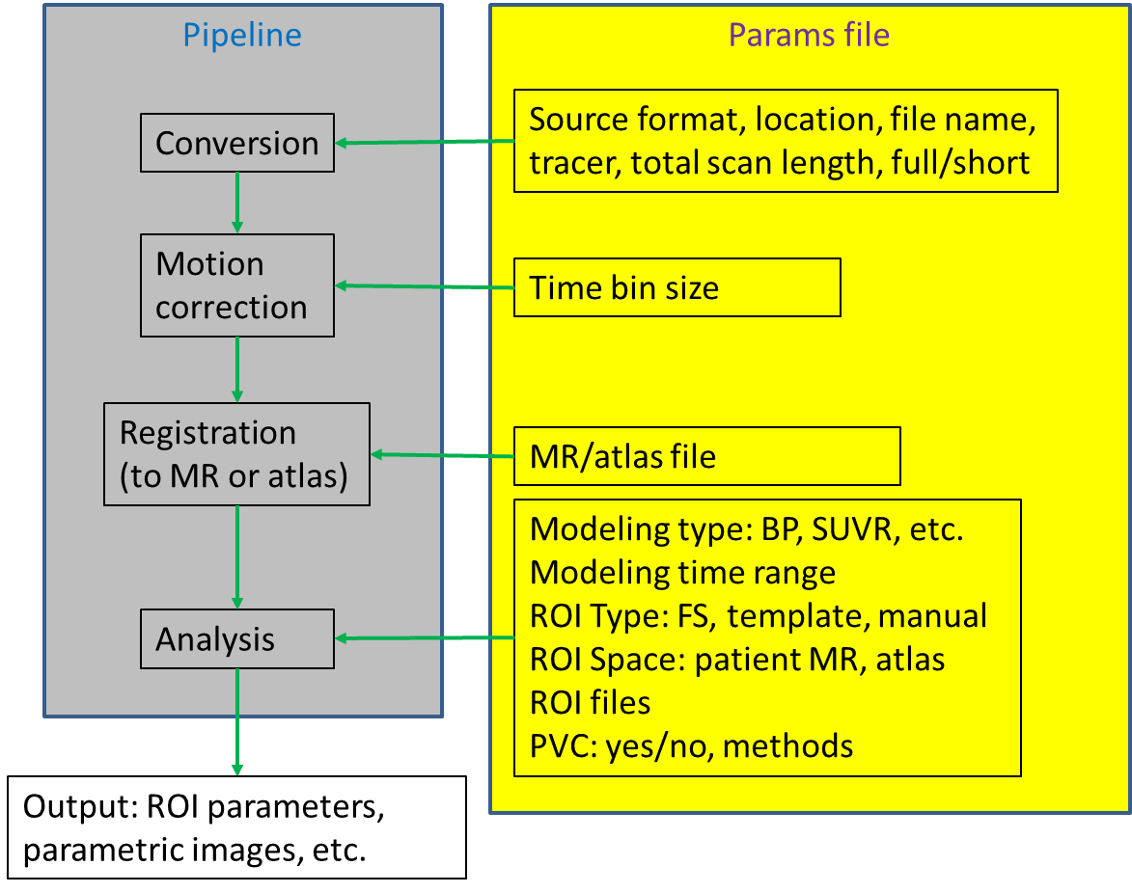

*Figure 5*

1. Raw PET and T1 weighted MRI must meet quality standards
2. ROI definition must be completed (FreeSurfer, hand-drawn, template) and meet quality standards
3. An imaging conversion engine is used to convert raw imaging data to 4dfp format
4. PET motion correction is performed to align PET frames acquired at different times
5. PET to target ( T1 weighted MR, or PET atlas) registration is performed
6. ROI-based analysis is performed to obtain regional SUVRs, BPs, etc.
7. Partial volume correction is performed if requested (for FreeSurfer based ROI only)
8. Check quality assurance measurements

Each subject’s PET data were motion corrected and registered to their MRI using methods described in detail elsewhere (Eisenstein et al., 2012, Rowland et al., 2005). For each FreeSurfer region-of-interest, standardized uptake value ratio (SUVR) was calculated using a *cerebellar* reference.

The Central Neuroimaging Data Archive (CNDA), using the open-source XNAT (Marcus 2007), provides the foundation for archiving and the interface for processing MRI and PIB data. FreeSurfer regions are used to process PET in the CNDA with processing pipelines. This in-house software has been described in Mintun 2006, and Morris 2010 (http://nrg.wikispaces.com/PipelineWiki). To summarize: the dynamic PET scan is divided into early, middle, and late frames and registered to correct for head motion. The T1 weighted MRI scan is registered to the Talairach atlas and to the PET images (Rowland), and transformed into atlas space. Time activity curves (TACs) may be made using FreeSurfer or expert hand-drawn regions. Models of PET binding are then calculated.

Typical ROIs defined manually for amyloid imaging analysis encompass both gray and white matter brain tissue, while beta amyloid deposition is usually limited to gray matter. In addition the commonly adopted two tissue PVC model does not differentiate white matter from gray matter (Meltzer et al., 1999). We have implemented an automated quantitative image analysis approach that use ROIs generated with FreeSurfer (Fischl et al., 2002), with a more advanced regional spread function technique (Frouin et al., 2002; Starck et al., 2002) for PVC. It is demonstrated that a set of FreeSurfer regions can be determined that reproduce manual ROI analysis. The estimated binding potential values are highly correlated with and without PVC, but partial-volume effect has a differential impact on the estimated binding potentials for different ROIs.

PET imaging has a spatial resolution around 6mm, which is considerably lower than structural imaging modalities such as MR. Because of this, the regional activity measured directly from PET is a linear combination of activity from different regions. This phenomenon is known as the partial volume effect (Frouin 2002, Rousset 2006). To compensate for this, a regional spread function (RSF) based approach for partial volume correction of PET data has been implemented. The RSF is a function that describes the linear mixture model of region of interest (ROI) signal detected by PET due to partial volume effect. An iterative approach was used to solve the linear system model to recover the true ROI signal (Rousset 1998). This PVC RSF PET processing using FreeSurfer regions is implemented in the CNDA.

The CNDA has also been employed to model PiB binding with expert manually determined regions. Subjects without FreeSurfer regions, due to subject motion or pathology problems, will require manually determined regions. Standard operating procedures are in place to manually determine ten brain regions. PET processing with hand-drawn regions is done in three steps with two pipelines. First, MRI data in the CNDA are registered to and transformed into atlas space (Talairach 1988). Then trained experts determine the regions on the atlas transformed MRI using Analyze (Robb 1989) and clearly defined protocols (Mintun 2006, McCormick 2006). High levels of inter rater reliability are maintained with strict adherence to protocols and periodic reviews. Finally the region data are uploaded into the CNDA, and binding potentials are calculated on the motion corrected PET. A mean cortical binding potential (MCBP) is calculated from averaging the BP of four cortical regions (prefrontal, gyrus rectus, lateral temporal, and precuneus, Morris et. al., 2010).

The current variable names of the binding potentials in these four manually-determined regions are **mBP_PREFRN, mBP_GYREC, mBP_TMP,** and **mBP_PRECUNEUS**. Their FreeSurfer-determined counterparts are named **fBP_TOTFS_PREFRN, fBP_TOTFS_GYREC, fBP_TOTFS_TMP,** and **fBP_TOT_CTX_PRECUNEUS**.

## PiB and FDG data normalization

The PiB and FDG data have been normalized to the cerebellum. Investigators may use these data directly. However, it is common practice in familial AD studies *to normalize to the brainstem instead of the cerebellum*. To do this, divide subject’s regional value by the regional value given for their respective brainstem. Individual brainstem regions should be divided by their values to change their reference SUVR to 1.0 (denoting it as the normalization reference).

It should be noted because the SUVR number is a ratio, any region can be used as a reference region. Simply divide the region values for any subject by their reference ROI SUVR value. The decision of what PET reference region to use is up to investigator preference.

Example:

Two regions with raw counts. We want to normalize to ROI1

Consider ROI1cerebellum and ROI2 brainstem.

cid:image001.png@01CD3E72.B332FEF0 (cbll referenced to itself)

cid:image002.png@01CD3E72.B332FEF0 (brainstem normalized to cbll)

cid:image004.png@01CD3E72.B332FEF0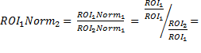

(cbll normalized to brainstem)

It’s a simple ratio. Even after normalizing to the cerebellum applying normalization with ROI2 (aka brainstem) yields the same result as if you had originally used ROI2.

# Mean Cortical PiB SUVR

The following variables may be averaged to calculate the partial volume corrected (rsf) mean cortical PiB SUVR (fSUVR_rsf_TOT_CORTMEAN):

PIB_fSUVR_rsf_TOTFS_PREFRN

PIB_fSUVR_rsf_TOTFS_TMP

PIB_fSUVR_rsf_TOTFS_GYREC

PIB_fSUVR_rsf_TOT_CTX_PRECUNEUS

***Binding Potentials (BP) should never be normalized***

To calculate mean cortical binding potentials (fBP_TOT_CORTMEAN), average the following four variables:

fBP_TOTFS_PREFRN

fBP_TOTFS_GYREC

fBP_TOTFS_TMP

fBP_TOT_CTX_PRECUNEUS

# PET Variable Nomenclature

Our data naming convention provides a standard for listing the region and the processing method. Left and right brain structures use L and R. When left and right are averaged together the suffix includes the designation TOT. Six prefixes are used:

|  |  |  |
| --- | --- | --- |
| **Data Type** | **Definition** | **Example Name** |
| mBP_ | *manually calculated Binding Potential* | mBP_TOT_PRECUNEUS |
| fBP_ | *FreeSurfer calculated Binding Potential* | fBP_TOT_ACCUMBENS |
| mSUVR_ | *manually calculated SUVR* | mSUVR_TOT_PRECUNEUS |
| fBP_rsf_ | *FreeSurfer calculated, partial volume corrected Binding Potential* | fBP_rsf_TOT_ACCUMBENS |
| fSUVR_ | *FreeSurfer calculated SUVR* | fSUVR_TOT_ACCUMBENS |
| fSUVR_rsf_ | *FreeSurfer calculated, partial volume corrected SUVR,* the gold standard | fSUVR_rsf_TOT_ACCUMBENS |

|  |  |  |
| --- | --- | --- |
| **Tracer** | **Definition** | **Example Name** |
| FDG | *[18F]-Fluodeoxyglucose* | FDG_mSUVR_TOT_ACCUMBENS |
| PiB | *[11C]-Pittsburg Compound B* | PiB_fBP_TOT_ACCUMBENS |

**The prefixes (tracer+processed_outcome) are applied to the SAS correlate suffix to create a descriptive SAS compliant name.**

* **PiB_mBP_TOT_CTX_ROSANTCNG** is the [11C]PiB BP calculated using the average of the **hand-drawn** right and left rostral anterior cingulate.
* **PiB_ fSUVR_rsf_TOT_CTX_PRECUNEUS** is the [11C] PiB partial volume corrected SUVR of the gray matter in both the right and left FreeSurfer precuneus.
* **FDG_fSUVR_rsf_TOT_WM_PRECUNEUS** is the [18F] FDG partial volume corrected SUVR of the white matter calculated using the average activity in both the right and left FreeSurfer precuneus.
* **FDG_fBP_TOT_CORTMEAN** is the [18F] FDG average BP of the four MCBP cortical structures using FreeSurfer regions (TOTFS_PREFRN, TOTFS_TMP, TOTFS_GYREC, TOT_CTX_PRECUNEUS).

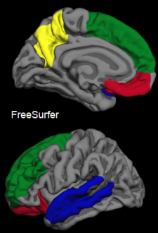

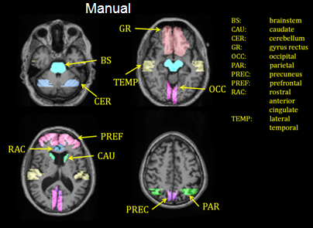

*Figure 6: FreeSurfer Regions Figure 7: Expert Manual Regions*

# PET Processing Variables & Biostatistics Correlates

|  |  |
| --- | --- |
| **Structure Name** | **Biostat Standardizations** |
| Accumbens_area | TOT_ACCUMBENS |
| Amygdala | TOT_AMYGDALA |
| Brain_Stem | TOT_BRAINSTEM |
| Caudate | TOT_CAUD |
| CC_Anterior | CRPCLM_ANT |
| CC_Central | CRPCLM_CNTRL |
| CC_Mid_Anterior | CRPCLM_MID_ANT |
| CC_Mid_Posterior | CRPCLM_MID_POST |
| CC_Posterior | CRPCLM_POST |
| Cerebellum_Cortex | TOT_CBLL_CORTEX |
| Cerebellum_White_Matter | TOT_CBLL_WM |
| choroid_plexus | TOT_CHORPLEX |
| ctx_bankssts | TOT_CTX_SSTSBANK |
| ctx_caudalanteriorcingulate | TOT_CTX_CAUDANTCNG |
| ctx_caudalmiddlefrontal | TOT_CTX_CAUDMIDFRN |
| ctx_corpuscallosum | TOT_CTX_CRPCLM |
| ctx_cuneus | TOT_CTX_CUNEUS |
| ctx_entorhinal | TOT_CTX_ENTORHINAL |
| ctx_frontalpole | TOT_CTX_FRNPOLE |
| ctx_fusiform | TOT_CTX_FUSIFORM |
| ctx_inferiorparietal | TOT_CTX_INFERPRTL |
| ctx_inferiortemporal | TOT_CTX_INFERTMP |
| ctx_insula | TOT_CTX_INSULA |
| ctx_isthmuscingulate | TOT_CTX_ISTHMUSCNG |
| ctx_lateraloccipital | TOT_CTX_LATOCC |
| ctx_lateralorbitofrontal | TOT_CTX_LATORBFRN |
| ctx_lh_bankssts | L_CTX_SSTSBANK |
| ctx_lh_caudalanteriorcingulate | L_CTX_CAUDANTCNG |
| ctx_lh_caudalmiddlefrontal | L_CTX_CAUDMIDFRN |
| ctx_lh_corpuscallosum | L_CTX_CRPCLM |
| ctx_lh_cuneus | L_CTX_CUNEUS |
| ctx_lh_entorhinal | L_CTX_ENTORHINAL |
| ctx_lh_frontalpole | L_CTX_FRNPOLE |
| ctx_lh_fusiform | L_CTX_FUSIFORM |
| ctx_lh_inferiorparietal | L_CTX_INFRPRTL |
| ctx_lh_inferiortemporal | L_CTX_INFRTMP |
| ctx_lh_insula | L_CTX_INSULA |
| ctx_lh_isthmuscingulate | L_CTX_ISTHMUSCNG |
| ctx_lh_lateraloccipital | L_CTX_LATOCC |
| ctx_lh_lateralorbitofrontal | L_CTX_LATORBFRN |
| ctx_lh_lingual | L_CTX_LINGUAL |
| ctx_lh_medialorbitofrontal | L_CTX_MEDORBFRN |
| ctx_lh_middletemporal | L_CTX_MIDTMP |
| ctx_lh_paracentral | L_CTX_PARACNTRL |
| ctx_lh_parahippocampal | L_CTX_PARAHPCMPL |
| ctx_lh_parsopercularis | L_CTX_PARSOPRCLRS |
| ctx_lh_parsorbitalis | L_CTX_PARSORBLS |
| ctx_lh_parstriangularis | L_CTX_PARSTRNGLRS |
| ctx_lh_pericalcarine | L_CTX_PERICLCRN |
| ctx_lh_postcentral | L_CTX_POSTCNTRL |
| ctx_lh_posteriorcingulate | L_CTX_POSTCNG |
| ctx_lh_precentral | L_CTX_PRECNTRL |
| ctx_lh_precuneus | L_CTX_PRECUNEUS |
| ctx_lh_rostralanteriorcingulate | L_CTX_ROSANTCNG |
| ctx_lh_rostralmiddlefrontal | L_CTX_ROSMIDFRN |
| ctx_lh_superiorfrontal | L_CTX_SUPERFRN |
| ctx_lh_superiorparietal | L_CTX_SUPERPRTL |
| ctx_lh_superiortemporal | L_CTX_SUPERTMP |
| ctx_lh_supramarginal | L_CTX_SUPRAMRGNL |
| ctx_lh_temporalpole | L_CTX_TMPPOLE |
| ctx_lh_transversetemporal | L_CTX_TRANSTMP |
| ctx_lingual | TOT_CTX_LINGUAL |
| ctx_medialorbitofrontal | TOT_CTX_MEDORBFRN |
| ctx_middletemporal | TOT_CTX_MIDTMP |
| ctx_paracentral | TOT_CTX_PARACNTRL |
| ctx_parahippocampal | TOT_CTX_PARAHPCMPL |
| ctx_parsopercularis | TOT_CTX_PARSOPCLRS |
| ctx_parsorbitalis | TOT_CTX_PARSORBLS |
| ctx_parstriangularis | TOT_CTX_PARSTRNGLS |
| ctx_pericalcarine | TOT_CTX_PERICLCRN |
| ctx_postcentral | TOT_CTX_POSTCNTRL |
| ctx_posteriorcingulate | TOT_CTX_POSTCNG |
| ctx_precentral | TOT_CTX_PRECNTRL |
| ctx_rh_bankssts | R_CTX_SSTSBANK |
| ctx_rh_caudalanteriorcingulate | R_CTX_CAUDANTCNG |
| ctx_rh_caudalmiddlefrontal | R_CTX_CAUDMIDFRN |
| ctx_rh_corpuscallosum | R_CTX_CRPCLM |
| ctx_rh_cuneus | R_CTX_CUNEUS |
| ctx_rh_entorhinal | R_CTX_ENTORHINAL |
| ctx_rh_frontalpole | R_CTX_FRNPOLE |
| ctx_rh_fusiform | R_CTX_FUSIFORM |
| ctx_rh_inferiorparietal | R_CTX_INFPRTL |
| ctx_rh_inferiortemporal | R_CTX_INFTMP |
| ctx_rh_insula | R_CTX_INSULA |
| ctx_rh_isthmuscingulate | R_CTX_ISTHMUSCNG |
| ctx_rh_lateraloccipital | R_CTX_LATOCC |
| ctx_rh_lateralorbitofrontal | R_CTX_LATORBFRN |
| ctx_rh_lingual | R_CTX_LINGUAL |
| ctx_rh_medialorbitofrontal | R_CTX_MEDORBFRN |
| ctx_rh_middletemporal | R_CTX_MIDTMP |
| ctx_rh_paracentral | R_CTX_PARACNTRL |
| ctx_rh_parahippocampal | R_CTX_PARAHPCMPL |
| ctx_rh_parsopercularis | R_CTX_PARSOPRCLRS |
| ctx_rh_parsorbitalis | R_CTX_PARSORBLS |
| ctx_rh_parstriangularis | R_CTX_PARSTRNGLRS |
| ctx_rh_pericalcarine | R_CTX_PERICLCRN |
| ctx_rh_postcentral | R_CTX_POSTCNTRL |
| ctx_rh_posteriorcingulate | R_CTX_POSTCNG |
| ctx_rh_precentral | R_CTX_PRECNTRL |
| ctx_rh_precuneus | R_CTX_PRECUNEUS |
| ctx_rh_rostralanteriorcingulate | R_CTX_ROSANTCNG |
| ctx_rh_rostralmiddlefrontal | R_CTX_ROSMIDFRN |
| ctx_rh_superiorfrontal | R_CTX_SUPERFRN |
| ctx_rh_superiorparietal | R_CTX_SUPERPRTL |
| ctx_rh_superiortemporal | R_CTX_SUPERTMP |
| ctx_rh_supramarginal | R_CTX_SUPRAMRGNL |
| ctx_rh_temporalpole | R_CTX_TMPPOLE |
| ctx_rh_transversetemporal | R_CTX_TRANSTMP |
| ctx_rostralanteriorcingulate | TOT_CTX_ROSANTCNG |
| ctx_rostralmiddlefrontal | TOT_CTX_ROSMIDFRN |
| ctx_superiorfrontal | TOT_CTX_SUPERFRN |
| ctx_superiorparietal | TOT_CTX_SUPERPRTL |
| ctx_superiortemporal | TOT_CTX_SUPERTMP |
| ctx_supramarginal | TOT_CTX_SUPRAMRGNL |
| ctx_temporalpole | TOT_CTX_TMPPOLE |
| ctx_transversetemporal | TOT_CTX_TRANSTMP |
| Hippocampus | TOT_HIPPOCAMPUS |
| Left_Accumbens_area | L_ACCUMBENS |
| Left_Amygdala | L_AMYGDALA |
| Left_Caudate | L_CAUD |
| Left_Cerebellum_Cortex | L_CTX_CBLL |
| Left_Cerebellum_White_Matter | L_WM_CBLL |
| Left_choroid_plexus | L_CHORPLEX |
| Left_Hippocampus | L_HIPPOCAMPUS |
| Left_Pallidum | L_PALLIDUM |
| Left_Putamen | L_PUTAMEN |
| Left_Substancia_Nigra | L_SUBSTNCA_NGRA |
| Left_Thalamus_Proper | L_THALAMUS |
| Left_UnsegmentedWhiteMatter | L_WM_UNSEGMENTED |
| Left_VentralDC | L_VENTRALDC |
| OCC_FS | TOTFS_OCC |
| Pallidum | TOT_PALLIDUM |
| Putamen | TOT_PUTAMEN |
| Right_Accumbens_area | R_ACCUMBENS |
| Right_Amygdala | R_AMYGDALA |
| Right_Caudate | R_CAUD |
| Right_Cerebellum_Cortex | R_CTX_CBLL |
| Right_Cerebellum_White_Matter | R_WM_CBLL |
| Right_choroid_plexus | R_CHORPLEX |
| Right_Hippocampus | R_HIPPOCAMPUS |
| Right_Pallidum | R_PALLIDUM |
| Right_Putamen | R_PUTAMEN |
| Right_Substancia_Nigra | R_SUBSTNCA_NGRA |
| Right_Thalamus_Proper | R_THALAMUS |
| Right_UnsegmentedWhiteMatter | R_WM_UNSEGMENTED |
| Right_VentralDC | R_VENTRALDC |
| Substancia_Nigra | TOT_SUBSTNCA_NGRA |
| Thalamus_Proper | TOT_THALAMUS_PRPR |
| UnsegmentedWhiteMatter | TOT_WM_UNSEGMENTED |
| VentralDC | TOT_VENTRALDC |
| wm_bankssts | TOT_WM_SSTSBNK |
| wm_caudalanteriorcingulate | TOT_WM_CAUDANTCNG |
| wm_caudalmiddlefrontal | TOT_WM_CAUDMIDFRN |
| wm_corpuscallosum | TOT_WM_CRPCLM |
| wm_cuneus | TOT_WM_CUNEUS |
| wm_entorhinal | TOT_WM_ENTORHINAL |
| wm_frontalpole | TOT_WM_FRNPOLE |
| wm_fusiform | TOT_WM_FUSIFORM |
| wm_inferiorparietal | TOT_WM_INFERPRTL |
| wm_inferiortemporal | TOT_WM_INFERTMP |
| wm_insula | TOT_WM_INSULA |
| wm_isthmuscingulate | TOT_WM_ISTHMUSCNG |
| wm_lateraloccipital | TOT_WM_LATOCC |
| wm_lateralorbitofrontal | TOT_WM_LATORBFRN |
| wm_lh_bankssts | L_WM_SSTSBANK |
| wm_lh_caudalanteriorcingulate | L_WM_CAUDANTCNG |
| wm_lh_caudalmiddlefrontal | L_WM_CAUDMIDFRN |
| wm_lh_corpuscallosum | L_WM_CRPCLM |
| wm_lh_cuneus | L_WM_CUNEUS |
| wm_lh_entorhinal | L_WM_ENTORHINAL |
| wm_lh_frontalpole | L_WM_FRNPOLE |
| wm_lh_fusiform | L_WM_FUSIFORM |
| wm_lh_inferiorparietal | L_WM_INFPRTL |
| wm_lh_inferiortemporal | L_WM_INFTMP |
| wm_lh_insula | L_WM_INSULA |
| wm_lh_isthmuscingulate | L_WM_ISTHMUSCNG |
| wm_lh_lateraloccipital | L_WM_LATOCC |
| wm_lh_lateralorbitofrontal | L_WM_LATORBFRN |
| wm_lh_lingual | L_WM_LINGUAL |
| wm_lh_medialorbitofrontal | L_WM_MEDORBFRN |
| wm_lh_middletemporal | L_WM_MIDTMP |
| wm_lh_paracentral | L_WM_PARACNTRL |
| wm_lh_parahippocampal | L_WM_PARAHPCMPL |
| wm_lh_parsopercularis | L_WM_PARSOPRCLRS |
| wm_lh_parsorbitalis | L_WM_PARSORBLS |
| wm_lh_parstriangularis | L_WM_PARSTRIANGLRS |
| wm_lh_pericalcarine | L_WM_PERICLCRN |
| wm_lh_postcentral | L_WM_POSTCNTRL |
| wm_lh_posteriorcingulate | L_WM_POSTCNG |
| wm_lh_precentral | L_WM_PRECNTRL |
| wm_lh_precuneus | L_WM_PRECUNEUS |
| wm_lh_rostralanteriorcingulate | L_WM_ROSANTCNG |
| wm_lh_rostralmiddlefrontal | L_WM_ROSMIDFRN |
| wm_lh_superiorfrontal | L_WM_SUPERFRN |
| wm_lh_superiorparietal | L_WM_SUPERPRTL |
| wm_lh_superiortemporal | L_WM_SUPERTMP |
| wm_lh_supramarginal | L_WM_SUPRAMRGNL |
| wm_lh_temporalpole | L_WM_TMPPOLE |
| wm_lh_transversetemporal | L_WM_TRANSTMP |
| wm_lingual | TOT_WM_LINGUAL |
| wm_medialorbitofrontal | TOT_WM_MEDORBFRN |
| wm_middletemporal | TOT_WM_MIDTMP |
| wm_paracentral | TOT_WM_PARACNTRL |
| wm_parahippocampal | TOT_WM_PARAHPCMPL |
| wm_parsopercularis | TOT_WM_PARSOPRCLRS |
| wm_parsorbitalis | TOT_WM_PARSORBLS |
| wm_parstriangularis | TOT_WM_PARSTRNGLRS |
| wm_pericalcarine | TOT_WM_PERICLCRN |
| wm_postcentral | TOT_WM_POSTCNTRL |
| wm_posteriorcingulate | TOT_WM_POSTCNG |
| wm_precentral | TOT_WM_PRECNTRL |
| wm_precuneus | TOT_WM_PRECUNEUS |
| wm_rh_bankssts | R_WM_SSTSBANK |
| wm_rh_caudalanteriorcingulate | R_WM_CAUDANTCNG |
| wm_rh_caudalmiddlefrontal | R_WM_CAUDMIDFRN |
| wm_rh_corpuscallosum | R_WM_CRPCLM |
| wm_rh_cuneus | R_WM_CUNEUS |
| wm_rh_entorhinal | R_WM_ENTORHINAL |
| wm_rh_frontalpole | R_WM_FRNPOLE |
| wm_rh_fusiform | R_WM_FUSIFORM |
| wm_rh_inferiorparietal | R_WM_INFERIORPRTL |
| wm_rh_inferiortemporal | R_WM_INFERIORTMP |
| wm_rh_insula | R_WM_INSULA |
| wm_rh_isthmuscingulate | R_WM_ISTHMUSCNG |
| wm_rh_lateraloccipital | R_WM_LATOCC |
| wm_rh_lateralorbitofrontal | R_WM_LATORBFRN |
| wm_rh_lingual | R_WM_LINGUAL |
| wm_rh_medialorbitofrontal | R_WM_MEDORBFRN |
| wm_rh_middletemporal | R_WM_MIDTMP |
| wm_rh_paracentral | R_WM_PARACNTRL |
| wm_rh_parahippocampal | R_WM_PARAHPCMPL |
| wm_rh_parsopercularis | R_WM_PARSOPRCLRS |
| wm_rh_parsorbitalis | R_WM_PARSORBLS |
| wm_rh_parstriangularis | R_WM_PARSTRNGLRS |
| wm_rh_pericalcarine | R_WM_PERICLCRN |
| wm_rh_postcentral | R_WM_POSTCNTRL |
| wm_rh_posteriorcingulate | R_WM_POSTCNG |
| wm_rh_precentral | R_WM_PRECNTRL |
| wm_rh_precuneus | R_WM_PRECUNEUS |
| wm_rh_rostralanteriorcingulate | R_WM_ROSANTCNG |
| wm_rh_rostralmiddlefrontal | R_WM_ROSMIDFRN |
| wm_rh_superiorfrontal | R_WM_SUPERFRN |
| wm_rh_superiorparietal | R_WM_SUPERPRTL |
| wm_rh_superiortemporal | R_WM_SUPERTMP |
| wm_rh_supramarginal | R_WM_SUPRAMRGNL |
| wm_rh_temporalpole | R_WM_TMPPOLE |
| wm_rh_transversetemporal | R_WM_TRANSTMP |
| wm_rostralanteriorcingulate | TOT_WM_ROSANTCNG |
| wm_rostralmiddlefrontal | TOT_WM_ROSMIDFRN |
| wm_superiorfrontal | TOT_WM_SUPERFRN |
| wm_superiorparietal | TOT_WM_SUPERPRTL |
| wm_superiortemporal | TOT_WM_SUPERTMP |
| wm_supramarginal | TOT_WM_SUPRAMRGNL |
| wm_temporalpole | TOT_WM_TMPPOLE |
| wm_transversetemporal | TOT_WM_TRANSTMP |
| ctx_precuneus | TOT_CTX_PRECUNEUS |
| GR_FS | TOTFS_GYREC |
| PREF_FS | TOTFS_PREFRN |
| TEMP_FS | TOTFS_TMP |
| MCBP | TOT_CORTMEAN |

# Manual Region PET Processing Biostatistics Variables

|  |  |  |
| --- | --- | --- |
| PiB_mBP_TOT_BRAINSTEM | PiB_mSUVR_TOT_BRAINSTEM | FDG_mSUVR_TOT_BRAINSTEM |
| PiB_mBP_TOT_OCC | PiB_mSUVR_TOT_OCC | FDG_mSUVR_TOT_OCC |
| PiB_mBP_TOT_PREFRN | PiB_mSUVR_TOT_PREFRN | FDG_mSUVR_TOT_PREFRN |
| PiB_mBP_TOT_TMP | PiB_mSUVR_TOT_TMP | FDG_mSUVR_TOT_TMP |
| PiB_mBP_TOT_PRECUNEUS | PiB_mSUVR_TOT_PRECUNEUS | FDG_mSUVR_TOT_PRECUNEUS |
| PiB_mBP_TOT_CAUD | PiB_mSUVR_TOT_CAUD | FDG_mSUVR_TOT_CAUD |
| PiB_mBP_TOT_GYREC | PiB_mSUVR_TOT_GYREC | FDG_mSUVR_TOT_GYREC |
| PiB_mBP_TOT_PRTL | PiB_mSUVR_TOT_PRTL | FDG_mSUVR_TOT_PRTL |
| PiB_mBP_TOT_ROSANTCNG | PiB_mSUVR_TOT_ROSANTCNG | FDG_mSUVR_TOT_ROSANTCNG |
| PiB_mBP_TOT_CORTMEAN | PiB_mSUVR_TOT_CORTMEAN | FDG_mSUVR_TOT_CORTMEAN |

# 

# For ANNE

## SUVR and Binding Potential Cutoff Values

The cutoff for non-RSF corrected data is still 0.18. When using partial volume corrected data the equivalent cutoff for MC_SUVR_RSF is **1.42** when compared to the original Mean Cortical Binding Potential (MCBP) of 0.18. This 1.42 value generates identical classifications of PiB positivity based on a study population of 77 subjects (not published).

Using on the 77 subjects studied in the PLOS One paper (Su, 2013), here are the cutoff values for some common measurements that would generate best matched PiB positivity classification as using manual MCBP=0.18:

Cerebellar Reference:

MCBP(FS):                         0.18

MCBPRSF:                          0.37

MCBPPVC2C:                    0.37

MCSUVR:                            1.31

MCSUVRRSF:                    1.42

MCSUVRPVC2C:              1.52

Brainstem Reference:

MCSUVRBS:                       0.79

MCSUVRBSRSF:               0.72

MCSUVRBSPVC2C:         0.90

# Processing References

Eisenstein SA et al. (2012) Characterization of extrastriatal D2 in vivo specific binding of [18F](N-methyl)benperidol using PET. Synapse.

Fischl B. FreeSurfer. *NeuroImage* 2012; 62(2):774-781. PMCID: PMC: 222857

Frouin V, Comtat C, Reilhac A, Gre ́goire MC. Correction of Partial-Volume Effect for PET Striatal Imaging: Fast Implementation and Study of Robustness. J Nucl Med 2002; 43:1715–1726

Jack CR et al. (2008) The Alzheimer's disease neuroimaging initiative (ADNI): MRI methods. J Magn Reson Imaging 27:685–691.

Jack CR Jr et al. (2010) Update on the Magnetic Resonance Imaging core of the Alzheimers Disease Neuroimaging Initiative. Alzheimer's & Dementia 6:212–220.

Marcus, DS, Archie, KA, Olsen, T, Ramaratnam, M. The open source neuroimaging research enterprise. *J. Digital Imaging* 2007; 20:130-138.

McCormick LM, Ziebell S, Nopoulos P, Cassell M, Andreasen NC, Brumm M. Anterior Cingulate Cortex: An MRI-based parcellation method. *NeuroImage* 2006; 32:1167-1175.

Mintun MA, LaRossa GN, Sheline YI, Dence CS, Lee SY, Mach RH, Klunk WE, Mathis CA, DeKosky ST, Morris JC. [11C]PIB in a nondemented population: Potential antecedent marker of Alzheimer disease. *Neurology* 2006; 67;446-452

Morris, JC, Roe, CM, Xiong, C, Fagan, AM, Goate, AM, Holtzman, DM, Mintun, MA. APOE predicts amyloid-beta but not tau Alzheimer pathology in cognitively normal aging. *Ann Neurol* 2010; 67:122-131.

Robb, R.A., Hanson, D.P., Karwoski, R.A., Larson, A.G., Workman, E.L., Stacy, M.C. Analyze: a comprehensive, operator-interactive software package for multidimensional medical image display and analysis. *Comput Med Imaging Graph* 1989; 13:433-454.

Rousset O, Ma Y, Evans A. Correction for partial volume effects in PET: principle and validation. *J Nucl Med* 1998; 39:904–11.

Rousset O, Zaidi H. Correction of partial volume effects in emission tomography. In: Zaidi H, ed- itor. Quantitative analysis of nuclear medicine images. New York: Springer; 2006. p. 236–271.

Rowland DJ, Garbow JR, Laforest R, Snyder AZ. 2005 Registration of [18F]FDG microPET and small-animal MRI. *Nucl Med Biol* 2005; 32:567-72

Talairach J, Tournoux P. Co-planar Stereotaxic Atlas of the Human Brain: 3-D Proportional System: An Approach to Cerebral Imaging. Stuttgart, Germany: Thieme Medical Publishers; 1988.