There are several criterion to evaluate a machine learning regression model: training error, testing error, and somethings validation error. We want to get low training error because it means models are trained to fit the training data. However, it is difficult to tell how high the training accuracy should be. Some models can be trained to get 100% training accuracy, but the objective of training machine learning models is to use history o predict future unseen data.

Example: k nearest neighbors model

Setting k=1 can guarantee 0 training error, but when the model is used to predict unseen data, only one history data is useful.

In order to observe which k is the best for unseen data, we need validation set to verify its generalization ability.

The following pictures are learning curve of kNN models at different k. The upper image shows average validation error of 10 bins, the bottom average training error.

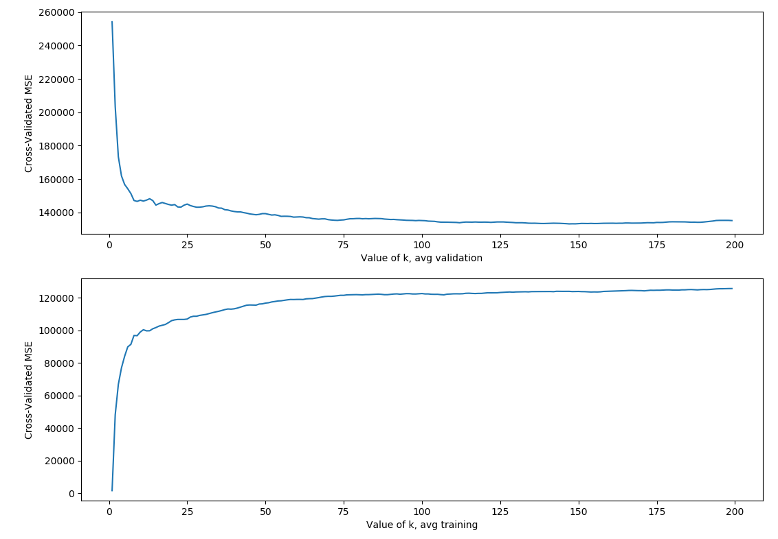
The picture shows that validation error decreases with k grows, and the best k is 147, when MSE=123686.90669573046. However, when k is set to a large value, training error also becomes large. We observe that validation error is almost stable when k is >75, so we can set k to 75 to have reasonable good performance while lowering calculation cost.

DT:
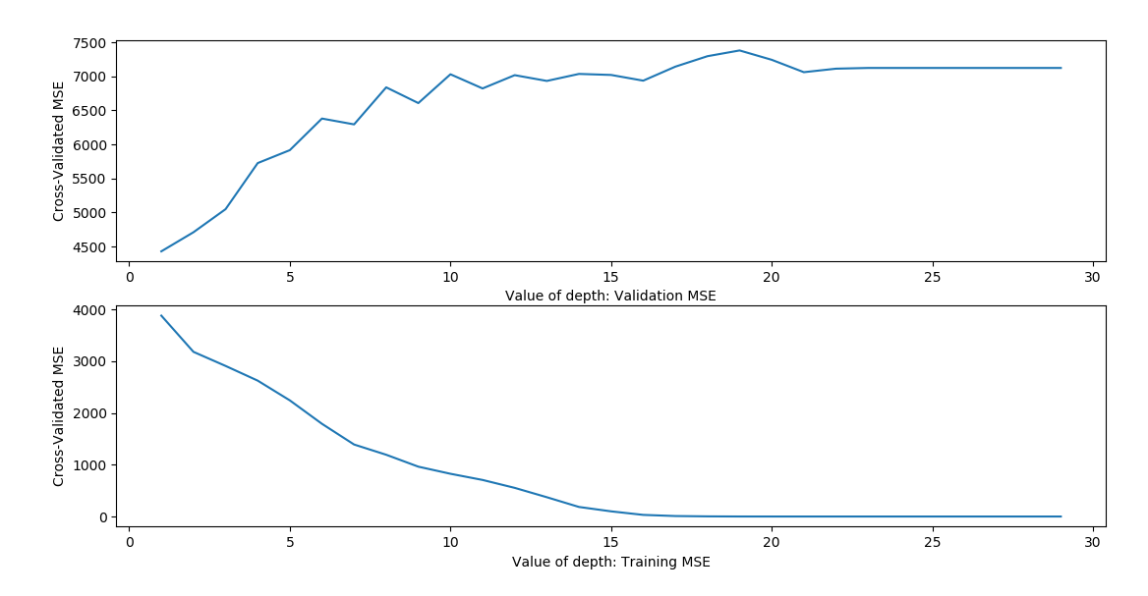

The minimum is when depth=1, which says it will only predict one value.

