##### 数字逻辑（双语）2020年下学期第一次平时测试题

##### 1. Choose the best answer from the four choices. (20points)

**(1) Which one is the negative logic? ( )**

**A.H=1,L=1 B.H=1,L=0 C.H=0,L=1 D.H=0,L=0**

**(2)In a given digital waveform, the period is four times the pulse width, then the duty cycle is ( ).**

**A.20% B.50% C.25% D.100%**

**(3)In the 2’s complement form,the binary number 11010110 is equal to the decimal number ( ).**

**A.-41 B.-42 C.-86 D.+214**

**(4) (5B7A)16，whose the third character B has a bit weight of ( ).**

**A.(2816)10  B. (256)10 C. (4)10  D. (100)10**

**(5) Which method can be used in digital systems to convert subtraction operations to addition operations.( )**

**A. Original code B. ASCII code C.Complement code D. BCD code**

**(6)As shown in the figure,which logical relationship is reflected.( )**

**A.AND B.XOR C.OR D.XNOR**

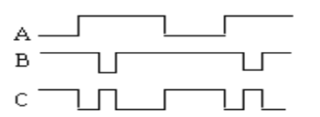

**(7)The same is”1”,the difference is “0”,what is its logic relationship?( )**

**A.AND B.OR C.XOR D.XNOR**

**(8) Which is correct about 8421BCD code operation. ()**

**A.00111000 + 10000011 = 10111011 B. 11001001 + 00000001 = 11001010**

**C. 01001000 + 00100100 = 10000010 D. 01010011 + 00010100 = 01100111**

**(9) Which is the equivalent form of the logic diagram. ( )**

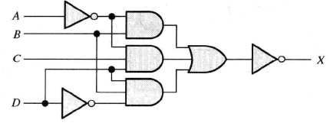

**A. B.**

**C. D.**

**(10) F = f(A,B) = m0+m3, select the right answer for ( )**

**A. B. C. D. All above**

##### 2. Fill in the blanks with the correct answer. (20 points)

**(1) Thetime interval between the amplitude of 10% and 90% at the front of the pulse is_____________; thetime interval between the amplitude of 90% and 10% at the behind of the pulse is_____________.**

**(2) (46.25)10=(__)2=(__)16= ()BCD.**

**(3) Apply DeMorgan’s theorems to the expression $\overline{A.\overline{B}+B\overline{.A}}$.The answer is _____ ___,which belongs to ______ gate.**

**(4) The output of an exclusive-OR is ___ if the inputs are opposite.**

**(5)The universal gates are the gates of _______ and ______.**

**3.Fill the T or F.(T represents true,F represents false )(10points)**

**(1)A anolog had a continous value.( )**

**(2) Parity can detect two errors in a set of data.( )**

**(3)AND gate has only two inputs.( )**

**(4)BCD represents binary-to-decimal decoder.( )**

**(5) If the arbitrary input of a OR gate is 1, then its output is 1.( )**

##### 4.Calculation and Analysis (40 points)

**(1)Please convert (125.125)10 to binary, octal , hexadecimal, and BCD code.(8 points)**

**(2)Please answer the function of the following waveform. Write the expression X and draw the diagram.(2+2)**

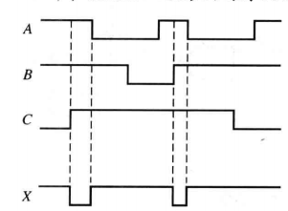

**(3) As shown in the following logic diagram, write the expression P and the standard and or expression, then list the corresponding truth table of expression Y. (2+(2+3)+3=10points)**

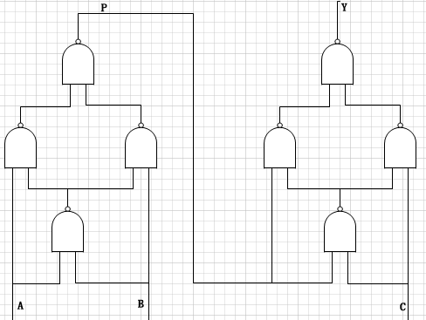

**(4)Write down the simplest and or expression of each karnaugh maps.(3+3)**

|  |  |  |  |  |
| --- | --- | --- | --- | --- |
| **BC**  **A** | **00** | **01** | **11** | **10** |
| **0** | 1 | 0 | 0 | 1 |
| **1** | 1 | 0 | 1 | 1 |

|  |  |  |  |  |
| --- | --- | --- | --- | --- |
| **CD**  **AB** | **00** | **01** | **11** | **10** |
| **00** | 1 | 1 | 1 | 1 |
| **01** | 1 | 1 | 0 | 0 |
| **11** | 0 | 0 | 0 | 0 |
| **10** | 1 | 0 | 1 | 1 |

**(5) Simplify the following expression using karnaugh maps .(6points)**

**F(A,B,C,D)=Σm(0,1,2,3,6,8)+ Σd(10,11,12,13,14,15)**