##### 数字逻辑（双语）第二次平时测试题（2020年下学期）

##### 1. Choose the best answer from the four choices. (20 points)

1) Compare two the binary numbers A=A0A1 and B=B0B1, output F=1 while A>B, then the expression of F is ( )

（A） （B）



（C） （D）



2) With the inputs A=1, B=0, Cin=1, the outputs of the Full Adder is ( ).

(A) Cout=0, Sum=0 (B) Cout=1, Sum=0;

(C) Cout=0, Sum=1 (D) Cout=1, Sum=1;

3) The inputs of 74HC85 magnitude comparator are A = 1000 and B = 1010, the outputs are ( A )

(A) A > B = 0, A < B = 1, A = B = 0 (B) A > B = 0, A < B = 0, A = B = 1

(C) A > B = 0, A < B = 0, A = B = 0 (D) A > B = 0, A < B = 1, A = B = 1

4) If a 1-of-16 decoder with active-LOW outputs exhibits a LOW on the decimal 12 output, what are the inputs? ( C )

(A) A3A2A1A0 = 1010 (B) A3A2A1A0 = 1110

(C) A3A2A1A0 = 1100 (D) A3A2A1A0 = 0100

5） If an octal-to-binary priority encoder has its 0, 2, 5, and 6 inputs at the active level, the active- HIGH binary output is ( ).

(A) 110 (B) 000 (C) 101 (D) 010

**2. Design a logic circuit to implement the Gray-to-Binary code conversion specified in the following table.** **(20 points)**

|  |  |
| --- | --- |
| Gray Code | Binary Code |
| 000 | 000 |
| 001 | 001 |
| 011 | 010 |
| 010 | 011 |
| 110 | 100 |
| 111 | 101 |
| 101 | 110 |
| 100 | 111 |

**3. Implement the logic expression F = f( a,b,c,d ) = ( 0,3,4,5,7,9,13,15 ) using a 8-input data selector.** **(16 points)**

**4. Use one 8-1 multiplexer(74LS151) to implement the following function. (20 points)**

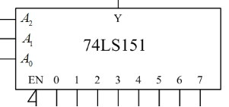

**5. Analyse the logic function of the combinational circuit composed of a dual four-input multiplexer. The diagram is shown in Figure (a), and use the 74LS138 decoder in Figure (b) to implement it again. The requirements are as follows: (24 points)**

1. **Give the truth table, and write the logic eqations.**
2. **Explain the logic fuction.**
3. **Draw the circuit according to Figure (b)**

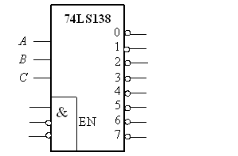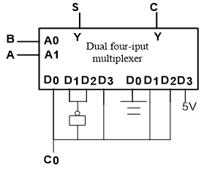

(a) (b)