##### 数字逻辑（双语）第二次测试题（2020年下学期）

##### 1. Choose the best answer from the four choices. (20points)

1) Compare two the binary numbers A=A0A1 and B=B0B1, output F=1 while A>B, then the expression of F is ( )

（A） （B）



（C） （D）



2) With the inputs A=1, B=0, Cin=1, the outputs of the Full Adder is ( ).

(A) Cout=0, Sum=0 (B) Cout=1, Sum=0;

(C) Cout=0, Sum=1 (D) Cout=1, Sum=1;

3) The inputs of 74HC85 magnitude comparator are A = 1000 and B = 1010, the outputs are ( )

(A) A > B = 0, A < B = 1, A = B = 0 (B) A > B = 0, A < B = 0, A = B = 1

(C) A > B = 0, A < B = 0, A = B = 0 (D) A > B = 0, A < B = 1, A = B = 1

4) If a 1-of-16 decoder with active-LOW outputs exhibits a LOW on the decimal 12 output, what are the inputs? ( )

(A) A3A2A1A0 = 1010 (B) A3A2A1A0 = 1110

(C) A3A2A1A0 = 1100 (D) A3A2A1A0 = 0100

5） If an octal-to-binary priority encoder has its 0, 2, 5, and 6 inputs at the active level, the active- HIGH binary output is ( ).

(A) 110 (B) 000 (C) 101 (D) 010

**2. Design a logic circuit to implement the Gray-to-Binary code conversion specified in the following table.** (20 points)

|  |  |
| --- | --- |
| Gray Code | Binary Code |
| 000 | 000 |
| 001 | 001 |
| 011 | 010 |
| 010 | 011 |
| 110 | 100 |
| 111 | 101 |
| 101 | 110 |
| 100 | 111 |

解：这是一个 3 输入 3 输出的问题，设格雷码由高到低各位为 a，b，c，而对应二进制码由高到底各位为 x，y，z。（2 分）

列真值表如下：（4 分）

|  |  |  |  |  |  |
| --- | --- | --- | --- | --- | --- |
| 输入 | | | 输出 | | |
| a | b | c | x | y | z |
| 0 | 0 | 0 | 0 | 0 | 0 |
| 0 | 0 | 1 | 0 | 0 | 1 |
| 0 | 1 | 1 | 0 | 1 | 0 |
| 0 | 1 | 0 | 0 | 1 | 1 |
| 1 | 1 | 0 | 1 | 0 | 0 |
| 1 | 1 | 1 | 1 | 0 | 1 |
| 1 | 0 | 1 | 1 | 1 | 0 |
| 1 | 0 | 0 | 1 | 1 | 1 |

列出方程：（方程和化简，各3 分，共 9 分）

x=abc’+abc+ab’c+ab’c’= ∑m(4，5，6，7) =a

y=a’bc+a’bc’+ab’c+ab’c’ = ∑m(2，3，6，7) =a’b+ab’=ab



z=a’b’c+a’bc’+abc+ab’c’ = ∑m(1，3，5，7) = abc



（图 5分）

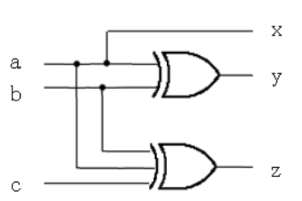

**3. Implement the logic expression F = f( a,b,c,d ) = ( 0,3,4,5,7,9,13,15 ) using a 8-input data selector.** (16 points)

解：用 a、b、c 作为 8-1 多路器选择变量，利用真值表或卡诺图来确定多路器输入 Di 与变量 d 的关系（4 分，或写出多路复用器通用逻辑函数也得1分），得到：

D0= d’，D1= d，D2= 1，D3= d，D4= d，D5= 0，D6= d，D7= d（8 分）

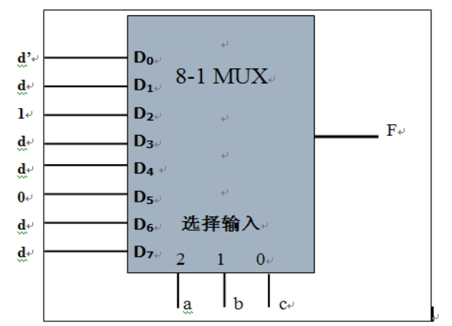

连接图如下：（画图正确得 4 分）

**4. Use one 8-1 multiplexer(74LS151) to implement the following function. (20 points)**

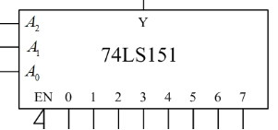

Answer：

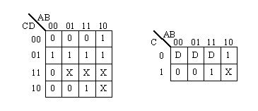

(5 points) （用真值表也可以）

Y= A2’A1’A0’D0+A2’A1’A0D1+A2’A1A0’D2+A2’A1A0D3+A2A1’A0’D4+ A2A1’A0D5+ A2A1A0’D6+ A2A1A0D7 =∑miDi (5 points)

(4 points)

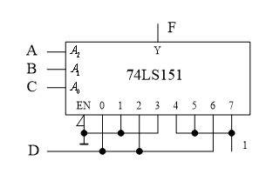

(6 points)



**5. Analyse the logic function of the combinational circuit composed of a dual four-input multiplexer. The diagram is shown in Figure (a), and use the 74LS138 decoder in Figure (b) to implement it again. The requirements are as follows:** (24 points)

1. **Give the truth table, and write the logic eqations.**
2. **Explain the logic fuction.**
3. **Draw the circuit according to Figure (b)**

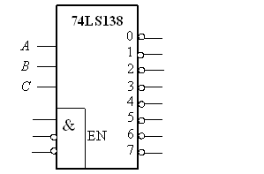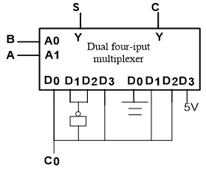

(a) (b)

(1) 真值表和表达式（真值表6分，表达式6分）

|  |  |  |  |
| --- | --- | --- | --- |
| A | B | S | C |
| 0 | 0 |  | 0 |
| 0 | 1 |  |  |
| 1 | 0 |  |  |
| 1 | 1 |  | 1 |

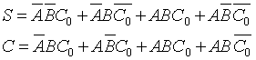

(2) 电路说明：电路实现全加器功能。S为全加器的和，C显示进位。（6分）

(3) 逻辑图（6分）

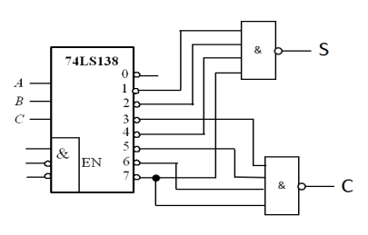

（后面两个与非门改为非或门也可以）