

应用基础实践（一）网络与JAVA
课程设计实验报告

学生姓名 | 王品呈
学 号 | 8208230704
专业班级 | 计科2306班
指导教师 | 刘嫔
学 院 | 计算机学院
完成时间 | 2025/1/17

计算机学院

2025年1月
    - 系统描述。
1.整个考试系统分为
1、题库管理 | 2、自动生成考卷 | 3、用户管理 | 4考试试卷提交
1.1、数据字典增删该查； | 2.1、考题生成规则配置（规则的增删该查） | 3.1、用户增删改查 | 4.1、客观题自动评分
1.2、数据字典类型 增删该查; | 2.2、根据规则生成试卷 | 3.2、用户密码加密 | 4.2、试卷保存
1.3、考题增删改查 | 2.3、按课程随机生成训练题 | 3.3、登录(允许扩展) | 4.3、试卷查询
1.4、考题批量导入 | 2.4、错题库 |  | 4.4、个人考试成绩统计、分析
1.5、考题去重 | 2.5、根据错题库生成训练题 |  | 4.5、班级成绩统计、分析
1.6、查询的时候支持分页功能
2.本小组重新构思了考试系统的功能划分，仿照现实考试流程按照：
用户——>题目——>试卷——>考试——>错题的顺序将整个系统分为5个模块，具体如下图所示：
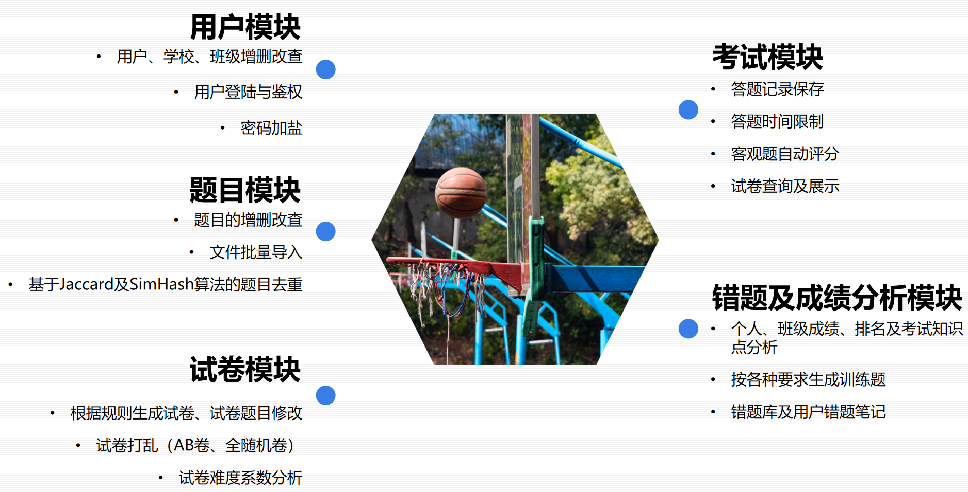
考试功能模块划分
在5个模块中我负责考试模块。主要实现了一下几个功能：
（1）创建一场考试，可以指定考试试卷、设置定时长考试或定时段考试。
（2）创建一场考试会话，记录用户抽到的真实试卷与考试开始时间，实时校验当前是否处在可以提交时间短。
（3）对试卷题目进行自定义更新，并实时计算试卷难度。
（4）基本的试卷、逻辑试卷的增删改查（分页）。
3.数据库架构
为了实现以上功能，本小组精心构思了数据库的组成，最终敲定创建了如图所示的表：
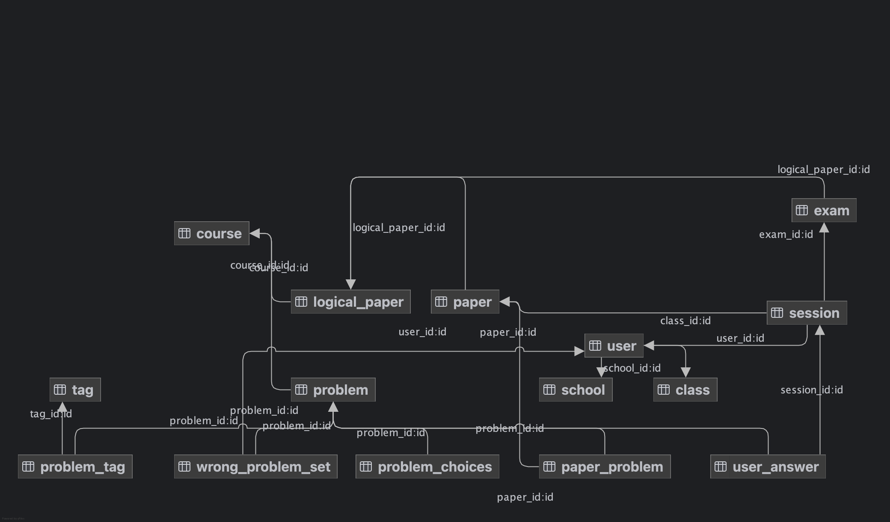
数据库表总览
其中我主要使用的是exam表、session表、user_answer表。
最终我创建了以下几个类：
实体类（Entity）：ExamEntity（考试实体类）、SessionEntity（考试会话实体类）、UserAnswerEntity（学生作答中间表）
服务类（Service）：ExamService、SessionService、UserAnswerService
控制器（Controller）:ExamController、SessionController
Dao层：ExamDAO、SessionDAO、UserAnswerDAO

    - 功能模块结构
在确立功能模块结构之前，我深入思考了考试功能逻辑，对项目功能计划中的考试模块进行了二次抽象。
对于现实生活中的考场、考次，我将其抽象为考试exam，而对于每一个学生在考试时进行作答，我将其抽象为考试会话session。这样做的好处是，可以分别保存不同主体的相关信息，比如，学生的作答开始时间、抽到的真实试卷编号等数据，与个人强相关，适宜存储在session中；而考试允许作答时间、可用试卷集等信息，与考试整体强相关，适宜存储在exam中。
综上，根据我所设计的考试及考试会话模块，学生完成一次考试及自动评分的流程图如下图所示。
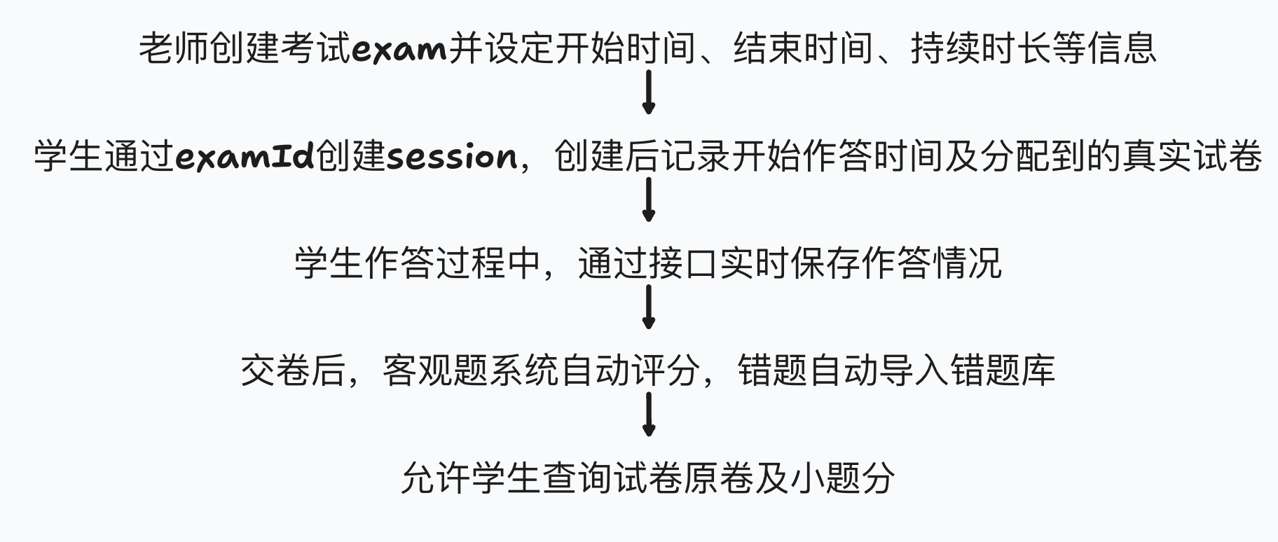
学生考试流程图

1. ExamService（考试服务）
负责考试的基本信息管理，如考试时间、显示成绩、修改考试设置等。
- 功能1：getById(Long id)
  - 通过考试ID获取考试的详细信息。
- 功能2：add(ExamEntity examEntity)
  - 插入新的考试记录。
- 功能3：modifyById(Long id, ExamEntity examEntity)
  - 根据考试ID修改考试信息。
- 功能4：changeStartTime(Long id, LocalDateTime startTime)
  - 修改考试开始时间。
- 功能5：changeEndTime(Long id, LocalDateTime endTime)
  - 修改考试结束时间。
- 功能6：isShowScore(Long id)
  - 判断考试是否立刻显示成绩（0为不显示，1为显示）。

2. SessionService（考试会话服务）
负责考试会话的管理，包括用户的考试状态、成绩、自动评分等。
- 功能1：getById(Long id)
  - 通过考试会话ID获取详细信息。
- 功能2：listAll(Integer curPage, Integer limit)
  - 分页查询所有考试会话记录。
- 功能3：modifyById(Long id, SessionEntity sessionEntity)
  - 根据会话ID修改会话信息。
- 功能4：autoJudge(Long sessionId)
  - 自动批改考试会话，计算总分。
- 功能5：getNScores(Long userId, Long courseId, Long n)
  - 查询用户在指定课程中的前n次考试的成绩。
- 功能6：isTimeValid(Long sessionId)
  - 检查当前时间是否在考试会话的有效时间内。

3. UserAnswerService（答题记录服务）
负责管理用户的答题记录，包括答题内容、得分、批改等。
- 功能1：insert(UserAnswerEntity userAnswerEntity)
  - 插入新的用户答题记录。
- 功能2：update(UserAnswerEntity userAnswerEntity)
  - 更新用户的答题记录。
- 功能3：delete(UserAnswerEntity userAnswerEntity)
  - 删除指定的答题记录。
- 功能4：getScore(Long sessionId, Long problemId)
  - 获取用户在某个考试会话中，针对某道题的得分。
- 功能5：checkAnswer(Long sessionId, Long problemId)
  - 检查用户的答案是否正确。
- 功能6：setAnswer(Long sessionId, Long problemId, String answer)
  - 设置用户的某道题目的答案。

四、核心代码分析

1. ExamServiceImpl（考试服务实现类）
public ExamEntity getById(Long id) {
LambdaQueryWrapper<ExamEntity> query = Wrappers.lambdaQuery();
query.eq(ExamEntity::getId, id);
return baseMapper.selectOne(query);
}
该方法使用 LambdaQueryWrapper 构造查询条件，查询指定ID的考试数据。通过 baseMapper.selectOne(query) 查询数据库中的一条记录。如果记录存在，返回对应的考试实体对象；否则返回 null。
为什么用 LambdaQueryWrapper？
- LambdaQueryWrapper 提供了类型安全的查询方式，能够避免硬编码字符串字段名，提高代码的可维护性和可读性。
public ExamEntity changeStartTime(Long id, LocalDateTime startTime) {
ExamEntity examEntity = getById(id); // 获取考试实体
examEntity.setStartTime(startTime); // 设置新的开始时间
baseMapper.updateById(examEntity); // 更新到数据库
return examEntity; // 返回更新后的考试实体
}
该方法实现了修改考试开始时间的功能。首先根据考试ID获取考试实体，然后修改其开始时间，最后调用 baseMapper.updateById() 将修改后的实体更新到数据库。
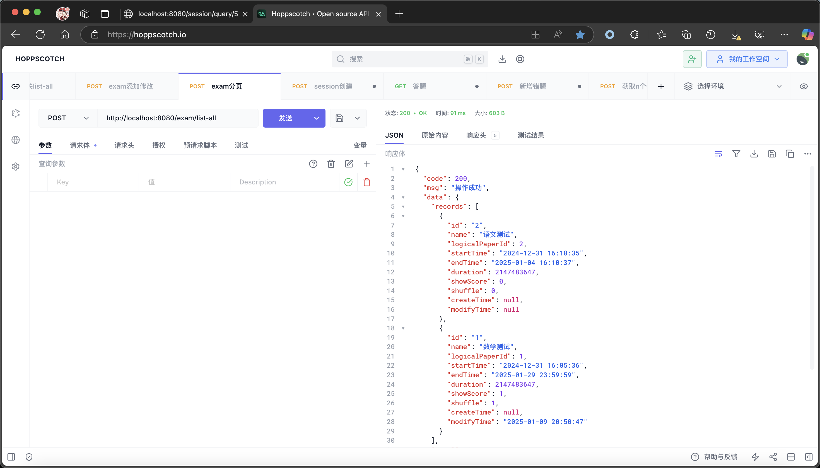

2. SessionServiceImpl（考试会话服务实现类）
public SessionEntity autoJudge(Long sessionId) {
LambdaQueryWrapper<SessionEntity> query = Wrappers.lambdaQuery();
query.eq(SessionEntity::getId, sessionId);
SessionEntity sessionEntity = baseMapper.selectOne(query); // 获取考试会话

Long paperId = sessionEntity.getPaperId(); // 获取试卷ID
List<Long> problemIds = paperProblemService.getProblemIdsByPaperId(paperId); // 获取试卷中的所有题目
Integer score = 0;
for (Long problemId : problemIds) {
Integer point = userAnswerService.getScore(sessionId, problemId); // 获取每道题的得分
score += point; // 累加总分
userAnswerService.setCorrect(sessionId, problemId, point); // 设置答题正确性
}
sessionEntity.setScore(score); // 设置总分
baseMapper.update(sessionEntity, query); // 更新会话总分到数据库
return sessionEntity;
}
该方法实现了自动批改功能。它首先查询考试会话，获取试卷中的所有题目，然后通过调用 UserAnswerService 获取每道题的得分，并累加到总分中。最后将计算得到的总分更新到会话实体中。
自动批改逻辑：
- 通过用户的答题记录，逐题检查答案并给分。
- 如果用户回答错误，将错误记录保存下来，供后续查看。
- 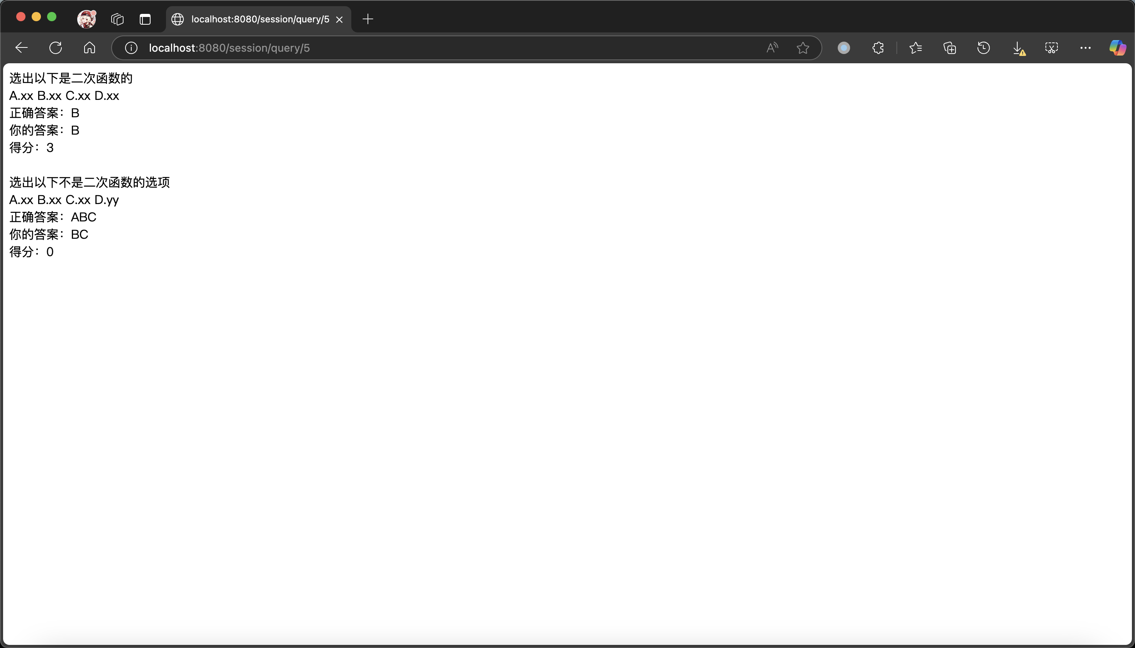

3. UserAnswerServiceImpl（答题记录服务实现类）
public Boolean setAnswer(Long sessionId, Long problemId, String answer) {
LambdaQueryWrapper<UserAnswerEntity> query = Wrappers.lambdaQuery();
query.eq(UserAnswerEntity::getSessionId, sessionId).eq(UserAnswerEntity::getProblemId, problemId);
UserAnswerEntity userAnswerEntity = baseMapper.selectOne(query); // 查询用户答题记录
if (userAnswerEntity != null) {
userAnswerEntity.setAnswer(answer); // 修改答案
userAnswerEntity.setCorrect(0); // 设置为未批改
return baseMapper.update(userAnswerEntity, query) == 1; // 更新答案
} else {
userAnswerEntity = new UserAnswerEntity(); // 新建记录
userAnswerEntity.setSessionId(sessionId);
userAnswerEntity.setProblemId(problemId);
userAnswerEntity.setAnswer(answer);
userAnswerEntity.setCorrect(0);
return baseMapper.insert(userAnswerEntity) == 1; // 插入新的答题记录
}
}
此方法用于设置用户的某道题目的答案。如果该记录已经存在，则更新答案；如果不存在，则创建一条新的记录并插入数据库。
业务分析：
- 对于每道题，系统需要能够处理用户的答案提交。如果已经有记录，系统将更新答案；如果没有记录，系统会插入一条新的答题记录。
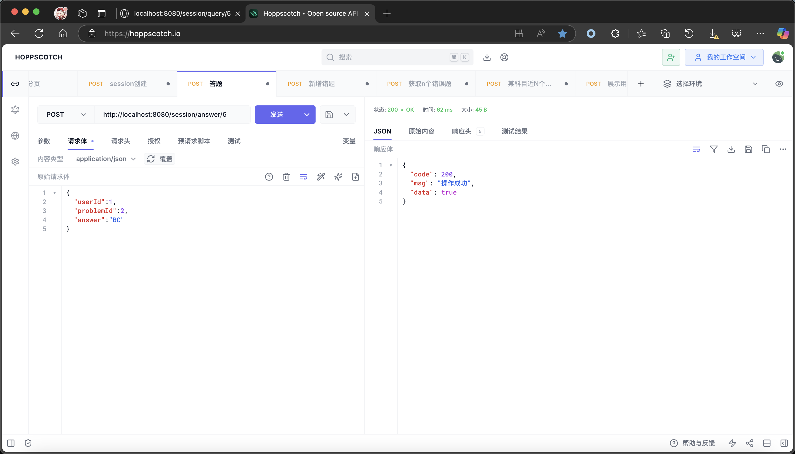
    - 课程设计总结
通过本次实验，我成功实现了在线考试系统的核心服务层功能。所有服务模块均能够正确执行，具体表现如下：
- 考试管理服务：能够对考试的基本信息进行增、删、改、查操作。
- 考试会话服务：能够自动批改试卷、查询成绩、查询会话数据等。
- 答题记录服务：能够插入、更新、删除、查询用户答题记录，并能进行正确与否的验证。
本次实验让我深刻理解了如何结合Spring Boot框架和MyBatis-Plus简化数据访问操作，并通过合理的架构设计将复杂的业务逻辑拆解为多个独立的服务模块。此外，我还学习了如何处理数据库中的数据表关系，如何通过服务层与DAO层交互来实现各种功能。整个实验不仅提高了我的编程能力，也增强了我在实际项目开发中如何设计系统、处理数据交互和优化业务逻辑的能力。
    - 参考文献
《java程序设计与应用开发（第二版）》 -郭克华 李一帆 孙王斌
https://baomidou.com Mybatis-Plus官网，里面有大量文档

    - 附录：
ExamServiceImpl
package group.one.service.impl;
import com.baomidou.mybatisplus.core.conditions.query.LambdaQueryWrapper;
import com.baomidou.mybatisplus.core.metadata.IPage;
import com.baomidou.mybatisplus.core.toolkit.Wrappers;
import com.baomidou.mybatisplus.extension.service.impl.ServiceImpl;
import group.one.dao.ExamDAO;
import group.one.entity.ExamEntity;
import group.one.service.ExamService;
import org.springframework.stereotype.Service;
import java.time.LocalDateTime;
@Service("examService")
public class ExamServiceImpl extends ServiceImpl<ExamDAO,ExamEntity> implements ExamService {
@Override
public ExamEntity getById(Long id) {
LambdaQueryWrapper<ExamEntity> query = Wrappers.lambdaQuery();
query.eq(ExamEntity::getId, id);
//返回第一个元素，如果没有元素，返回null
return baseMapper.selectOne(query);
/*query.orderByDesc(ExamEntity::getId);
int curPage=1;
int limit=10;
if(ObjectUtils.isNotEmpty(params.get("page"))){
curPage=Integer.parseInt(params.get("page").toString());
}
if(ObjectUtils.isNotEmpty(params.get("limit"))){
limit=Integer.parseInt(params.get("limit").toString());
}
IPage<ExamEntity> page= Page.of(curPage,limit);
return baseMapper.selectPage(page,query);*/
}
@Override
public ExamEntity add(ExamEntity examEntity) {
baseMapper.insert(examEntity);
return examEntity;
}
public void delete(Long id){
baseMapper.deleteById(id);
}
@Override
public IPage<ExamEntity> listAll(Integer curPage, Integer limit) {
LambdaQueryWrapper<ExamEntity> query=Wrappers.lambdaQuery();
query.orderByDesc(ExamEntity::getId);
return baseMapper.selectPage(new com.baomidou.mybatisplus.extension.plugins.pagination.Page<>(curPage,limit),query);
}
public ExamEntity modifyById(Long id,ExamEntity examEntity){
System.out.println(examEntity);
examEntity.setId(id);
baseMapper.updateById(examEntity);
return examEntity;
}
@Override
public ExamEntity changeStartTime(Long id, LocalDateTime startTime) {
ExamEntity examEntity = getById(id);
examEntity.setStartTime(startTime);
baseMapper.updateById(examEntity);
return examEntity;
}
@Override
public ExamEntity changeEndTime(Long id, LocalDateTime endTime) {
ExamEntity examEntity = getById(id);
examEntity.setEndTime(endTime);
baseMapper.updateById(examEntity);
return examEntity;
}
@Override
public ExamEntity changeDuration(Long id, Integer duration) {
ExamEntity examEntity = getById(id);
examEntity.setDuration(duration);
baseMapper.updateById(examEntity);
return examEntity;
}
@Override
public ExamEntity changeShowScore(Long id, Integer showScore) {
ExamEntity examEntity = getById(id);
examEntity.setShowScore(showScore);
baseMapper.updateById(examEntity);
return examEntity;
}
@Override
public ExamEntity changeShuffle(Long id, Integer shuffle) {
ExamEntity examEntity = getById(id);
examEntity.setShuffle(shuffle);
baseMapper.updateById(examEntity);
return examEntity;
}
@Override
public Boolean isShowScore(Long id) {
ExamEntity entity=getById(id);
return entity.getShowScore()!=0;//0为不立刻显示成绩
}
@Override
public LocalDateTime getStartTime(Long id) {
ExamEntity entity=getById(id);
return entity.getStartTime();
}
@Override
public LocalDateTime getEndTime(Long id) {
ExamEntity entity=getById(id);
return entity.getEndTime();
}
@Override
public Integer getDuration(Long id) {
ExamEntity entity=getById(id);
return entity.getDuration();
}
}
SessionServiceImpl
package group.one.service.impl;
import com.baomidou.mybatisplus.core.conditions.query.LambdaQueryWrapper;
import com.baomidou.mybatisplus.core.metadata.IPage;
import com.baomidou.mybatisplus.core.toolkit.Wrappers;
import com.baomidou.mybatisplus.extension.service.impl.ServiceImpl;
import group.one.dao.SessionDAO;
import group.one.entity.SessionEntity;
import group.one.service.*;
import org.springframework.beans.factory.annotation.Autowired;
import org.springframework.context.annotation.Lazy;
import org.springframework.stereotype.Service;
import java.time.LocalDateTime;
import java.util.ArrayList;
import java.util.Collections;
import java.util.List;
@Service("sessionService")
public class SessionServiceImpl extends ServiceImpl<SessionDAO, SessionEntity> implements SessionService {
@Autowired
@Lazy
private ExamService examService;
@Autowired
@Lazy
private PaperService paperService;
@Autowired
@Lazy
private WrongProblemService wrongProblemService;
@Autowired
@Lazy
private PaperProblemService paperProblemService;
@Autowired
@Lazy
private ProblemServiceImpl problemService;
@Autowired
@Lazy
private ProblemChoicesServiceImpl problemChoicesService;
@Autowired
private UserAnswerServiceImpl userAnswerService;
@Override
public SessionEntity getById(Long id) {
LambdaQueryWrapper<SessionEntity> query = Wrappers.lambdaQuery();
query.eq(SessionEntity::getId, id);
return baseMapper.selectOne(query);
}
@Override
public SessionEntity add(SessionEntity sessionEntity) {
baseMapper.insert(sessionEntity);
return sessionEntity;
}
@Override
public void delete(Long id) {
baseMapper.deleteById(id);
}
@Override
public IPage<SessionEntity> listAll(Integer curPage, Integer limit) {
LambdaQueryWrapper<SessionEntity> query = Wrappers.lambdaQuery();
query.orderByDesc(SessionEntity::getId);
return baseMapper.selectPage(new com.baomidou.mybatisplus.extension.plugins.pagination.Page<>(curPage, limit), query);
}
@Override
public SessionEntity modifyById(Long id, SessionEntity sessionEntity) {
sessionEntity.setId(id);
baseMapper.updateById(sessionEntity);
return sessionEntity;
}
@Override
public List<Integer> getNScores(Long userId, Long courseId, Long n) {
LambdaQueryWrapper<SessionEntity> query = Wrappers.lambdaQuery();
query.eq(SessionEntity::getUserId, userId);
List<Long> paperIds = paperService.getPaperIdsByCourseId(courseId);
log.debug("paperIds: "+paperIds);
query.in(SessionEntity::getPaperId, paperIds);
query.orderByDesc(SessionEntity::getId);
List<SessionEntity> queryList=baseMapper.selectList(query);
log.debug("queryList: "+queryList);
//提取sessionEntity中的前n个score，如果不足n个则返回全部
ArrayList<Integer> result= new ArrayList<>();
for (int i = 0; i < queryList.size() && i < n; i++) {
result.add(queryList.get(i).getScore());
}
return result;
}
@Override
public List<Integer> getNRanks(Long userId, Long courseId, Long n) {
LambdaQueryWrapper<SessionEntity> query = Wrappers.lambdaQuery();
query.eq(SessionEntity::getUserId, userId);
List<Long> paperIds = paperService.getPaperIdsByCourseId(courseId);
query.in(SessionEntity::getPaperId, paperIds);
query.orderByDesc(SessionEntity::getId);
List<SessionEntity> queryList=baseMapper.selectList(query);
//提取sessionEntity中的前n个rank，如果不足n个则返回全部
ArrayList<Integer> result= new ArrayList<>();
for (int i = 0; i < queryList.size() && i < n; i++) {
result.add(queryList.get(i).getRanking());
}
return result;
}
/*
@Override
public List<Integer> getNWrongProblems(Long userId, Long courseId, Integer n) {
LambdaQueryWrapper<SessionEntity> query = Wrappers.lambdaQuery();
query.eq(SessionEntity::getUserId, userId);
List<Long> paperIds = paperService.getPaperIdsByCourseId(courseId);
query.in(SessionEntity::getPaperId, paperIds);
query.orderByDesc(SessionEntity::getId);
List<SessionEntity> queryList=baseMapper.selectList(query);
//提取sessionEntity中的前n个wrongProblems，如果不足n个则返回全部
ArrayList<Integer> result= new ArrayList<>();
for (int i = 0; i < queryList.size() && i < n; i++) {
String correctness = queryList.get(i).getCorrectness();
//correctness为"1;0;1;0;..."的形式，1代表正确
String[] correctnessArray = correctness.split(";");
for (int j = 0; j < correctnessArray.length; j++) {
if (correctnessArray[j].equals("0")) {
result.add(j);
}
}
}
//去重
List<Integer> resultList = new ArrayList<>();
for (Integer integer : result) {
if (!resultList.contains(integer)) {
resultList.add(integer);
}
}
return resultList;
}
*/
@Override
public Long getPaperId(Long id) {
LambdaQueryWrapper<SessionEntity> query = Wrappers.lambdaQuery();
query.eq(SessionEntity::getId, id);
SessionEntity sessionEntity = baseMapper.selectOne(query);
return sessionEntity.getPaperId();
}
@Override
public SessionEntity autoJudge(Long sessionId) {
LambdaQueryWrapper<SessionEntity> query = Wrappers.lambdaQuery();
query.eq(SessionEntity::getId, sessionId);
SessionEntity sessionEntity = baseMapper.selectOne(query);
Long paperId = sessionEntity.getPaperId();
//get all problemId from PaperProblemService
List<Long> problemIds = paperProblemService.getProblemIdsByPaperId(paperId);
Integer score = 0;
for (Long problemId : problemIds) {
if(problemChoicesService.selectAnswerHeadsByProblemId(problemId).isEmpty()){
continue;
}
Integer point=userAnswerService.getScore(sessionId, problemId);
score += point;
userAnswerService.setCorrect(sessionId, problemId, point);
if (!userAnswerService.checkAnswer(sessionId, problemId)){
wrongProblemService.addErrorProblem(sessionEntity.getUserId(), problemId);
}
}
sessionEntity.setScore(score);
baseMapper.update(sessionEntity,query);
return sessionEntity;
}
@Override
public Boolean isTimeValid(Long sessionId) {
SessionEntity sessionEntity = getById(sessionId);
Long examId= sessionEntity.getExamId();
LocalDateTime now = LocalDateTime.now();
if(now.isBefore(examService.getStartTime(examId))|| now.isAfter(examService.getEndTime(examId))){
return false;
}
return !now.isAfter(sessionEntity.getStartTime().plusMinutes(examService.getDuration(examId)));
}
@Override
public List<Integer> getScores(List<Long> userId, Long courseId) {
LambdaQueryWrapper<SessionEntity> query = Wrappers.lambdaQuery();
query.in(SessionEntity::getUserId, userId);
List<Long> paperIds = paperService.getPaperIdsByCourseId(courseId);
query.in(SessionEntity::getPaperId, paperIds);
query.orderByDesc(SessionEntity::getId);
List<SessionEntity> queryList=baseMapper.selectList(query);
ArrayList<Integer> result= new ArrayList<>();
for (SessionEntity sessionEntity : queryList) {
result.add(sessionEntity.getScore());
}
return result;
}
@Override
public String querySessionData(Long sessionId) {
LambdaQueryWrapper<SessionEntity> query=Wrappers.lambdaQuery();
query.eq(SessionEntity::getId,sessionId);
SessionEntity sessionEntity=baseMapper.selectOne(query);
Long paperId=sessionEntity.getPaperId();
List<Long> problemIds=paperProblemService.getProblemIdsByPaperId(paperId);
StringBuilder result=new StringBuilder();
List<String> titles=problemService.selectTitlesByProblemIds(problemIds);
List<String> descriptions=problemService.selectDescriptionsByProblemIds(problemIds);
List<String> userAnswers=userAnswerService.getAnswerList(sessionId);
List<Integer> scores=userAnswerService.getScoreList(sessionId);
int n=titles.size();
log.warn(problemIds.toString());//FIXME题目和作答的顺序不对应，数据库主键有关
for (int i = 0; i < n; i++) {
result.append(titles.get(i)).append("<br>");
result.append(descriptions.get(i)).append("<br>");
String correctAnswer=problemChoicesService.selectAnswerHeadsByProblemId(problemIds.get(i));
if(!correctAnswer.isEmpty()){
result.append("正确答案：").append(correctAnswer).append("<br>");
}
String userAnswer=userAnswers.get(i);
if(userAnswer.isEmpty()){
result.append("你的答案：未作答").append("<br>");
}
else{
result.append("你的答案：").append(userAnswer).append("<br>");
}
if(scores.get(i)==null){
result.append("得分：未批改").append("<br>");
}
else{
result.append("得分：").append(scores.get(i)).append("<br>");
}
result.append("<br>");
}
return result.toString();
}
}
UserAnswerServiceImpl
package group.one.service.impl;
import com.baomidou.mybatisplus.core.conditions.query.LambdaQueryWrapper;
import com.baomidou.mybatisplus.core.toolkit.Wrappers;
import com.baomidou.mybatisplus.extension.service.impl.ServiceImpl;
import group.one.dao.UserAnswerDAO;
import group.one.entity.UserAnswerEntity;
import group.one.service.PaperProblemService;
import group.one.service.ProblemChoicesService;
import group.one.service.SessionService;
import group.one.service.UserAnswerService;
import org.springframework.beans.factory.annotation.Autowired;
import org.springframework.context.annotation.Lazy;
import org.springframework.stereotype.Service;
import java.util.ArrayList;
import java.util.List;
@Service("userAnswerService")
public class UserAnswerServiceImpl extends ServiceImpl<UserAnswerDAO, UserAnswerEntity> implements UserAnswerService {
@Autowired
@Lazy
private SessionService sessionService;
@Autowired
@Lazy
private PaperProblemService paperProblemService;
@Autowired
@Lazy
private ProblemChoicesService problemChoicesService;
@Override
public UserAnswerEntity insert(UserAnswerEntity userAnswerEntity) {
return baseMapper.insert(userAnswerEntity)==1?userAnswerEntity:null;
}
@Override
public boolean delete(UserAnswerEntity userAnswerEntity) {
LambdaQueryWrapper<UserAnswerEntity> query=Wrappers.lambdaQuery();
query.eq(UserAnswerEntity::getSessionId,userAnswerEntity.getSessionId());
query.eq(UserAnswerEntity::getProblemId,userAnswerEntity.getProblemId());
return baseMapper.delete(query)==1;
}
@Override
public UserAnswerEntity update(UserAnswerEntity userAnswerEntity) {
LambdaQueryWrapper<UserAnswerEntity> query=Wrappers.lambdaQuery();
query.eq(UserAnswerEntity::getSessionId,userAnswerEntity.getSessionId());
query.eq(UserAnswerEntity::getProblemId,userAnswerEntity.getProblemId());
return baseMapper.update(userAnswerEntity,query)==1?userAnswerEntity:null;
}
@Override
public UserAnswerEntity select(UserAnswerEntity userAnswerEntity) {
return null;
}
@Override
public Integer getScore(Long sessionId, Long problemId) {
if(this.checkAnswer(sessionId,problemId)){
Long paperId=sessionService.getPaperId(sessionId);
log.warn(paperProblemService.getPointByPaperIdAndProblemId(paperId,problemId).toString());
return paperProblemService.getPointByPaperIdAndProblemId(paperId,problemId).intValue();
}
return 0;
}
@Override
public Boolean checkAnswer(Long sessionId, Long problemId) {
LambdaQueryWrapper<UserAnswerEntity> query = Wrappers.lambdaQuery();
query.eq(UserAnswerEntity::getSessionId, sessionId);
query.eq(UserAnswerEntity::getProblemId, problemId);
UserAnswerEntity userAnswerEntity = baseMapper.selectOne(query);
String userAnswer=getAnswer(sessionId,problemId);
String correctAnswer=problemChoicesService.selectAnswerHeadsByProblemId(problemId);
log.warn("userAnswer:"+userAnswer+" correctAnswer:"+correctAnswer);
return userAnswer.equals(correctAnswer);
}
@Override
public String getAnswer(Long sessionId, Long problemId) {
LambdaQueryWrapper<UserAnswerEntity> query = Wrappers.lambdaQuery();
query.eq(UserAnswerEntity::getSessionId, sessionId);
query.eq(UserAnswerEntity::getProblemId, problemId);
UserAnswerEntity userAnswerEntity = baseMapper.selectOne(query);
if(userAnswerEntity!=null){
return userAnswerEntity.getAnswer();
}
return "";
}
@Override
public Boolean setAnswer(Long sessionId, Long problemId, String answer) {
LambdaQueryWrapper<UserAnswerEntity> query=Wrappers.lambdaQuery();
query.eq(UserAnswerEntity::getSessionId,sessionId).eq(UserAnswerEntity::getProblemId,problemId);
UserAnswerEntity userAnswerEntity=baseMapper.selectOne(query);
if(userAnswerEntity!=null){
log.debug("Enter modify logic");
userAnswerEntity.setAnswer(answer);
userAnswerEntity.setCorrect(0);
return baseMapper.update(userAnswerEntity,query)==1;
}
else {
log.debug("Enter insert logic");
userAnswerEntity=new UserAnswerEntity();
userAnswerEntity.setSessionId(sessionId);
userAnswerEntity.setProblemId(problemId);
userAnswerEntity.setAnswer(answer);
userAnswerEntity.setCorrect(0);
return baseMapper.insert(userAnswerEntity)==1;
}
}
@Override
public List<String> getAnswerList(Long sessionId) {
LambdaQueryWrapper<UserAnswerEntity> query=Wrappers.lambdaQuery();
query.eq(UserAnswerEntity::getSessionId,sessionId);
List<UserAnswerEntity> userAnswerEntities=baseMapper.selectList(query);
List<String> answerList=new ArrayList<>(userAnswerEntities.size());
for(UserAnswerEntity userAnswerEntity:userAnswerEntities){
answerList.add(userAnswerEntity.getAnswer());
}
return answerList;
}
@Override
public List<Integer> getScoreList(Long sessionId) {
LambdaQueryWrapper<UserAnswerEntity> query=Wrappers.lambdaQuery();
query.eq(UserAnswerEntity::getSessionId,sessionId);
List<UserAnswerEntity> userAnswerEntities=baseMapper.selectList(query);
List<Integer> scoreList=new ArrayList<>(userAnswerEntities.size());
for(UserAnswerEntity userAnswerEntity:userAnswerEntities){
scoreList.add(userAnswerEntity.getCorrect());
}
return scoreList;
}
@Override
public Boolean setCorrect(Long sessionId, Long problemId, Integer point) {
LambdaQueryWrapper<UserAnswerEntity> query=Wrappers.lambdaQuery();
query.eq(UserAnswerEntity::getSessionId,sessionId);
query.eq(UserAnswerEntity::getProblemId,problemId);
UserAnswerEntity userAnswerEntity=baseMapper.selectOne(query);
if(userAnswerEntity!=null){
userAnswerEntity.setCorrect(point);
log.error("session"+sessionId+" problem"+problemId+" id"+userAnswerEntity.getId()+" point"+point);
return baseMapper.updateById(userAnswerEntity)==1;
}
return false;
}
}
ExamController
package group.one.controller;
import group.one.entity.ExamEntity;
import group.one.service.ExamService;
import lombok.extern.slf4j.Slf4j;
import org.springframework.beans.factory.annotation.Autowired;
import org.springframework.web.bind.annotation.*;
import group.one.utils.Result;
import java.util.Map;
@Slf4j
@RestController
@RequestMapping("/exam")
public class ExamController {
@Autowired
private ExamService examService;
@PostMapping("/list-all")
public Result<?> listAll(@RequestBody Map<String,Object> params) {
int curPage=1;
int limit=5;
if(params.containsKey("curPage")) {
curPage = Integer.parseInt(params.get("curPage").toString());
}
if(params.containsKey("limit")) {
limit = Integer.parseInt(params.get("limit").toString());
}
return Result.success(examService.listAll(curPage,limit));
}
@GetMapping("/get-by-id/{id}")
public Result<ExamEntity> getById(@PathVariable("id") Long id) {
return Result.success(examService.getById(id));
}
@PostMapping("/add")
public Result<ExamEntity> add(@RequestBody ExamEntity examEntity) {
examService.add(examEntity);
return Result.success(examEntity);
}
@GetMapping("/delete-by-id/{id}")
public Result<Void> delete(@PathVariable("id") Long id) {
if(examService.removeById(id))
return Result.success();
else
return Result.error();
}
@PostMapping("/update/{id}")
public Result<ExamEntity> update(@PathVariable("id") Long id,@RequestBody ExamEntity examEntity) {
return Result.success(examService.modifyById(id,examEntity));
}
}
SessionController
package group.one.controller;
import group.one.entity.ExamEntity;
import group.one.entity.PaperEntity;
import group.one.entity.SessionEntity;
import group.one.service.ExamService;
import group.one.service.PaperService;
import group.one.service.SessionService;
import group.one.service.UserAnswerService;
import lombok.extern.slf4j.Slf4j;
import org.springframework.beans.factory.annotation.Autowired;
import org.springframework.web.bind.annotation.*;
import group.one.utils.Result;
import java.time.LocalDateTime;
import java.util.List;
import java.util.Map;
@Slf4j
@RestController
@RequestMapping("/session")
public class SessionController {
@Autowired
private SessionService sessionService;
@Autowired
private UserAnswerService userAnswerService;
@Autowired
private ExamService examService;
@Autowired
private PaperService paperService;
// @Autowired
// private ExamService examService;
@GetMapping("/query/{id}")
public String query(@PathVariable("id") Long id) {
return sessionService.querySessionData(id);
}
@PostMapping("/list-all")
public Result<?> listALl(@RequestBody Map<String,Object> params) {
int curPage=1;
int limit=5;
if(params.containsKey("curPage")) {
curPage = Integer.parseInt(params.get("curPage").toString());
}
if(params.containsKey("limit")) {
limit = Integer.parseInt(params.get("limit").toString());
}
return Result.success(sessionService.listAll(curPage,limit));
}
@GetMapping("/get-by-id/{id}")
public Result<SessionEntity> getById(@PathVariable("id") Long id) {
return Result.success(sessionService.getById(id));
}
@PostMapping("/add")
public Result<SessionEntity> add(@RequestBody Map<String,Object> params) {
Long examId=Long.parseLong(params.get("examId").toString());
ExamEntity exam=examService.getById(examId);
SessionEntity entity=new SessionEntity();
List<PaperEntity> papers=paperService.getPapersByLogicalId(exam.getLogicalPaperId());
int size=papers.size();
//randomly pick one
int index=(int)(Math.random()*size);
entity.setPaperId(papers.get(index).getId());
entity.setUserId(Long.parseLong(params.get("userId").toString()));
entity.setExamId(examId);
entity.setStartTime(LocalDateTime.now());
entity.setEndTime(LocalDateTime.now().plusSeconds(exam.getDuration()));
entity.setScore(0);
sessionService.add(entity);
return Result.success(entity);
}
@DeleteMapping("/delete-by-id/{id}")
public Result<Void> delete(@PathVariable("id") Long id) {
return sessionService.removeById(id)?Result.success():Result.error();
}
@PostMapping("/update-by-id/{id}")
public Result<SessionEntity> update(@PathVariable("id") Long id,@RequestBody SessionEntity sessionEntity) {
return Result.success(sessionService.modifyById(id,sessionEntity));
}
@GetMapping("/judge/{id}")
public Result<SessionEntity> judge(@PathVariable("id") Long id) {
return Result.success(sessionService.autoJudge(id));
}
@PostMapping("/answer/{sessionId}")
public Result<?> answer(@PathVariable("sessionId") Long sessionId,@RequestBody Map<String,Object> params) {
if(!sessionService.isTimeValid(sessionId)) {
return Result.error("Session not started or already ended");
}
if(!params.containsKey("problemId")) {
return Result.error(400,"problem id is required");
}
Long problemId = Long.parseLong(params.get("problemId").toString());
if(!params.containsKey("answer")) {
return Result.error(400,"answer is required");
}
String answer = params.get("answer").toString();
return Result.success(userAnswerService.setAnswer(sessionId,problemId,answer));
}
}
有关项目的更多代码请参考gitee在线仓库。

