LitchiGuard-Net: An Efficient Algorithm for Litchi Pest and Disease Detection

Chaohao Liang ^{1,a,*}
¹ School of Computer Science and Technology
Xidian University
Xi’an, Shaanxi, China
*corresponding author: ª1957301610@qq.com

Abstract—Litchi yield and quality are significantly affected by pests and diseases, while traditional manual monitoring methods are inefficient and difficult to scale. To address challenges such as small lesion regions, subtle features, complex backgrounds, and varying illumination in orchard environments, this paper proposes LitchiGuard-Net, an improved detection model based on YOLOv12. The model incorporates a Multi-Scale Pest Feature Fusion (MSPFF) module, an Orchard Environment Guided Attention (OEGA) mechanism, and a Fine-Grained Disease Enhancement Unit (FGDEU) to enhance multi-scale feature representation, suppress background interference, and improve the detection of small and early-stage lesions. Experimental results show that LitchiGuard-Net achieves an mAP of 96.1%, outperforming YOLOv12 while maintaining high efficiency. The proposed method provides an effective solution for litchi pest and disease detection in complex orchard environments.
Keywords- Litchi pest and disease detection; Deep learning; Object detection; Smart agriculture; Computer vision

Introduction
With the advancement of smart agriculture, accurate detection of litchi pests and diseases has become essential for ensuring yield and quality. Traditional methods are inefficient and struggle in complex environments, especially for small lesions, while deep learning-based object detection provides a more robust and effective solution [1].
Traditional pest and disease recognition methods rely on handcrafted features and classifiers such as SVM, showing limited robustness in complex environments despite improvements such as the CNN-SVM model proposed by Gupta et al. [2]. In contrast, deep learning-based object detection enables end-to-end feature learning, providing higher accuracy and adaptability, and has become a more effective solution for automated agricultural pest and disease detection.
Deep learning-based object detection methods are generally categorized into two-stage and single-stage approaches. Two-stage detectors, such as Faster R-CNN [3] and Mask R-CNN [4], achieve high accuracy but suffer from high computational cost and limited real-time performance. For example, Kumar et al. [5] proposed a CNN and Random Forest-based model with over 92% accuracy in litchi disease detection. In contrast, single-stage methods like YOLO [6] and SSD [7] offer a better balance between accuracy and efficiency. Recent improvements, such as the lightweight YOLOv8-based model by Chen et al. [8], enhance performance through attention mechanisms and multi-scale fusion. However, existing methods still face challenges in detecting small lesions under complex orchard conditions, indicating room for further improvement.
To address challenges in litchi pest and disease detection under complex orchard environments, this paper proposes LitchiGuard-Net, a deep learning framework that balances accuracy and efficiency. The model introduces three modules: MSPFF for multi-scale feature fusion, OEGA for context-aware attention to suppress background interference, and FGDEU for enhancing fine-grained lesion features. Experimental results show that LitchiGuard-Net outperforms several mainstream methods in mAP, precision, and recall while maintaining high efficiency. The proposed framework provides an effective solution for intelligent pest detection in smart agriculture.

Related Work
In recent years, with the rapid development of deep learning and computer vision, object detection has shown great potential in agricultural management and crop pest and disease recognition. Image-based automatic detection methods, characterized by high efficiency and strong adaptability to natural environments, have become important tools in smart agriculture. For example, Xie et al. [9] proposed a lightweight network based on an improved FCOS, incorporating G-GhostNet-3.2 and a central moment pooling attention mechanism, achieving 91.3% accuracy (IoU = 0.5) with efficient performance and successful deployment on mobile devices. Lu et al. [10] developed a multimodal data fusion model for litchi downy blight prediction, integrating IoT sensors, LSTM, and Bayesian probability modeling, achieving an accuracy of 89.58%. These studies demonstrate the effectiveness of deep learning and multimodal approaches in litchi pest and disease detection and prediction.
YOLOv12 provides an efficient solution for agricultural pest and disease detection by balancing accuracy and real-time performance. It introduces an Area Attention (A2) mechanism to enhance small target perception while reducing computational complexity, and adopts R-ELAN to improve gradient flow and robustness under complex conditions. With scalable model variants, YOLOv12 achieves a strong trade-off between accuracy and efficiency, outperforming earlier YOLO versions and demonstrating advantages over two-stage methods such as Faster R-CNN, making it well-suited for litchi pest and disease detection in real-world orchard environments.

Methods

Overview
As shown in Figure 1, LitchiGuard-Net is designed to improve litchi pest and disease detection in complex orchard environments, addressing challenges such as small lesions, complex textures, and varying illumination. Built upon YOLOv12, the model employs multi-level feature fusion to enhance both spatial and semantic representations. It further incorporates three key modules: MSPFF for multi-scale feature integration, OEGA for context-aware attention to suppress background interference, and FGDEU for enhancing fine-grained lesion features. These components collectively improve detection accuracy and robustness while maintaining high efficiency.
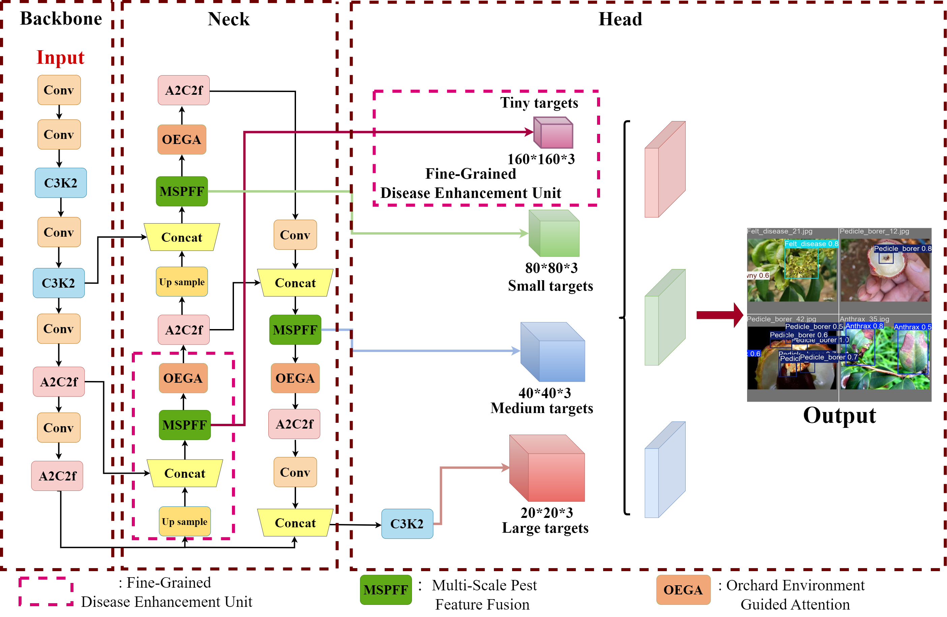
Figure 1: Architecture of LitchiGuard-Net based on YOLOv12. The backbone extracts multi-level features, the neck (with MSPFF and OEGA) enhances cross-scale and contextual representations, and the head predicts categories and bounding boxes for accurate pest and disease detection.

Multi-Scale Pest Feature Fusion Module
The MSPFF module enhances litchi pest and disease detection in complex orchard environments by jointly modeling fine-grained local textures and global contextual information. To address challenges such as small, subtle, and irregularly distributed lesions, it adopts a multi-branch architecture to extract multi-scale features in parallel. Specifically, MSPFF consists of three branches: a dilated convolution branch with 3×3 kernels at different dilation rates to capture multi-scale receptive fields, a 1×1 convolution branch for channel compression and semantic emphasis, and an identity mapping branch to preserve spatial information and facilitate gradient propagation, thereby improving feature representation and robustness.
The outputs of the three branches are concatenated along the channel dimension to form a unified multi-scale feature map, expressed as:
$F_{out}=Concat\left(F_{dilated,}F_{1*1},F_{identity}\right)$ 1
where$F_{dilated}$​, $F_{1*1}{,F}_{identity}$​ denote the outputs of the dilated convolution, 1×1 convolution, and identity branches, respectively, and Concat represents channel concatenation. Each convolution layer is followed by Batch Normalization (BN) and a ReLU activation function to improve stability and discriminative capability.
Dilated convolution can significantly expand the receptive field without increasing the number of parameters. Given an input $x\left(m,n\right)$ and output $y\left(m,n\right)$, the operation can be expressed as:
$y\left(m,n\right)=\sum_{i=1}^{M}{\sum_{j=1}^{N}{x\left(m+r*i+n+r*j\right)ω\left(i,j\right)}}$ 2
where $M$ and $N$ denote the kernel size, $ω\left(i,j\right)$ represents the convolution kernel weights, and $r$ is the dilation rate. When $r=1$, the receptive field is 3×3; when $r=2$, it expands to 5×5; and when $r=3$, it covers a 7×7 region, thereby enlarging the perceptual range while maintaining resolution.
For a $k*k$ dilated convolution, the effective receptive field (RF) and output resolution (H) can be calculated as:
$RF=\left(r-1\right)\left(k-1\right)+k$ 3
$H=\frac{h+2p-RF}{s}+1$ 4
where $p$ denotes the padding size, $h$ is the input feature map size, and $s$ is the convolution stride. Through this multi-scale fusion mechanism, MSPFF effectively integrates features across different levels while maintaining sensitivity to small lesions, thereby significantly improving detection performance in complex orchard environments.

Orchard Environment Guided Attention
The proposed Orchard Environment Guided Attention (OEGA) enhances litchi pest and disease detection in complex orchard environments by leveraging contextual information to emphasize disease-relevant features and suppress background interference. Built upon YOLOv12, OEGA adopts a dual-branch structure that jointly models spatial and channel attention, enabling improved robustness against challenges such as complex textures, occlusions, and illumination variations.
Spatial attention path: Given an input feature map $Q∈R^{C×H×w}$, convolutional mappings generate two feature sets $\left\{R,S\right\}ϵR^{C×H×w}$, which are reshaped into two-dimensional matrices $R∈R^{C×N}$and $S∈R^{C×N}$, where $N=H×W$. A spatial attention map $U∈R^{N×N}$ is computed via matrix multiplication followed by a softmax operation:
$u_{ji}=\frac{e^{\left(R_{i}⋅S_{j}\right)}}{Σ_{ⅈ=1}^{N}e^{\left(R_{i}⋅S_{j}\right)}}$ 5
This spatial attention mechanism establishes global dependencies among pixels, enabling the model to focus more intently on the feature responses within pest and disease regions, even amidst complex backgrounds. Subsequently, the transformed feature map $T$ is weighted and fused with the attention map $U$, and a residual connection is introduced:
$V_{j}=β\sum_{i=1}^{N}{\left(u_{ji}T_{i}\right)}+Q_{j}$ 6
where $β$ is a learnable parameter initialized to zero and adaptively updated during training.
Channel attention path: To model global dependencies across channels, the input feature $Q∈R^{C×H×w}$ is reshaped into $Q∈R^{C×N}$. A channel attention map $Z∈R^{C×C}$ is obtained via self-correlation:
$z_{ji}=\frac{e^{\left(Q_{i}⋅Q_{j}\right)}}{Σ_{ⅈ=1}^{C}e^{\left(Q_{i}⋅Q_{j}\right)}}$ 7
The final output is produced by channel-wise weighted aggregation with a residual connection:
$V_{j}=γ\sum_{i=1}^{C}{\left(z_{ji}Q_{i}\right)}+Q_{j}$ 8
where $γ$ is a learnable parameter that enables progressive optimization of inter-channel dependency modeling during training.
By jointly modeling spatial and channel dependencies, OEGA dynamically adjusts feature importance according to orchard context, enabling the model to focus on pest and disease regions while suppressing background interference. Experimental results demonstrate that OEGA significantly improves detection accuracy and robustness in complex orchard environments.

Fine-Grained Disease Enhancement Unit
Although YOLOv12 performs well in general detection tasks, it still struggles with small lesions in complex orchard environments due to subtle textures, blurred boundaries, and information loss from downsampling. To address this, the proposed FGDEU enhances feature representation through cross-layer fusion and fine-grained texture enhancement, improving the detection of small and early-stage lesions.
Specifically, a feature map 80×80×128 is extracted from intermediate layers (denoted as Feature Map 1), containing rich semantic information with moderate spatial resolution. A 1×1 convolution is then applied for channel compression and semantic alignment, reducing background interference.
$Feature Map 1^{'}=σ\left(W_{1}*Feature Map 1\right)$ 9
where $σ$ denotes the activation function, $*$ represents the convolution operation, and $W_{1}$​​ is a learnable parameter. This process enhances the consistency of feature representation while reducing channel redundancy, enabling the model to better distinguish between diseased regions and complex leaf backgrounds.
Next, $Feature Map 1^{'}$ is upsampled to 160×160×64 and fused with a shallow feature map (Feature Map 2) of the same resolution, producing a cross-layer compensated feature map:
$Feature Map 1^{''}=Upsample\left(Feature Map 1^{'}\right)$ 10
$Feature Map 3=Feature Map 1^{''}+Feature Map 2$ 11
This cross-layer fusion combines high-resolution spatial details from shallow features with semantic information from deeper layers, compensating for the loss of fine-grained details.
Subsequently, Feature Map 3 is processed by multiple convolution layers and nonlinear activations to generate the final prediction feature map Feature Map 4 with resolution 160×160×18:
$Feature Map 4=σ\left(W_{2}*Feature Map 3\right)$ 12
By constructing a high-resolution prediction layer, FGDEU enhances the detection of small lesions, dense disease regions, and partially occluded targets. Experimental results demonstrate that FGDEU significantly improves recall and overall detection accuracy with minimal computational overhead, providing reliable support for intelligent litchi pest and disease monitoring.

Experiments and Results

Experimental Setup and Dataset
All experiments were conducted on a server with an NVIDIA RTX 4090D GPU, Intel Xeon CPU, and 80 GB memory, using Ubuntu 22.04, Python 3.10, CUDA 11.8, and PyTorch. The dataset consists of approximately 2,000 annotated litchi pest and disease images collected from real orchard environments, resized to 640×640, and characterized by diverse backgrounds, lighting conditions, and occlusions, making it suitable for evaluating small object detection. During training, data augmentation techniques including geometric transformations, color jittering, Mosaic, and MixUp were applied to improve robustness. The model uses Kaiming initialization, weighted cross-entropy for classification, and CIoU loss for bounding box regression, and is optimized with AdamW (learning rate 1×10⁻⁴, weight decay 0.0005) with cosine annealing and warm-up. Training is performed for 100 epochs with a batch size of 24. Performance is evaluated using Precision, Recall, F1-score, and mAP, with detailed results shown in Figure. 2.
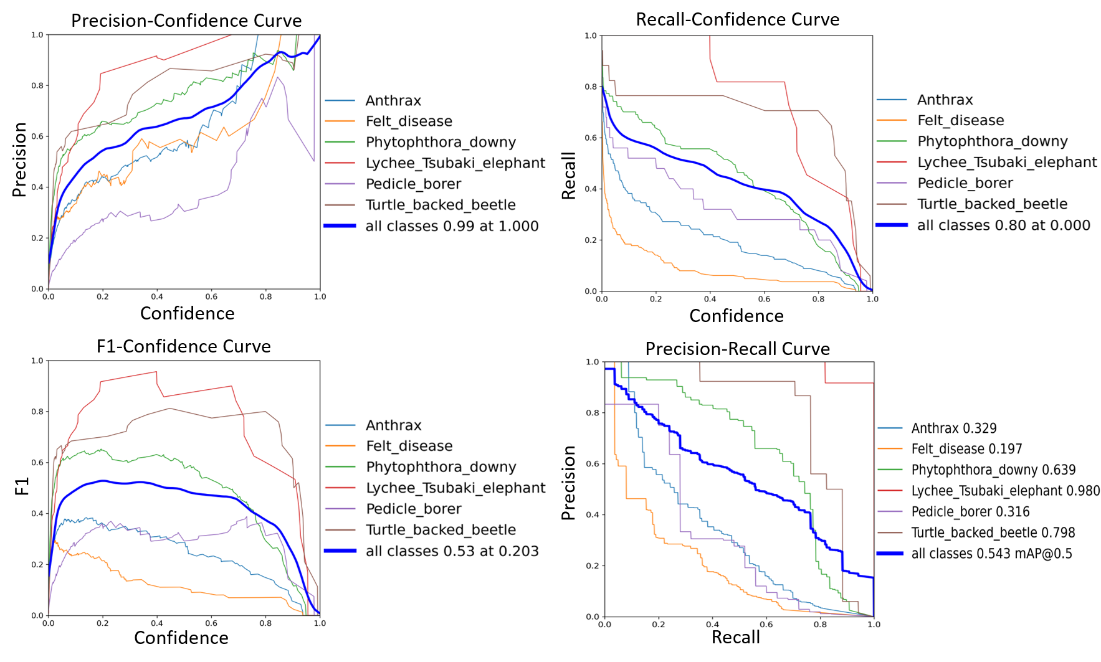
Figure 2: Performance evaluation of LitchiGuard-Net on the litchi pest and disease dataset, including Precision, Recall, F1-score, and PR curve metrics.

Ablation Studies
Ablation experiments were conducted to evaluate MSPFF, OEGA, and FGDEU (Table 1). The baseline YOLOv12 achieves 81.4% Precision, 79.0% Recall, and 82.1% mAP@0.5. Adding MSPFF improves multi-scale detection (85.2% / 84.3% / 85.1%), OEGA further enhances robustness (mAP@0.5: 85.4%), and FGDEU boosts small lesion detection (Recall: 85.4%). Combining modules yields additional gains (mAP@0.5 ≥ 88%), demonstrating their complementarity. The full model achieves the best performance (96.2% Precision, 95.0% Recall, 96.1% mAP@0.5), confirming the effectiveness of the proposed design.

Results and Discussion
LitchiGuard-Net was evaluated against several mainstream detection models (Table 2). It achieves an mAP of 96.1%, surpassing SKS-YOLO (89.4%), STBi-YOLO (85.6%), CenterNet (81.4%), Faster R-CNN (80.1%), and SSD (73.3%), demonstrating the effectiveness of MSPFF, OEGA, and FGDEU for multi-scale feature representation and small lesion detection. The model contains only 10.3M parameters—fewer than RetinaNet, SKS-YOLO, and EfficientDet—while achieving the fastest inference speed (94 FPS). Compared with STBi-YOLO and SKS-YOLO, it delivers higher accuracy with lower complexity and faster speed, indicating a strong balance between performance and efficiency. Overall, LitchiGuard-Net shows robust performance in real orchard environments and is suitable for intelligent monitoring systems. Visualization results are shown in Figure. 3.
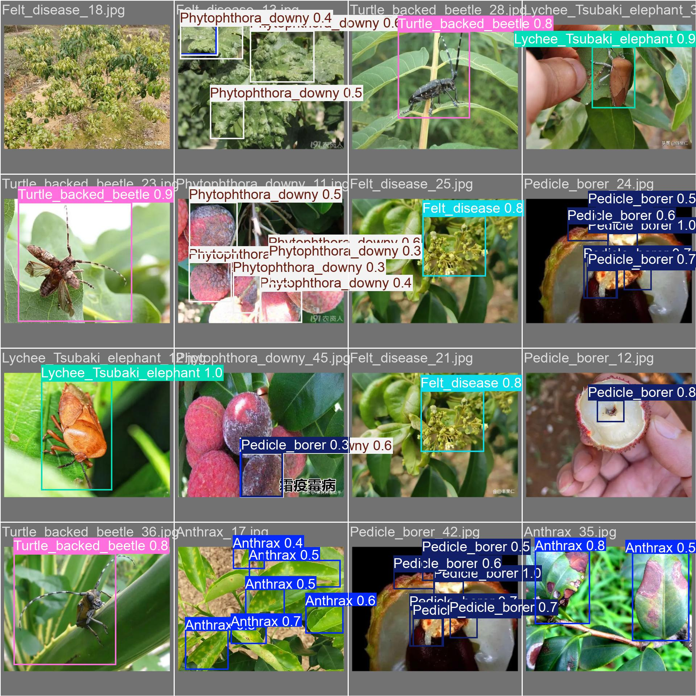
Figure 3: Visualization results of LitchiGuard-Net in real orchard environments.
- Ablation study results of LitchiGuard-Net on the litchi pest and disease detection dataset
YOLOv12 | MSPFF | OEGA | FGDEU | Precision(%) | Recall(%) | mAP@0.5(%)
√ | × | × | × | 81.4 | 79.0 | 82.1
√ | √ | × | × | 85.2 | 84.3 | 85.1
√ | × | √ | × | 85.2 | 84.3 | 85.4
√ | × | × | √ | 84.0 | 85.4 | 85.1
√ | √ | √ | × | 88.0 | 86.6 | 89.2
√ | √ | × | √ | 88.2 | 87.7 | 88.6
√ | × | √ | √ | 88.4 | 88.8 | 89.2
√ | √ | √ | √ | 96.2 | 95.0 | 96.1
- Performance comparison of LitchiGuard-Net with mainstream object detection models on the litchi pest and disease detection task
Model | mAP% | Params/M | FPS/(Frames/s)
Faster R-CNN | 80.1 | 18.4 | 11
SSD | 73.3 | 21.5 | 30
RetinaNet | 56.5 | 34.6 | 25
SKS-YOLO | 89.4 | 43.8 | 55
CenterNet | 81.4 | 47.2 | 20
STBi-YOLO | 85.6 | 15.5 | 66
EfficientDet | 69.3 | 62.1 | 15
LitchiGuard-Net (Our) | 96.1 | 10.3 | 94

Conclusion
This paper proposes LitchiGuard-Net, an improved YOLOv12-based model for litchi pest and disease detection under challenges such as small lesions, complex backgrounds, and varying illumination. By integrating MSPFF, OEGA, and FGDEU, the model enhances multi-scale feature representation and robustness. Experimental results show that it achieves 96.1% mAP, 94 FPS, and 10.3M parameters, outperforming several mainstream methods. Future work will focus on transfer learning and lightweight optimization to improve generalization in practical smart agriculture applications.

References
- Zhu D J, Xie L Z, Chen B X, et al. Knowledge graph and deep learning based pest detection and identification system for fruit quality[J]. Internet of Things, 2023, 21: 100649.
- Gupta B, Kumar S, Chhabra M, et al. Enhancing Crop Health a Novel CNN-SVM Hybrid Model for Litchi Disease Detection[C]//International Conference on Modern Practices and Trends in Expert Applications and Security. Singapore: Springer Nature Singapore, 2024: 439-447.
- Ren S, He K, Girshick R, et al. Faster R-CNN: Towards real-time object detection with region proposal networks[J]. IEEE transactions on pattern analysis and machine intelligence, 2016, 39(6): 1137-1149.
- He K, Gkioxari G, Dollár P, et al. Mask r-cnn[C]//Proceedings of the IEEE international conference on computer vision. 2017: 2961-2969.
- Kumar R, Kumar A, Singh M, et al. Litchi Leaf Disease Multiclasssification: Unraveling the Enigma Using CNN-Random Forest Model[C]//2024 International Conference on Automation and Computation (AUTOCOM). IEEE, 2024: 12-15.
- Hussain M. YOLO-v1 to YOLO-v8, the rise of YOLO and its complementary nature toward digital manufacturing and industrial defect detection[J]. Machines, 2023, 11(7): 677.
- Liu W, Anguelov D, Erhan D, et al. Ssd: Single shot multibox detector[C]//European conference on computer vision. Cham: Springer International Publishing, 2016: 21-37.
- Chen J S, Liu M, Li J S, et al. LFA-YOLO: Detection of Lychee Fruit Anthracnose Based on UAV Images and Deep Learning[J]. Applied Engineering in Agriculture, 2024, 40(5): 515-523.
- Xie J, Zhang X, Liu Z, et al. Detection of litchi leaf diseases and insect pests based on improved FCOS[J]. Agronomy, 2023, 13(5): 1314.
- Lu J, Wu Z, Lan Y, et al. Study on the prediction model of litchi downy blight damage based on IoT and hyperspectral data fusion[J]. IEEE Internet of Things Journal, 2024, 11(16): 27184-27200.

