LitchiGuard-Net: An Efficient Detection Algorithm for Litchi Diseases and Insect Pests

line 1: 1st Given Name Surname
line 2: dept. name of organization (of Affiliation)
line 3: name of organization (of Affiliation)
line 4: City, Country
line 5: email address or ORCID
line 1: 2nd Given Name Surname
line 2: dept. name of organization (of Affiliation)
line 3: name of organization (of Affiliation)
line 4: City, Country
line 5: email address or ORCID
line 1: 3rd Given Name Surname
line 2: dept. name of organization (of Affiliation)
line 3: name of organization (of Affiliation)
line 4: City, Country
line 5: email address or ORCID
line 1: 4th Given Name Surname
line 2: dept. name of organization (of Affiliation)
line 3: name of organization (of Affiliation)
line 4: City, Country
line 5: email address or ORCID

line 1: 5th Given Name Surname
line 2: dept. name of organization (of Affiliation)
line 3: name of organization (of Affiliation)
line 4: City, Country
line 5: email address or ORCID
line 1: 6th Given Name Surname
line 2: dept. name of organization (of Affiliation)
line 3: name of organization (of Affiliation)
line 4: City, Country
line 5: email address or ORCID

Abstract: As an important economic fruit tree in China, the yield and quality of litchi are greatly affected by diseases and insect pests. The traditional monitoring of litchi diseases and insect pests mainly relies on manual experience for identification and judgment, which is not only inefficient but also difficult to achieve rapid and accurate monitoring in large-scale orchard environments. With the development of deep learning and computer vision technology, automatic pest and disease identification methods based on object detection models have gradually become an important research direction in the field of smart agriculture. However, in actual orchard environments, litchi diseases and insect pests are often characterized by small lesion areas, subtle features, complex leaf backgrounds and obvious changes in lighting conditions. These factors put forward high requirements for the accuracy and robustness of detection models. Although YOLOv12 has high detection speed and good real-time performance in object detection tasks, there is still room for improvement in its ability to identify tiny lesions and pest features in complex natural scenes. To solve the above problems, this paper proposes an improved litchi disease and pest detection model based on YOLOv12, named LitchiGuard-Net. Combined with the visual characteristics of diseases and insect pests on litchi leaves, the network structure is optimized in a targeted manner. Firstly, the Multi-Scale Pest Feature Fusion (MSPFF) module is introduced to improve the model's detection ability for pest targets of different scales by enhancing information fusion between features at different levels. Secondly, the Orchard Environment Guided Attention (OEGA) mechanism is designed to dynamically assign weights to feature maps using the context information of orchard scenes, so as to highlight the characteristics of pest and disease regions and effectively suppress complex background interference. Finally, the Fine-Grained Disease Enhancement Unit (FGDEU) is proposed to improve the model's ability to identify tiny lesions and early disease characteristics by enhancing the expression of shallow texture features. Experimental results on the litchi disease and pest dataset show that the proposed LitchiGuard-Net effectively improves the detection performance while maintaining high detection speed, and the mAP of the model reaches 96.1%, which is significantly improved compared with the original YOLOv12 model. The experimental results verify the effectiveness of the proposed method in litchi disease and pest detection in complex orchard environments, and provide a feasible technical solution for intelligent monitoring of orchard diseases and insect pests and smart agricultural management.
Keywords: Litchi Pest and Disease Detection; Deep Learning; Object Detection; Smart Agriculture; Computer Vision

Introduction
With the continuous advancement of smart agriculture and information technology, intelligent monitoring of orchard crop health status has gradually emerged as a crucial research direction in modern agricultural management. As one of the most important economic fruit trees in China, litchi is vulnerable to various diseases and insect pests during its growth cycle. Consequently, timely and accurate detection of litchi diseases and insect pests is of great significance for safeguarding yield stability and fruit quality. Traditional monitoring methods for litchi pests and diseases primarily rely on manual patrols or recognition based on simple image features. However, in practical applications, these methods are often plagued by low detection efficiency, poor adaptability to complex orchard environments, and inadequate capability in identifying small-scale lesions, which makes it difficult to meet the requirements of large-scale orchard management for both detection efficiency and accuracy. With the rapid development of artificial intelligence and computer vision technologies, deep learning-based object detection methods have gradually become a prominent research direction for agricultural pest and disease identification. Compared with traditional approaches, deep learning models can automatically learn high-level semantic features from images, exhibit superior robustness under complex background conditions and variable lighting environments, and demonstrate stronger advantages in improving the recognition accuracy of small-scale lesions. Thus, they provide a more efficient and reliable technical approach for the intelligent detection of litchi diseases and insect pests [1].
In agricultural pest and disease identification tasks, traditional image processing methods usually depend on manually designed feature descriptors and image preprocessing operations, such as image denoising, edge detection, color space conversion, and region segmentation. These methods typically integrate color feature analysis, texture pattern extraction, or morphological structure modeling, and employ traditional machine learning classifiers (e.g., support vector machine (SVM), Random Forest, or k-nearest neighbor (KNN)) to accomplish disease identification. For instance, Gupta et al. [2] proposed a hybrid detection model that fuses convolutional neural networks (CNNs) with SVM. This model comprises three convolutional layers, three max-pooling layers, and one fully connected layer, where deep features are extracted via CNN and efficient classification is achieved by combining with SVM. Experimental results demonstrated that the proposed model exhibits excellent performance in the identification of insect pests on litchi leaves. Nevertheless, in general, such methods rely heavily on manual experience and specific rules, resulting in relatively limited generalization ability. It is often challenging to maintain stable recognition performance in orchard scenes characterized by complex natural environments, varying illumination, and strong background interference.
With the rapid progression of deep learning technologies, object detection methods have achieved remarkable advancements in the field of agricultural pest and disease identification. In contrast to traditional methods, detection models based on deep neural networks can automatically learn high-level semantic features from images through large-scale data training, enabling an end-to-end object recognition process. This data-driven approach not only significantly improves detection accuracy but also exhibits stronger adaptability in complex background environments, lighting variations, and multi-scale object recognition, effectively reducing the reliance on manually designed features. In agricultural pest and disease detection tasks, deep learning models can more accurately capture lesion texture features and pest region information, thereby providing important technical support for the automatic monitoring of orchard crop health status.
Currently, mainstream deep learning-based object detection algorithms can be roughly categorized into two classes: two-stage detection methods and one-stage detection methods. Two-stage detectors are represented by Faster R-CNN [3] and Mask R-CNN [4]. Typically, such methods first generate candidate regions via a region proposal network (RPN), followed by classification and bounding box regression on these candidate regions. Although two-stage methods demonstrate excellent performance in terms of detection accuracy, their complex network structure and high computational overhead often limit their detection speed in real-time application scenarios. Kumar et al. [5] proposed a polyphenol detection model based on the fusion of CNN and Random Forest, which identifies litchi diseases by combining a large volume of sample data and a six-category classification architecture. Experimental results indicated that the model achieves a micro-average accuracy of 92.16%, a macro-average accuracy of 92.11%, and a weighted average accuracy of 92.20%, laying a solid foundation for the future improvement of CNN-based methods.
In contrast, one-stage object detection methods, represented by the YOLO (You Only Look Once) series [6] and SSD (Single Shot MultiBox Detector) [7], transform the detection task into a unified regression problem. They utilize a single network to simultaneously predict object categories and locations, achieving a favorable balance between detection accuracy and computational efficiency. In recent years, to address the challenges of small-scale lesions, complex backgrounds, and leaf occlusion in agricultural pest and disease detection, researchers have proposed various improved methods. For example, Chen et al. [8] proposed a lightweight object detection method based on an improved YOLOv8 model. This method achieves efficient deployment by integrating a multi-path coordinate attention mechanism and LeanNet, and puts forward an innovative idea of applying channel-grouped multi-scale fusion convolution to the C2f module and decoupled detection head. Experimental results showed that the proposed method achieves 88.61 mAP@50, with precision and recall reaching 90.18% and 82.77%, respectively. The number of parameters and computational cost are reduced to 61% and 48% of those of the baseline network, and the detection speed reaches 90.3 FPS. This method has been successfully deployed on Jetson Nano, verifying its feasibility for deployment on edge computing devices. However, existing one-stage detection models are still prone to missed detection and false detection in complex orchard environments and early tiny disease identification tasks, indicating that there is still room for further optimization of their detection performance.
Aiming at the key problems of litchi pest and disease detection in complex orchard environments, this paper proposes a deep learning detection framework LitchiGuard-Net that takes both detection accuracy and real-time performance into account. Focusing on key problems such as large differences in lesion object scales, complex orchard background interference and inconspicuous fine-grained disease features, the model designs three targeted improved modules. Firstly, the Multi-Scale Pest Feature Fusion module (MSPFF) is introduced to improve the model’s detection effect on pest and disease objects of different scales by enhancing the information fusion ability between features of different levels. Secondly, the Orchard Environment Guided Attention mechanism (OEGA) is constructed to dynamically weight features using orchard scene context information, so as to highlight the features of pest and disease regions, reduce background interference and improve the model’s robustness in complex environments. Finally, the Fine-Grained Disease Enhancement Unit (FGDEU) is designed to enhance features for tiny lesions and early disease features, thereby improving the model’s ability to recognize fine-grained disease objects.
Experimental results demonstrate that the proposed LitchiGuard-Net outperforms several mainstream detection algorithms in terms of mAP, precision, and recall while ensuring high detection efficiency. The main contributions of this paper are summarized as follows: proposing a deep learning detection framework LitchiGuard-Net specifically for litchi pest and disease detection tasks; designing the MSPFF module and OEGA mechanism to enhance the model’s feature extraction capability for multi-scale pest and disease objects and complex background environments; introducing the FGDEU enhancement unit, which effectively improves the detection performance for tiny lesions and early disease objects. This research provides reliable technical support for the intelligent monitoring of orchard pests and diseases in smart agriculture environments.

Related work
In recent years, with the rapid development of deep learning and computer vision technology, object detection technology has shown broad application potential in the fields of intelligent agricultural management and crop pest and disease identification. Especially in agricultural pest and disease detection tasks, image‑based automatic recognition methods have gradually become an important technical means in intelligent agricultural monitoring systems due to their advantages of high detection efficiency and strong adaptability to natural environments. For example, Xie et al. [9] proposed a lightweight network based on improved FCOS, which combined G‑GhostNet‑3.2 and central moment pooling attention mechanism to optimize the network structure. The detection accuracy on the dataset reached 91.3% (IoU = 0.5), the detection speed was 62 frames per minute, and the number of parameters was 17.64M. The detection accuracies for Litchiomyia chinensis and litchi algal spot disease reached 93.2% and 92% respectively, verifying its feasibility for deployment on mobile terminals. Lu et al. [10] proposed a prediction model for litchi downy blight based on multimodal data fusion. Combined with IoT sensors, LSTM networks, the S‑G algorithm, the SPA algorithm and a Bayesian probability model based on adaptive kernel density estimation, the model realized effective fusion of multimodal data. Experiments showed that its accuracy reached 89.58%, providing a new idea for the early prediction of litchi diseases.
In agricultural pest and disease detection tasks, YOLOv12 provides an advanced deep learning solution that balances detection accuracy and real‑time performance, enabling fast localization and recognition of lesion and pest targets in natural environments. Traditional YOLO series models are usually based on standard convolutional neural network structures and perform well in conventional object detection tasks. However, they still have certain computational overhead problems under the conditions of high‑resolution agricultural images and complex natural backgrounds. To address this issue, YOLOv12 introduces the Area Attention (A2) mechanism. By dividing the feature map into multiple sub‑regions, it maintains a large receptive field while reducing the computational complexity of self‑attention, thereby improving the model’s perception ability for small‑scale lesion targets and meeting real‑time detection requirements. In addition, YOLOv12 introduces the Residual Efficient Layer Aggregation Network (R‑ELAN) in the network structure, which optimizes the gradient propagation path in deep networks, accelerates model convergence, and enhances detection stability under complex illumination and natural environmental changes.
Compared with early YOLO series models, YOLOv12 exhibits more balanced performance advantages in agricultural object detection tasks and achieves a good balance between detection accuracy and computational efficiency. By providing different model scales (such as N, S, M, L, X), YOLOv12 can be flexibly deployed on different hardware platforms according to actual application requirements, such as agricultural monitoring equipment or cloud analysis systems. Experimental results show that YOLOv12‑N achieves a high mAP while maintaining low inference latency, striking a good balance between detection efficiency and accuracy, and its performance is significantly better than models such as YOLOv10 and YOLOv11. For application scenarios requiring high detection accuracy, YOLOv12‑X further improves recognition capability with relatively low computational overhead, and can effectively handle pest and disease detection in complex orchard environments. Compared with two‑stage detection methods such as Faster R‑CNN, YOLOv12 has obvious advantages in computational resource consumption, inference speed and system efficiency, providing a reliable technical foundation for efficient automatic detection of litchi pests and diseases.

Method

Overview
As shown in Figure 1, the overall framework of LitchiGuard-Net aims to enhance the model's ability to detect litchi pests and diseases in complex orchard environments, especially optimizing the network's feature expression capability and contextual information understanding ability in response to issues such as small-scale lesion targets, complex leaf textures, and obvious changes in natural illumination. The model first performs basic feature extraction on the input orchard images, and combines the standard convolutional structure of YOLOv12 with the residual efficient layer aggregation mechanism to conduct deep feature modeling on litchi leaves and their surrounding environmental information, so as to adapt to the changing characteristics of pests and diseases under different shooting distances, leaf postures, and scale conditions. Subsequently, a multi-level feature fusion path is adopted to integrate feature maps of different scales, enabling the model to retain high-resolution spatial information while obtaining richer semantic expression capabilities, and providing a more stable and discriminative feature representation for subsequent detection modules.To further improve the model's detection capability in complex natural environments, this paper introduces a Multi-Scale Pest and Disease Feature Fusion Module (MSPFF) into the network structure. By jointly integrating feature information from different network levels, this module effectively fuses the detailed texture information of shallow layers with the semantic information of deep layers, thereby alleviating the insufficient feature expression caused by factors such as large differences in lesion scales, complex leaf structures, and changes in natural illumination. On this basis, this paper designs an Orchard Environment-Guided Attention mechanism (OEGA), which models the contextual information in the orchard scene, uses a dynamic weight allocation method to strengthen the feature responses highly related to pest and disease regions, and suppresses the interference of irrelevant information such as leaf textures, branch structures, and background vegetation, thus improving the detection stability and recognition accuracy of the model in complex orchard environments. In addition, in view of the characteristics of litchi pests and diseases in images, such as small area, fine texture, and blurred edges, this paper further proposes a Fine-Grained Disease Enhancement Unit (FGDEU). This module strengthens the fine-grained feature expression of tiny lesion regions and integrates cross-level feature information, effectively improving the model's ability to recognize early diseases and small-scale lesion targets, and reducing missed detections and false positives in the detection process. Through the synergistic effect of the above three key modules, LitchiGuard-Net achieves a good balance between detection accuracy and inference efficiency in the task of litchi pest and disease detection under multi-scale and complex natural environmental conditions, providing an efficient and reliable technical solution for automatic orchard pest and disease monitoring in smart agriculture.
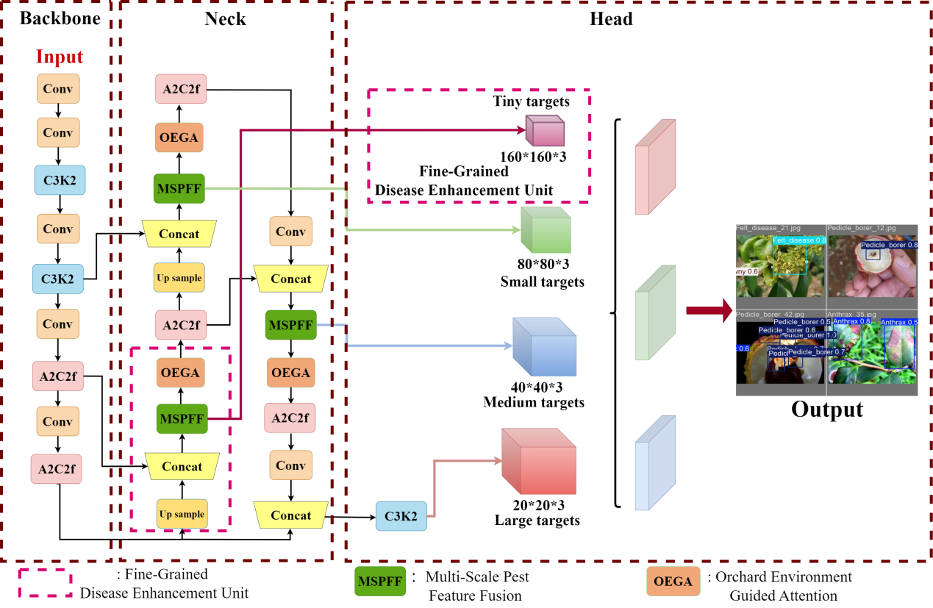
- Schematic diagram of the overall architecture of the LitchiGuard-Net model.
This architecture is built on YOLOv12, where the Backbone is mainly used to extract multi-level spatial features of litchi leaves and their surrounding environment from orchard images; the Neck part integrates key modules proposed in this paper, such as MSPFF and OEGA, to realize cross-scale feature fusion and contextual semantic information enhancement, thereby improving the model's feature expression ability for pest and disease targets of different scales; the Head part is used to output the final prediction results of litchi pest and disease categories and the corresponding bounding box localization information, realizing accurate detection of lesion and pest regions.

MSPFF, Multi-Scale Pest Feature Fusion
The design goal of the MSPFF module is to jointly model the local fine-grained texture features of litchi diseases and pests and the global context information of orchard scenes, so as to improve the model’s overall perception ability and feature expression ability for pest and disease targets in complex natural environments. In actual orchard images, lesion areas are usually small-scale, fine-textured and irregularly distributed targets. The single-scale convolution feature extraction method can hardly meet the detection requirements of tiny lesions and large disease areas at the same time. To solve this problem, this paper proposes the Multi-Scale Pest and Disease Feature Fusion Module (MSPFF), which extracts spatial information and semantic features of different scales at the same feature level through a parallel multi-branch structure, so as to enhance the model’s feature expression ability in complex background environments and alleviate the feature degradation caused by factors such as natural illumination changes, complex leaf textures and coexistence of multiple targets.
Specifically, the MSPFF module consists of three parallel feature extraction paths, which are used for multi-scale context information modeling, key semantic feature compression and original spatial information preservation respectively. The first path is the Multi-Scale Dilated Convolution Branch. By using 3×3 convolution kernels with different dilation rates, this branch constructs receptive fields of different ranges while maintaining the spatial resolution of feature maps, enabling the network to focus on both large-scale lesion areas and tiny disease texture features, thus improving the model’s detection ability for pest and disease targets of different scales. The second path is the Channel Feature Compression Branch, which maps and compresses features in the channel dimension through 1×1 convolution, making the network pay more attention to the semantic information related to pest and disease areas and reducing the consumption of computing resources by redundant features. The third path is the Identity Mapping Branch, which directly retains the original representation of the input feature map to ensure that shallow spatial location information can be effectively transmitted and improve the gradient propagation path in the network, thereby improving the stability during model training.
The outputs of the three branches are concatenated along the channel dimension to form a unified multi-scale feature map. The fusion formula is given as follows:
${\text{F}}_{\text{out}}\text{=Concat}\text{(}{\text{F}}_{\text{dilated,}}{\text{F}}_{\text{1∗1}}\text{,}{\text{F}}_{\text{identity}}\text{)}\text{.}$ (1)
Where ${\text{F}}_{\text{dilated}}$、${\text{F}}_{\text{1∗1}}$and ${\text{F}}_{\text{identity}}$denote the outputs of the dilated convolution branch, the 1×1 convolution branch, and the identity mapping branch, respectively. Concat represents the channel-wise concatenation operation. BatchNorm and the ReLU activation function are added after each convolution layer to enhance the nonlinear representation ability and training stability.
Dilated convolution can expand the receptive field without significantly increasing the number of parameters. Given the input $x\left(m,n\right)$ and the output $y\left(m,n\right)$ , it can be expressed as:
$\text{y}\left(\text{m,n}\right)\text{=}\sum_{\text{i}\text{=1}}^{\text{M}}{\sum_{\text{j}\text{=1}}^{\text{N}}{\text{x}\text{(}\text{m}\text{+}\text{r}\text{∗}\text{i}\text{+}\text{n}\text{+}\text{r}\text{∗}\text{j}\text{)}\text{ω}\text{(}\text{i}\text{,}\text{j}\text{)}}}\text{.}$ (2)
where M and N are the sizes of the convolution kernel, $ω\left(i,j\right)$ represents the convolution kernel weight, and r denotes the dilation rate. When r=1, the receptive field is 3×3; when r=2, it expands to 5×5; and when r=3, it can cover a 7×7 region, thereby expanding the target perception range while maintaining the resolution.
For a dilated convolution of size k×k, the calculation formulas of its equivalent receptive field (RF) and output resolution (H) are given as follows:
$\text{RF}\text{=}\text{(}\text{r}\text{−1}\text{)(}\text{k}\text{−1}\text{)}\text{+}\text{k}\text{.}$ (3)
$\text{H}\text{=}\frac{\text{h}\text{+2}\text{p}\text{−}\text{RF}}{\text{s}}\text{+1}\text{.}$ (4)
Where p denotes the padding size, h denotes the size of the input feature map, and s denotes the convolution stride. Through the above multi-scale feature fusion mechanism, MSPFF can maintain the sensitivity to tiny lesion targets while realizing the effective integration of semantic information at different levels, thereby significantly improving the litchi pest and disease detection performance of the model in complex orchard environments.

OEGA, Orchard Environment Guided Attention
With the continuous evolution of deep learning model structures, the attention mechanism has become an important technical method to improve object detection performance in complex scenes, especially showing obvious advantages in highlighting key target regions and suppressing background interference. In the task of litchi pest and disease detection, the orchard environment usually contains a large number of complex background factors, such as leaf textures, branch structures, fruit occlusion and illumination changes, which easily interfere with the accurate identification of lesion regions by the model. Since litchi disease targets are usually small in area and fine in texture, they are easily covered by background information in complex natural environments, resulting in missed detection or false detection of the detection model. Traditional attention mechanisms usually adopt a fixed weight strategy, which is difficult to dynamically adjust the feature response intensity according to different orchard environments. To solve this problem, this paper proposes the Orchard Environment Guided Attention (OEGA) mechanism. This mechanism guides the network to pay more attention to the feature regions related to pest and disease areas by modeling the visual context information in the orchard scene, so as to improve the detection stability and discrimination ability of the model in complex natural environments. The OEGA module is designed based on the YOLOv12 network structure and adopts a dual-path structure for parallel modeling of spatial attention and channel attention, which characterizes the spatial position relationship and channel semantic dependency in the feature map simultaneously. Its overall structure is shown as follows.
Spatial attention path: Suppose the input feature map is $Q∈ℝ^{C×H×w}$, which is mapped into $\left\{R,S\right\}ϵℝ^{C×H×w}$ via convolution operations, and then flattened into two-dimensional matrices ${R∈ℝ}^{C×N}$ and $S∈R^{C×N}$ (where $N=H∗W$). The spatial attention map $U∈ℝ^{N×N}$ is obtained through matrix multiplication and the softmax operation:
${\text{u}}_{\text{ji}}\text{=}\frac{{\text{e}}^{({\text{R}}_{\text{i}}⋅{\text{S}}_{\text{j}})}}{{\text{Σ}}_{\text{ⅈ=1}}^{\text{N}}{\text{e}}^{({\text{R}}_{\text{i}}⋅{\text{S}}_{\text{j}})}}\text{.}$ (5)
This spatial attention mechanism can establish the global dependency between pixels, enabling the model to pay more attention to the feature responses of pest and disease regions under complex backgrounds. Subsequently, the transformed feature map T and attention map U are weighted and fused, and a residual connection is introduced:
${\text{V}}_{\text{j}}\text{=β}\sum_{\text{i=1}}^{\text{N}}{({\text{u}}_{\text{ji}}{\text{T}}_{\text{i}})}\text{+}{\text{Q}}_{\text{j}}\text{.}$ (6)
Where $β$ is a learnable parameter initialized to 0 and automatically updated during the training process.
Channel attention path: To model the global dependencies among different channels, the input feature $Q∈ℝ^{C×H×w}$ is remapped into ${Q∈R}^{C×N}$, and the channel attention map $Z∈ℝ^{C×C}$ is obtained through correlation computation calculation:
${\text{z}}_{\text{ji}}\text{=}\frac{{\text{e}}^{({\text{Q}}_{\text{i}}⋅{\text{Q}}_{\text{j}})}}{{\text{Σ}}_{\text{ⅈ=1}}^{\text{C}}{\text{e}}^{({\text{Q}}_{\text{i}}⋅{\text{Q}}_{\text{j}})}}\text{.}$ (7)
The final output is obtained through channel-weighted aggregation and residual connection:
${\text{V}}_{\text{j}}\text{=γ}\sum_{\text{i=1}}^{\text{C}}{({\text{z}}_{\text{ji}}{\text{Q}}_{\text{i}})}\text{+}{\text{Q}}_{\text{j}}\text{.}$ (8)
Where $γ$ is a learnable parameter that ensures the network gradually optimizes the dependency modeling between channels during training.
Through the synergistic effect of spatial attention and channel attention, OEGA can dynamically adjust the importance of different regions and feature channels according to the orchard environmental characteristics, enabling the model to effectively focus on litchi pest and disease regions when facing complex backgrounds such as leaf textures, branch structures, illumination changes and so on.Experimental results show that after introducing the OEGA mechanism, both the detection accuracy and model robustness of LitchiGuard-Net in complex orchard environments are significantly improved, providing reliable technical support for the intelligent identification and monitoring of litchi diseases and insect pests.

FGDEU, Fine-Grained Disease Enhancement Unit
Although YOLOv12 has exhibited satisfactory comprehensive performance in conventional object detection tasks, it still faces certain challenges in detecting tiny lesion targets in complex orchard environments. In practical orchard images, litchi diseases and insect pests usually appear as small-area lesions or local pest regions, which often occupy only a few pixels in the image. Meanwhile, affected by factors such as natural illumination variation, leaf textures and background vegetation, the edge features of lesions tend to be blurred, making it difficult for the model to accurately capture key details during feature extraction. With the deepening of network layers, the resolution of feature maps is gradually reduced in the downsampling process, and the spatial information of tiny disease targets is easily weakened or even lost, resulting in missed detection or inaccurate localization during detection. In view of the above situation, this paper proposes the Fine-Grained Disease Enhancement Unit (FGDEU). Through cross-layer feature fusion and fine-grained texture enhancement mechanisms, the key information lost by the network during downsampling is compensated, thereby improving the model’s recognition ability for tiny lesion targets.
Specifically, the model first extracts the feature map with a resolution of 80×80×128 from the middle layer of the network (denoted as Feature Map 1). This feature map maintains certain spatial resolution while containing rich semantic information. To enhance its response capability to lesion regions, FGDEU first uses 1×1 convolution to perform channel compression and remapping on the feature map to achieve semantic alignment and reduce the interference of background information, whose calculation process is expressed as:
$\text{Feature} \text{Map} {\text{1}}^{\text{'}}\text{=}\text{σ}\text{(}{\text{W}}_{\text{1}}\text{∗}\text{Feature} \text{Map} \text{1}\text{)}\text{.}$ (9)
Where σ denotes the activation function, ∗ represents the convolution operation, and ${\text{W}}_{\text{1}}\text{.}$​ denotes the learnable parameters. This process reduces channel redundancy while improving the consistency of feature representation, enabling the model to better distinguish disease regions from complex leaf backgrounds.
Subsequently, Feature Map 1' is upsampled to 160×160×64 and fused with Feature Map 2 from the shallow layer (also 160×160×64) to obtain the cross-layer compensation feature map:
$\text{Feature} \text{Map}\text{ 1'' = }\text{Upsample}\text{(}\text{Feature} \text{Map}\text{ 1')}\text{.}$ (10)
$\text{Feature} \text{Map}\text{ 3 = }\text{Feature} \text{Map}\text{ 1'' + }\text{Feature} \text{Map}\text{ 2}\text{.}$ (11)
This cross-layer fusion structure effectively combines the high-resolution texture information retained in shallow features with the semantic information in middle-layer features, thereby compensating for the lack of detailed information that may occur when deep networks process tiny lesions, enabling the model to more accurately capture the edge contours and spatial positions of disease regions.
Subsequently, Feature Map 3 undergoes multi-layer convolution and nonlinear activation to generate the final prediction feature map Feature Map 4 with a resolution of 160×160×18:
$\text{Feature} \text{Map}\text{ 4 = σ}\text{(}{\text{W}}_{\text{2}} \text{∗} \text{Feature} \text{Map}\text{ 3}\text{).}$ (12)
By constructing a high-resolution prediction layer, Feature Map 4 can complete the category prediction and position regression of pest and disease targets on a finer-grained spatial grid, thus significantly enhancing the model’s detection ability for tiny lesions, dense disease regions and partially occluded targets.
Experimental results show that after introducing the FGDEU module, the performance of LitchiGuard-Net in the tiny lesion detection task is significantly improved with almost no additional computational overhead. The recall rate and overall detection accuracy of the model in complex orchard environments are effectively improved, providing more reliable technical support for the automatic identification and intelligent monitoring of litchi diseases and insect pests.

Experiments and Results

Experimental Settings
In this study, all experiments were conducted on a high-performance server equipped with an NVIDIA RTX 4090D (24GB VRAM), an Intel Xeon Platinum 8474C (15-core) CPU, and 80GB RAM. The operating system was Ubuntu 22.04, and the experiments were implemented using Python 3.10, CUDA 11.8, and the PyTorch framework.

Dataset
The litchi disease and pest detection dataset used in this study was constructed from image data collected in actual orchards combined with manual annotation. The data were mainly obtained by orchard monitoring equipment and mobile shooting devices, covering various types of litchi leaf diseases and pests. The pest and disease regions were accurately annotated for model training and performance evaluation. The dataset contains about 2000 images in total, and all images are uniformly resized to 640×640 pixels to meet the input requirements of the YOLOv12 network structure. In terms of annotation specifications, the dataset adopts the standard object detection format to accurately annotate the position and category information of litchi leaf lesions and pest regions. During data collection, the diversity of scenes was ensured as much as possible, including different orchard backgrounds, various shooting angles, and multiple natural lighting conditions, such as strong light, local shadows, cloudy days, and uneven illumination. In addition, some images also contain leaf occlusion, crossed branches, and complex vegetation backgrounds, making the dataset challenging in small-scale lesion recognition and complex background interference. Since litchi diseases and pests usually appear as small lesion areas with low pixel proportion in images, this dataset can effectively verify the model performance in small object detection and robustness in complex environments.

Implementation Details
To ensure the reproducibility of experimental results and the fairness of comparisons among different models, all training and test samples were uniformly resized to 640×640 in this paper. In the training phase, LitchiGuard-Net adopted various data augmentation strategies to improve the adaptability of the model to complex orchard environments, including common data augmentation methods such as random geometric transformation, color jittering, horizontal flipping, and brightness and contrast adjustment. Meanwhile, Mosaic and MixUp multi-image fusion augmentation strategies were combined to simulate common situations in orchard environments such as illumination variation, leaf occlusion, and coexistence of multiple targets, thereby enhancing the robustness of the model to small-scale disease and pest targets.
In terms of network structure settings, the model used a 3×3 convolutional layer at the front end for initial feature extraction with a stride of 1 to retain the edge information and spatial details of litchi leaf lesion regions as much as possible. The network weights were initialized with the Kaiming initialization method to improve the stability of gradient propagation in the early stage of deep network training.
In the design of the loss function, a weighted cross-entropy loss function was used in the target classification branch to alleviate the impact of unbalanced class sample distribution on the classification task; the CIoU (Complete Intersection over Union) loss function was introduced in the bounding box regression branch to more accurately measure the geometric matching relationship between the predicted box and the ground-truth box. AdamW was chosen as the model optimizer, with an initial learning rate of 1×10⁻⁴ and a weight decay coefficient of 0.0005. A cosine annealing learning rate scheduling strategy combined with a linear warm-up mechanism was adopted to improve stability and accelerate convergence during model training.
For specific training configurations, the batch size was set to 24 and the total training epoch was 100. Common metrics including Precision, Recall, F1-score, and mAP were used for model performance evaluation. The variation curves of the loss function and performance metrics were recorded during training to comprehensively analyze the actual performance of LitchiGuard-Net in the litchi disease and pest detection task. The relevant experimental results are shown in Figure 2.
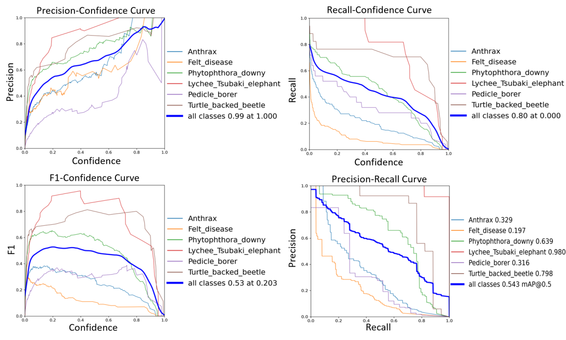
- Performance evaluation results of LitchiGuard-Net on the litchi disease and pest detection dataset, including the comprehensive performance of Precision, Recall, F1-score, and PR curve.

Ablation experiment
To evaluate the independent contributions and synergistic effects of the three modules proposed in this paper, namely MSPFF, OEGA and FGDEU, in the task of litchi disease and pest detection, this paper conducts systematic ablation experiments on the litchi disease and pest detection dataset, with the experimental results shown in Table 1. The baseline model YOLOv12 without any improved modules achieves Precision, Recall and mAP@0.5 of 81.4%, 79.0% and 82.1%, respectively. On this basis, gradually adding different modules can improve the model performance to varying degrees.
First, after introducing the MSPFF module, the Precision, Recall and mAP@0.5 of the model are improved to 85.2%, 84.3% and 85.1%, respectively. The results demonstrate that the multi-scale feature fusion mechanism can effectively enhance the model’s perception ability for pest and disease targets of different scales, especially under complex leaf backgrounds and large differences in lesion sizes, and can improve the model’s overall recognition ability for pest and disease regions. Second, after introducing the OEGA module, the Precision and Recall of the model are increased to 85.2% and 84.3%, respectively, and the mAP@0.5 reaches 85.4%. By introducing the context information of the orchard environment and dynamically weighting the features, this module enables the model to pay more attention to pest and disease regions in complex natural environments, and reduces the interference of leaf textures and background vegetation on detection results, thereby improving the detection stability of the model. Meanwhile, after adding the FGDEU module, the model exhibits an obvious improvement in the Recall metric (reaching 85.4%), indicating that this module plays a positive role in enhancing the feature representation of tiny lesions and can effectively improve the recognition ability for fine-grained disease targets.
When any two modules are used in combination, the model performance is further improved, and the mAP@0.5 is close to or exceeds 88%, indicating that different modules have good complementarity.For example, when MSPFF and OEGA are introduced simultaneously, the model can further utilize orchard environment information for feature enhancement on the basis of multi-scale feature fusion, thus significantly improving the overall detection accuracy. When OEGA and FGDEU are combined, the model performs particularly prominently on the Recall metric, indicating that fine-grained feature enhancement and environmental attention mechanism can effectively improve the recognition ability for tiny lesion targets.
Finally, when the three modules MSPFF, OEGA and FGDEU are introduced simultaneously, the model achieves the optimal performance. Its Precision, Recall and mAP@0.5 reach 96.2%, 95.0% and 96.1% respectively, which are significantly improved compared with the baseline YOLOv12. The experimental results show that the three improved modules have good synergy in the task of litchi pest and disease detection, which can effectively improve the detection accuracy and robustness of the model in complex orchard environments, thus verifying the effectiveness of the LitchiGuard-Net model design.
- Analysis of Ablation Experiment Results of LitchiGuard-Net on the Litchi Disease and Pest Detection Dataset
YOLOv12 | MSPFF | OEGA | FGDEU | Precision(%) | Recall(%) | mAP@0.5(%)
√ | × | × | × | 81.4 | 79.0 | 82.1
√ | √ | × | × | 85.2 | 84.3 | 85.1
√ | × | √ | × | 85.2 | 84.3 | 85.4
√ | × | × | √ | 84.0 | 85.4 | 85.1
√ | √ | √ | × | 88.0 | 86.6 | 89.2
√ | √ | × | √ | 88.2 | 87.7 | 88.6
√ | × | √ | √ | 88.4 | 88.8 | 89.2
√ | √ | √ | √ | 96.2 | 95.0 | 96.1

- Performance Comparison between LitchiGuard-Net and Mainstream Object Detection Models in Litchi Disease and Pest Detection
Model | mAP% | Params/M | FPS/(Frames/s)
Faster R-CNN | 80.1 | 18.4 | 11
SSD | 73.3 | 21.5 | 30
RetinaNet | 56.5 | 34.6 | 25
SKS-YOLO | 89.4 | 43.8 | 55
CenterNet | 81.4 | 47.2 | 20
YOLOv5s | 85.6 | 15.5 | 66
EfficientDet | 69.3 | 62.1 | 15
LitchiGuard-Net (Our) | 96.1 | 10.3 | 94

Results and Discussion
To comprehensively evaluate the overall performance of LitchiGuard-Net in the task of litchi disease and pest detection, this paper conducts comparative experiments with various mainstream object detection models on the constructed dataset, with the experimental results shown in Table 2. In terms of detection accuracy, the mAP of LitchiGuard-Net reaches 96.1%, which is significantly better than other mainstream detection algorithms, including SKS-YOLO (89.4%), YOLOv5s (85.6%), CenterNet (81.4%), Faster R-CNN (80.1%), SSD (73.3%) and other models. The experimental results show that the three key modules MSPFF, OEGA and FGDEU proposed in this paper can effectively improve the feature representation ability of the model for disease and pest targets of different scales, and exhibit stronger recognition ability in complex orchard environments and small-scale lesion detection tasks. This result is also consistent with the analysis results of the ablation experiments in Table 1.
In terms of model complexity and inference efficiency, LitchiGuard-Net also shows favorable performance advantages. Its model parameters are only 10.3M, which is significantly lower than those of RetinaNet (34.6M), SKS-YOLO (43.8M) and EfficientDet (62.1M), reflecting good lightweight characteristics. Meanwhile, in terms of inference speed, the detection speed of LitchiGuard-Net reaches 94 FPS, which performs best among all comparison models. Compared with YOLOv5s (66 FPS, 15.5M parameters) and SKS-YOLO (55 FPS, 43.8M parameters), LitchiGuard-Net further reduces the model size while maintaining higher detection accuracy, and significantly improves inference efficiency, showing a good balance between accuracy and speed.
It can be seen from the comprehensive experimental results that LitchiGuard-Net has strong adaptability and application potential in the task of litchi disease and pest detection. Especially when dealing with practical orchard scenarios such as small-scale lesion targets, complex leaf texture backgrounds and natural illumination changes, the model can still maintain high detection accuracy and stability. At the same time, its low parameter size and high inference speed make it more suitable for deployment in orchard intelligent monitoring equipment or agricultural automation management systems, providing effective technical support for the real-time monitoring and precise prevention and control of litchi diseases and insect pests. Visual examples of partial detection results are shown in Figure 3.
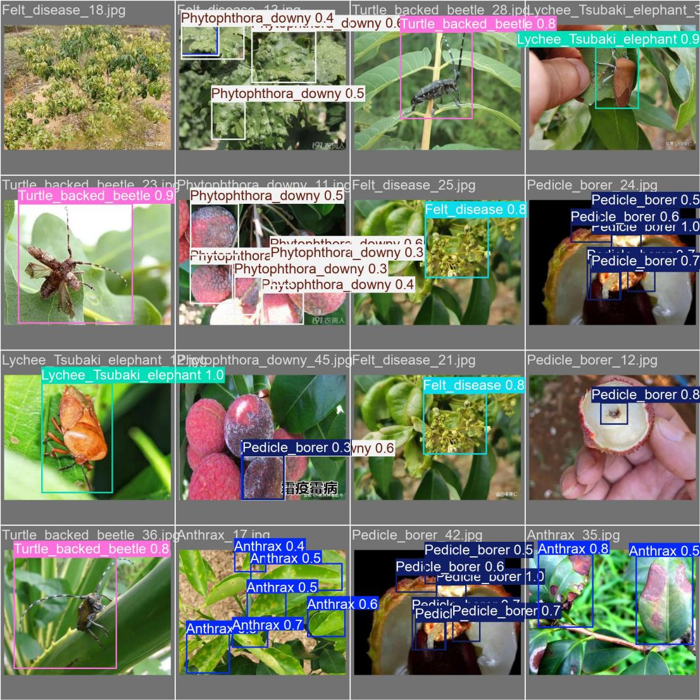
- Visual detection results of LitchiGuard-Net in real orchard environments.

Conclusion
Aiming at the problems of small lesion target scale, complex orchard background and natural illumination variation in litchi disease and pest detection, this paper proposes an improved detection model LitchiGuard-Net based on YOLOv12. By introducing the multi-scale pest and disease feature fusion module (MSPFF), orchard environment-guided attention mechanism (OEGA) and fine-grained disease enhancement unit (FGDEU), the model improves the recognition ability of pest and disease targets from three aspects: multi-scale feature fusion, environmental information guidance and fine-grained feature enhancement. Experimental results show that LitchiGuard-Net achieves 96.1% mAP on the litchi disease and pest detection dataset, with an inference speed of 94 FPS and only 10.3M parameters. It outperforms various mainstream detection algorithms in terms of detection accuracy, model size and real-time performance, showing good robustness and application potential. In the future, cross-scenario transfer learning and model lightweight optimization will be further studied to improve the generalization ability and application value of the model in practical smart agricultural systems.

References
- Zhu D J, Xie L Z, Chen B X, et al. Knowledge graph and deep learning based pest detection and identification system for fruit quality[J]. Internet of Things, 2023, 21: 100649.
- Gupta B, Kumar S, Chhabra M, et al. Enhancing Crop Health a Novel CNN-SVM Hybrid Model for Litchi Disease Detection[C]//International Conference on Modern Practices and Trends in Expert Applications and Security. Singapore: Springer Nature Singapore, 2024: 439-447.
- Ren S, He K, Girshick R, et al. Faster R-CNN: Towards real-time object detection with region proposal networks[J]. IEEE transactions on pattern analysis and machine intelligence, 2016, 39(6): 1137-1149.
- He K, Gkioxari G, Dollár P, et al. Mask r-cnn[C]//Proceedings of the IEEE international conference on computer vision. 2017: 2961-2969.
- Kumar R, Kumar A, Singh M, et al. Litchi Leaf Disease Multiclasssification: Unraveling the Enigma Using CNN-Random Forest Model[C]//2024 International Conference on Automation and Computation (AUTOCOM). IEEE, 2024: 12-15.
- Hussain M. YOLO-v1 to YOLO-v8, the rise of YOLO and its complementary nature toward digital manufacturing and industrial defect detection[J]. Machines, 2023, 11(7): 677.
- Liu W, Anguelov D, Erhan D, et al. Ssd: Single shot multibox detector[C]//European conference on computer vision. Cham: Springer International Publishing, 2016: 21-37.
- Chen J S, Liu M, Li J S, et al. LFA-YOLO: Detection of Lychee Fruit Anthracnose Based on UAV Images and Deep Learning[J]. Applied Engineering in Agriculture, 2024, 40(5): 515-523.
- Xie J, Zhang X, Liu Z, et al. Detection of litchi leaf diseases and insect pests based on improved FCOS[J]. Agronomy, 2023, 13(5): 1314.
- Lu J, Wu Z, Lan Y, et al. Study on the prediction model of litchi downy blight damage based on IoT and hyperspectral data fusion[J]. IEEE Internet of Things Journal, 2024, 11(16): 27184-27200.

