**Project Name**

**Team**

NB

**Date**

2021/3/13



# Executive Summary

**Purpose of Report**

The recommendation system was designed and implemented to realize the purpose of the company that in real-estate and have the ability to compete with other websites. So, it would focus to have a much better interface design and higher performance system.

The purpose of this report are to；

(1) Determine core demands of the company

(2) Determine the website form and core system

**Methods**

An analyzation of the competitor was implemented including 5 major website that focus on housing market. A total of 50 main functions were analyzed which focused on recommendation and information display. The request amount of each functions are calculated and collected to analysis the customer preference.

**Findings and Conclusions**

The major request (80%) is finding the house neat their location. The searching of oversea house is the most useless function which only contain 1% amount. The preference of customer is highlighted:

(1) Find house in the range of five Kilometers.

(2) Barely have customer want to find a oversea or far away house.

**Recommendations for website design**

Agile develop, Cost-effective scalable recommendations include:

(1) Determine the core requirements

(2) Parallel develop

(3) Cut some useless function

(4) construct serve in one place

# Statement of the Problem

There is a startup company in real-estate market which is created by a group of business leaders. They hope that they can have technologies and platforms for using and compete with some other existing platforms. The team was hired to meet customer needs.

The leaders have not decided the details of their platform and all decisions about tools and technologies are allowed to be selected by the team. The target of this company is extracting value from existing real estate datasets and offering them to users. The platform should be web based. Target users of this platform should be people who are looking to buy house and those in industries associated with or depend on this market.

In conclusion, the core is to decide and implement what is valuable for the business and their product.

# Objectives

The objective of this project is to provide targeted and quality services for users and value for customers.

At first, some basic functions will be included in this project, such as registration and login of user, browsing and search of data, communication between clients and staff. Some other functions will be added into project if it is necessary.

Besides, this project will focus on recommender system. User can be recommended some information they may need depending on their daily browsing by this system.

All functions in this project will be displayed in a pretty and user-friendly user interface.

# Technical Approach

The website would including three main parts Front-end ,Back-end and recommendation algorithm. For front-end we would use HTML, CSS and Flask framework. The Back-end we would use a online server to support the online request Flask framework would be used The CentOS which is widely used and be known as a steady and simple Linux system. The recommendation system would use both techniques form Machin learning and Information retrieval.

# Project Schedule

Our team plan is listed below.

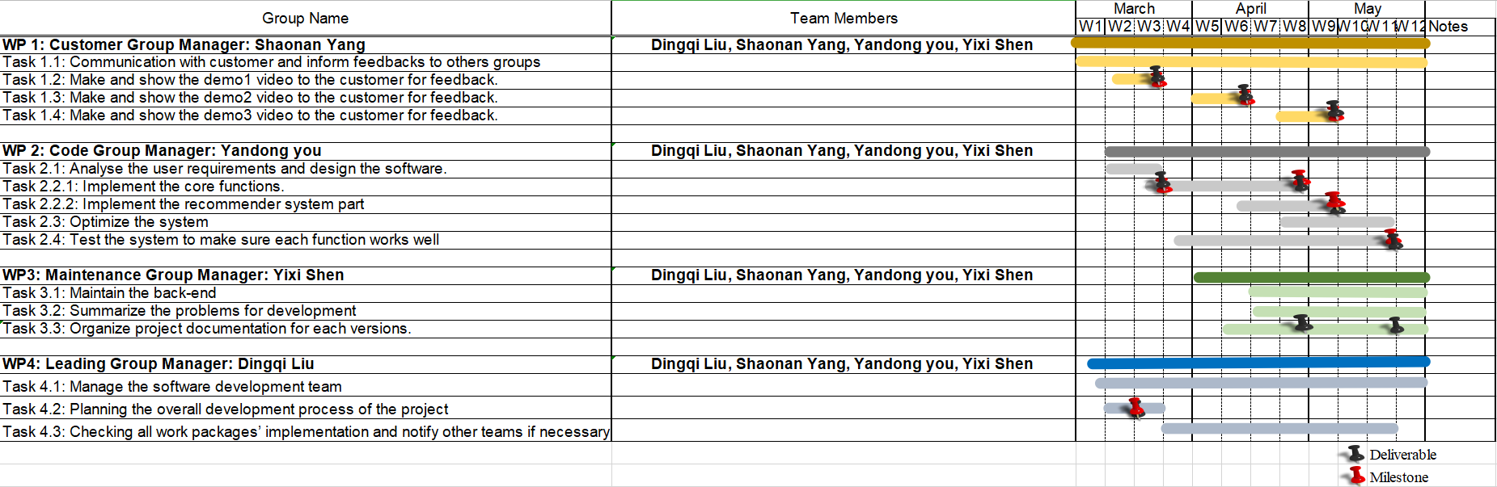

# Deliverables

This project will deliver a real-estate system and relative documents and files for customers.

For system, a cloud-based system will be delivered, and it can run on both mobile phones and computers. It can satisfy the requirements of customers. Before final release delivered,

versions that implement parts of the functions will be delivered in the form of demo video. It will be delivered every several weeks and will be used for testing, risk assessment discussion with customers about the project. Development will be adjusted based on the feedback from the discussion.

For documents, all documents during development will be delivered. It includes documentation of development plan and process which include work packages, Gantt chart, and weekly update. These record division of labor, tasks of each week and communication of our team. Another documents deliverable is project report. It provides description and summarized different part of the project

# Project Focus

Mention any additional details that you feel appropriate.

# Team Qualifications

This is also optional. If you would like to list out each person’s strength and role on the project, that would be excellent.