# Github服务端操作

## 创建远程仓库，

选的属性是public

选择拷贝仓库方式为ssh：

git@github.com:llll-2000/demo-git.git

…or create a new repository on the command line

echo "# demo-git" >> README.md

git init

git add README.md

git commit -m "first commit"

git branch -M main

git remote add origin git@github.com:llll-2000/demo-git.git

git push -u origin main

…or push an existing repository from the command line

git remote add origin git@github.com:llll-2000/demo-git.git

git branch -M main

git push -u origin main

# 二、本地操作

## 1、安装git

国内网址：https://blog.csdn.net/qq_46255808/article/details/130250543

## 2、设置

1） git config --global user.name "llll-2000"

## 3、创建SSH Key

$ ssh-keygen -t rsa

Generating public/private rsa key pair.

Enter file in which to save the key (/c/Users/Administrator/.ssh/id_rsa):

Enter passphrase (empty for no passphrase):

Enter same passphrase again:

Your identification has been saved in /c/Users/Administrator/.ssh/id_rsa.

Your public key has been saved in /c/Users/Administrator/.ssh/id_rsa.pub.

The key fingerprint is:

SHA256:7eCq3z4f+aXMH8jOhlRGGmftqIL/JlTcSSARqMSU0Hk Administrator@USER-20221227OX

The key's randomart image is:

+---[RSA 2048]----+

| .=.o .+o.. . |

| * E .. = . |

| . o . O + |

| . .+ * . |

| .S..+ |

| ..oooo . |

| o.o+.o o |

| o+ oB.o . |

| .oo.o*o.B.. |

+----[SHA256]-----+

## 4、github增加ssh-key

1）先登录

2）在用户-》setting->ssh-key>new ssh key后，将/c/Users/Administrator/.ssh/id_rsa.pub内容拷

贝到编辑框中，title填写一个名字，点击add key，成功后会看到新增的ssh key。

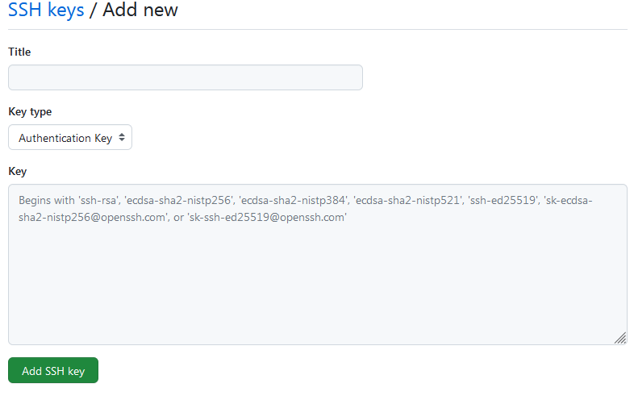

添加成功显示：

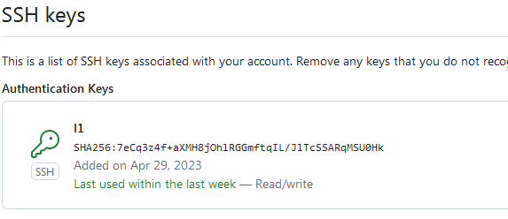

## 5、拷贝远程仓库到本地

$ git clone git@github.com:llll-2000/demo-git.git

Cloning into 'demo-git'...

warning: You appear to have cloned an empty repository.

表示拷贝成功。

## 6、新增文件到本地仓库

Administrator@USER-20221227OX MINGW64 /f/git-repo/demo-git (master)

$ vi readme.txt

Administrator@USER-20221227OX MINGW64 /f/git-repo/demo-git (master)

$ git status

On branch master

No commits yet

Untracked files:

(use "git add <file>..." to include in what will be committed)

readme.txt

nothing added to commit but untracked files present (use "git add" to track)

Administrator@USER-20221227OX MINGW64 /f/git-repo/demo-git (master)

$ add ./

bash: add: command not found

Administrator@USER-20221227OX MINGW64 /f/git-repo/demo-git (master)

$ git add ./

warning: LF will be replaced by CRLF in readme.txt.

The file will have its original line endings in your working directory

$ git commit -m "test for demo"

[master (root-commit) b8af822] test for demo

1 file changed, 1 insertion(+)

create mode 100644 readme.txt

## 7、同步到远程仓库

$ git push origin master

Enumerating objects: 3, done.

Counting objects: 100% (3/3), done.

Writing objects: 100% (3/3), 231 bytes | 231.00 KiB/s, done.

Total 3 (delta 0), reused 0 (delta 0)

To github.com:llll-2000/demo-git.git

* [new branch] master -> master

表示同步成功。在github上能看readme.txt文件。

