**一、表结构操作**

**1.建立一个表scores，有两个列族grade和course**

**hbase(main):006:0> create 'scores','grade','course'**

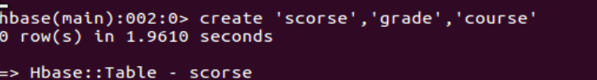

**2.查看Hbase中的所有表**

**hbase(main):007:0> list**

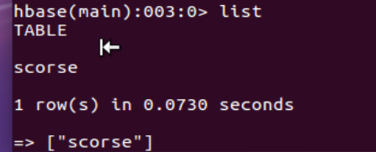

**3.查看scores表结构**

**hbase(main):008:0> desc 'scores‘**

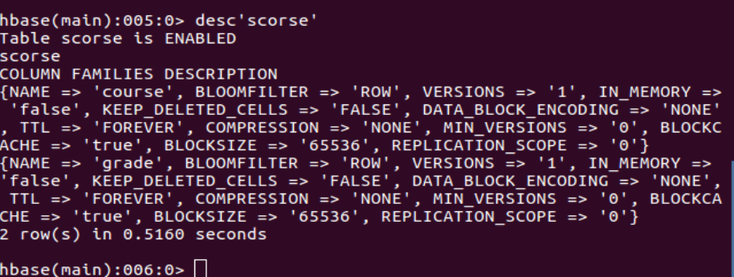

**4.查询表scores是否存在**

**hbase(main):009:0>** 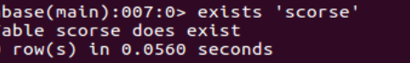

**5.判断表scores是否enable**

**hbase(main):010:0> is_enabled 'scores'**

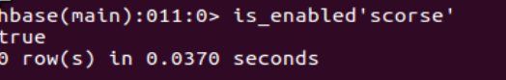

**6.判断表scores是否disable**

**hbase(main):011:0> is_disabled 'scores'**

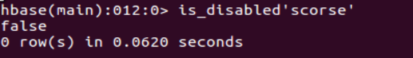

**7.使表scores不可用**

**hbase(main):012:0> disable 'scores'**

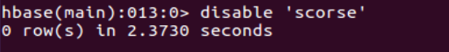

**8.恢复表scores可用**

**hbase(main):013:0> enable 'scores'**



**.增加一个school列族**

**hbase(main):002:0> alter 'scores',{NAME=>'school',VERSIONS=>3}**

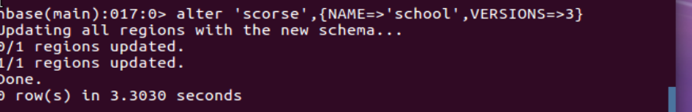

**10.删除一个school列族**

**hbase(main):005:0> alter 'scores',{NAME=>'school',METHOD=>'delete'}**

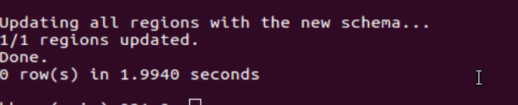

**11.删除表scores**

**操作步骤：先禁用表，再删除表**

**hbase(main):004:0> disable 'scores' #先将scores表改为offline状态**

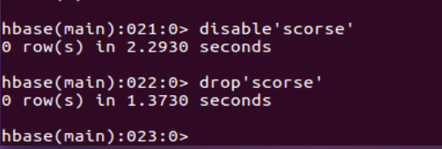

**hbase(main):005:0> drop 'scores' #再删除表**

**二、DML操作（数据操纵）**

**1.添加scores数据**

**其scores表数据如下：**

**Tom grade: 5 Jim grade: 4**

**Tom course:math 97 Jim course:chinese 89**

**Tom course:art 87 Jim course:english 80**

**Tom course:english 80**

**hbase(main):006:0> put 'scores','Tom','grade','5'**

**hbase(main):007:0> put 'scores','Tom','course:math','97'**

**hbase(main):009:0> put 'scores','Tom','course:art','87'**

**hbase(main):010:0> put 'scores','Tom','course:english','80'**

**hbase(main):012:0> put 'scores','Jim','grade','4'**

**hbase(main):013:0> put 'scores','Jim','course:chinese','89'**

**hbase(main):014:0> put 'scores','Jim','course:english','80'**

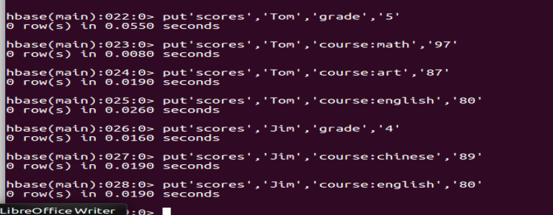

**2.查看数据**

**a.全表scores扫描**

**hbase(main):015:0> scan 'scores'**

**ROW COLUMN+CELL**

**Jim column=course:chinese, timestamp=1464871444954, value=89**

**Jim column=course:english, timestamp=1464871467549, value=80**

**Jim column=grade:, timestamp=1464871414324, value=5**

**Tom column=course:art, timestamp=1464871299895, value=87**

**Tom column=course:english, timestamp=1464871325997, value=80**

**Tom column=course:math, timestamp=1464871198158, value=97**

**Tom column=grade:, timestamp=1464871151963, value=5**

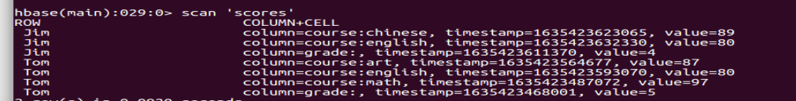

**b.查看表scores中Jim的一行的数据**

**hbase(main):015:0> get 'scores','Jim'**

**COLUMN CELL**

**course:chinese timestamp=1525517153708, value=89**

**course:english timestamp=1525517175237, value=80**

**grade: timestamp=1525517135348, value=5**

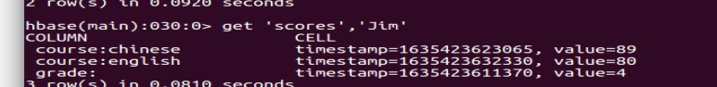

**c.查看一个单元格的数据**

**hbase(main):016:0> get 'scores','Tom',{COLUMN=>'course:math'}**

**COLUMN CELL**

**course:math timestamp=1464871198158, value=97**

**1 row(s) in 0.0900 seconds**

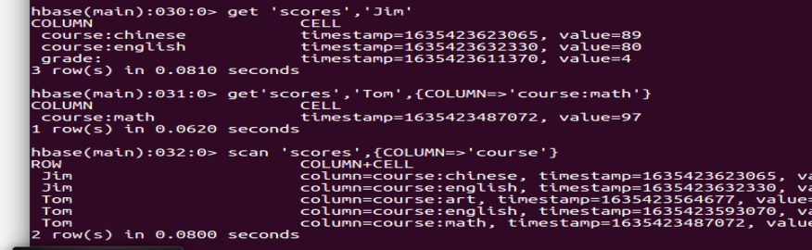

**d.查看一个course列族的数据**

**hbase(main):017:0> scan 'scores',{COLUMN=>'course'}**

**ROW COLUMN+CELL**

**Jim column=course:chinese, timestamp=1464871444954, value=89**

**Jim column=course:english, timestamp=1464871467549, value=80**

**Tom column=course:art, timestamp=1464871299895, value=87**

**Tom column=course:english, timestamp=1464871325997, value=80**

**Tom column=course:math, timestamp=1464871198158, value=97**

**2 row(s) in 0.0170 seconds**



**e.查看表scores中的course:english列的数据**

**hbase(main):019:0> scan 'scores',{COLUMN=>'course:english'}**

**ROW COLUMN+CELL**

**Jim column=course:english, timestamp=1464871467549, value=80**

**Tom column=course:english, timestamp=1464871325997, value=80**

**2 row(s) in 0.0260 seconds**



**f.统计表scores的行数**

**hbase(main):020:0> count 'scores'**

**2 row(s) in 0.0890 seconds**

**=> 2**



**3.修改数据**

**a.修改scores表中的Tom的math值为100**

**hbase(main):021:0> put 'scores','Tom','course:math','100'**

**0 row(s) in 0.0140 seconds**



**b.修改scores表中列族course的VERSIONS=>3**

**hbase(main):022:0> alter 'scores',{NAME=>'course',VERSIONS=>3}**

**Updating all regions with the new schema...**

**0/1 regions updated.**

**1/1 regions updated.**

**Done.**

**0 row(s) in 2.2190 seconds**

**再进行修改cores表中的Tom的math值为90，80，70**

**hbase(main):023:0> put 'scores','Tom','course:math','100'**

**.......**

**0 row(s) in 0.0490 seconds**

**再按VERSIONS=>3查看该表中course:math的值**

**hbase(main):025:0> get 'scores','Tom',{COLUMN=>'course:math',VERSIONS=>3}**

**COLUMN CELL**

**course:math timestamp=1464872264511, value=70**

**course:math timestamp=1464872264509, value=80**

**course:math timestamp=1464872264507, value=90**

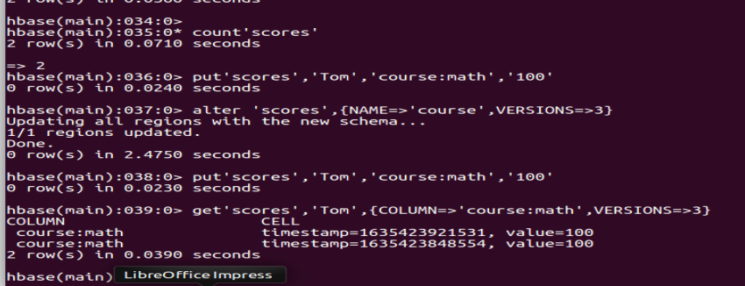

**4.删除数据**

**a.删除scores表Jim的course:chinese的值**

**hbase(main):027:0> delete 'scores','Jim','course:chinese'**

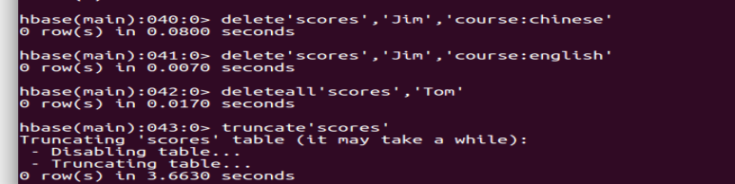

**b.删除scores表Tom的course:english的值**

**hbase(main):029:0> delete 'scores','Tom','course:english'**



**c.删除scores表Tom一行**

**hbase(main):032:0> deleteall 'scores','Tom'**



**d.清空scores表中的内容**

**hbase(main):031:0> truncate 'scores'**



**把书上P96-97的三张表（表4-22、表4-23、表4-24）设计成适合HBase存储的表结构，建表并录入数据**

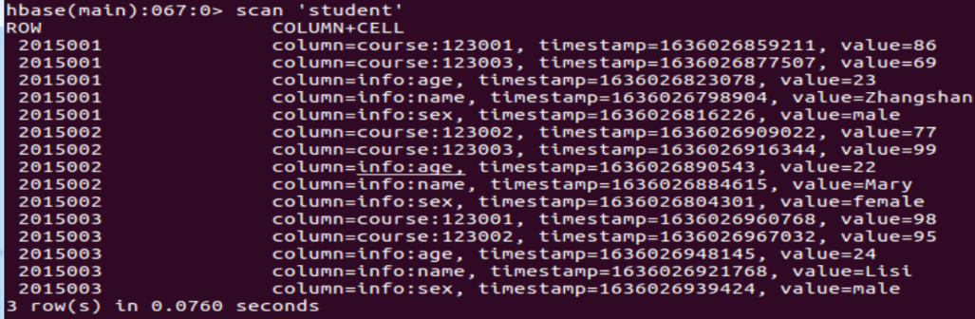

**针对书上P96-97的三张表设计的HBase表，实现书上P97指定的(1)、(2)、(3)、(5)的功能**

