Memorandum
Date: 30.10.2013
From: Group 9
To: IEEE E-Board
Subject: NXT Robotics Progress

Progress during last week:
Up to date git repo: https://github.com/llllllllll/nxt_robot (My github account).
Programming mostly. UI has pretty much settled down, with status indicators on the left, and a console log on the right. The console now supports writing in different attributes (colors, bold, underlined) so that different events can be quickly noticed, especially errors. We defined a standardized color scheme to make reading the console very easy. All log entries start with a header in the form of “[hour:minute:second]:” so that events have more context. I know Trent said that he never could get a bluetooth connection to last, but I looked into the opcodes for the NXT and have the screen spawn a pthread that writes a raw message of 0x80 0x0D or a direct message with no response of type stay alive every 60 seconds. This thread forces the NXT not to power down for another couple of minutes, so this makes sure it never drops on us. This thread is created after the connection is properly established with the NXT so that there are now invalid writes. Because this thread is also logging to the console, I had to employ something from other ncurses work I have done, where I have a lock on the writing. The writeln function starts with a while(lock); to hold it until the lock is off, so that if two threads try to log at the same time, one will not affect the other, and they will block eachother and take turns. This also prevents a memory corruption or segfault on the logv, and logattr arrays when the two threads race on the same data. I also added locks to all functions that move or print so that there is no races on the screen that would cause corrupted output. We also capture the SIGINT from the OS in the terminal to allow for a graceful exit where all memory is free' d causing no leaks. I think the only task left is to flush out the autonomous code, and maybe move the sensors around based on our testing.

Problems encountered:
Segfaults everywhere. No, but I had a couple that needed to be cleaned up. Also, I had to look into the stay alive message myself by reading the lego bluetooth standards, because there is almost no documentation on it, and non for what I needed. However, that made it all the more rewarding when I was able to get that working, and I tested by keeping the NXT alive for 30 minutes without touching it before I decided it worked and was ready to push my commits. I also ran into problems with the console painting properly on a terminal resize, but that was pretty trivial, and was just do to an allocation of the wrong size. I am also severly regretting the fact that I used some cpp librarys because it makes my code dumb, I mean, why am I wrapping my functions in an object for no reason, why do I need to cast my mallocs? However, I am saving a little bit of time with the NXT connection so I am going to let it be, barring an FFI rewrite.

Future plans:
we plan on having a little preformance tweaks here and there for the UI, and on fine grain testing the autonomous programs for hours. This might mean tweaking the physical robot, but we are okay with that. We may want to move the third motor to the drive mechanisms instead of dumping, and then constructing a mechanical delivery mechanism.

Activities of members:

Joe Jevnik worked on all of the programming (and the memo if you couldn't tell). Chris Stewart and Joe Fancher worked on the physical construction. And David has not shown up since before NXT started and left us with no means of contacting him, so he has not participated at all.

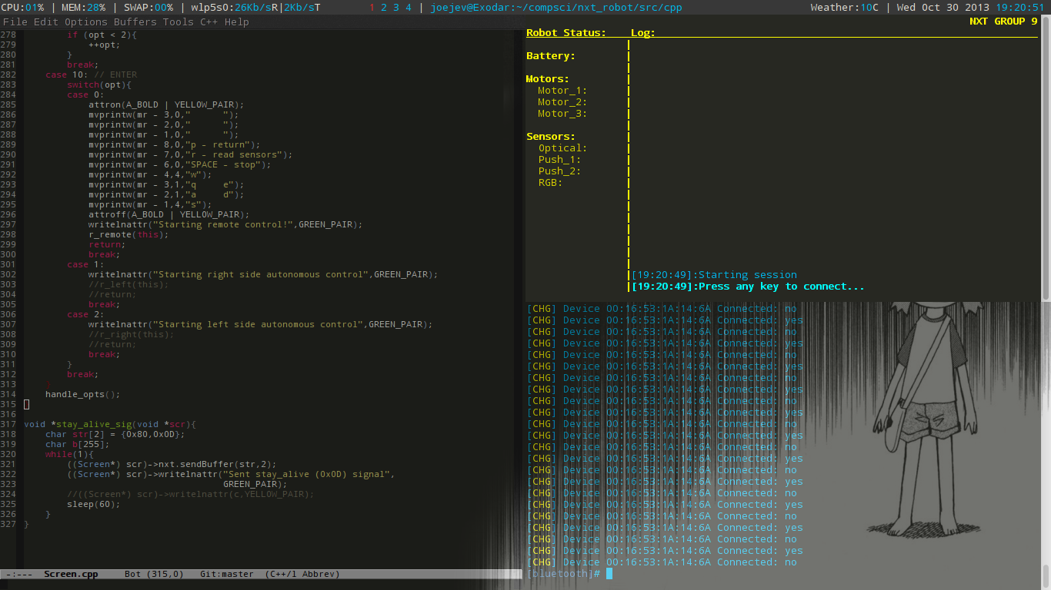
Included Pictures:
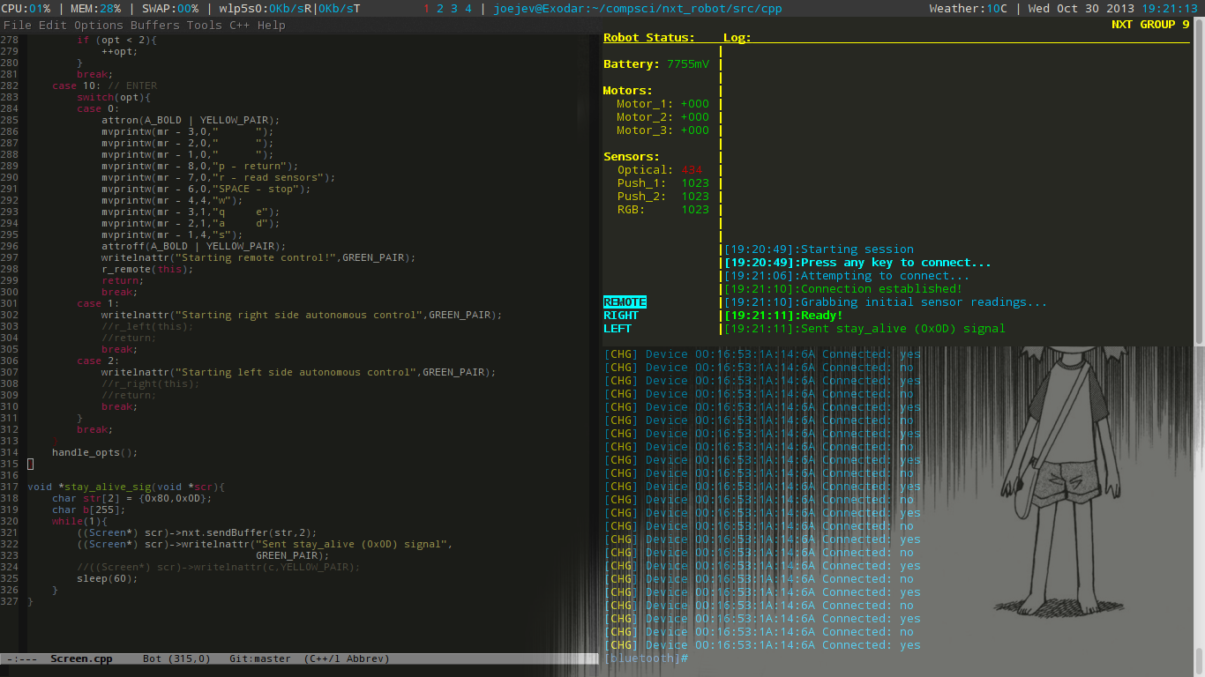
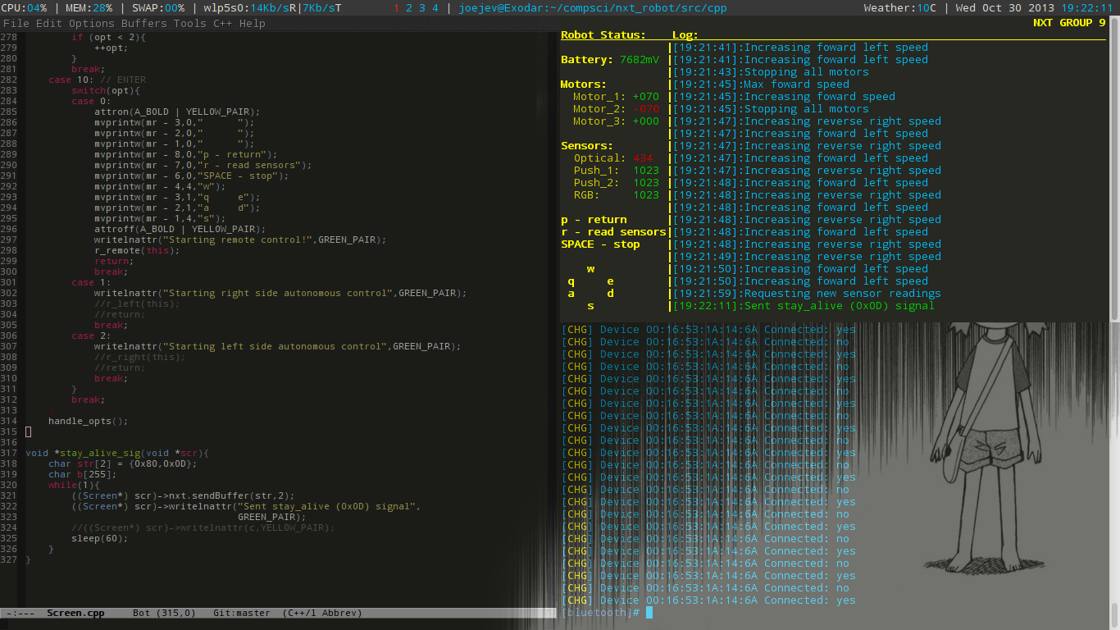

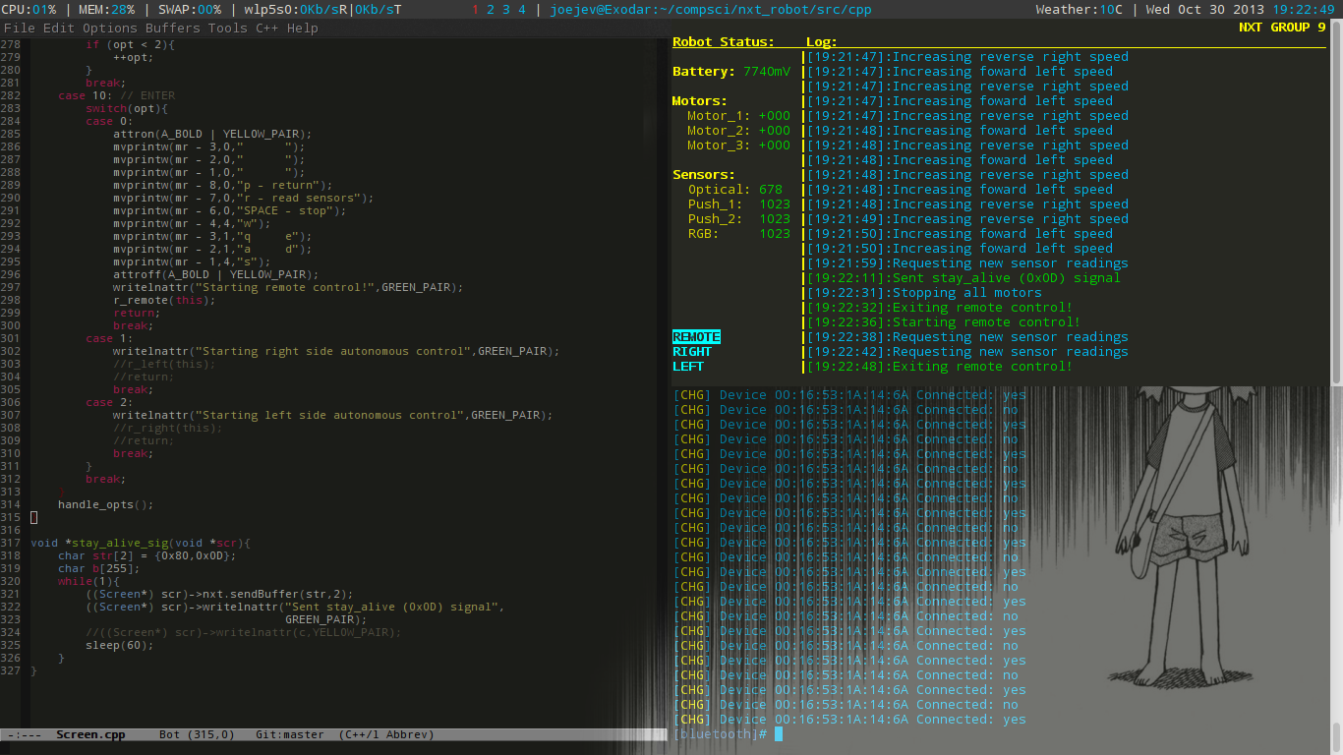
NOTE: There was a change to the color of the signal prints from green to yellow. Also the code in the image is outdated.

