Group 9
October 23, 2013
Week One
Memorandum

Construction:
We began construction of the main robot, completing the ball dispensing mechanism and base. We omitted inclusion of the sensors until we know how we want to go about programming it.
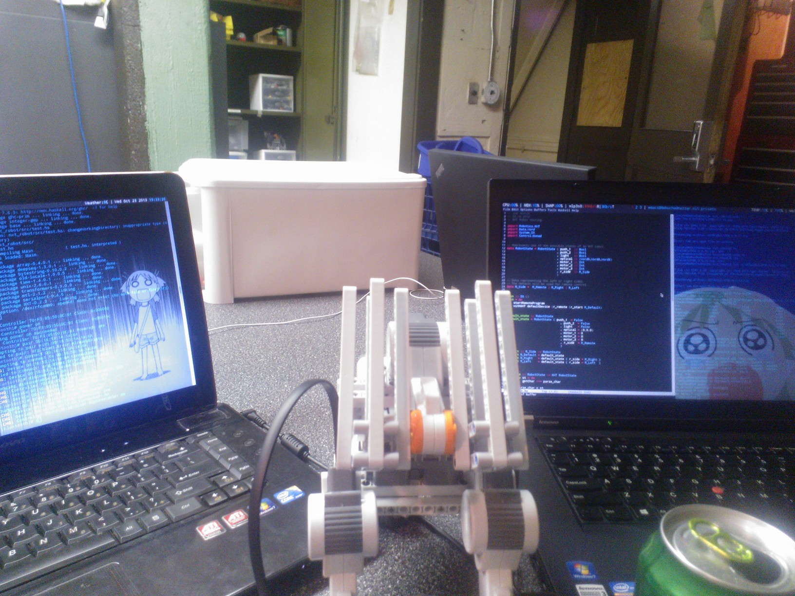
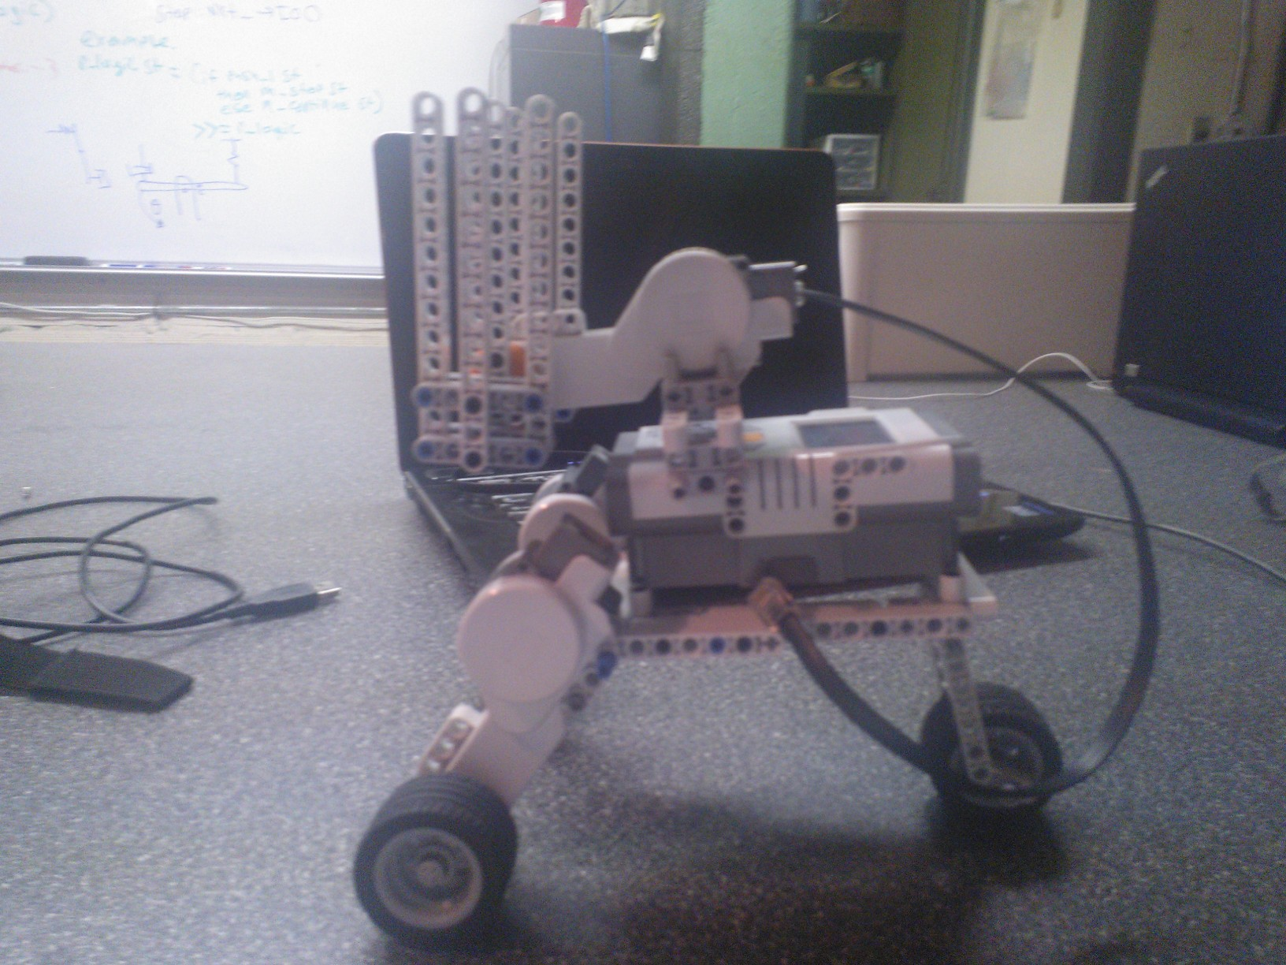
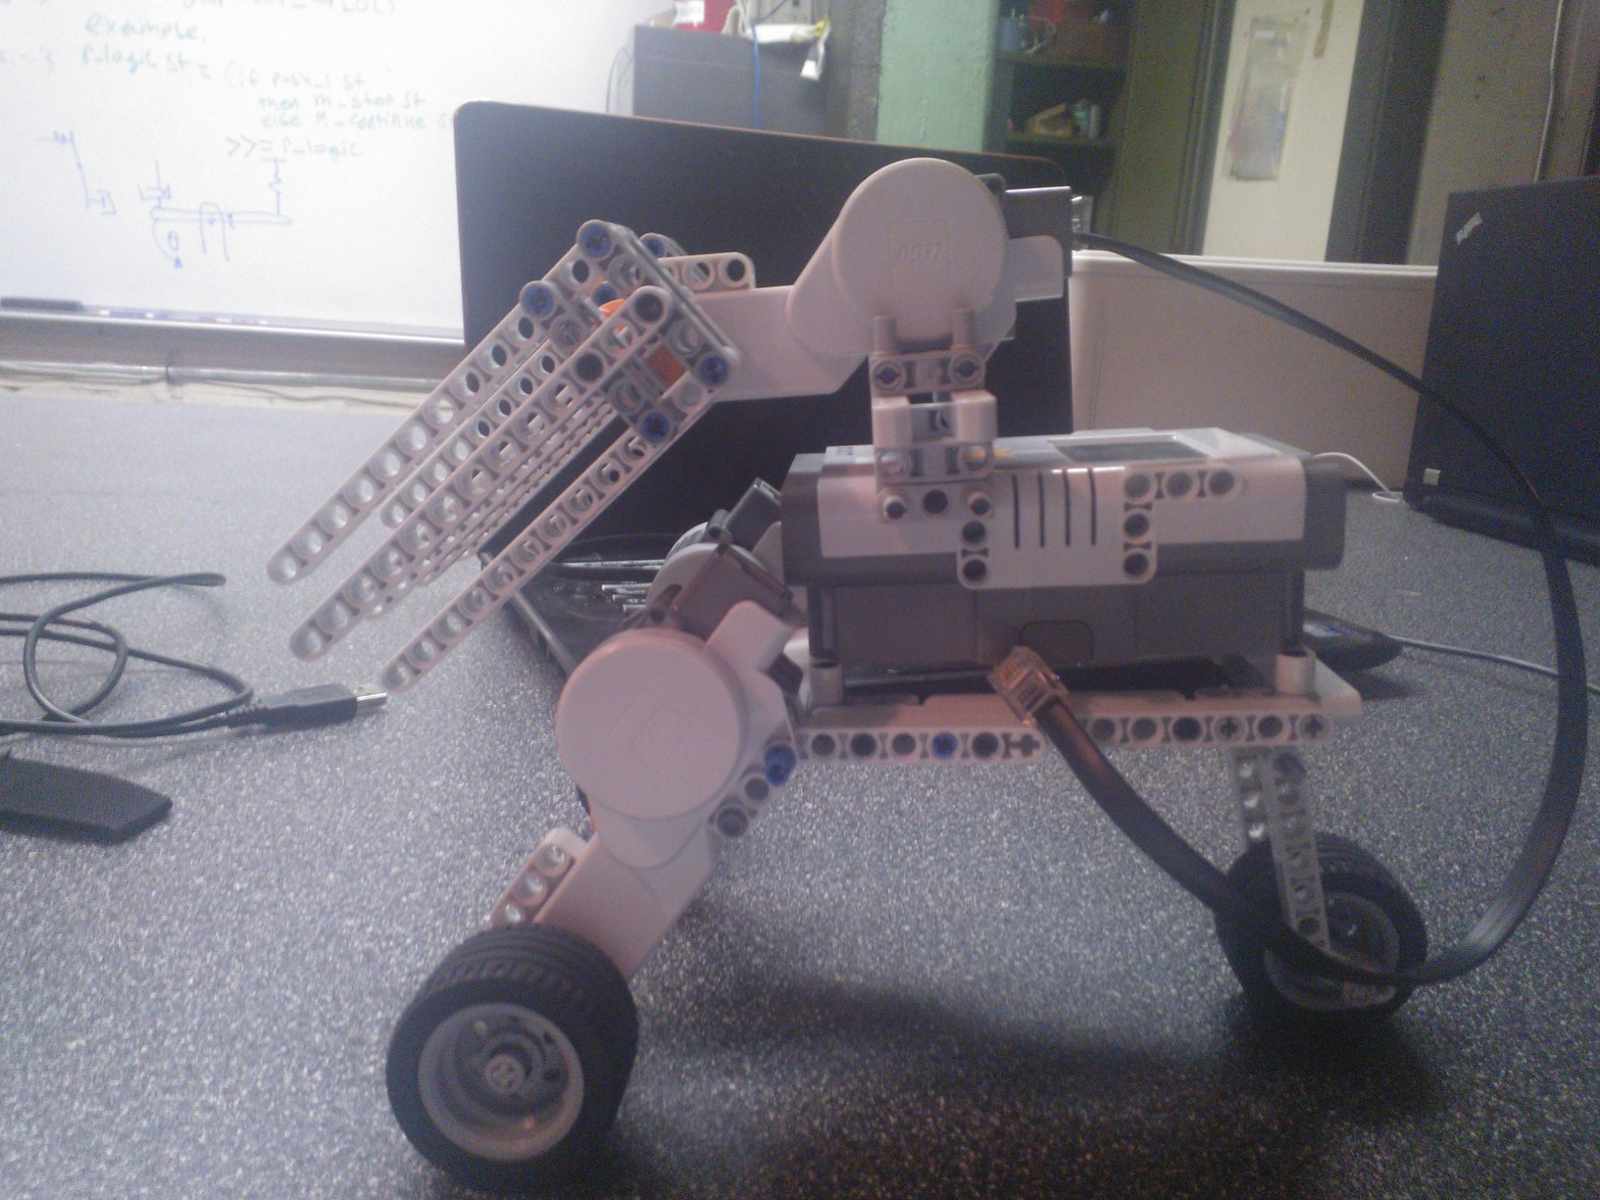
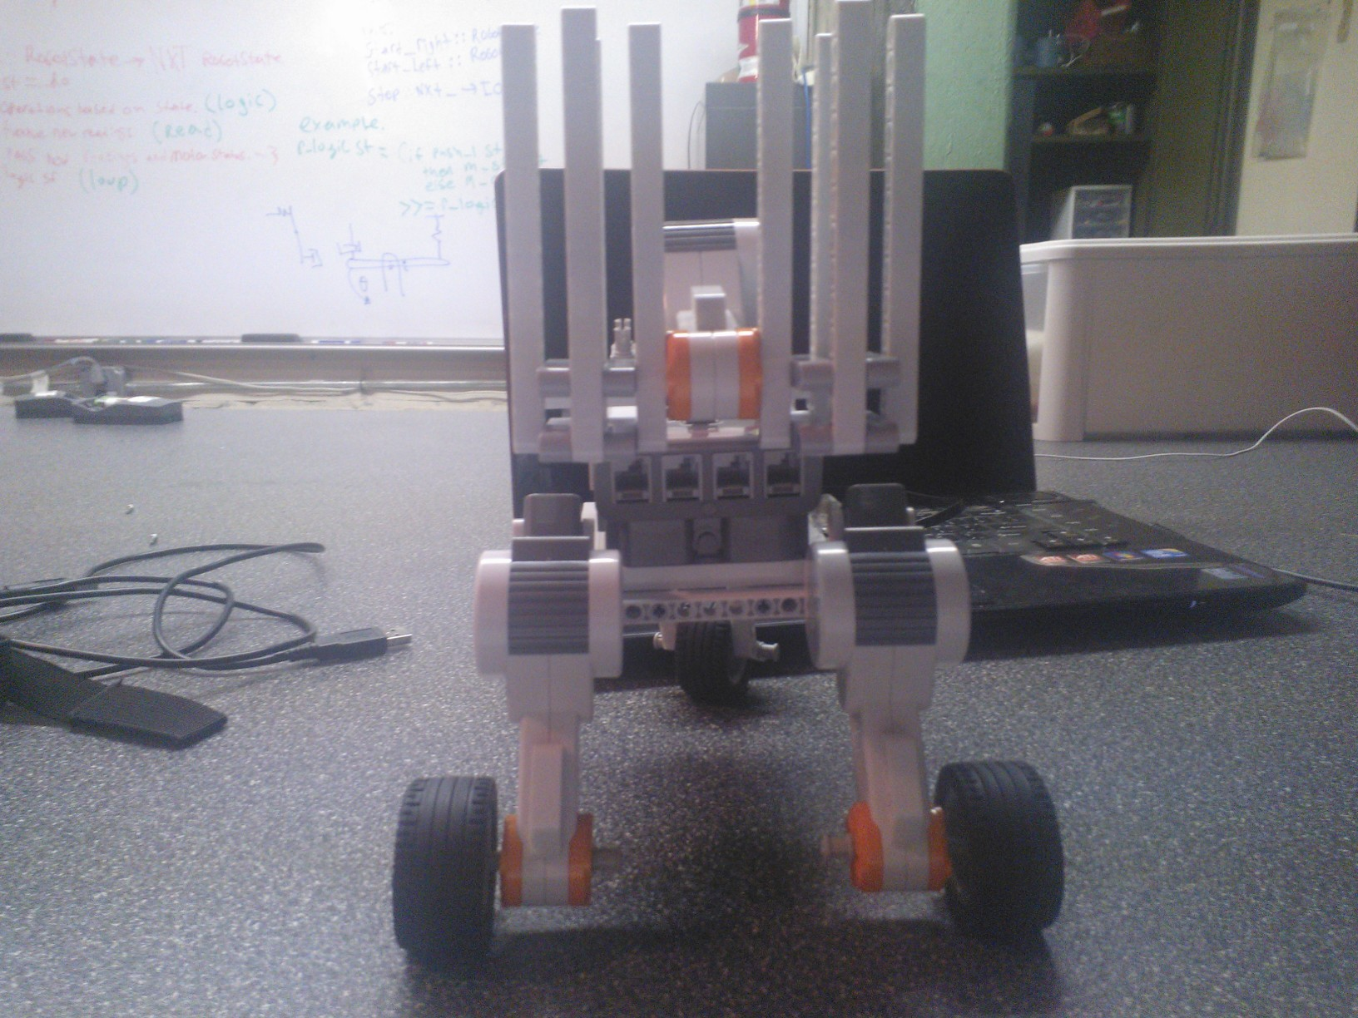

Dispenser:

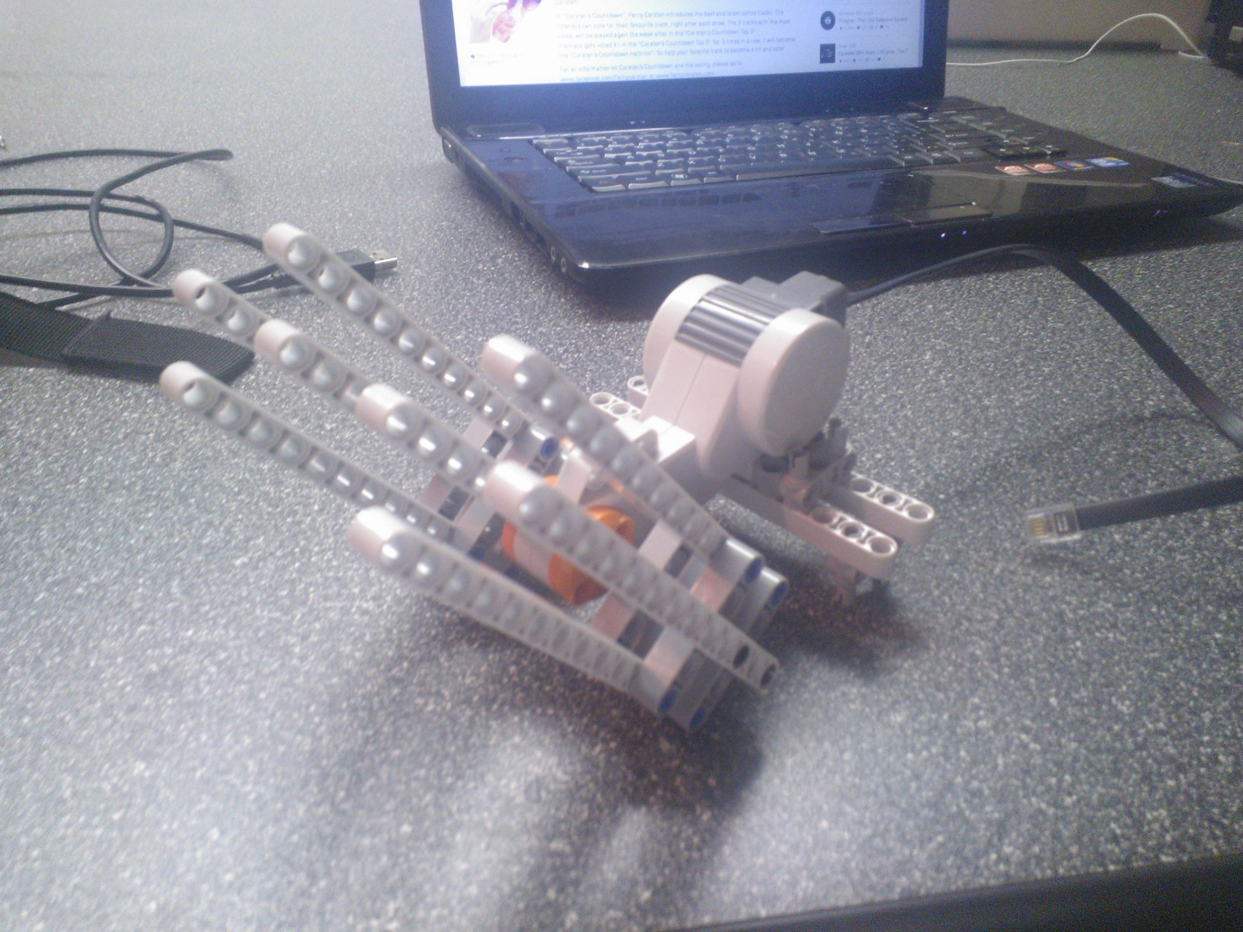
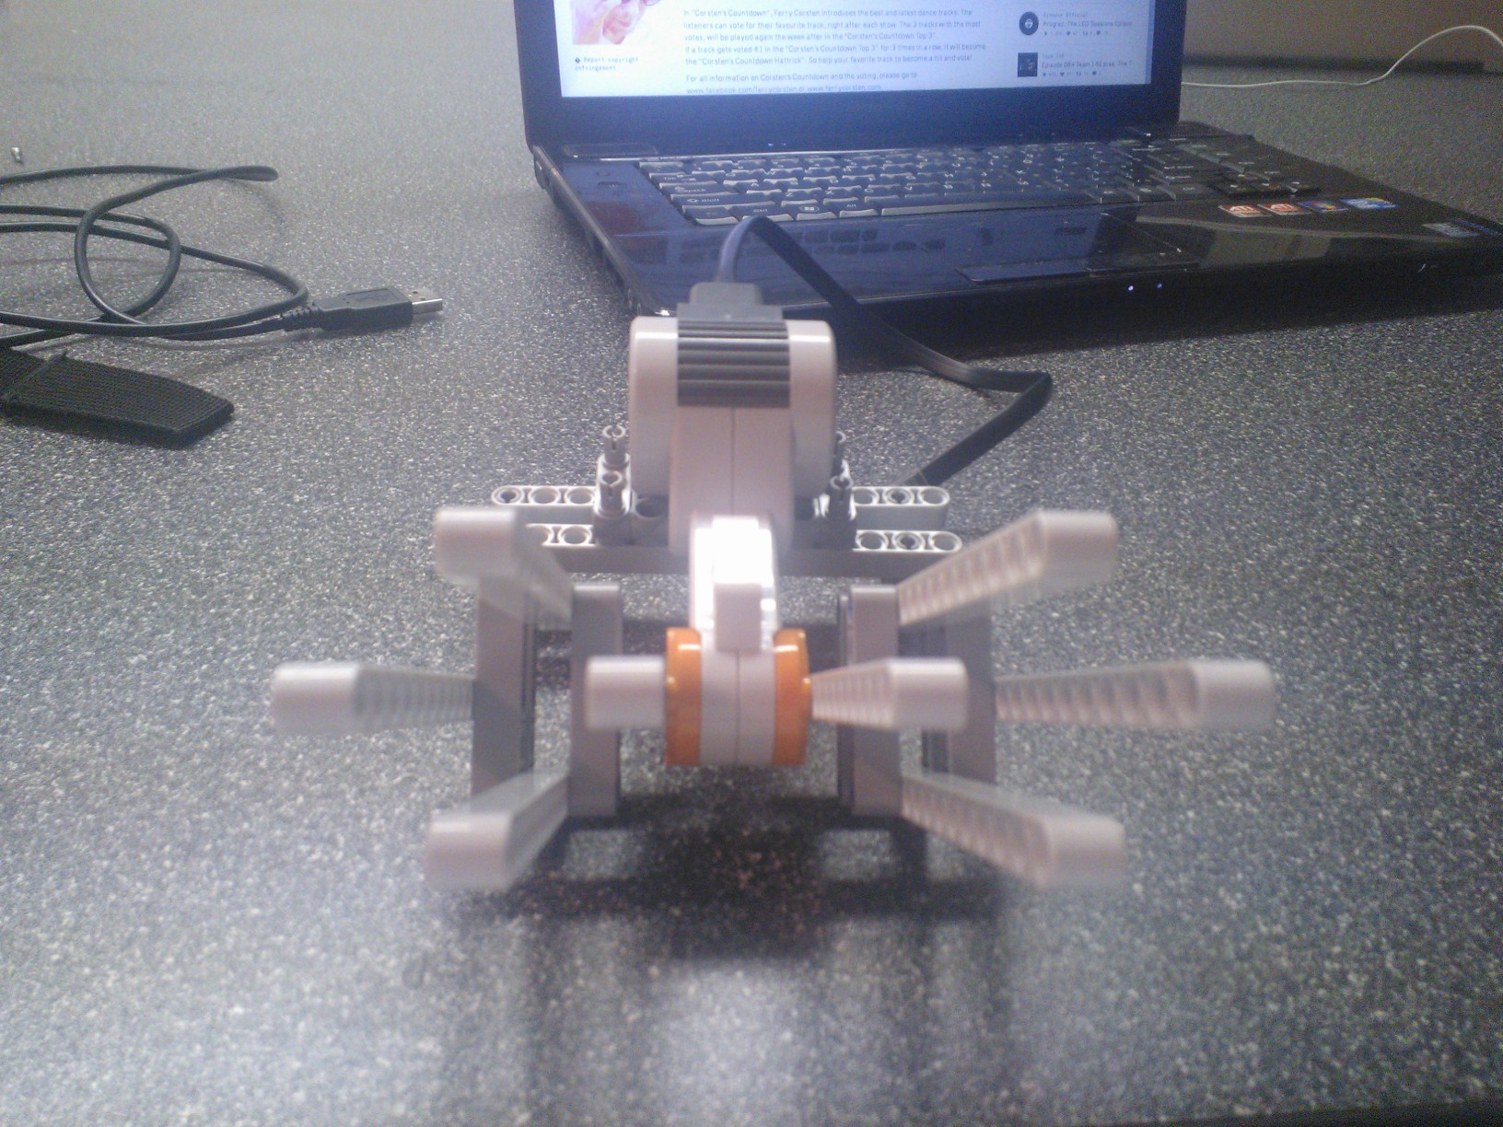

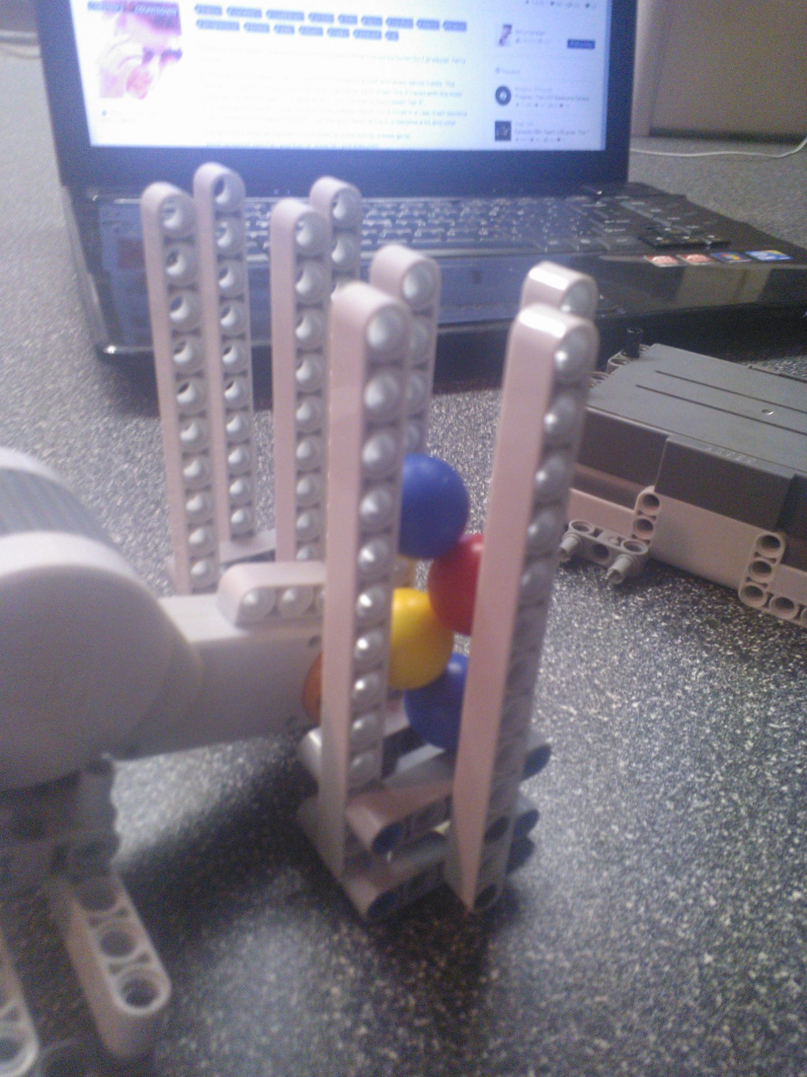

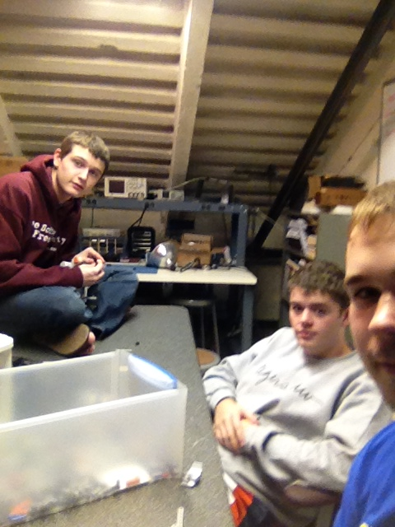
Eye Candy:

Programming:
Computers are magic, programming is for nerds. But these are my ideas for a remote
controlled robot with the server running on my laptop and the client program (written in C), running
on the robot. The idea would be to have the C program interact with messages sent over the bluetooth
connection, and adjust the state of the robot, while the logic and heavy lifting are done on the laptop.
This would also allow us to cut down on weight from sensors because we could control it remotely, and the speed would also be faster than the robot's decision making. I am also exploring writing something in C, compiled with GCC for ARM, that would run nativly, using sensors to navigate the game. I would probably do something similar with a struct representing a robot state, and then I woul d write functions to modify that state and pass them along. This would also allow me to wrap some more complex actions behind a cute boilerplate type interface so that my group mates could write parts if they wanted. The images are my musings on a whiteboad about data structures and functions for a haskell robot, but the ideas could be moved to C


