**《计算机视觉》实验报告**

**姓名：刘远航 学号：22121883**

实验八

1. **采用SIFT特征实现图像检索功能，即输入一张图片，在数据集中检索出相似的图片，数据集自选。**
   1. **核心代码：**

import cv2  
import numpy as np  
from os import listdir  
def extract_sift_features(image_path):  
 # 读取图像并转换为灰度图  
 image = cv2.imread(image_path)  
 gray = cv2.cvtColor(image, cv2.COLOR_BGR2GRAY)  
 # 创建SIFT对象  
 sift = cv2.SIFT_create()  
 # 检测关键点和计算描述符  
 keypoints, descriptors = sift.detectAndCompute(gray, None)  
 return keypoints, descriptors  
def find_similar_images(query_image_path, dataset_folder):  
 # 提取待检索图片的SIFT特征  
 query_keypoints, query_descriptors = extract_sift_features(query_image_path)  
  
 # 遍历数据集中的每张图片，并计算相似度  
 similarities = []  
 for image_file in listdir(dataset_folder):  
 image_path = dataset_folder + "/" + image_file  
 keypoints, descriptors = extract_sift_features(image_path)  
  
 # 创建FLANN匹配器  
 FLANN_INDEX_KDTREE = 0  
 index_params = dict(algorithm=FLANN_INDEX_KDTREE, trees=5)  
 search_params = dict(checks=50)  
 flann = cv2.FlannBasedMatcher(index_params, search_params)  
  
 # 使用KNN匹配器计算特征相似度  
 matches = flann.knnMatch(query_descriptors, descriptors, k=2)  
  
 # 计算相似度  
 good_matches = []  
 for m, n in matches:  
 if m.distance < 0.7 * n.distance:  
 good_matches.append(m)  
  
 similarity = len(good_matches)  
 similarities.append((image_path, similarity))  
  
 # 根据相似度排序  
 similarities.sort(key=lambda x: x[1], reverse=True)  
  
 return similarities  
# 测试  
query_image_path = "O.jpg"  
dataset_folder = "jianzhu"  
similar_images = find_similar_images(query_image_path, dataset_folder)  
# 输出相似图片  
for i, (image_path, similarity) in enumerate(similar_images):  
 print("Similar image {} - Similarity: {}, Path: {}".format(i + 1, similarity, image_path))

* 1. **实验结果截图**

检所结果会按照相似度进行排序：

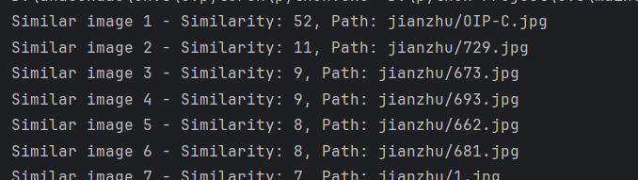

取最相似的与原图对比：

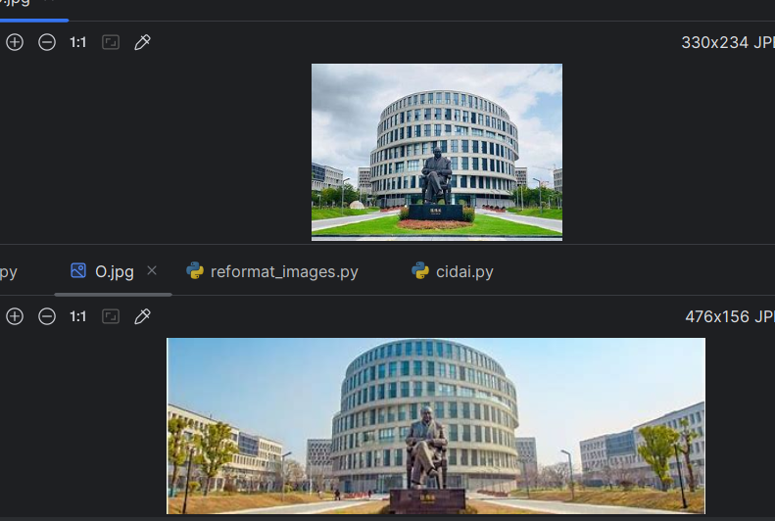

* 1. **实验小结**

这次实验是用sift特征进行图像检索，搜集到数据集后进行对比，发现确实能检索到相似的图片，很好的完成了实验任务。

1. **选做： （1）基于词袋模型实现（2）检索结果按照相似度进行排序**
   1. **核心代码：**

构建词袋模型：

def extract_sift_features(image):  
 gray = cv2.cvtColor(image, cv2.COLOR_BGR2GRAY)  
 sift = cv2.SIFT_create()  
 keypoints, descriptors = sift.detectAndCompute(gray, None)  
 return descriptors  
  
# Step 2: 从数据集中提取所有特征  
def extract_features_from_dataset(dataset_path):  
 all_descriptors = []  
 for filename in os.listdir(dataset_path):  
 if filename.endswith(".jpg") or filename.endswith(".png"):  
 image_path = os.path.join(dataset_path, filename)  
 image = cv2.imread(image_path)  
 descriptors = extract_sift_features(image)  
 if descriptors is not None:  
 all_descriptors.extend(descriptors)  
 return np.array(all_descriptors)  
  
# Step 3: 使用K均值聚类构建词袋模型  
def build_vocabulary(features, k):  
 kmeans = KMeans(n_clusters=k)  
 kmeans.fit(features)  
 return kmeans.cluster_centers_  
  
# 示例用法  
dataset_path = "jianzhu"  
k = 100 # 选择聚类中心的数量  
all_features = extract_features_from_dataset(dataset_path)  
vocabulary = build_vocabulary(all_features, k)  
  
# 将词袋模型保存为文件  
np.save("vocabulary.npy", vocabulary)

待测图像检验：

def extract_sift_features(image):  
 gray = cv2.cvtColor(image, cv2.COLOR_BGR2GRAY)  
 sift = cv2.SIFT_create()  
 keypoints, descriptors = sift.detectAndCompute(gray, None)  
 return keypoints, descriptors  
# 2. 构建词袋模型  
def build_vocabulary(descriptors, k):  
 kmeans = KMeans(n_clusters=k)  
 kmeans.fit(descriptors)  
 return kmeans.cluster_centers_  
# 3. 计算图像的特征向量  
def calculate_feature_vector(descriptors, vocabulary):  
 feature_vector = np.zeros(len(vocabulary))  
 if descriptors is None:  
 return feature_vector  
 distances = cosine_similarity(descriptors, vocabulary)  
 nearest_word = np.argmax(distances, axis=1)  
 for word in nearest_word:  
 feature_vector[word] += 1  
 return feature_vector  
# 4. 计算相似度  
def calculate_similarity(query_vector, dataset_vectors):  
 similarities = cosine_similarity([query_vector], dataset_vectors)  
 return similarities[0]  
# 5. 图像检索  
def image_retrieval(query_image_path, dataset_path, k):  
 query_image = cv2.imread(query_image_path)  
 query_keypoints, query_descriptors = extract_sift_features(query_image)  
 vocabulary = np.load("vocabulary.npy") # 加载预先计算好的词袋模型  
 query_vector = calculate_feature_vector(query_descriptors, vocabulary)  
 dataset_vectors = []  
 image_paths = []  
 for filename in os.listdir(dataset_path):  
 if filename.endswith(".jpg") or filename.endswith(".png"):  
 image_path = os.path.join(dataset_path, filename)  
 image = cv2.imread(image_path)  
 _, descriptors = extract_sift_features(image)  
 vector = calculate_feature_vector(descriptors, vocabulary)  
 dataset_vectors.append(vector)  
 image_paths.append(image_path)  
  
 similarities = calculate_similarity(query_vector, dataset_vectors)  
 sorted_indices = np.argsort(similarities)[::-1]  
 # 输出相似度最高的前k张图片路径  
 for i in range(k):  
 print(f"Similarity {i+1}: {similarities[sorted_indices[i]]}, Image Path: {image_paths[sorted_indices[i]]}")  
# 示例用法  
query_image_path = "d.jpg"  
dataset_path = "jianzhu"  
k = 5  
image_retrieval(query_image_path, dataset_path, k)

* 1. **实验结果截图**

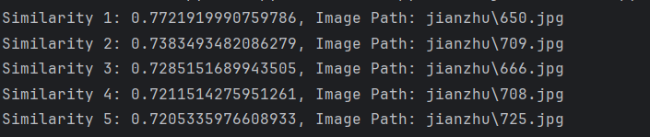

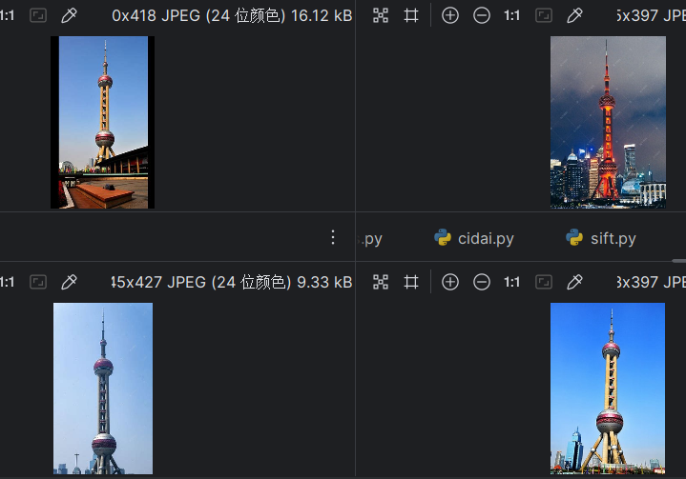

* 1. **实验小结**

经过这次实验，我明白了词袋模型的具体实现步骤，也明白了实现图像检索所需要的步骤，很好的完成了实验任务。