# Generate code from and deploy model to VeriStand

## Download and Install

[1] [VeriStand](https://www.ni.com/zh-cn/support/downloads/software-products/download.veristand.html) - the only available version for trial is the latest, here I used 2024 Q1

[2] [MATLAB](https://www.mathworks.com/downloads/) - refer to [this page](https://www.ni.com/en/support/documentation/compatibility/22/veristand-model-generation-support-and-mathworks-simulink--compa.html) for compatibility, I used R2020b. A snapshot is taken below:

[3[] VeriStand Code Generation Spkg](https://www.mathworks.com/matlabcentral/fileexchange/106420-veristand-model-generation-support) - download links for supported compilers are available within the page:

[3-1] [MinGW-w64](https://www.mathworks.com/matlabcentral/fileexchange/52848-matlab-support-for-mingw-w64-c-c-fortran-compiler) – toolchain for Windows target

[3-2] [Toolchain for NI Linux RT](https://www.ni.com/en/support/downloads/software-products/download.c-c---development-tools.html)

## Model setup

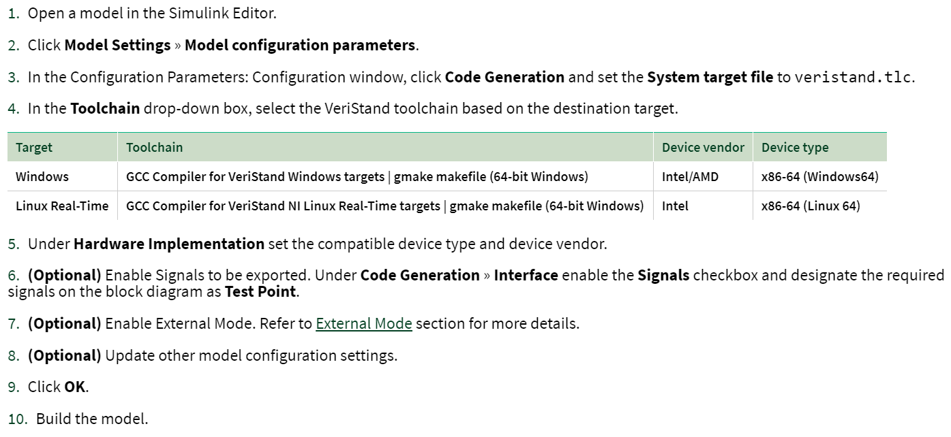

*No VeriStand library blocks needed

*No NIVeristandIO.tlc or other .tlc files would be available

## Code generation and build

.vsmodel, together with the dynamic linked library would be generated in current folder:

Build for Windows:

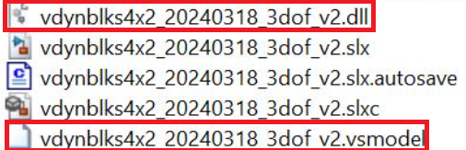

Build for Linux RT:

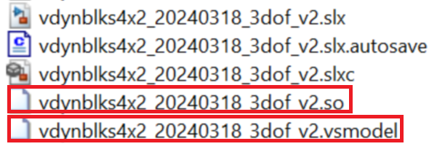

## Import into VeriStand

The above libraries can’t be imported into System Explorer:

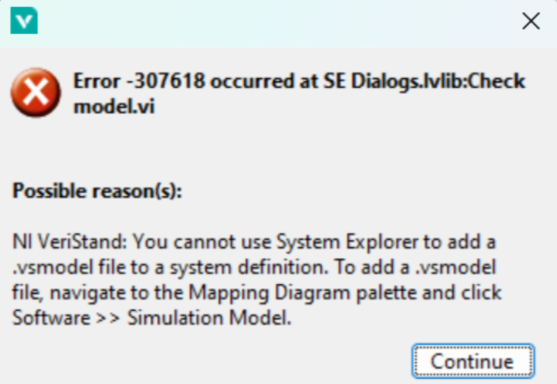

Instead, from Mapping Diagram:

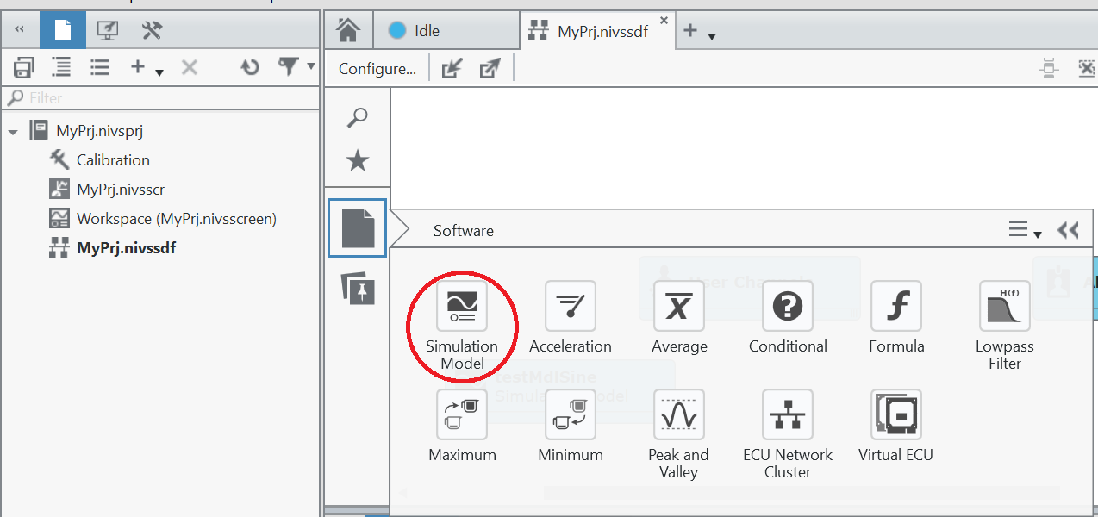

Then select the .vsmodel.

## Simulation

### Log Signals (?doesn’t seem to work fully as expected)

Signals can be found in Model Signal Viewer if it’s set as a test point in model:

and the option Generate C API for Signals in Code Generation configuration is checked:

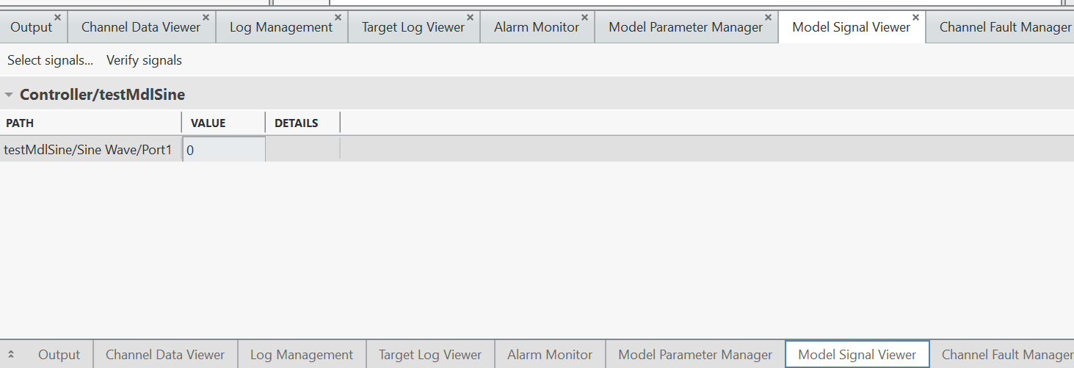

### Deploy to target and run

|  |  |  |
| --- | --- | --- |
|  |  |  |

### View waveforms

Open workspace:

Switch to edit mode:

Add scope from Workspace Controls > Graph > Simple

Select corresponding signal and with the model running:

### Connecting model channels

Configure system definition:

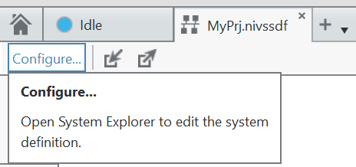

Configure system mappings:

Select channels for source and destination, then hit “connect”:

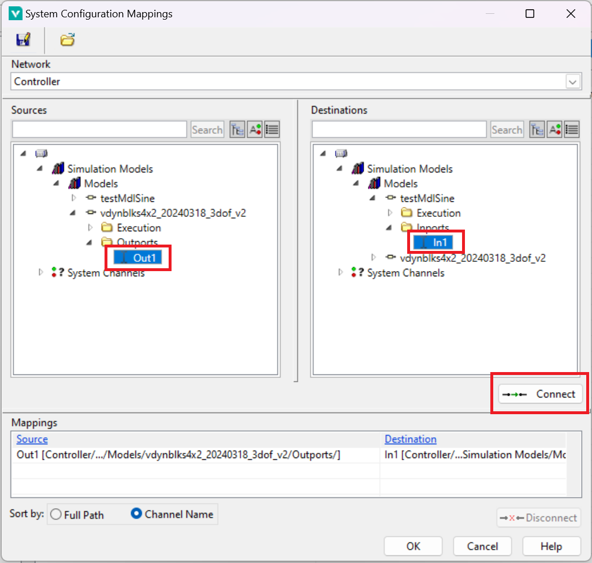

View the connection in system definition:

