# 模型生成代码并部署到VeriStand

## 下载及安装

[1] [VeriStand](https://www.ni.com/zh-cn/support/downloads/software-products/download.veristand.html) – 只有最新版可供试用，此处使用的是 2024 Q1

[2] [MATLAB](https://www.mathworks.com/downloads/) – 版本兼容性参考 [此链接](https://www.ni.com/en/support/documentation/compatibility/22/veristand-model-generation-support-and-mathworks-simulink--compa.html) ，此处使用的是R2020b. 部分版本支持情况摘录如下

[3[] VeriStand Code Generation 支持包](https://www.mathworks.com/matlabcentral/fileexchange/106420-veristand-model-generation-support) – 本页中包含所需编译器的下载链接：

[3-1] [MinGW-w64](https://www.mathworks.com/matlabcentral/fileexchange/52848-matlab-support-for-mingw-w64-c-c-fortran-compiler) – Windows目标环境编译器

[3-2] [NI Linux RT](https://www.ni.com/en/support/downloads/software-products/download.c-c---development-tools.html)环境编译器

## 模型配置

主要修改tlc、硬件配置和工具链：

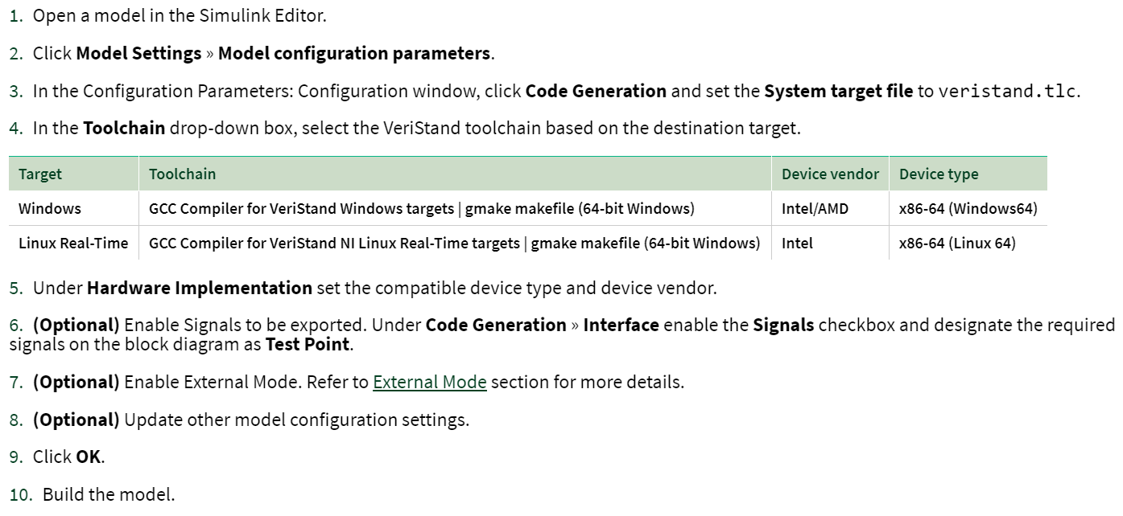

*没有 VeriStand 的库模块

*没有 NIVeristandIO.tlc 等其他tlc

## 代码生成和打包

当前路径下会生成.vsmodel 与对应平台的动态库：

Windows:

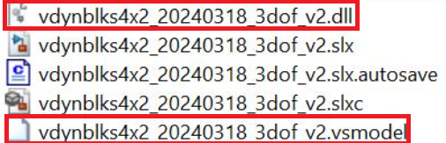

Linux RT:

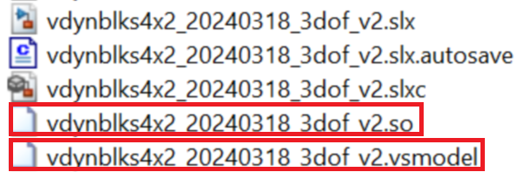

## 导入到 VeriStand

以上动态库不能直接导入 System Explorer:

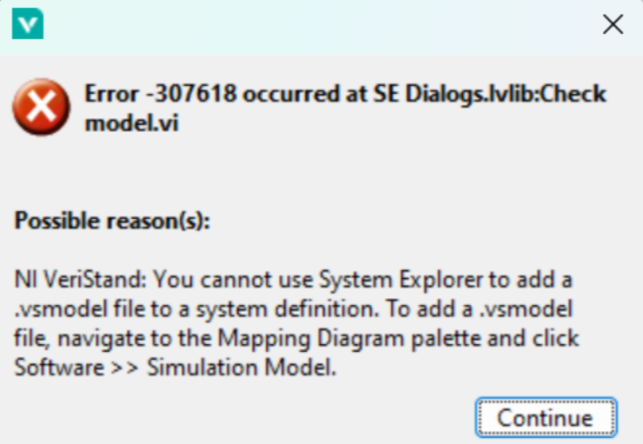

在 Mapping Diagram界面：

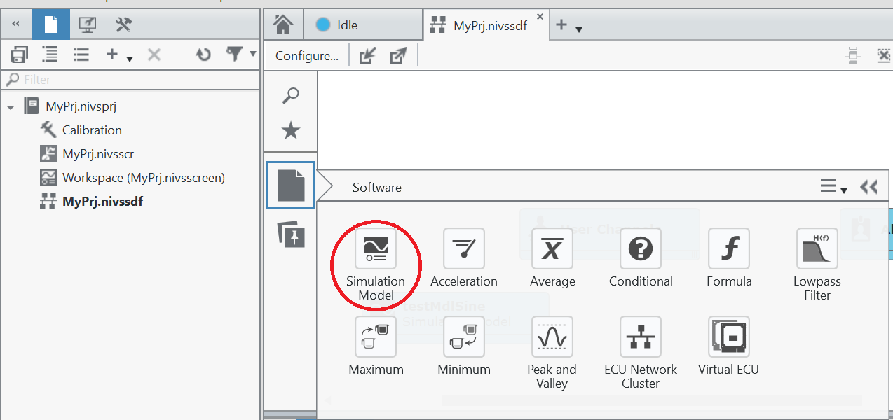

然后选择 .vsmodel.

## 仿真

### 信号记录（？不确定，有时不work）

Model Signal Viewer中找到对应信号，前提是信号设置为test point：

以及在代码生成选项中勾选为信号生成 C API：

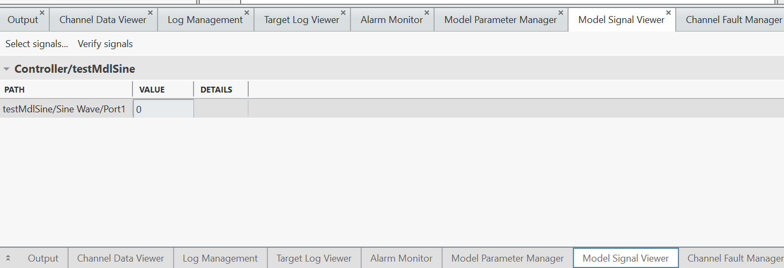

### 部署到目标环境并运行

|  |  |  |
| --- | --- | --- |
|  |  |  |

### 查看波形

打开workspace:

打开 edit mode:

在画布上添加 Workspace Controls > Graph > Simple

选择对应的输出信号，运行模型：

### 连接不同模型的信号通道

系统定义（.nivssdf）中点击“Configure”:

点击”Configure Mappings”配置映射：

选择对应的源和目标，点击 “connect”:

系统定义中可以看到连接关系：

