Proposal for The Course Project

Project Name: Epic Origin

School: South China University of Technology
Major: Data Science and Big Data Technology
Group Member: Luo Zijia, Liu Zicheng, Zhang Zhengxi, Wang Mingxuan, Mai Weitong, Shang Yushuo
Supervisor: Zhang Huaidong
Submission Date: April 23, 2026

1. System Requirements Analysis

1.1 System Background and Development Motivation
In the current game market, strategy games with rich gameplay and a strong sense of achievement are widely popular among players, especially those integrating exploration, simulation, and turn-based combat. These games not only satisfy players' demand for strategic thinking, but also bring the pleasure of growth and conquest. However, many existing strategy games either lack randomness and replayability, or have complex operations and high entry barriers, making it difficult to balance the needs of casual players and core strategy players.
Epic Origin is a turn-based card strategy game with the core theme of "epic warfare", set in a fantasy continent full of treasures and conflicts. There are five races with equal population and power on the continent: Human, Heaven, Hell, Ghost, and Dragon. Each race occupies a fixed initial stronghold, forming a pattern of mutual checks and balances and covetousness. Players will control the hero of their chosen race to explore resources, upgrade strongholds, summon troops, and conquer hostile forces, ultimately becoming the sole ruling race of the continent.
The initial development motivation of this project is to practice object-oriented programming skills and problem-solving abilities through the development of this game, so as to meet the learning objectives of the Advanced Language Programming course. At the same time, as avid strategy game fans, we hope to develop a game that combines strategic depth and playability, which can not only consolidate our professional knowledge, but also let us experience the fun of independent development. During the development process, we will strictly follow the requirements of object-oriented programming, apply relevant technologies such as classes, inheritance, and polymorphism, complete the game development while ensuring code quality, and strive to achieve excellent results in the course and improve our comprehensive programming capabilities.
In addition, through this project, we aim to master the methods of software design, debugging and error correction, learn to write scientific and standardized project proposals and reports, and cultivate teamwork, communication and critical thinking skills, laying a solid foundation for future study and work.

1.2 System Objectives
We are committed to developing a turn-based card strategy game with an epic warfare theme, integrating three core gameplay categories: exploration and conquest, turn-based card combat, and simulation management. We aim to create a gaming experience with both strategic depth and satisfying feedback, meet the requirements of the Advanced Language Programming course and player needs, and complete the core development of Epic Origin. The specific objectives are as follows:
- Develop a user-friendly and aesthetically pleasing User Interface (UI), including race selection, overworld map exploration, stronghold management, and turn-based card combat interfaces, with concise operation and excellent visual performance to meet the course UI requirements; meanwhile, it fits the game tone and adapts to the operational needs of the "exploration-management-combat" closed-loop gameplay.
- Complete the development of the core gameplay of the game, realize the three modules of overworld map exploration (random point refresh, wild troop interaction), stronghold simulation management (level upgrade, resource management), and turn-based card combat (race restraint, deck building), forming a complete gameplay loop.
- Implement random file processing functions, complete the writing, reading and updating of game data such as game progress, player resources, card information, and stronghold levels, support game saving and loading, and meet the technical requirements of the course.
- Complete the differentiated design of the five races, realize the distinction of advantages and disadvantages of each race in infrastructure, troop summoning, and combat characteristics, ensure racial balance, and allow players to experience differentiated gameplay of different races.
- Implement roguelike random content in the game, including random refresh of map points, random event triggering, and secret realm competition, to improve the replayability and playability of the game.
- Strictly follow the requirements of object-oriented programming, design no less than 5 classes and no less than 2 levels of inheritance hierarchy, with no less than 2000 lines of source code and standardized code comments, to meet the technical requirements of the course.
- Ensure the stable operation of the game system without obvious vulnerabilities, fully demonstrate the growth rhythm and conquest process of a single 30-turn session, pass the function and system tests, and achieve the core task objective of normal playable game.

1.3 Project Concept and Framework
This project takes "epic warfare" as the core theme, builds a fantasy continent with checks and balances among the five races, and creates a closed-loop gameplay of "exploration-management-combat"; it adopts a single-session roguelike mode, incorporates random points, random events and other content to improve playability; unlocks cards through stronghold upgrades, relies on racial differentiation and numerical balance design to achieve a standard 30-turn growth rhythm, and finally achieves the core goal of "eradicating hostile forces and ruling the continent". At the same time, it strictly follows the course technical requirements such as object-oriented programming to complete the game development.
The flow chart of the core gameplay concept framework is as follows:
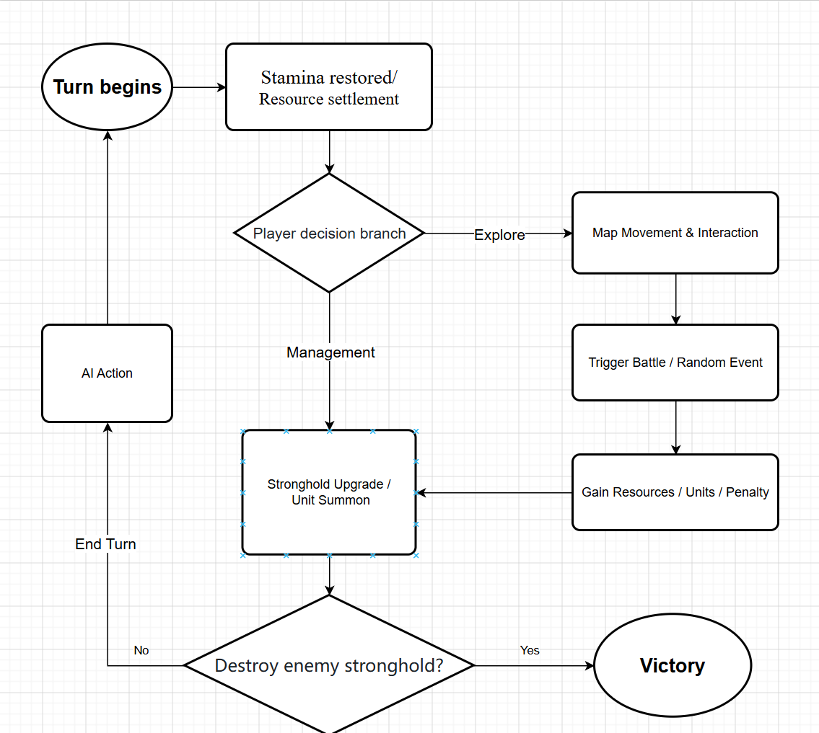

2. Program Analysis

2.1 Key System Issues
During the development of the Epic Origin game project, the team will face a number of key issues, which are closely related to the realization of game functions, meeting the course requirements, and improving player experience. The specific key issues are as follows:
- Implementation of object-oriented programming: Design no less than 5 classes and no less than 2 levels of inheritance hierarchy, reasonably realize the encapsulation, inheritance and polymorphism of classes, and ensure that the class design can meet the functional requirements of core modules such as races, cards, and strongholds.
- Random file processing: Design a reasonable file storage format to ensure stable and lossless reading and writing of game data, and realize the saving and loading of game progress.
- UI design and implementation: Use C# to develop a UI interface adapted to the game gameplay, to ensure smooth interface and convenient operation.
- Implementation of random content: Design a reasonable random algorithm to realize controllable random refresh of map points and random events, taking into account diversity and game balance.
- Combat balance design: Reasonably set card values and race restraint effects to ensure the strategic nature and fairness of turn-based combat.
- Code standardization: Ensure clear code comments and standardized writing, to meet the course requirements for code comments and quality.
- System stability: Efficiently debug and correct errors to ensure normal game functions, stable operation, and complete demonstration of core gameplay.

2.2 Task Division
Our team consists of 6 members, with reasonable division of labor and collaborative promotion. The specific division of labor is as follows:
- Game Planner & Lead Scene Builder: Oversee project progress, design game gameplay, racial characteristics and rules, coordinate all members to promote development, and be responsible for art resource provision, scene construction and follow-up code follow-up.
- UI Development Engineer: Develop various UI interfaces of the game, realize the interaction between the interface and the background logic, and ensure smooth operation.
- Back-end Development Engineer & File Processing Development Engineer: Design and implement the object-oriented class structure, develop the core game logic (resource, stronghold, combat calculation), and realize the reading, writing and updating of random files, as well as the development of game saving and loading functions.
- Combat System Development Engineer & Random Content Development Engineer: Develop the turn-based card combat system, debug combat balance and vulnerabilities. Realize the random refresh function of map points and random events.
- Audio and Visual Effects Development Engineer: Assist in the main program development and regulate the matching of sound effects and special effects.
- Tester & Code Comment Specialist: Responsible for system testing, vulnerability recording, and standardized writing of code comments. Find and fix bugs.
All team members will cooperate in a coordinated manner, solve development problems in a timely manner, and ensure the high-quality completion of the project on schedule.

2.3 Workflow
The workflow chart of our project is as follows:
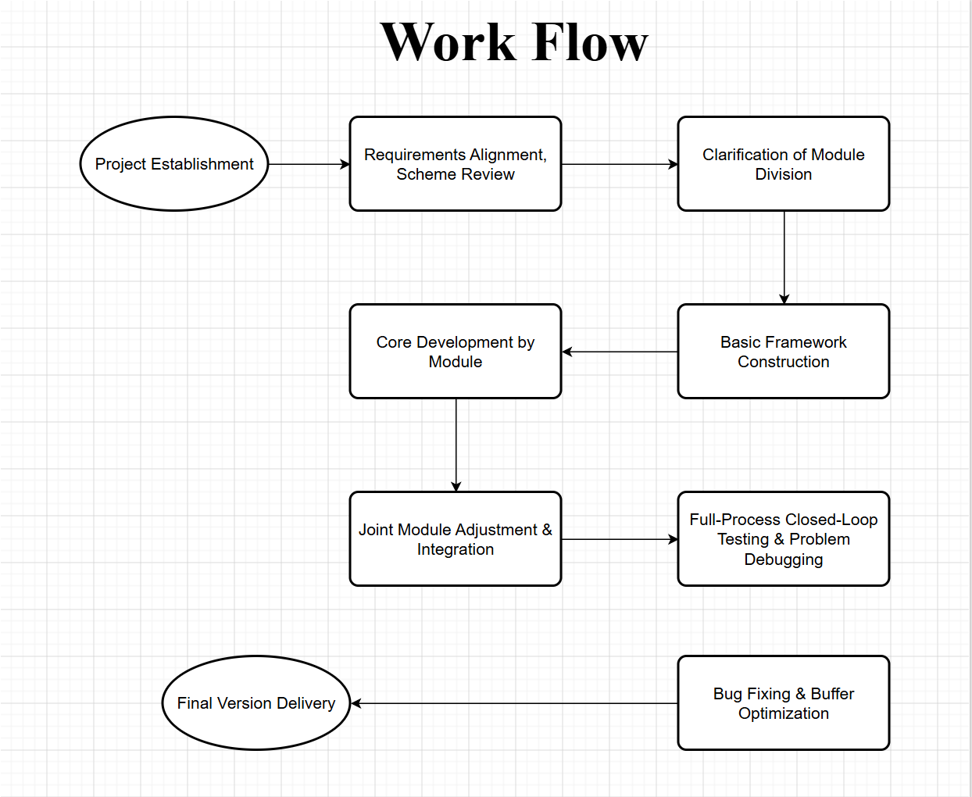

3. References
1. Unity User Manual : Help understand how to use Unity and assist with game development.
2. C# Development Tutorial : For learning the C# language, understanding Unity development logic, and ensuring: game design and implementation.
3. C++ How to Program 9E: The textbook provided by the instructor, used to learn and apply object-oriented programming concepts, including classes, objects, encapsulation, inheritance, polymorphism, and more.

