To: Professor Krasso

From: Laurie Mailloux

Date: June 9, 2020

Subject: From Legacy to SOA

Legacy modernization is defined as a process of transforming or converting a legacy system to a more modern infrastructure that will reduce cost improve flexibility collaboration and also consistency. It does have its challenges, such as obsolete or outdated technology, the lack of skill sets in the market to run older systems, outdated, inaccurate or incomplete documentation, and lock of support for older software systems. About 44% of CIOs believe that complex legacy technologies may pose a barrier to a company’s digital transformation.

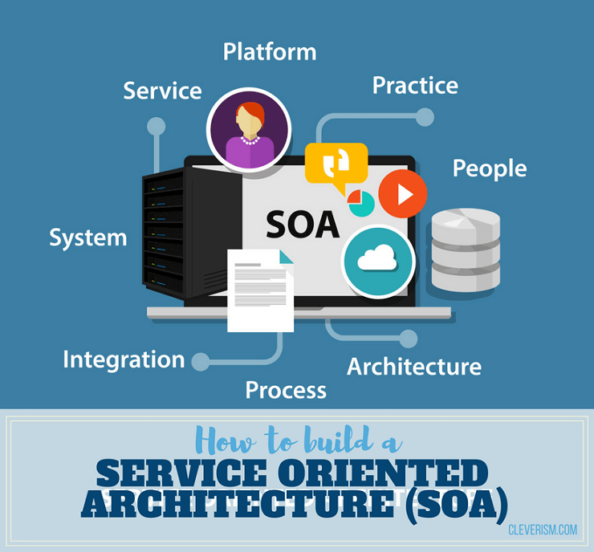

© Shutterstock.com | Bakhtiar Zein

Service-oriented Architecture (SOA) is a structure that lets services communicate with other services across other languages and different platforms. It does this by implementing a “loose coupling” system. The concept of SOA has been around for years, it’s only within the past decade it has risen to the top of software-related technologies. (Community, 2019) Service-Oriented Architecture (SOA) is a style of software design where services are provided to the other components by application components, through a communication protocol over a network. Its principles are independent of vendors and other technologies. Efficient and structurally sound SOA is a great upfront investment.

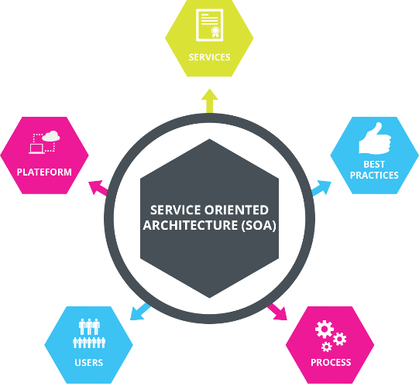 (Community, 2019)

We will be transition from legacy architecture to a to provide this “loose coupling” system. Basically this means that we our making a network that we will be able to modify and update the systems individually without having to worry about the impact it might have on other systems. The client will be able to communicate with a service even though they may not be closely related. This is achieved by the implementation of specified interface that performs the necessary actions that allow for the transmission of the data. There is a lot to the software and planning that will be needed for the transition. Once it is up and running, t will be extremely powerful.

The Legacy Corporation consist of 10 independent systems that look like this:

http://content.bellevue.edu/cst/WEB/WEB420/Legacy%20Corporation.pdf

The transition from legacy system over to SOA can be complicated, first we will take inventory of what is there and if we can reused or repurpose, we with work with that. We also need to map out how SOA will need to work to ensure the flow control functions as desired.

To begin the migration, first we mush determine what applications need to be use or up and running right away. We also need to determine how best to update these systems. Financial systems such as payroll and budget systems will be top priority. These are both important to keep things running smoothly. Once that system is transition and the data is able to exchange with central database, we will move forward to GitLab, training active directory and service desk functions. Lastly, we will bring the new system online, we want to evaluate the system and run test, and also fix any errors and make recommendations for future needs if any.

References

Community, S. D. (February 13, 2019). What Is Service-Oriented Architecture? Retrieved June 13, 2020, from <https://medium.com/@SoftwareDevelopmentCommunity/what-is-service-oriented-architecture-fa894d11a7ec>

Georgiou, Michael. (July 4, 2019) Why Businesses Should Modernize Their Legacy Applications? Retrieved on June 13, 2020 from <https://www.imaginovation.net/blog/why-businesses-should-modernize-legacy-applications/>

Watts, Stephen. (May 31, 2017) What is Service-Oriented Architecture? Retrieved on June 13, 2020 from <https://www.bmc.com/blogs/service-oriented-architecture-overview/>