Bob’s Computer Repair Shop

TECHNICAL DESIGN DOCUMENT

|  |  |
| --- | --- |
| Author: | *Laurie Mailloux* |
| Last Updated: | August 18, 2020 |
| Version Number: | *1.0* |

Version History

|  |  |  |  |
| --- | --- | --- | --- |
| Name | Date | Reason for Change | Version |
|  |  |  |  |
|  |  |  |  |
|  |  |  |  |
|  |  |  |  |
|  |  |  |  |
|  |  |  |  |
|  |  |  |  |
|  |  |  |  |
|  |  |  |  |
|  |  |  |  |

Table of Contents

SECTION 1: INTRODUCTION 3

Purpose 3

Terminology 3

Related Documents 3

Document Control Change 4

Reviewers 4

Required Skills 4

SECTION 2: Architecture 4

Physical Architecture 4

Logical Architecture 4

SECTION 3: PROCESS DESIGN 5

Object Relational Diagram(s) 5

NoSQL Data Structure 5

Wireframes 5

SECTION 4: REFERENCES 6

# SECTION 1: INTRODUCTION

## Purpose

The purpose of this project is to build a web site that will serve users and employees to sell, track, and finalize orders. We need to provide an application that can take work orders from customers online. The application needs to be easy to use and relatively simple, and user friendly. It must have functionality which allows employees to enter estimated work hours and also the cost for parts. Users need to be able to view a copy of the work order with the option of saving or printing it.

## 

## Terminology

Angular – A JavaScript/TypeScript framework which allows for the creation of rich single page applications.

SPA – Single Page Application; an application which does not require the browser to reload the page, but instead relies on code to change the view and asynchronously load resources in the background.

Order – The document generated by a request for services. It is comprised of service information, labor, and parts costs.

Wireframe – A design document which contains basic design information such as structure and placement of elements.

MEAN Stack – MongoDB, Express, Angular, and Node.js

VS Code – Development IDE

Angular Material - [*https://material.angular.io/*](https://material.angular.io/)

Flex-Layout - [*https://github.com/angular/flex-layout*](https://github.com/angular/flex-layout)

## 

## Related Documents

<https://angular.io/>

[https://material.io/design/material-theming/#](https://material.io/design/material-theming/)

**Document Change Control:**

Changes made to the design document must be approved by Laurie Mailloux. Changes will be discussed with product owner and approved or denied within two business days after submitting. Change proposals can be sent to: [lmailloux@my365.bellevue.edu](mailto:lmailloux@my365.bellevue.edu)

## Reviewers

|  |  |  |
| --- | --- | --- |
| **Approvers:** | **Name:** | **Date:** |
| **Approved By (**Client Acceptors, can be more than one) | Bob | 08/18/20 |
| **Approved By** (Solution Architect) | Professor Krasso | 08/18/20 |
| **Approved By (**Development Team) | John Smith | 08/19/20 |

## Required Skills

* + AngularJS
  + Angular CLI
  + Material Design
  + MongoDB
  + CSS
  + HTML
  + Express Javascript
  + Database Design
  + GIT

# SECTION 2: Architecture

# SECTION 3: Process Design

{

    "users": [

        {

            "customer_name": "Tina Smith",

            "customer_email": "tsmith@gmail.com",

            "customer_address": "525 W Dewey Street, Smithson, IN, 47858",

            "customer_phone": "655-252-1452",

            "item": [

                {

                    "item_number": "15255",

                    "item_name": "Spyware Removal",

                    "item_cost": "60.00",

                    "estimate": {

                        "parts_labor": "150.00",

                        "parts_hours": "2.5"

                    }

                }

            ]

        }

    ]

}

Wireframe

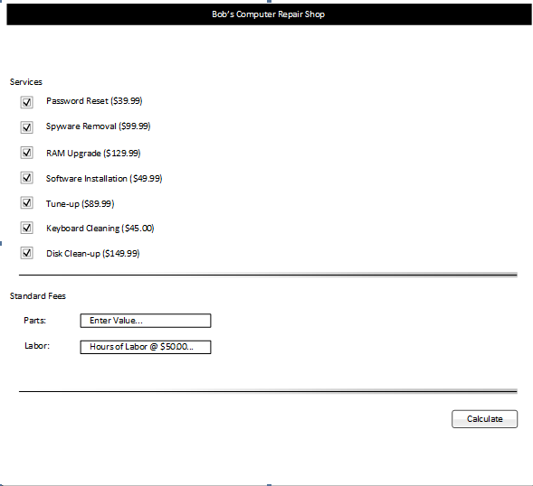

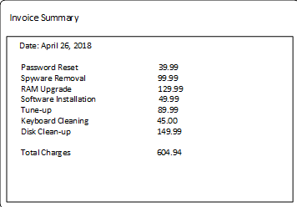

# SECTION 4: REFERENCES