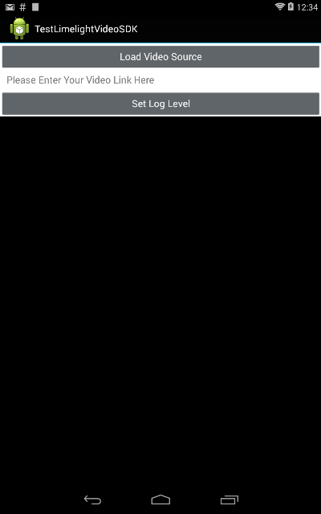

Video Player Area

Set Log level button

Video URL field

Load video source button

Screen shot of the main application.

The main application has the following UI elements -

**Load Video Source Button**

This button has two distinct behaviours. If the Video URL field has a Value then it tries to load the video specified in the video URL field. Else if it is empty – it loads the dialog to load a local video from the device. In either case once, an attempt to play the video is made at the end of the user action.

**Video URL field**

Specify the URL of the video to be played here. You can either specify it manually or load the video from the local file.

**Set Log Level button**

This button provides the option to enable the log level and the log4j logger. This is used only when you are debugging.

**NOTE**

This is not a full-fledged app and does not do a lot of error checking. So while using the app please take care of the following:

1. Minimum Android version supported is 4.0.
2. Current testing environment has been Android 4.4
3. Also was tested very minimally on Android 4.1
4. The app is not signed. Inorder to install, make sure you have enabled Unknown sources under, settings -> Security -> Device Administration
5. The app needs the network permission.
6. To install the app just copy it to your device and tap on it to install.
7. Make sure the URLS are correct.
8. If you are looking to play a local video , Make sure that the URL field is empty and then tap on the Load Video Source button.
9. The key board does not automatically go away. You can get rid of the key board using the back key.