TestLimelightVideoSDK (Test Application)

TestLimelightVideoSDK can be directly imported in eclipse or Android Studio.

Explanation:

TestLimelightVideoSDK has two pages. Navigation between these pages can be done by page swiping or tapping on the page title.

1. Setting page.
2. Player page.

Setting Page:

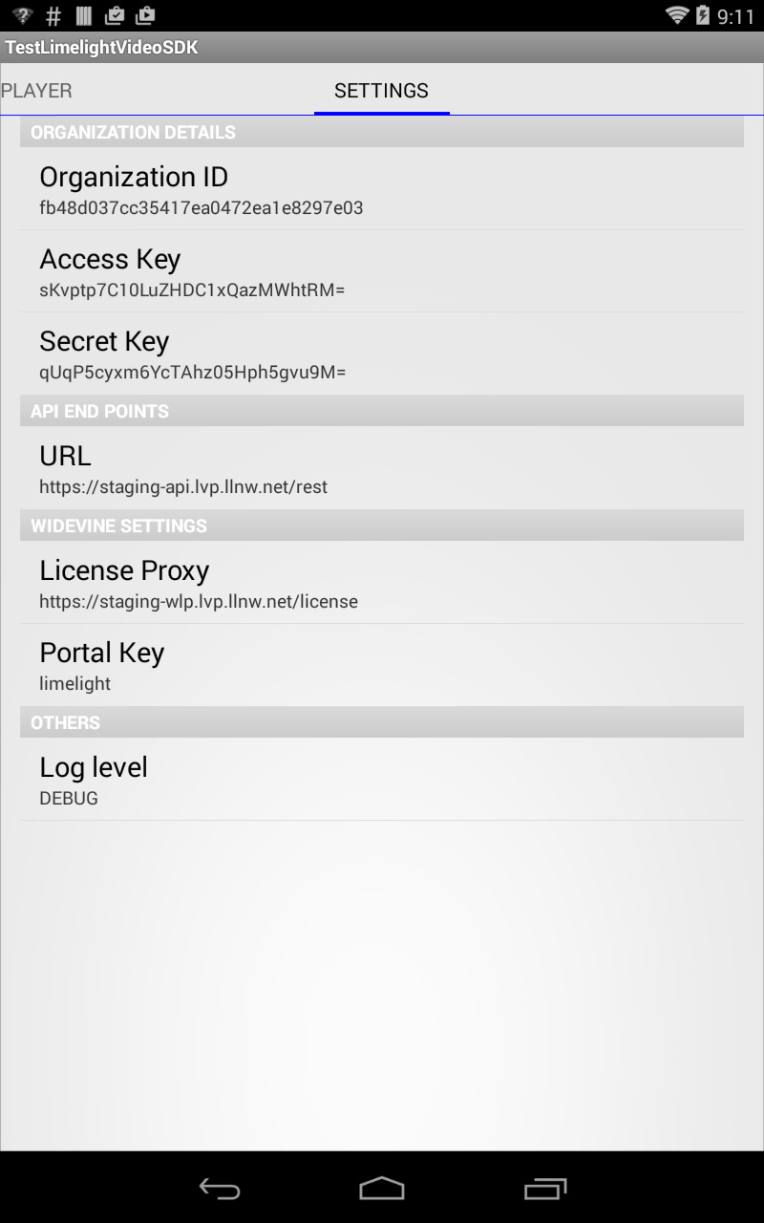

- It has preferences for Organization Id, Secret Key, and Access Key.

- It has API end point URL.

- It has widevine specific settings like License Proxy URL and Portal key.

- The values of the above preferences are set to some default value, which can be changed by user.

- User can set the level of logging done by SDK. The priority order of levels is
  - Debug
  - Info
  - Warn
  - Error
  - Fatal.
Logs below or equal to current level will only be logged. eg: If current level is set to error, then only error and fatal logs will be logged. Selecting off, turns off the logging.

Player page:

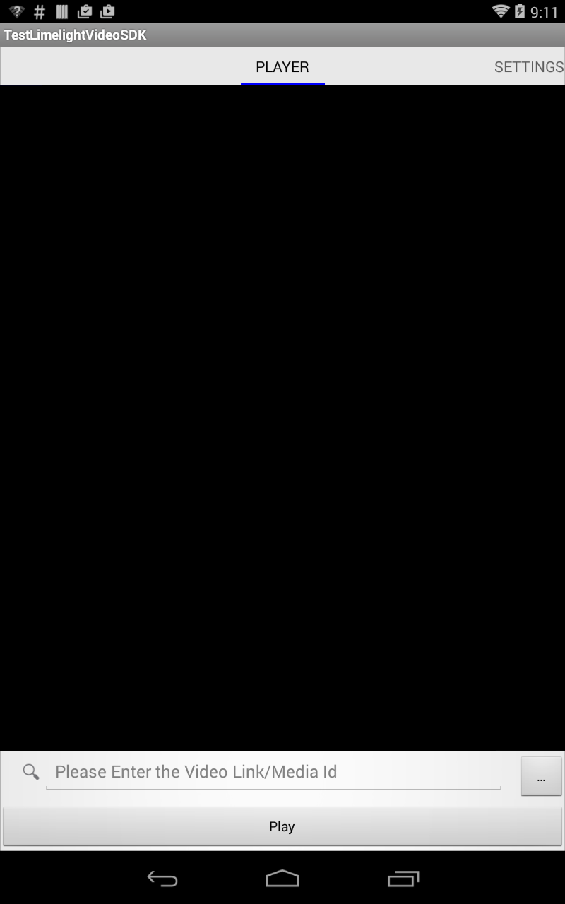

- In Edit Text, user can enter the can enter a media ID OR media Id manually.

- “…” button is used to load local files.

- To load a local video file, fire intent to start the "file chooser" UI and select local video content. If the Device is running with android 4.3 or high then use Storage access framework(SAF) to get the video file. SAF scope is very wide and the video file can also be from Google Drive. If the device is running lower than 4.3 then use normal video content picker.

- Video file picker returns in OnActivityResult. The video file Uri is in result data. It sets this Uri in Player.

- Player displays a Player view when Uri is set.

- On selecting Play button Test Application will resolve that whether the entered string is remote media link or remote media Id or local content.

- If it is remote link Player will fetch the data and displays a player view and starts playing

- If it is local content link, player will start playing directly.

- If it is media Id, the player fetches all the encodings for that media Id. On selecting a particular encoding, player fetches media related to the selected encoding and starts playing.

- If the selected encoding is widevine, player fetches the rights related to media and on rights validation, starts playing.

- In invalid cases, player displays error messages.

- Handle the configuration changes in OnConfigurationChanged.

- Set a listener which initializes control when player is attached to test application.

- Set a listener which handles error scenarios of player.

- Set a listener when video view in player is prepared.

- Set a listener when the encodings are fetched.

Encodings Dialog

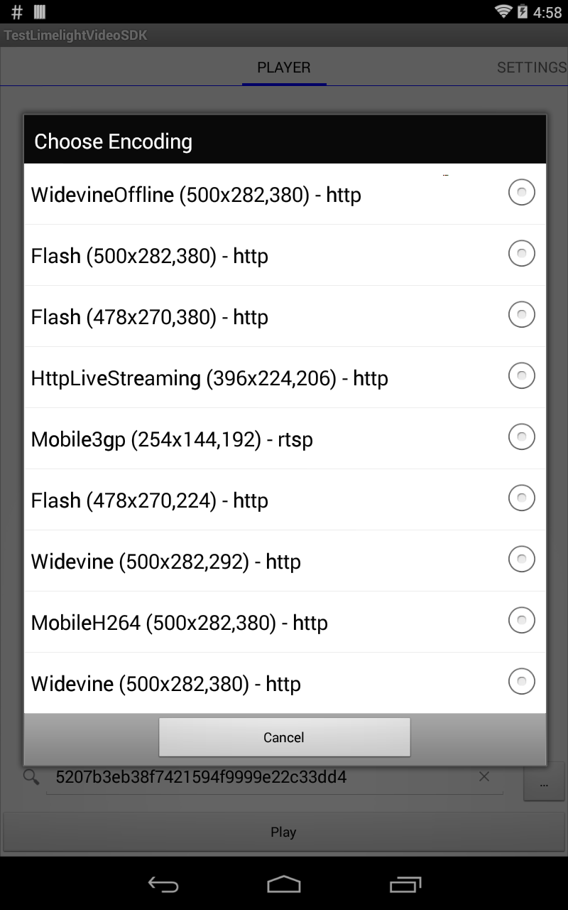

- The encoding dialog displays the available encodings for the media Id given by user.

- These encodings are fetched from Limelight Server by the LimelightVideoSDK.

- Each encoding here comprises of Primary Use, Resolution, Bit rate and Protocol.

Widevine

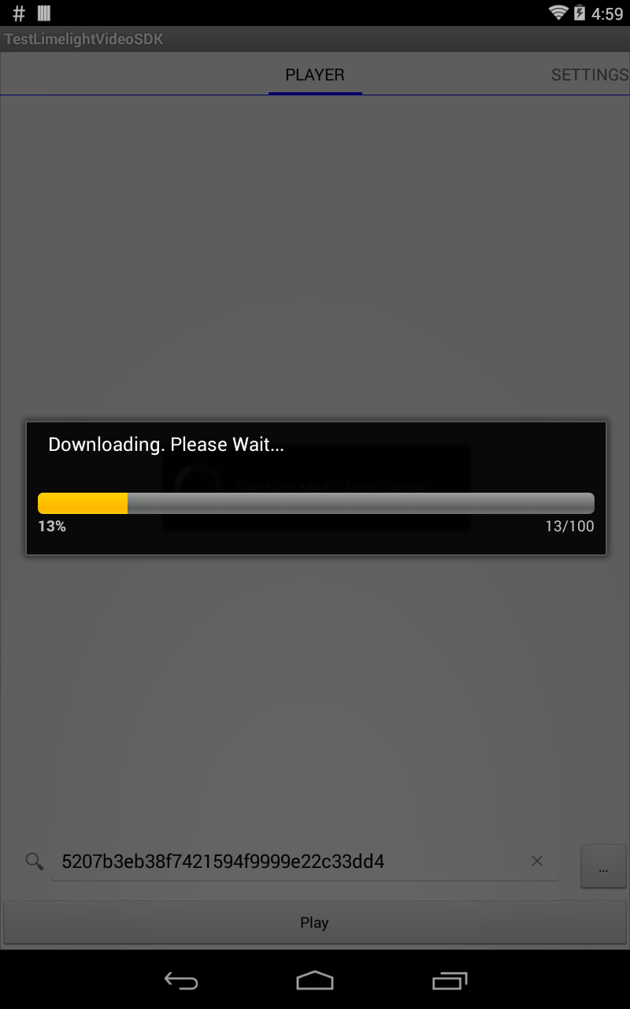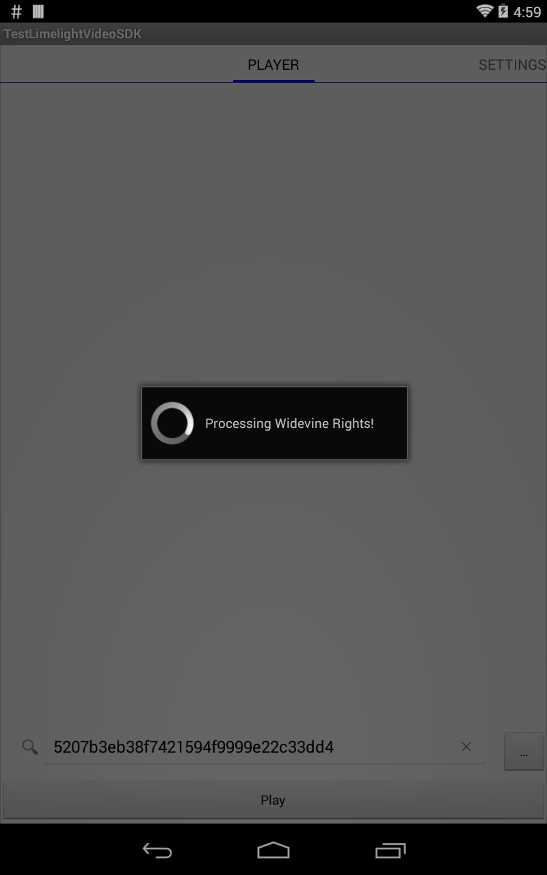

- Widevine offline involves downloading protected media from Limelight network.

- LimelightVideoSDK is downloading the content and showing the download progress.

- LimelightVideoSDK is also doing the rights validation for the protected content, either online or offline.

Creating Application using LimelightVideoSDK in Eclipse

- Create an android application in ADT bundle’s eclipse.
- Include LimelightVideoSDK.jar in the libs folder and add it as a jar in application class path by configuring application build path.
- Create a package and write classes and methods to access LimelightVideoSDK APIs in “src” folder. Write layout and resources under “res” folder.

Creating Application using LimelightVideoSDK in Android Studio

- Create a new Project in Android Studio.
- Write classes and methods to access LimelightVideoSDK APIs under “app” folder. Write layouts and resources under “res” folder
- Copy LimelightVideoSDK.jar in the libs folder and add it as a file dependency using Project Structure → app → dependency → + → File Dependency. Or modify build.gradle file of the app by adding below line under dependency :
compile files ('libs/limelightvideosdk.jar')

Application Installation

Once application development is done, the .apk can be run on device.

For emulator documentation, Please refer:
http://developer.android.com/tools/devices/emulator.html

1) To install and run the application using adb

- Once the application is successfully compiled and .apk has been generated, open command prompt/terminal and navigate to path where adb is located. Or, set the environment variables for adb.
- Use command adb install apkpath
- Here apkpath is the path where apk is located.
- Once apk is installed, application can be run from application launcher on device.

2) To install and run the application using Eclipse

Once the application is successfully compiled and .apk has been generated, right click on project and select “run as” → “Android Application”

3) To install and run the application using Android Studio

Once the application is successfully compiled, select Run → “Run app”

4) To install the app just copy it to your device and tap on it to install

NOTE

This is not a full-fledged app and does not do a lot of error checking. So while using the app.

Please take care of the following:

1) Minimum Android version supported is 4.0.

2) Current testing environment has been Android 4.4

3) The app is not signed. In order to install, make sure you have enabled Unknown sources
under, settings -> Security -> Device Administration

4) The app needs the network permission.

5) To install the app just copy it to your device and tap on it to install.

6) Make sure the Media Id is correct.

7) Make sure URLs are correct.

8) If you are looking to play a local video, tap on the “…” button.

9) The key board does not automatically go away. You can get rid of the key board using the back key.

10) If you face any problem with Progress Dialog, press the back key. It will cancel the progress dialog but it will not stop the task going on in background.

11) Device system time should be proper for playing wide vine content.

