TestLimelightVideoSDK (Test Application)

TestLimelightVideoSDK can be directly imported in eclipse or Android Studio.

Explanation:

TestLimelightVideoSDK has 7 pages. Navigation between these pages can be done by page swiping or tapping on the page title.

- Setting.
- Channel Groups
- All Channels
- Channels
- All Media
- Media
- Player

Setting Page

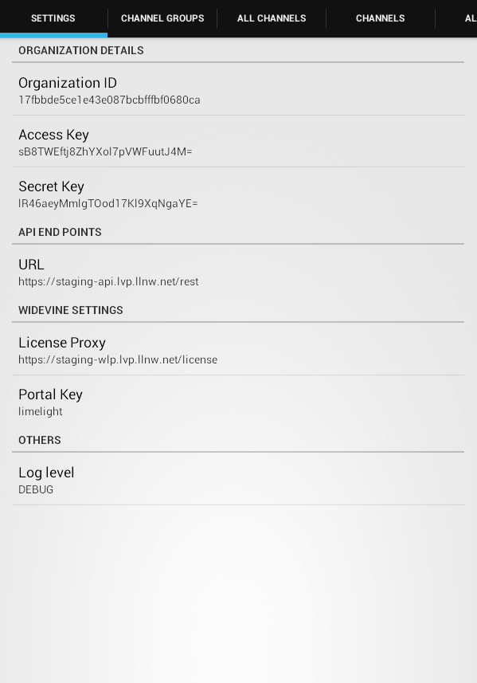
- It has preferences for Organization details like Organization Id, Secret Key, and Access Key.

- It has API end point URL from where the data like encoding, channel group, channel and media etc can be fetched.

- It has widevine specific settings like License Proxy URL and Portal key.

- The values of the above preferences are set to some default value, which can be changed by user.

- User can set the level of logging done by SDK. The priority order of levels is
  - Debug
  - Info
  - Warn
  - Error
  - Fatal.
Logs below or equal to current level will only be logged. e.g.: If current level is set to error, then only error and fatal logs will be logged. Selecting off, turns off the logging.

Channel Groups page

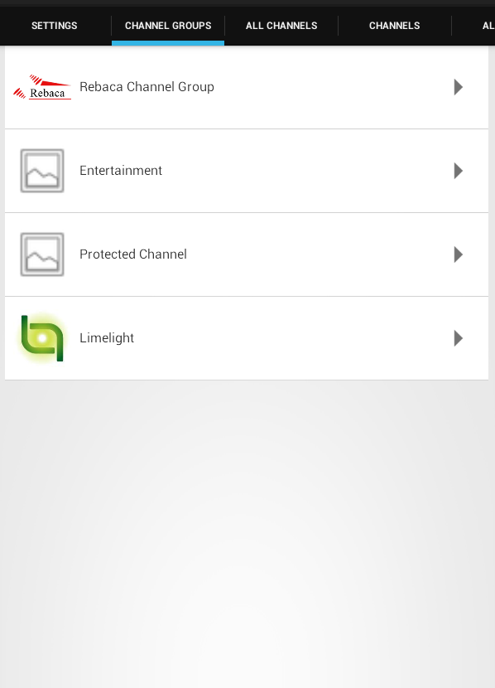

- This page lists the channel groups available on limelight server.

- Channels groups list can be refreshed by pulling the list down at the top.

- The max number of groups to be fetched from server in each request is 500. But we are setting it to 100 from application. So the page size is 100.

- If there are more than 100 groups on server, scrolling the list down will automatically fetch the next 100 groups.

- Error messages are also shown in this page and list will not be visible in error case.

- On selecting a particular group in this list, SDK fetches the channels for the selected group and the Page automatically changes to channels page.

All Channels page

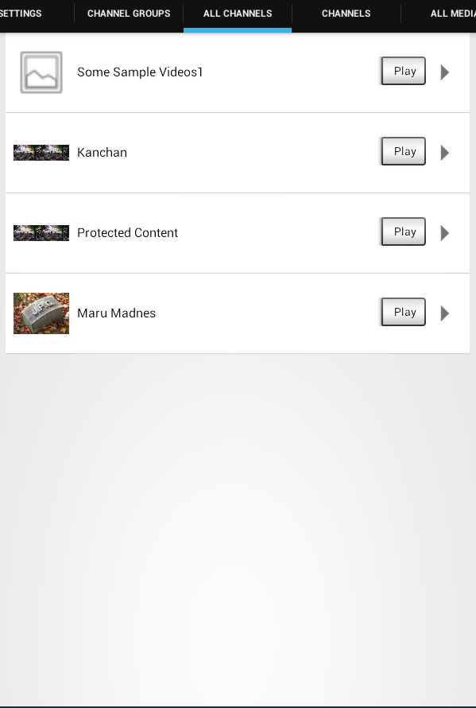

- This page lists the channels available on limelight server.

- Channels list can be refreshed by pulling the list down at the top.

- The max number of channels to be fetched from server in each request is 500. But we are setting it to 100 from application. So the page size is 100.

- If there are more than 100 channels on server, scrolling the list down will automatically fetch the next 100 channels.

- Error messages are also shown in this page and list will not be visible in error case.
- On Selecting a particular channel in this list, fetches the media for the selected channel and the page automatically changes to media page.

- Selecting “Play” button in a particular channel will start the playback of all the media present in that channel. Channel acts as a playlist here. The test application will show the player page automatically and start playing the first media in the channel.

Channels page

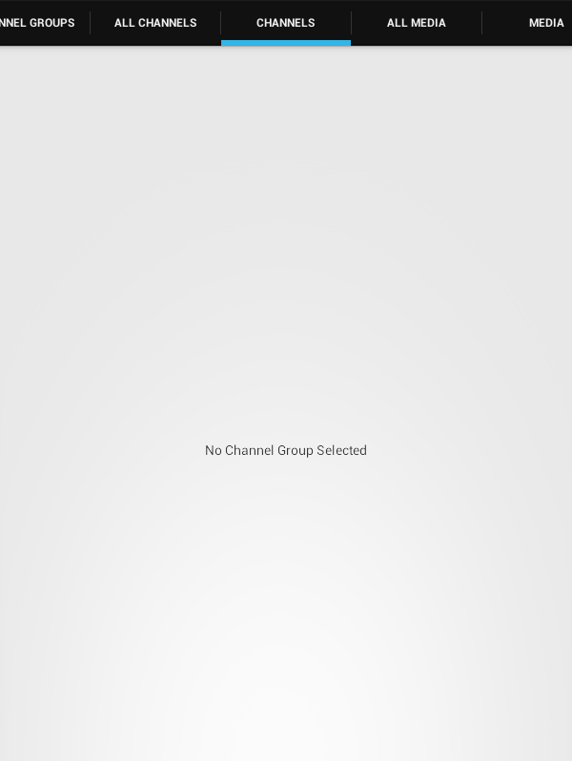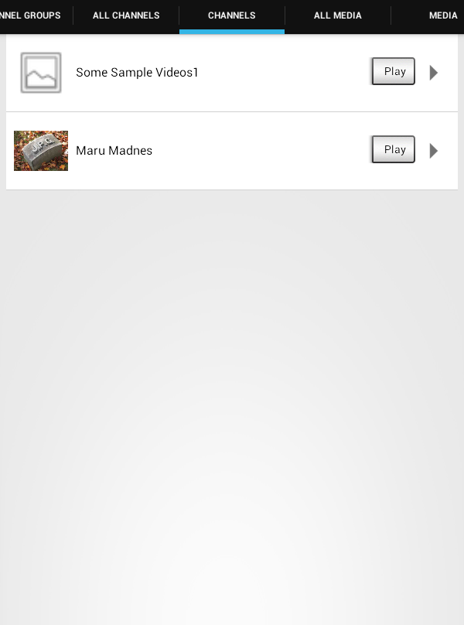

- This page lists the channels for a selected Channel Group.

- Channels list can be refreshed by pulling the list down at the top.

- The max number of channels to be fetched from server in each request is 500. But we are setting it to 100 from application. So the page size is 100.

- If there are more than 100 channels in the selected channel group on server, scrolling the list down will automatically fetch the next 100 channels.

- Error messages are also shown in this page and list will not be visible in error case.

- On Selecting a particular channel in this list, fetches the media for the selected channel and the Page automatically changes to media page.

- Selecting “Play” button in a particular channel will start the playback of all the media present in that channel. Channel acts as a playlist here. The test application will show the player page automatically and start playing the first media in the channel.

All Media page

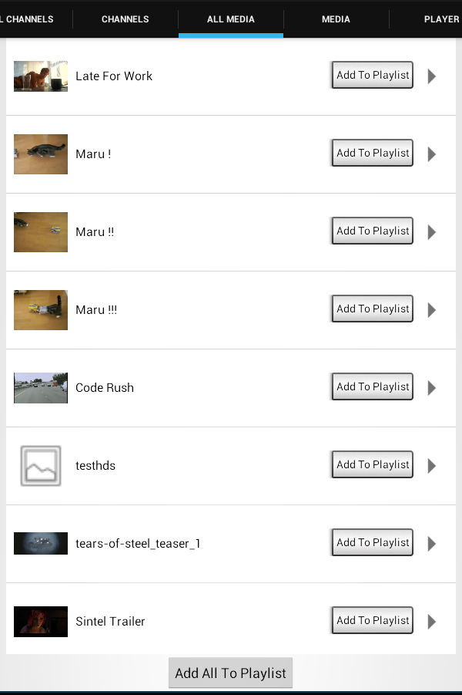

- This page lists all the media available on limelight server.

- Media list can be refreshed by pulling the list down at the top.

- The max number of media to be fetched from server in each request is 500. But we are setting it to 100 from application. So the page size is 100.

- If there are more than 100 media on server, scrolling the list down will automatically fetch the next 100 media.

- Error messages are also shown in this page and list will not be visible in error case.

- On Selecting a particular media in this list, fetches the encodings for the selected group and the Page automatically changes to player page.

- Each media in the All Media page can be added to playlist by clicking “Add To Playlist” button.

- All the media in All Media page can be added to playlist by clicking “Add All To Playlist.

Media page

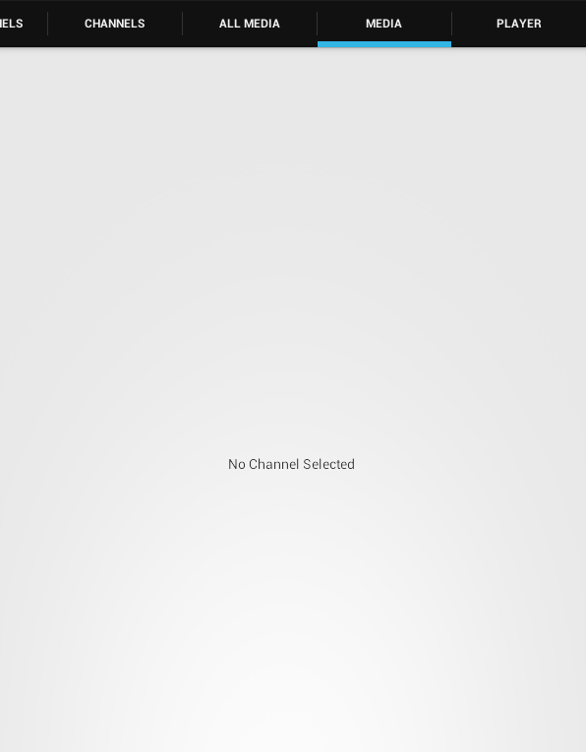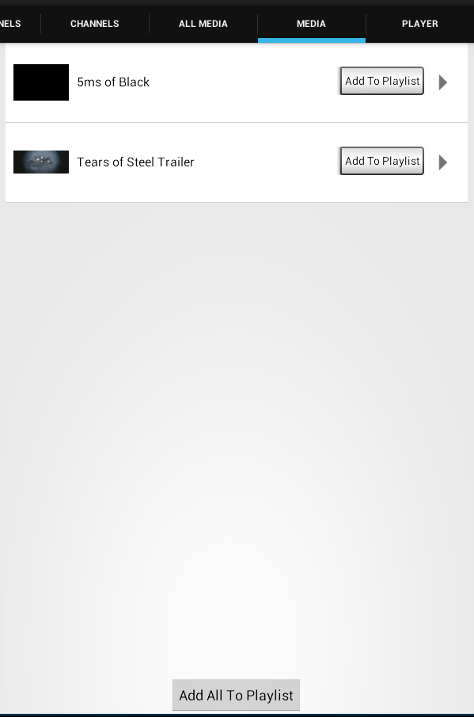

- This page lists the media for a selected channel.

- Media list can be refreshed by pulling the list down at the top.

- The max number of media to be fetched from server in each request is 500. But we are setting it to 100 from application. So the page size is 100.

- If there are more than 100 media on server, scrolling the list down will automatically fetch the next 100 media.

- Error messages are also shown in this page and list will not be visible in error case.

- On Selecting a particular media in this list, fetches the encodings for the selected group and the Page automatically changes to player page.

- Each media in the Media page can be added to playlist by clicking “Add To Playlist” button.

- All the media in Media page can be added to playlist by clicking “Add All To Playlist.

Player page

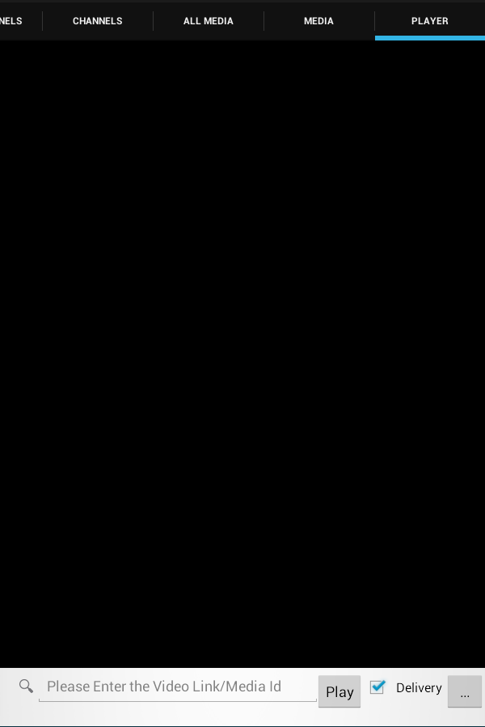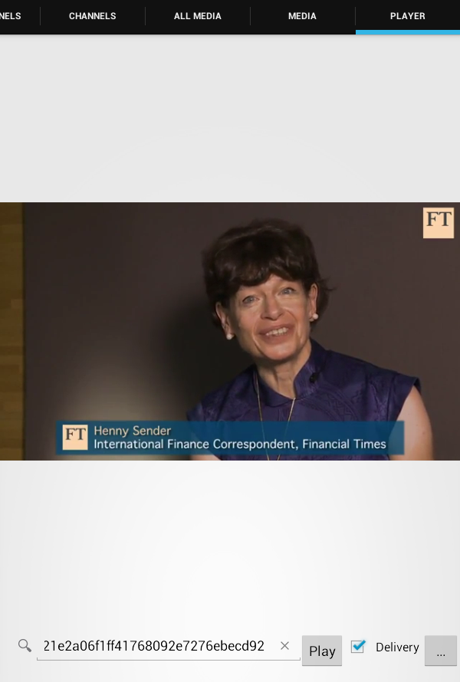

- In Edit Text, user can enter a media ID OR media link manually.

- “…” button is used to load local files.

- To load a local video file, TestLimeLightVideoSDK fires intent to start the "file chooser" UI and select local video content. If the Device is running with android 4.3 or high then use Storage access framework(SAF) to get the video file. SAF scope is very wide and the video file can also be from Google Drive. If the device is running lower than 4.3 then use normal video content picker.

- Video file picker returns in OnActivityResult. The video file Uri is in result data. It sets this Uri in Player.

- Local file name is also displayed below the edit text.

- LimelightVideoSDK displays a Player view when Uri is set.

- On selecting Play button LimelightVideoSDK will resolve that whether the entered string is remote media link or remote media Id or local content.

- If it is remote link LimelightVideoSDK will fetch the data and displays a player view and starts playing

- If it is local content link, LimelightVideoSDK will start playing directly.

- If it is media Id, and delivery check box is not selected, the LimelightVideoSDK fetches all the encodings for that media Id. On selecting a particular encoding, LimelightVideoSDK fetches media related to the selected encoding and starts playing.

- If the selected encoding is widevine, LimelightVideoSDK fetches the rights related to media and on rights validation, starts playing.

- If the selected encoding is widevine offline, LimelightVideoSDK first downloads the media, then fetches the rights related to media and on rights validation, starts playing.

- If the delivery checkbox is selected, then TestLimelightVideoSDK will request LimelightVideoSDK to automatically create a delivery to be played. LimelightVideoSDK will fetch the encodings and then creates a delivery and starts playing it. TestLimelightVideoSDK will not show any encodings to be selected by user.

- In invalid cases, player displays error messages.

- Handle the configuration changes in OnConfigurationChanged.

- Set a listener which initializes control when player is attached to test application.

- Set a listener which handles error scenarios of player.

- Set a listener when video view in player is prepared.

- Delivery check box is selected by default.

Player with PlayList

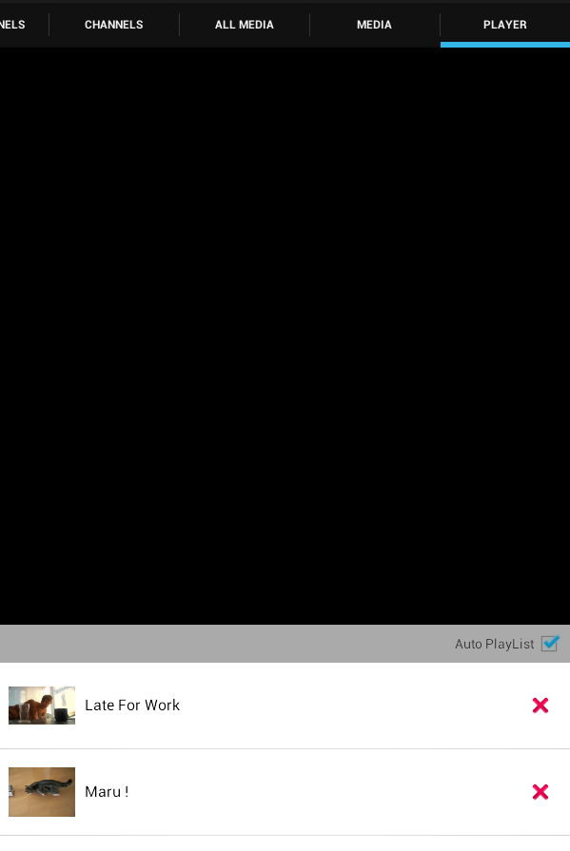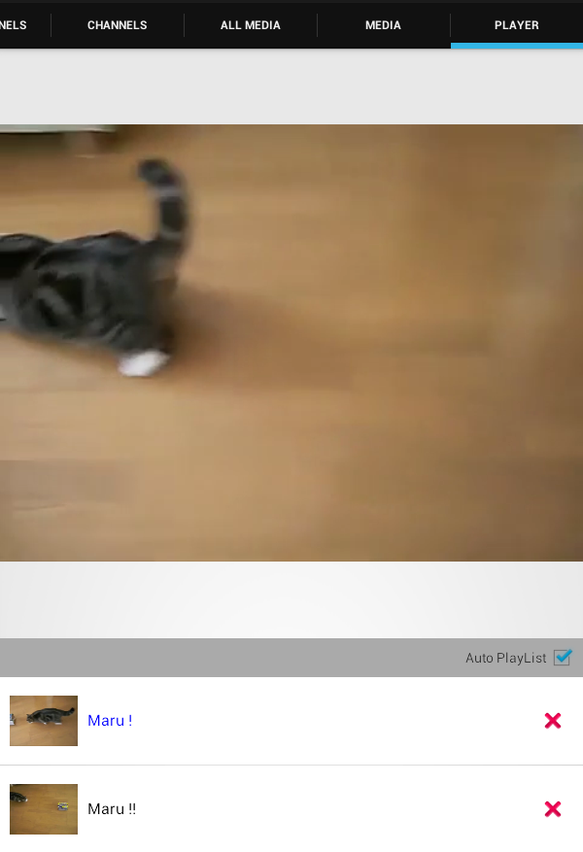

- Playlist in Player page will be visible only when any Media is added to playlist from All Media page or Media page.

- Selecting a media in playlist start playing that media.

- The currently playing Media will be highlighted.

- Checking “Auto Playlist” option plays the media in Playlist one after other.

- Media can be removed from playlist by “Delete” button.

Player with Channel Playlist

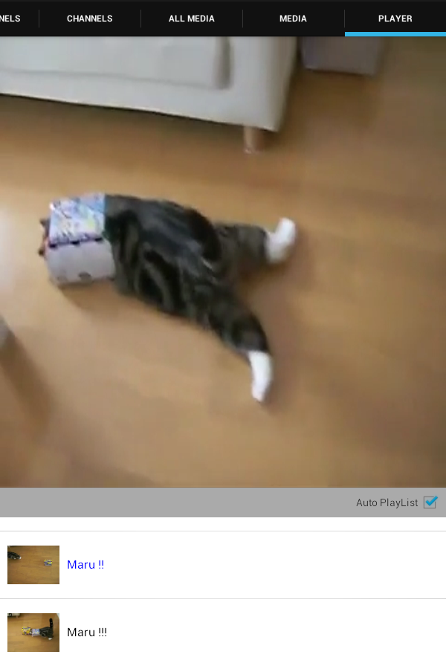

- Channel playlist in Player page will be visible only when any “Play” button is selected for a channel in All Channel page or Channel page.

- The currently playing Media will be highlighted.

- Checking “Auto Playlist” option plays the media in Playlist one after other.

- Media can not be removed from playlist.

Full Screen Player

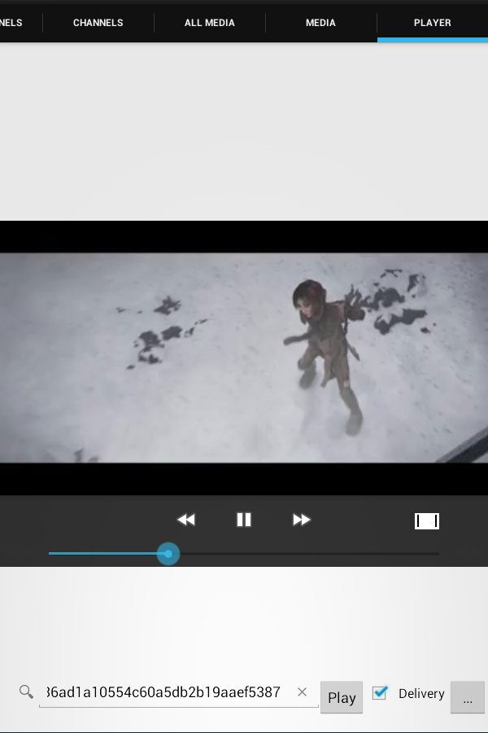

- MediaControl has Full Screen button in corner. On Clicking Full Screen Button when in normal screen, the video goes to full screen. On Clicking Full Screen Button when in full screen, the video goes to normal screen.

- The state of player remains unchanged.

Encodings Dialog

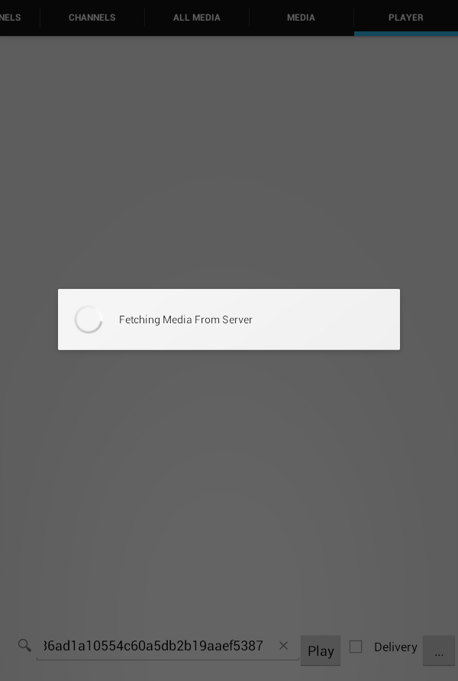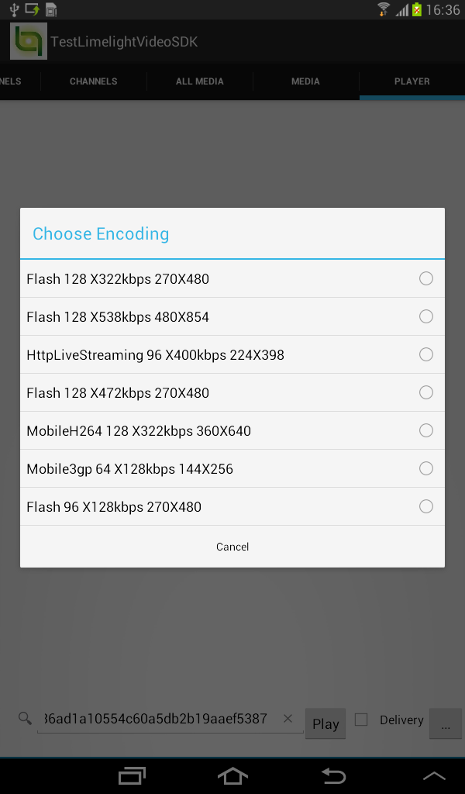

- The encoding dialog displays the available encodings for the media Id selected by user.

- These encodings are fetched from Limelight Server by the LimelightVideoSDK.

- Each encoding here comprises of Primary Use, Bit rate and Resolution.

Widevine

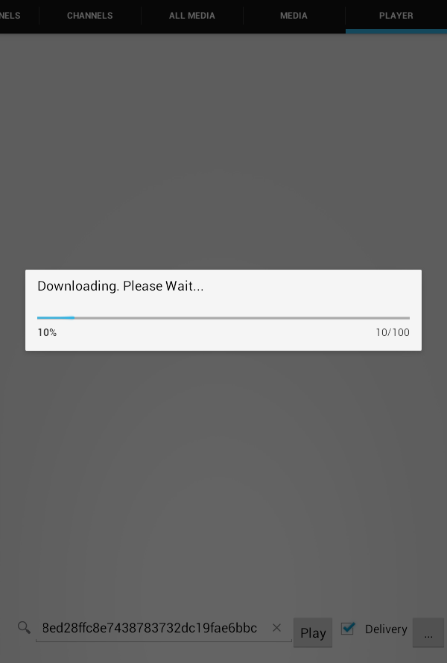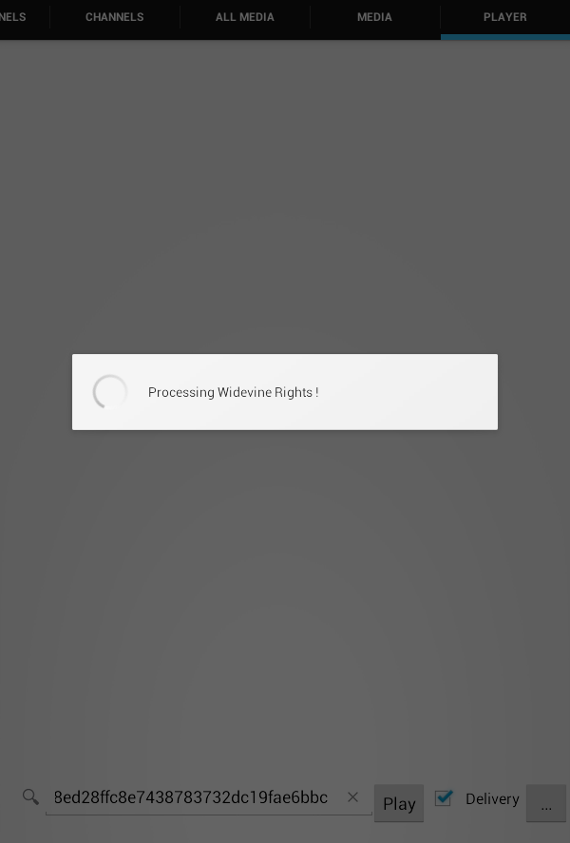

- Widevine offline involves downloading protected media from Limelight network.

- LimelightVideoSDK is downloading the content and showing the download progress.

- LimelightVideoSDK is also doing the rights validation for the protected content, either online or offline.

Creating Application using LimelightVideoSDK in Eclipse

- Create an android application in ADT bundle’s eclipse.
- Include LimelightVideoSDK.jar in the libs folder and add it as a jar in application class path by configuring application build path.
- Create a package and write classes and methods to access LimelightVideoSDK APIs in “src” folder. Write layout and resources under “res” folder.

Creating Application using LimelightVideoSDK in Android Studio

- Create a new Project in Android Studio.
- Write classes and methods to access LimelightVideoSDK APIs under “app” folder. Write layouts and resources under “res” folder
- Copy LimelightVideoSDK.jar in the libs folder and add it as a file dependency using Project Structure → app → dependency → + → File Dependency. Or modify build.gradle file of the app by adding below line under dependency :
compile files ('libs/limelightvideosdk.jar')

Application Installation

Once application development is done, the .apk can be run on device.

For emulator documentation, Please refer:
http://developer.android.com/tools/devices/emulator.html

1) To install and run the application using adb

- Once the application is successfully compiled and .apk has been generated, open command prompt/terminal and navigate to path where adb is located. Or, set the environment variables for adb.
- Use command adb install apkpath
- Here apkpath is the path where apk is located.
- Once apk is installed, application can be run from application launcher on device.

2) To install and run the application using Eclipse

Once the application is successfully compiled and .apk has been generated, right click on project and select “run as” → “Android Application”

3) To install and run the application using Android Studio

Once the application is successfully compiled, select Run → “Run app”

4) To install the app just copy it to your device and tap on it to install

NOTE

This is not a full-fledged app and does not do a lot of error checking. So while using the app.

Please take care of the following:

1) Minimum Android version supported is 4.0.

2) Current testing environment has been Android 4.4

3) The app is not signed. In order to install, make sure you have enabled Unknown sources
under, settings -> Security -> Device Administration

4) The app needs the network permission.

5) To install the app just copy it to your device and tap on it to install.

6) Make sure the Media Id is correct.

7) Make sure URLs are correct.

8) If you are looking to play a local video, tap on the “…” button.

9) The key board does not automatically go away. You can get rid of the key board using the back key.

10) If you face any problem with Progress Dialog, press the back key. It will cancel the progress dialog but it will not stop the task going on in background.

11) Device system time should be proper for playing wide vine content.

