Limelight Video Platform Android SDK

Prerequisites
- Target Android OS 4.0 to latest 5.x
- Android Studio
- Android SDK 4.0(building with 4.0 to support from 4.0 onwards)
- A Limelight Orchestrate Video account

Installation
To add LimelightVideoKit manually to your project follow these steps:
- Download the limelightvideosdk.jar for Android.
- Add the limelightvideosdk.jar to “libs” directory of your project.

How to create Simple Application using LimelightVideoSDK
This tutorial helps you create basic application using limelightvideosdk.jar to play a sample media.
There are two ways to try this Sample Application.
- Manually setup the project by following the steps below.
- Download the sample project as a starting point from Github
  - Get the entire project from Github.
  - Import to eclipse.
  - Build and run the project.

Create the project in Eclipse.
If you do not have it already, install Android Studio.
- Create a new project in Android Studio. Open Android Studio and from Menu select File -> New -> New Project. The following screen gets displayed.
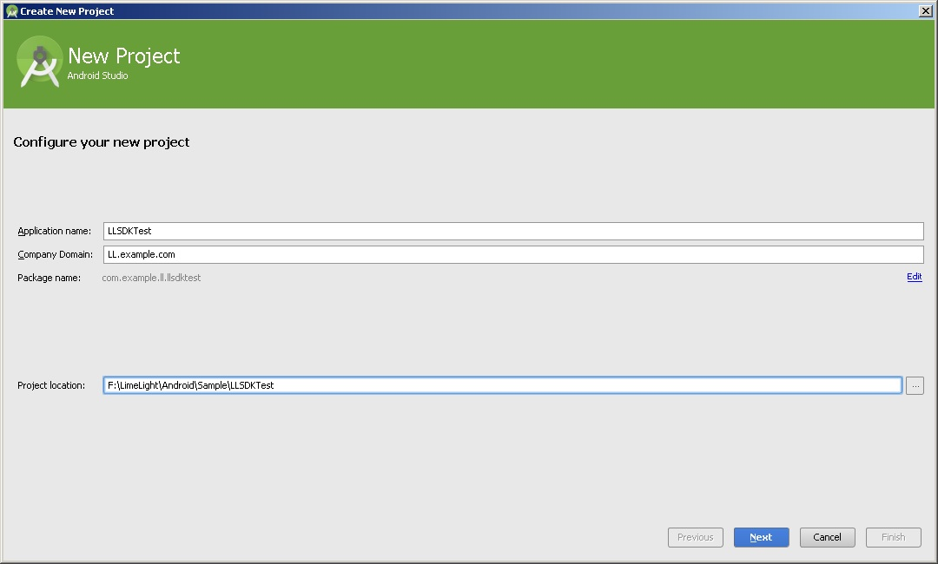

- Set the project details as follows.
Application Name: Desired application name (LLSKTest is given in the screen)
Company Domain: Desired (given LL.example.com in the screen)
Project location: Desired location.

Choose “Next” to proceed to next screen.

- Configure the project as follows
Select “Tabbed Activity”.
Choose “Next” to proceed to next screen.
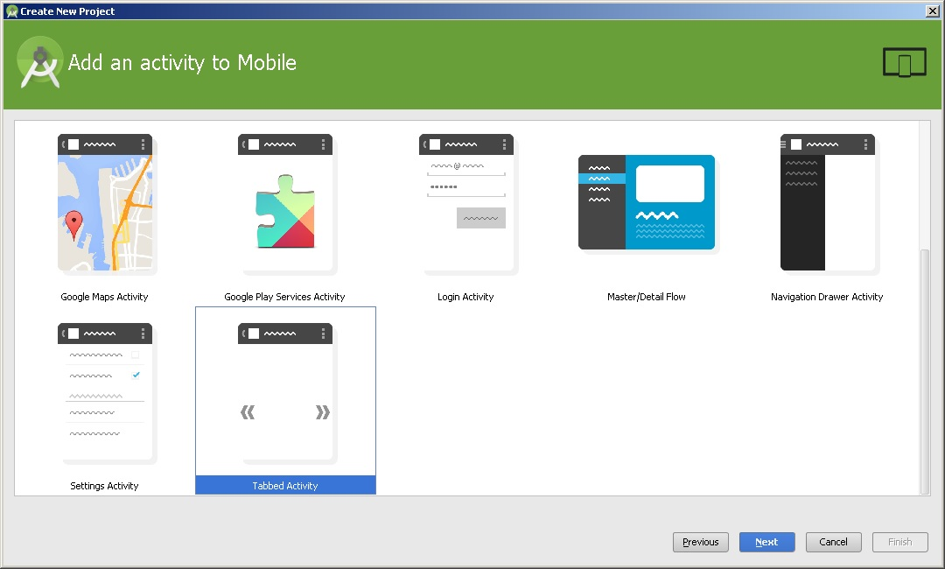

- Customize the Activity as follows
Activity Name: “MainActivity”
Layout Name: “activity_main”
Fragment Layout Name: “fragment_main”
Title: “Main Activity”
Menu Resource Name: Menu_main
Navigation style: “Action Bar Tabs (with View Pager)”
Choose “Finish” to proceed and create the project.

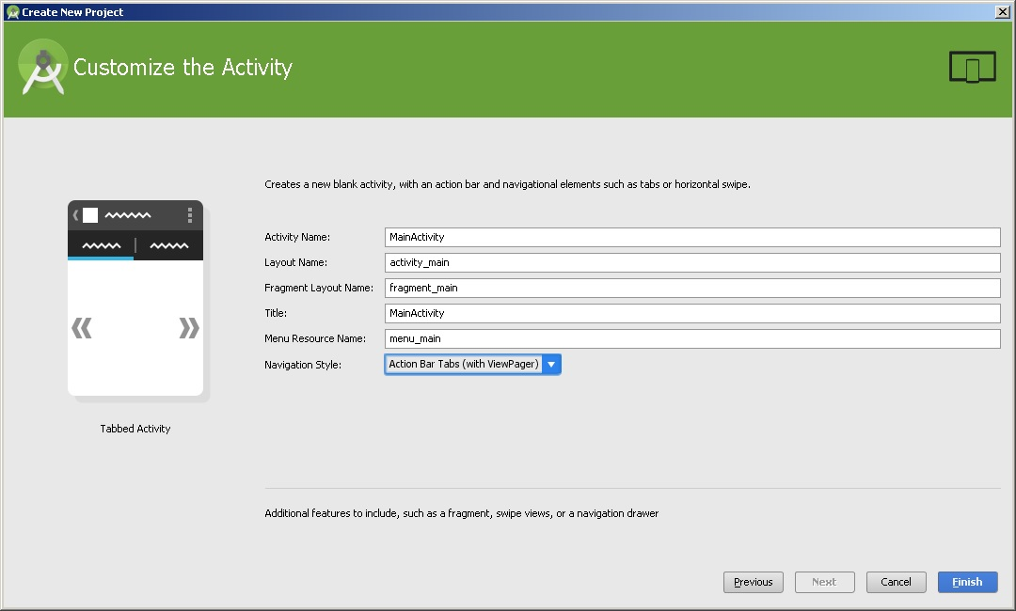

Adding SDK and setting up your project.
- Download the limelightvideosdk.jar for Android.
- Add the limelightvideosdk.jar to “libs” directory of your project.
- Open “AndroidManifest.xml” under project folders in Eclipse, edit “AndroidManifest.xml” using xml tab to have the following contents.
Under
<application
<activity
Add the following:

android:configChanges="keyboard|keyboardHidden|screenSize|orientation|screenLayout|touchscreen|uiMode"

- After the activity block add the following(for full screen player):
<activity android:name="com.limelight.videosdk.FullScreenPlayer" android:configChanges="keyboard|keyboardHidden|screenSize|orientation|screenLayout|touchscreen|uiMode">
</activity>
- Before the application block add the following for permissions:
<uses-permission android:name="android.permission.ACCESS_NETWORK_STATE"/>
<uses-permission android:name="android.permission.INTERNET"/>
<uses-permission android:name="android.permission.WRITE_EXTERNAL_STORAGE"/>
- Add string values to res->values->strings.xml, It should have the following values:
<resources>
<string name="app_name">LLSDKTest</string>
<string name="title_media_of_channel">MediaOfChannel</string>
<string name="title_player">Player</string>
</resources>
- Ensure that you have not set “android:theme” in <application> in AndroidManifest.xml. Doing so will disable the action bar in your app, resulting in an error during runtime. Remove this line if you see it.

For example, this:
<application
android:allowBackup="true"
android:icon="@mipmap/ic_launcher"
android:label="@string/app_name"
android:theme="@style/AppTheme">
should be changed to this:
<application
android:allowBackup="true"
android:icon="@mipmap/ic_launcher"
android:label="@string/app_name">
Your manifest should now look like:
<?xml version="1.0" encoding="utf-8"?>
<manifest xmlns:android="http://schemas.android.com/apk/res/android"
package="com.example.www.yourappname" >

<uses-permission android:name="android.permission.ACCESS_NETWORK_STATE"/>
<uses-permission android:name="android.permission.INTERNET"/>
<uses-permission android:name="android.permission.WRITE_EXTERNAL_STORAGE"/>

<application
android:allowBackup="true"
android:icon="@mipmap/ic_launcher"
android:label="@string/app_name">

<activity
android:name=".MainActivity"
android:label="@string/app_name"
android:configChanges="keyboard|keyboardHidden|screenSize|orientation|screenLayout|touchscreen|uiMode" >
<intent-filter>
<action android:name="android.intent.action.MAIN" />
<category android:name="android.intent.category.LAUNCHER" />
</intent-filter>
</activity>

<activity
android:name="com.limelight.videosdk.FullScreenPlayer"
android:configChanges="keyboard|keyboardHidden|screenSize|orientation|screenLayout|touchscreen|uiMode">
</activity>
</application>

</manifest>

Code the simple video player application
You are just few steps away from playing sample media in your application.
(Note: Don’t fix any errors until the end. Copying the code as it is will not result in an errors except for the ones described on step 24 and 25.)
- Open the activity_main.xml under res->layout, the contents should be like the following.
<android.support.v4.view.ViewPager xmlns:android="http://schemas.android.com/apk/res/android"
xmlns:tools="http://schemas.android.com/tools" android:id="@+id/pager"
android:layout_width="match_parent" android:layout_height="match_parent"
tools:context=".MainActivity" />
- Under res-> layout create the following resource xml files by right click, select New->xml->layout XML file. Resource xmls with names fragment_media, fragment_player, list_media and toast.
- Contents of fragment_media.xml should be as the following:
<?xml version="1.0" encoding="utf-8"?>
<android.support.v4.widget.SwipeRefreshLayout xmlns:android="http://schemas.android.com/apk/res/android"
android:id="@+id/swipe_container"
android:layout_width="match_parent"
android:layout_height="match_parent" >
<LinearLayout
xmlns:android="http://schemas.android.com/apk/res/android"
android:layout_width="match_parent"
android:layout_height="match_parent"
android:orientation="vertical"
android:paddingLeft="8dp"
android:paddingRight="8dp" >
<ListView
android:id="@id/android:list"
android:layout_width="match_parent"
android:layout_height="0dp"
android:layout_weight="1"
android:drawSelectorOnTop="false" />

<TextView
android:id="@id/android:empty"
android:layout_width="match_parent"
android:layout_height="0dp"
android:layout_weight="1"
android:gravity="center"
android:text="No data"
android:visibility="gone" />
<ProgressBar
android:id="@+id/progress"
android:layout_width="wrap_content"
android:layout_height="match_parent"
android:layout_gravity="center" />
<ProgressBar
android:id="@+id/progress_load"
android:layout_width="wrap_content"
android:layout_height="wrap_content"
android:layout_gravity="center" />
<LinearLayout
android:layout_width="match_parent"
android:layout_height="50dp"
android:orientation="horizontal"
android:paddingLeft="8dp"
android:paddingRight="8dp" >
</LinearLayout>
</LinearLayout>
</android.support.v4.widget.SwipeRefreshLayout>
- Contents of fragment_player.xml should be as the following:
<LinearLayout xmlns:android="http://schemas.android.com/apk/res/android"
xmlns:tools="http://schemas.android.com/tools"
android:layout_width="match_parent"
android:layout_height="match_parent"
android:orientation="vertical"
tools:context=".MainActivity" >
<RelativeLayout
android:id="@+id/videoLayout"
android:layout_width="match_parent"
android:layout_height="0dp"
android:layout_weight="1"
android:divider="@android:drawable/divider_horizontal_dark"
android:gravity="center" >
</RelativeLayout>
</LinearLayout>
- Contents of list_media.xml should be as the following:
<?xml version="1.0" encoding="utf-8"?>
<RelativeLayout xmlns:android="http://schemas.android.com/apk/res/android"
android:layout_width="match_parent"
android:layout_height="match_parent"
android:padding="10dp"
android:background="@android:color/background_light">
<FrameLayout
android:id="@+id/imageContainer"
android:layout_width="80dp"
android:layout_height="80dp"
android:layout_alignParentLeft="true"
android:layout_centerVertical="true"
android:paddingRight="10dp" >
<ProgressBar
android:id="@+id/progressThumbnail"
style="@android:style/Widget.ProgressBar.Small"
android:layout_width="wrap_content"
android:layout_height="wrap_content"
android:layout_gravity="center" >
</ProgressBar>
<ImageView
android:id="@+id/image"
android:layout_width="match_parent"
android:layout_height="match_parent" />
</FrameLayout>
<TextView
android:id="@+id/text"
android:layout_width="wrap_content"
android:layout_height="wrap_content"
android:layout_centerVertical="true"
android:layout_toRightOf="@id/imageContainer"
android:gravity="center"
android:lines="2"
android:textSize="16sp"
android:layout_marginRight="120dp"
android:textColor="@android:color/black"
android:text="No data" />
</RelativeLayout>
- Contents of toast.xml should be as the following:
<?xml version="1.0" encoding="utf-8"?>
<TextView xmlns:android="http://schemas.android.com/apk/res/android"
android:id="@+id/text"
android:layout_width="match_parent"
android:layout_height="wrap_content"
android:padding="10dp" style="@android:style/TextAppearance.DeviceDefault.Widget.TextView.PopupMenu"
android:textSize="30sp" >
</TextView>

- Edit MainActivity.java located user the “src” folder.
- Modify the class implementation as the following:
public class MainActivity extends FragmentActivity implements IPlayerCallback, OnPageChangeListener,ActionBar.TabListener
- Implement IPlayerCallback from SDK to communicate with the SDK.
- In onCreate add the following to configure the SDK(these are optional. If not provided the SDK will use the default production values.)
Setting.configureLimelightSettings(<Limelight API End point URL>, <Limelight license proxy URL>, <Limelight portal key>);
LoggerUtil.setLogLevelByString("Debug",this);
Setting.SetAnalyticsEndPoint(<Limelight Analytics End point URL>);

(Note: values for these are available in the Constants class)
- Add a member to hold the channel ID as the following
private String mChannelID = <your channel ID>;
- Use mouse hover on “MainActivity” class to add un-implemented methods.
- The contents of “MainActivity” should look like the following:
package com.example.llsdktest2;
import com.limelight.videosdk.Constants;
import com.limelight.videosdk.ContentService;
import com.limelight.videosdk.IPlayerCallback;
import com.limelight.videosdk.IPlayerControl;
import com.limelight.videosdk.LoggerUtil;
import com.limelight.videosdk.Constants.PlayerState;
import com.limelight.videosdk.utility.Setting;
import com.example.llsdktest2.MediaOfChannel.MediaOfChannelCallback;
import android.app.ActionBar;
import android.app.FragmentTransaction;
import android.support.v4.app.FragmentActivity;
import android.support.v4.view.ViewPager;
import android.support.v4.view.ViewPager.OnPageChangeListener;
import android.support.v4.app.Fragment;
import android.support.v4.app.FragmentManager;
import android.support.v4.app.FragmentPagerAdapter;
import android.util.SparseArray;
import android.os.Bundle;

public class MainActivity extends FragmentActivity implements IPlayerCallback, OnPageChangeListener,ActionBar.TabListener {
private String mChannelID = "<your_channel_id>";
private PlayersFragment mPlayersFragment = null;
private MediaOfChannel mMediaOfChannelFragment = null;
private IPlayerControl mControl;
private SparseArray<Fragment> mRefer = new SparseArray<Fragment>();

/**
* The {@link android.support.v4.view.PagerAdapter} that will provide
* fragments for each of the sections. We use a {@link FragmentPagerAdapter}
* derivative, which will keep every loaded fragment in memory. If this
* becomes too memory intensive, it may be best to switch to a
* {@link android.support.v13.app.FragmentStatePagerAdapter}.
*/
SectionsPagerAdapter mSectionsPagerAdapter;

/**
* The {@link ViewPager} that will host the section contents.
*/
ViewPager mViewPager;

@Override
protected void onCreate(Bundle savedInstanceState) {
super.onCreate(savedInstanceState);

/* configuring SDK
Setting.configureLimelightSettings(Constants.API_PROD, Constants.LICENSE_PROD, "limelight");
LoggerUtil.setLogLevelByString("Debug",this);
Setting.SetAnalyticsEndPoint(Constants.ANALYTICS_PROD);
*/

setContentView(R.layout.activity_main);

// Set up the action bar.
final ActionBar actionBar = getActionBar();
actionBar.setNavigationMode(ActionBar.NAVIGATION_MODE_TABS);

// Create the adapter that will return a fragment for each of the three
// primary sections of the activity.
mSectionsPagerAdapter = new SectionsPagerAdapter(getSupportFragmentManager());

// Set up the ViewPager with the sections adapter.
mViewPager = (ViewPager) findViewById(R.id.pager);
mViewPager.setOnPageChangeListener(this);
mViewPager.setAdapter(mSectionsPagerAdapter);
mViewPager.setOffscreenPageLimit(2);
actionBar.addTab(actionBar.newTab().setText(mSectionsPagerAdapter.getPageTitle(0)).setTabListener(this)); actionBar.addTab(actionBar.newTab().setText(mSectionsPagerAdapter.getPageTitle(1)).setTabListener(this));
}

MediaOfChannelCallback mediaOfChannelCallback = new MediaOfChannelCallback() {
@Override
public void playMediaId(String id, ContentService svc) {
if(mPlayersFragment != null){
mPlayersFragment.play(svc,id);
}
mViewPager.setCurrentItem(1);
}
};

@Override
public void onTabSelected(ActionBar.Tab tab,
FragmentTransaction fragmentTransaction) {
// When the given tab is selected, switch to the corresponding page in
// the ViewPager.
mViewPager.setCurrentItem(tab.getPosition());
}

@Override
public void onTabUnselected(ActionBar.Tab tab,
FragmentTransaction fragmentTransaction) {
}

@Override
public void onTabReselected(ActionBar.Tab tab,
FragmentTransaction fragmentTransaction) {
}

/**
* A {@link FragmentPagerAdapter} that returns a fragment corresponding to
* one of the sections/tabs/pages.
*/
public class SectionsPagerAdapter extends FragmentPagerAdapter {

private int mPageCount = 2;
public SectionsPagerAdapter(FragmentManager fm) {
super(fm);
}

public void setCount(int val) {
mPageCount = val;
}

@Override
public Fragment getItem(int position) {
Fragment retFragment = null;

if(position ==0){
mMediaOfChannelFragment = new MediaOfChannel(mediaOfChannelCallback,mChannelID);
retFragment = mMediaOfChannelFragment;
}else if(position ==1){
mPlayersFragment = new PlayersFragment();
mRefer.put(0, mPlayersFragment);
retFragment = mPlayersFragment;
}
return retFragment;
}

@Override
public int getCount() {
return 2;
}

@Override
public CharSequence getPageTitle(int position) {
String title = "";
switch (position) {
case 0:
title = getResources().getString(R.string.title_media_of_channel);
break;
case 1:
title = getResources().getString(R.string.title_player);
break;
}
return title;

}
}

@Override
public void onPageScrollStateChanged(int arg0) {}
@Override
public void onPageScrolled(int arg0, float arg1, int arg2) { }

@Override
public void onPageSelected(int page) {
if (mPlayersFragment == null) {
mPlayersFragment = (PlayersFragment) mRefer.get(0);
}
if (mPlayersFragment != null){
mPlayersFragment.hideController();
//page is for player
if(page == 1){
if(mPlayersFragment.getPlayerState() != PlayerState.stopped.ordinal())//stopped
mPlayersFragment.show();
}else{
if(mPlayersFragment.getPlayerState() != PlayerState.stopped.ordinal())//stopped
mControl.pause();
}
}
getActionBar().setSelectedNavigationItem(page);
}

@Override
public void playerAttached(IPlayerControl control) {
mControl = control;
//sometimes the mPlayerFragment can be null as it gets destroyed by the system, so using the cashed object
if (mPlayersFragment == null){
mPlayersFragment = (PlayersFragment) mRefer.get(0);
}
if (mPlayersFragment != null){
mPlayersFragment.setControl(mControl);
mPlayersFragment.showProgress(false,null);
}
}

@Override
public void playerMessage(int messageType,int value,String message) {
if (mPlayersFragment == null) {
mPlayersFragment = (PlayersFragment) mRefer.get(0);
}
if(mPlayersFragment != null){
if(messageType == Constants.Message.status.ordinal()){
if(value == Constants.PlayerState.completed.ordinal()){

}else{
mPlayersFragment.showProgress(true,message);
}
}
else if(messageType == Constants.Message.error.ordinal()){
mPlayersFragment.hide();
mPlayersFragment.showProgress(false,null);
mPlayersFragment.showMessage(message);
}
else if(messageType == Constants.Message.progress.ordinal()){
mPlayersFragment.hide();
mPlayersFragment.showProgress(false,null);
mPlayersFragment.showProgressDialog(value);
}
else{
mPlayersFragment.hide();
mPlayersFragment.showProgress(false,null);
mPlayersFragment.showMessage(message);
}
}
}

@Override
public void playerPrepared(IPlayerControl control) {

mControl = control;
if (mPlayersFragment == null)
mPlayersFragment = (PlayersFragment) mRefer.get(0);
if (mPlayersFragment != null) {
mPlayersFragment.setControl(mControl);
mPlayersFragment.showProgress(false,null);
mPlayersFragment.show();
mPlayersFragment.showKeyboard(false);
}
}
}

- Create new classes user “src” folder from File->New-> “Class”.
- The names of classes are MediaOfChannel, ModelHolder, ListAdapter and PlayersFragment
- The contents of “MediaOfChannel” should look like the following:
package com.example.llsdktest2;
import java.util.ArrayList;
import com.limelight.videosdk.Constants;
import com.limelight.videosdk.ContentService;
import com.limelight.videosdk.model.Media;
import com.limelight.videosdk.model.Media.MediaThumbnail;
import android.content.Context;
import android.net.Uri;
import android.os.Bundle;
import android.support.v4.app.Fragment;
import android.support.v4.app.LoaderManager;
import android.support.v4.content.AsyncTaskLoader;
import android.support.v4.content.Loader;
import android.view.LayoutInflater;
import android.view.View;
import android.view.ViewGroup;
import android.widget.AbsListView;
import android.widget.AdapterView;
import android.widget.ListView;
import android.widget.ProgressBar;
import android.widget.TextView;
import android.widget.AbsListView.OnScrollListener;
import android.widget.AdapterView.OnItemClickListener;

class MediaOfChannel extends Fragment implements LoaderManager.LoaderCallbacks<ModelHolder>,OnItemClickListener,OnScrollListener{
private static String organizationID = "YOUR_ORGANIZATION_ID";
private static String accessKey = "YOUR_ACCESS_KEY";
private static String secretKey = "YOUR_SECRET_KEY";
private ListView mListView;
private TextView mTextView;
private ProgressBar mProgress;
private ProgressBar mProgressLoad;
private static String mChannelId = null;
private static String mErrorMsg;
private MediaOfChannelCallback mActivityCallback;
private int mPreviousTotalCount = 0;
private static ContentService mContentService = null;
private static ArrayList<Media> mMedias = null;
private ListAdapter mAdapter;
private static final int TYPE_MEDIA = 3;
public MediaOfChannel(MediaOfChannelCallback callback,String id) {
mActivityCallback = callback;
mChannelId = id;
mAdapter= null;
mListView= null;
}

@Override
public View onCreateView(LayoutInflater inflater,ViewGroup container, Bundle savedInstanceState) {
View view = inflater.inflate(R.layout.fragment_media, container,false);

mListView = (ListView) view.findViewById(android.R.id.list);
mTextView = (TextView) view.findViewById(android.R.id.empty);
mProgress = (ProgressBar) view.findViewById(R.id.progress);
mProgressLoad = (ProgressBar) view.findViewById(R.id.progress_load);
mListView.setOnItemClickListener(this);
mListView.setOnScrollListener(this);
return view;
}
@Override
public void onActivityCreated(Bundle savedInstanceState) {
super.onActivityCreated(savedInstanceState);
setEmptyText("No Channel Selected");
mAdapter = new ListAdapter(getActivity(),TYPE_MEDIA);
mListView.setAdapter(mAdapter);
setListShown(false);
if(mChannelId == null){
setListShown(true);
}
else{
getActivity().getSupportLoaderManager().initLoader(13, null, this);
}
}
public interface MediaOfChannelCallback{
void playMediaId(String mediaId, ContentService contentservice);
}

private void setEmptyText(String string) {
mTextView.setText(string);
}
private void setListShown(boolean b) {
mProgressLoad.setVisibility(View.GONE);
if(b){
//Hide progress
mProgress.setVisibility(View.GONE);
//hide text if list exist
if(mMedias!= null && mMedias.size()>0){
mListView.setVisibility(View.VISIBLE);
mTextView.setVisibility(View.GONE);
}else{
mListView.setVisibility(View.GONE);
mTextView.setVisibility(View.VISIBLE);
}
}else{
//show progress hide text hide list
mListView.setVisibility(View.GONE);
mTextView.setVisibility(View.GONE);
mProgress.setVisibility(View.VISIBLE);
}
}

private void loadMore(){
mProgressLoad.setVisibility(View.VISIBLE);
Bundle b = new Bundle();
b.putBoolean("Refresh", true);
if(mChannelId != null){
getActivity().getSupportLoaderManager().restartLoader(13, b, this);
}
}
@Override
public void onScroll(AbsListView view, int firstVisibleItem, int visibleItemCount, int totalItemCount) {
if (totalItemCount == 0 || mAdapter == null)
return;
if (mPreviousTotalCount == totalItemCount)
return;
boolean loadMore = (firstVisibleItem + visibleItemCount >= totalItemCount);
if (loadMore){
//Fetching next page data
mPreviousTotalCount = totalItemCount;
loadMore();
}
}
@Override
public void onScrollStateChanged(AbsListView arg0, int arg1) {

}
@Override
public void onItemClick(AdapterView<?> arg0, View arg1, int position, long arg3) {
if((mContentService.getOrgId().equalsIgnoreCase(organizationID) == false) ||
(mContentService.getAccessKey().equalsIgnoreCase(accessKey) == false) ||
(mContentService.getSecret().equalsIgnoreCase(secretKey) == false)){
mContentService = new ContentService(getActivity(),organizationID,accessKey,secretKey);
}
if(mMedias!= null && !mMedias.isEmpty()){
mActivityCallback.playMediaId(mMedias.get(position).mMediaID, mContentService);
}
}
@Override
public Loader<ModelHolder> onCreateLoader(int arg0, Bundle arg1) {

MediaOfChannelLoader loader = new MediaOfChannelLoader(MediaOfChannel.this.getActivity(),arg1);
loader.forceLoad();
return loader;
}
@Override
public void onLoadFinished(Loader<ModelHolder> arg0, ModelHolder arg1) {

if(mMedias == null){
setEmptyText(mErrorMsg);
setListShown(true);
}
else if(mMedias.size()==0){
setEmptyText("No Media Found In This Channel");
setListShown(true);
}
mAdapter.setData(arg1.getTitles(),arg1.getUrls(),arg1.getIds());
mAdapter.notifyDataSetChanged();
setListShown(true);
}
@Override
public void onLoaderReset(Loader<ModelHolder> arg0) {
mAdapter.setData(null, null, null);
mListView.setAdapter(null);
}
/**
* This class is to fetch all the media of channel asynchronously.
*
*/
private static class MediaOfChannelLoader extends AsyncTaskLoader<ModelHolder> {

private ModelHolder mHolder;
private boolean refresh = false;
private Context mContext;

public MediaOfChannelLoader(Context context, Bundle arg1) {
super(context);
mContext = context;
if(arg1!= null){
refresh = arg1.getBoolean("Refresh", false);
}
mHolder = new ModelHolder();
if(mContentService == null){
mContentService = new ContentService(mContext,organizationID,accessKey,secretKey);
}
}

/**
* (non-Javadoc)
* @see android.support.v4.content.AsyncTaskLoader#loadInBackground()
* Communicating with the SDK and fetching the media data for a specific channel.
*/
@Override
public ModelHolder loadInBackground() {
ArrayList<String> tilteList = new ArrayList<String>();
ArrayList<Uri> urls = new ArrayList<Uri>();
ArrayList<String> mediaIds = new ArrayList<String>();

try {
if(mChannelId != null){
mContentService.setPagingParameters(50, Constants.SORT_BY_UPDATE_DATE, Constants.SORT_ORDER_DESC);
mMedias = mContentService.getAllMediaOfChannel(mChannelId,refresh);
}
} catch (Exception e) {
mMedias = null;
mErrorMsg = e.getMessage();
return mHolder;
}
for(int i = 0; i<mMedias.size() ;i++){
tilteList.add(mMedias.get(i).mTitle);
MediaThumbnail t = mMedias.get(i).mThumbnail;
if(t!= null)
urls.add((t.mUrl));
mediaIds.add(mMedias.get(i).mMediaID);
}
mHolder.setTitles(tilteList);
mHolder.setUrls(urls);
mHolder.setIds(mediaIds);
return mHolder;
}

@Override
public void deliverResult(ModelHolder data) {
super.deliverResult(data);
}
}
}

- The contents of “ListAdapter” should look like the following:

package com.example.llsdktest2;
import java.util.ArrayList;
import com.limelight.videosdk.utility.Downloader;
import com.limelight.videosdk.utility.Thumbnail;
import android.content.Context;
import android.graphics.Bitmap;
import android.graphics.BitmapFactory;
import android.net.Uri;
import android.support.v4.app.FragmentActivity;
import android.view.LayoutInflater;
import android.view.View;
import android.view.ViewGroup;
import android.widget.BaseAdapter;
import android.widget.ImageView;
import android.widget.ProgressBar;
import android.widget.TextView;

public class ListAdapter extends BaseAdapter {
private ArrayList<String> mTitleList;
private ArrayList<Uri> mUriList;
private ArrayList<String> mMediaIdList;
private FragmentActivity mFragmentActivity;
private Bitmap mLoadingBitmap = null;
private Downloader mDownloader = null;

class ViewHolder {
public TextView mTextView;
public ImageView mThumbnailImage;
public ProgressBar mProgress;
}
public ListAdapter(FragmentActivity mActivity) {
mFragmentActivity = mActivity;
mLoadingBitmap = BitmapFactory.decodeResource(mFragmentActivity.getResources(), android.R.drawable.ic_menu_gallery);
mDownloader = new Downloader(mFragmentActivity);
}
public ListAdapter(FragmentActivity mActivity,int type) {
mFragmentActivity = mActivity;
mLoadingBitmap = BitmapFactory.decodeResource(mFragmentActivity.getResources(), android.R.drawable.ic_menu_gallery);
mDownloader = new Downloader(mFragmentActivity);
}
public void setData(ArrayList<String> list, ArrayList<Uri> uri,ArrayList<String> mediaIds){
mUriList = uri;
mTitleList = list;
mMediaIdList = mediaIds;
}
public ListAdapter(FragmentActivity mActivity, ArrayList<String> mList, ArrayList<Uri> mUri) {
mTitleList = mList;
mFragmentActivity = mActivity;
mUriList = mUri;
mLoadingBitmap = BitmapFactory.decodeResource(mFragmentActivity.getResources(), android.R.drawable.ic_menu_gallery);
mDownloader = new Downloader(mFragmentActivity);
}
@Override
public int getCount() {
return mTitleList == null ? 0 : mTitleList.size();
}
@Override
public Object getItem(int position) {
return mTitleList == null ? null : mTitleList.get(position);
}
@Override
public long getItemId(int position) {
return position;
}

@Override
public View getView(final int position, View convertView, ViewGroup parent) {
View rowView = convertView;
if(rowView == null){
LayoutInflater inflater = (LayoutInflater) mFragmentActivity.getSystemService(Context.LAYOUT_INFLATER_SERVICE);
rowView = inflater.inflate(R.layout.list_media, null);
ViewHolder viewHolder = new ViewHolder();
viewHolder.mTextView = (TextView) rowView.findViewById(R.id.text);
viewHolder.mThumbnailImage = (ImageView) rowView.findViewById(R.id.image);
viewHolder.mProgress = (ProgressBar) rowView.findViewById(R.id.progressThumbnail);
rowView.setTag(viewHolder);
}

final ViewHolder holder = (ViewHolder) rowView.getTag();
holder.mTextView.setText(mTitleList.get(position));
if(mUriList.get(position)!= null){
mDownloader.startDownload(mUriList.get(position).toString(), null, null, mMediaIdList.get(position),new Downloader.DownLoadCallback(){
@Override
public void onSuccess(String path) {
Thumbnail t = new Thumbnail();
t.loadBitmap(mFragmentActivity, path, holder.mThumbnailImage, null);
holder.mProgress.setVisibility(View.GONE);
}
@Override
public void onError(Throwable ex) {
holder.mThumbnailImage.setImageBitmap(mLoadingBitmap);
holder.mProgress.setVisibility(View.GONE);
}
@Override
public void onProgress(int percentFinished) {
holder.mThumbnailImage.setImageBitmap(mLoadingBitmap);
holder.mProgress.setVisibility(View.VISIBLE);
}
});
}

return rowView;
}

}

- The contents of “ModelHolder” should look like the following:
package com.example.llsdktest2;
import java.util.ArrayList;
import android.net.Uri;

public class ModelHolder {

ArrayList<String> mTitleList = new ArrayList<String>();
ArrayList<Uri> mThumbnailUrlList = new ArrayList<Uri>();
ArrayList<String> mIdList = new ArrayList<String>();

public void setTitles(ArrayList<String> titleList) {
mTitleList = titleList;
}

public ArrayList<String> getTitles() {
return mTitleList;
}

public void setUrls(ArrayList<Uri> temp) {
mThumbnailUrlList = temp;
}
public ArrayList<Uri> getUrls() {
return mThumbnailUrlList;
}
public void setIds(ArrayList<String> idList) {
mIdList = idList;
}
public ArrayList<String> getIds() {
return mIdList;
}
}

- The contents of “PlayersFragment” should look like the following:
package com.example.llsdktest2;
import com.limelight.videosdk.ContentService;
import com.limelight.videosdk.IPlayerControl;
import com.limelight.videosdk.PlayerSupportFragment;
import android.app.ProgressDialog;
import android.content.Context;
import android.os.Bundle;
import android.support.v4.app.Fragment;
import android.util.Log;
import android.view.Gravity;
import android.view.LayoutInflater;
import android.view.View;
import android.view.ViewGroup;
import android.view.inputmethod.InputMethodManager;
import android.widget.TextView;
import android.widget.Toast;

public class PlayersFragment extends Fragment {

private PlayerSupportFragment mPlayer;
private ProgressDialog mProgress = null;
private ProgressDialog mProgressDialog = null;
private IPlayerControl mControl;

@Override
public View onCreateView(LayoutInflater inflater, ViewGroup container,
Bundle savedInstanceState) {
View rootView = inflater.inflate(R.layout.fragment_player, container,false);

mProgress = new ProgressDialog(getActivity(), ProgressDialog.STYLE_SPINNER);
mProgress.setCanceledOnTouchOutside(false);
mProgressDialog = new ProgressDialog(getActivity());
mProgressDialog.setProgressStyle(ProgressDialog.STYLE_HORIZONTAL);
mProgressDialog.setIndeterminate(false);
mProgressDialog.setMessage("Downloading. Please Wait...");
mProgressDialog.setCanceledOnTouchOutside(false);
showKeyboard(false);

mPlayer = new PlayerSupportFragment();
getChildFragmentManager().beginTransaction().add(R.id.videoLayout, mPlayer).addToBackStack(null).commitAllowingStateLoss();
return rootView;
}

public void play(ContentService svc, String mediaId) {
if (mControl != null) {
mControl.stop();
hide();
hideController();
mControl.play(mediaId, svc);//used with delivery
} else
Log.e(getActivity().getLocalClassName(), "Control is null");
}

public void setControl(IPlayerControl control) {
mControl = control;
}

public void showProgress(final boolean show, final String strMsg){
getActivity().runOnUiThread(new Runnable() {
@Override
public void run() {
if(mProgress != null)
if(show){
mProgress.setMessage(strMsg);
mProgress.show();
}
else{
mProgress.hide();
}
}
});
}

public void showProgressDialog(final int percent){
getActivity().runOnUiThread(new Runnable() {
@Override
public void run() {
if(mProgressDialog != null){
if(!mProgressDialog.isShowing() && percent==0){
mProgressDialog.show();
}
if(percent != 100){
mProgressDialog.setProgress(percent);
}else{
mProgressDialog.dismiss();
}
}
}
});
}

public void showMessage(final String msg){
getActivity().runOnUiThread(new Runnable() {
@Override
public void run() {
Toast toast = new Toast(getActivity());
toast.setGravity(Gravity.TOP, 0, 300);
toast.setDuration(Toast.LENGTH_LONG);
LayoutInflater inflater = (LayoutInflater) getActivity().getSystemService(Context.LAYOUT_INFLATER_SERVICE);
View view = inflater.inflate(R.layout.toast, null);
TextView tv = (TextView)view.findViewById(R.id.text);
tv.setText(msg);
toast.setView(view);
toast.show();
}
});
}

public void show() {
getChildFragmentManager().beginTransaction().show(mPlayer).addToBackStack(null).commitAllowingStateLoss();
}

public void hide() {
getChildFragmentManager().beginTransaction().hide(mPlayer).addToBackStack(null).commitAllowingStateLoss();
}

public void hideController(){
mPlayer.hideMediaController();
}

public int getPlayerState(){
return mPlayer.getCurrentPlayState();
}

public void showKeyboard(boolean show) {
// Check if no view has focus:
View view = getActivity().getCurrentFocus();
if (view != null) {
InputMethodManager inputManager = (InputMethodManager) getActivity().getSystemService(Context.INPUT_METHOD_SERVICE);
if(show){
inputManager.showSoftInput(view, InputMethodManager.HIDE_NOT_ALWAYS);
}else{
inputManager.hideSoftInputFromWindow(view.getWindowToken(), InputMethodManager.HIDE_NOT_ALWAYS);
view.clearFocus();
}
}
}
}

- Right click on Project select Open Module settings go to Dependencies tab
- Add library dependency to app under Modules by selecting the “+” symbol, select android-support-v13.
- Add file dependency to app under Modules by selecting the “+” symbol, browse and select the “limelightvideosdk.jar” located under “libs” directory.
- The Module settings ->Dependencies tab should look like the following image.
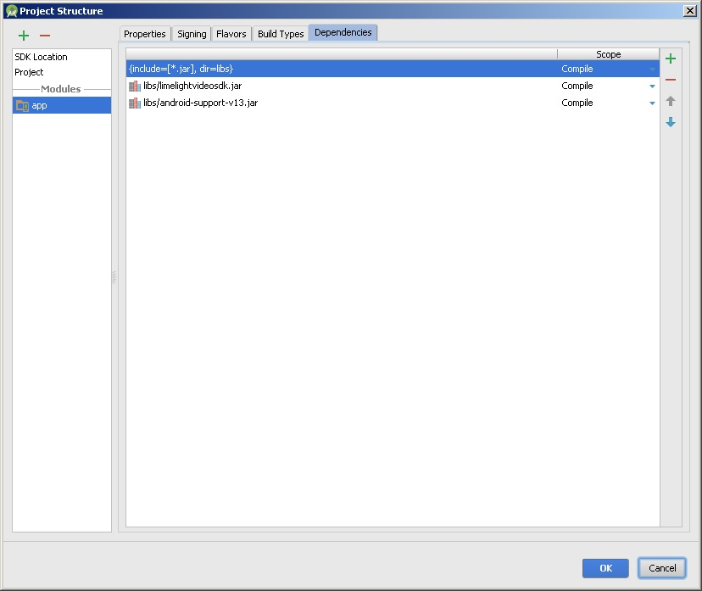

- Go through each Java file you created to have the proper package name. For example, if your Java files were in com -> example -> www -> sampleapplication, then each of those files needs to have this as the first line in their code.
package com.example.www.sampleapplication;
- Change the import below in MainActivity so it matches your package structure.
import com.example.llsdktest2.MediaOfChannel.MediaOfChannelCallback;
For example, if your MainActivity is in com.example.www.sampleapplication, change it to:
import com.example.www.sampleapplication.MediaOfChannel.MediaOfChannelCallback;
- The app is ready to run. Now you just need to set your organization id, access key, and secret key in MediaOfChannel.java (the first three attributes of the class) and set the channel id in MainActivity.java to a channel that you have access to.
- Run the application you should be able to fetch the media of a channel
- Selecting a media you should be able to load the player and play the media.

Congratulations! You should now have a working player. If not, please go back and ensure you’ve followed the steps exactly.

For more information on this SDK, please see the provided documentation.

