[s202s02](https://www.google.nl/search?q=s202s02&biw=1418&bih=725&tbm=isch&tbo=u&source=univ&sa=X&ved=0CCAQsARqFQoTCLfJor7C28cCFYE3FAodINgDHg) 230V 8A 180 Ohm voorschakel weerstand

SSR-10DA 330 Ohm voorschakel weerstand

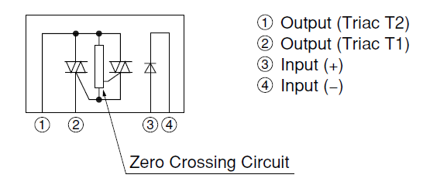

DS80B20 pullup 4k7 pin ~~8~~  7

HN Pin 5 100 ohm serie

330 ohm SSR serie weerstand pin ~~7~~ 8

SSR-10DA Solid State Relay

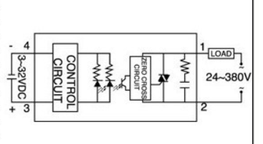

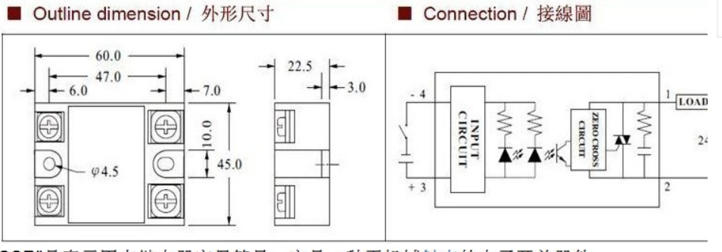

with Arduino's PWM frequency at about 500Hz,

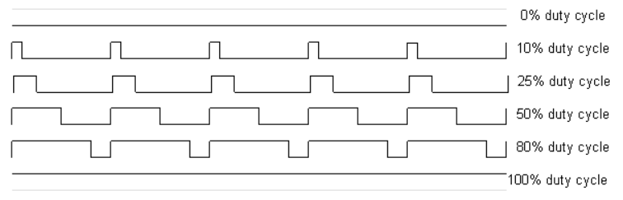

http://www.pamvotis.org/e-solutions/index.php/en/2013-01-05-14-08-40/arduino-acpwm-library

