|  |  |
| --- | --- |
| BC557B / BC560C PNP  Geel Vcc  Groen Serial-CLock SX A5  Rood Serial-Data SY A4  Zwart Gnd  22uF Vcc-line buffer !!  D4 Reed relais Thermostaat.  D5 Reed relais (geen voorschakel R)  500 ohm = 10 mA  Arduino ttl > rs232 Chint  Geel Vcc Vcc  Groen Rx0 Tx  Rood Tx1 Rx  Zwart Gnd Gnd  Temp Pin  D2 (4k7 pullUp DS18B20 parasite power) |  |

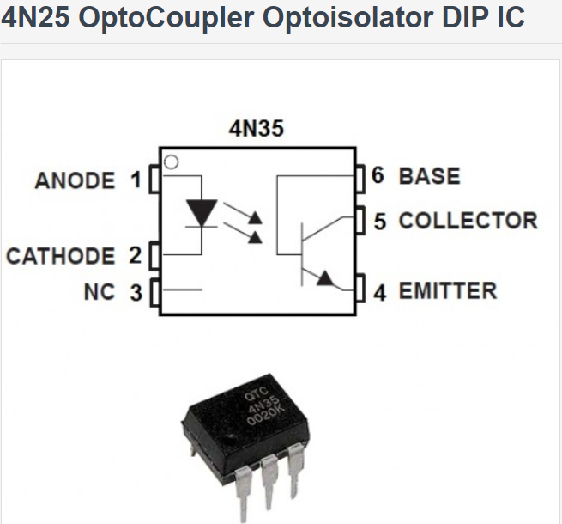

24v ----[ 1k ohm ] ----- 1] [

GND ------------------------ 2] [5 -----[ 100k ohm ]---------------

] [4 GND

5 ----------- Arduino digital input port.

# Open-Source Thermostatic Radiator Valve (OpenTRV)

<https://www.youtube.com/watch?v=QRE3n9HCQMs> EQ3 Model n

<http://iamnotachoice.com/iamnotathermostat/> hacking thermostat knop

<http://www.engineerathome.com/elektronica/meet+je+energieverbruik+met+arduino/9>

**TCRT5000 Optische sensor**

Its small and works well with Arduino. Don't forget use use resistors. Pro: lots of info found on the web. this were usefull: http://blog.huntgang.com/2014/06/17/arduino-tcrt5000-build-ir-sensor/ http://arduinotronics.blogspot.nl/2012/06/reflective-optical-sensor-with.html Cons: Use of extra resisor mandatory (I read on the web)

Pros: Inexpensive and once set up correctly provides accurate, quick and reliable output. Cons: The anode/cathode, and Emitter/Collectors is not marked where I can see. There is an extra nib on the package and I guessed correctly that this was the grounding side. The blue LED is obviously the emitter but I forgot to put a resistor in series and burned out one. It smells. Comments: There is an Arduino schematic easily searched. The resistor on the collector side is not needed if you use INPUT_PULLUP in your digitalRead. I repeat the resistor to the blue led (emmitter) is very much needed. I haven't realized till now how I have been accidentally toasting LED's. Now I know. I need to work out the timing but it is possible to create a speedometer/odometer/tachometer from this simple device

## Opto-elektronische reflectiekoppelaar CNY 70

BONATECH RPR220 Photoelectric Switch / Reflective Type Optocoupler Sensor - Black (2 PCS)