Discoveries/Findings

**Environment Verification**:

**Step 1**: Raise CX ticket to create chef user, add chef user to HGBU Organization and provide user key (User.pem file).

**step 2**: if the chef-starter.zip is in the artifactory,run a wget command. See example below:

wget http://depot.int.oracleindustry.com:8080/export/software/automation/chef/chef-starter.zip

After running the command you will have the chef-repo/.chef directory

**step 3**: cd .chef and edit the knife.rb,edit the knife.rb with your own chef username, chef user key user, chef organization url and knife[:vault_mode] = 'client'..See example below:

current_dir = File.dirname(__FILE__)

log_level :info

log_location STDOUT

node_name "<<Chef Username created in step 1>>"

client_key "#{current_dir}/<<Chef user key User.pem filename>>"

chef_server_url "Chef Organization Url"

cookbook_path ["#{current_dir}/../cookbooks"]

see reference below:

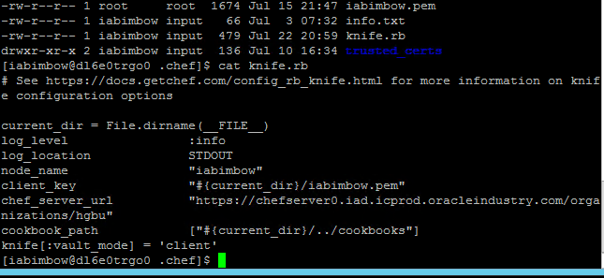

**Step 4: -> Get the chef server ssl certificate.**

knife ssl fetch

**-> Check chef server ssl certificate**.

knife ssl check

**-> Check Nodes bootstrapped to chef server.**

knife node list

knife node list | grep hostname

**Step 5: Check if users exist:**

Run the command su - oci_fmw

su: user oci_fmw does not exist

**Command to install user:**

useradd -u 35004 -g 35005 -d /home/oci_fmw -s /bin/bash oci_fmw

**Command to validate if the user is installed:**

id -a oci_fmw

**see output below:**

uid=35004(oci_fmw) gid=35005(oinstall) groups=35005(oinstall)

**Step 6: check limits.conf**

cat /etc/security/limits.conf to see if you have this values.....these are os limits for all the processes used by the user which is oci_fmw...as root user add above on each chef node and save it, if not available

1. oci_fmw soft nproc 10240
2. oci_fmw hard nproc 16384
3. oci_fmw soft nofile 4096
4. oci_fmw hard nofile 65536
5. oci_fmw soft stack 10240

**Step 7: check on each chef node for client.pem, validation.pem, client.rb and chefserver1_iad cert**

cd /etc/chef/

ls –larht

1. -rw-r--r--. 1 root root 305 Feb 5 2015 solo.rb
2. -rwxr--r--. 1 root root 367 Jun 4 07:26 client.rb
3. -rwxr-xr-x. 1 root root 1.7K Jun 4 07:26 validation.pem
4. drwxr-xr-x. 2 root root 4.0K Jun 4 07:28 trusted_certs
5. -rw-------. 1 root root 1.7K Jun 4 07:28 client.pem
6. drwxr-xr-x 3 root root 21 Jun 23 20:27 ohai
7. drwxr-xr-x. 4 root root 111 Jun 23 20:27 .
8. drwxr-xr-x. 97 root root 8.0K Aug 5 11:09 ..

**Step 8: ls -larht trusted_certs/ to check if below variables are available.**

1. -rw-r--r--. 1 root root 2.5K Jun 4 07:26 chefserver1_iad_icprod_oracleindustry_com.crt
2. -rw-r--r--. 1 root root 1.4K Jun 4 07:28 DigiCert_Global_Root_CA.crt
3. -rw-r--r--. 1 root root 2.5K Jun 4 07:28 avvociochap0010_int_oracleindustry_com.crt
4. drwxr-xr-x. 2 root root 4.0K Jun 4 07:28 .
5. -rw-r--r--. 1 root root 1.7K Jun 4 07:28 DigiCert_SHA2_Secure_Server_CA.crt
6. drwxr-xr-x. 4 root root 111 Jun 23 20:27 ..

**Install all yum packages if not available.**

vi yum_pkg_install.sh

**to apply yum install,**

log in as root, vi yum_pkg.sh,

chmod 755 yum_pkg.sh

then run ./yum_pkg.sh

#!/bin/bash

yum -y install xclock

yum -y install lsb

yum -y install compat-libcap1

yum -y install ksh

yum -y install glibc.x86_64

yum -y install glibc-devel.i686

yum -y install glibc-devel-2.12-1.209.0.3.e16_9.2.x86_64

yum -y install glibc-static.i686

yum –y install glibc-static.x86_64

yum -y install glibc-utils.x86_64

yum -y install libgcc.i686

yum -y install ibstdc++.i686

yum -y install compat-libstdc++-33.i686

yum -y install libstdc++-devel.i686

yum -y install glibc-devel.i686

yum -y install compat-libcap1

yum -y install compat-libcap1-1*

yum -y install compat-libstdc++-33

yum -y install libstdc++-devel

yum -y install gcc-c++

yum -y install libaio-devel

yum -y install dos2unix

**Create OPERA Schemas**

The purpose of this document is to install the OPERA, OXI, OXIHUB, OPERA_OIW and OPERA_OSS Schemas using the Opera SMT Tool. The creation of the OPERA_OIW and OPERA_OSS are only needed for OPERA Cloud

**The cx tickets below are needed for schema creation.**

* Database credentials required - P00740 HGBU Opera Cloud 19.2 (GBUCS 3.0)
* Please stage datapump files - needed for schema creation from opera SMT tool - P00740 HGBU Opera Cloud 19.2 (GBUCS 3.0)

**See cx ticket reference number for previous build below:**

* reference number as per cx tickets.....190822-002960 Database credentials required - P00740 HGBU Opera Cloud 19.2 (GBUCS 3.0)
* reference number as per cx tickets.....190822-003091 Please stage datapump files - needed for schema creation from opera SMT tool - P00740 HGBU Opera Cloud 19.2 (GBUCS 3.0)

**Provisioning team Prerequisite:** we need to determine if Unified Auditing is enabled on the DB's **(V5 application**) for any build. If it is, a CX ticket needs to be created for the DB team to disable this, as it causes issues with the V5 application. Run the command below on all V5 servers

select parameter, value from gv$option where parameter = 'Unified Auditing';

**If you have the output below**: then a cx ticket needs to be created:

SQL> select parameter, value from gv$option where parameter = 'Unified Auditing';PARAMETER  
----------------------------------------------------------------  
VALUE  
----------------------------------------------------------------  
Unified Auditing  
TRUEUnified Auditing  
TRUE

**Findings**:

The rcu schema should have atleast one special character to avoid failure during installation.

**OXI /OXI-HUB :**

The P00741 - Opera 5.6.5- Software Installation - OXI - v1.0 mentioned the below parameters to change Temp Paths, but I noticed the path to change the TEPM Paths is **control panel/system/advanced system/environment variables.**

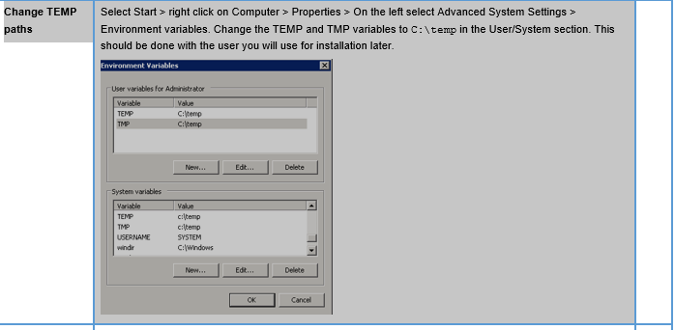

**Installation and upgrade parameter is D:\TEMP\client32,but the doc says below:**

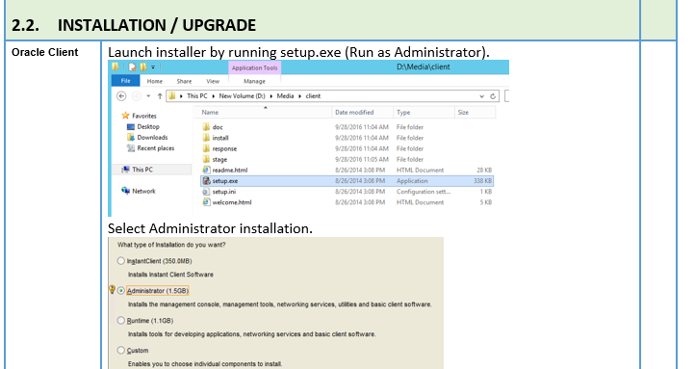

**Command to drop a schema in windows:**

DROP USER OPERA CASCADE; where schema name is OPERA, but make sure you connect to SQL first

**Command to check if DATA_PUMP_FILE has been created:**

select * from dba_directories where directory_name like '%PUMP%';

**The command below disconnects from the user session and closes the scripting shell.**

exit()

**Command to check server status,stop all servers and start all servers but not admin servers**

[oci_fmw@dm3q0v0pj0 bin]$ cd /u01/app/oracle/operainstance/bin/

[oci_fmw@dm3q0v0pj0 bin]$ ll

total 52

-rwx------ 1 oci_fmw oinstall 51986 Sep 17 00:04 opmnctl

[oci_fmw@dm3q0v0pj0 bin]$ ./opmnctl status -l

Processes in Instance: OPERAINST

---------------------------------+--------------------+---------+----------+------------+----------+-----------+------

ias-component | process-type | pid | status | uid | memused | uptime | ports

---------------------------------+--------------------+---------+----------+------------+----------+-----------+------

repdm3q0v0pj0opera | ReportsServerComp~ | 4702 | Alive | 589831234 | 106140 | 60:29:42 | N/A

emagent_OPERAINST | EMAGENT | 4701 | Alive | 589831233 | 106140 | 60:29:42 | N/A

RptSvr_dm3q0v0pj0_OPERAINST | ReportsServerComp~ | 4700 | Alive | 589831232 | 106140 | 60:29:42 | N/A

[oci_fmw@dm3q0v0pj0 bin]$ ./opmnctl stopall

opmnctl stopall: stopping opmn and all managed processes...

[oci_fmw@dm3q0v0pj0 bin]$ ./opmnctl status -l

opmnctl status: opmn is not running.

[oci_fmw@dm3q0v0pj0 bin]$ ps -ef | grep java

oci_fmw 5326 5291 0 Sep17 ? 00:04:22 /u01/jdk/bin/java -client -Xms32m -Xmx200m -XX:MaxPermSize=128m -Dweblogic.nodemanager.sslHostNameVerificationEnabled=false -Dweblogic.security.SSL.enableJSSE=true -Dcoherence.home=/u01/app/oracle/middleware/coherence_3.7 -Dweblogic.nodemanager.sslHostNameVerificationEnabled=false -Dweblogic.security.SSL.enableJSSE=true -Dbea.home=/u01/app/oracle/middleware -Dweblogic.nodemanager.sslHostNameVerificationEnabled=false -Dweblogic.security.SSL.enableJSSE=true -Dweblogic.nodemanager.sslHostNameVerificationEnabled=false -Dweblogic.security.SSL.enableJSSE=true -Dweblogic.security.SSL.enableJSSE=true -Xverify:none -Djava.security.policy=/u01/app/oracle/middleware/wlserver_10.3/server/lib/weblogic.policy -Dweblogic.nodemanager.javaHome=/u01/jdk weblogic.NodeManager -v

oci_fmw 10858 8863 0 14:46 pts/1 00:00:00 grep java

oemagent 16645 16543 0 Sep07 ? 00:51:19 /opt/oemagent/agent/agent_13.2.0.0.0/oracle_common/jdk/bin/java -Xmx128M -XX:MaxPermSize=96M -server -Djava.security.egd=file:///dev/./urandom -Dsun.lang.ClassLoader.allowArraySyntax=true -XX:-UseLargePages -XX:+UseLinuxPosixThreadCPUClocks -XX:+UseConcMarkSweepGC -XX:+CMSClassUnloadingEnabled -XX:+UseCompressedOops -Dwatchdog.pid=16543 -cp /opt/oemagent/agent/agent_13.2.0.0.0/jdbc/lib/ojdbc7.jar:/opt/oemagent/agent/agent_13.2.0.0.0/ucp/lib/ucp.jar:/opt/oemagent/agent/agent_13.2.0.0.0/oracle_common/modules/jsch-0.1.53.jar:/opt/oemagent/agent/agent_13.2.0.0.0/oracle_common/modules/com.oracle.http_client.http_client_12.1.3.jar:/opt/oemagent/agent/agent_13.2.0.0.0/oracle_common/modules/oracle.xdk_12.1.3/xmlparserv2.jar:/opt/oemagent/agent/agent_13.2.0.0.0/oracle_common/modules/oracle.dms_12.1.3/dms.jar:/opt/oemagent/agent/agent_13.2.0.0.0/oracle_common/modules/oracle.odl_12.1.3/ojdl.jar:/opt/oemagent/agent/agent_13.2.0.0.0/oracle_common/modules/oracle.odl_12.1.3/ojdl2.jar:/opt/oemagent/agent/agent_13.2.0.0.0/lib/optic.jar:/opt/oemagent/agent/agent_13.2.0.0.0/sysman/jlib/log4j-core.jar:/opt/oemagent/agent/agent_13.2.0.0.0/jlib/gcagent_core.jar:/opt/oemagent/agent/agent_13.2.0.0.0/sysman/jlib/emagentSDK-intg.jar:/opt/oemagent/agent/agent_13.2.0.0.0/sysman/jlib/emagentSDK.jar oracle.sysman.gcagent.tmmain.TMMain

[oci_fmw@dm3q0v0pj0 bin]$ cd /u01/

app/ filebeat-5.1.1/ jdk/ jdkprevious/ logs/ lost+found/ mfinstall/ micros/ mwfr/ oci_fmw/ oraInventory/ software/ tmp/

[oci_fmw@dm3q0v0pj0 bin]$ cd /u01/oci_fmw/

[oci_fmw@dm3q0v0pj0 oci_fmw]$ ll

**SRE PATCHES**

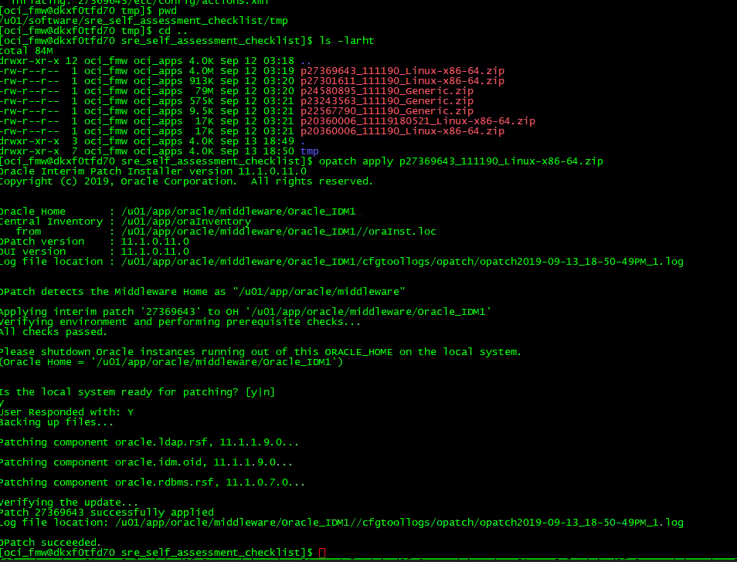

**Opatch version : To check the opatch version..**

**opatch lsinventory | grep 200675 to check the patch applied**

**ohs has no AdminServer**

**TO CHECK IF BOOTS.PROPERTIES IS ENCRYPTED**

**find . -name boot.properties | xargs cat**

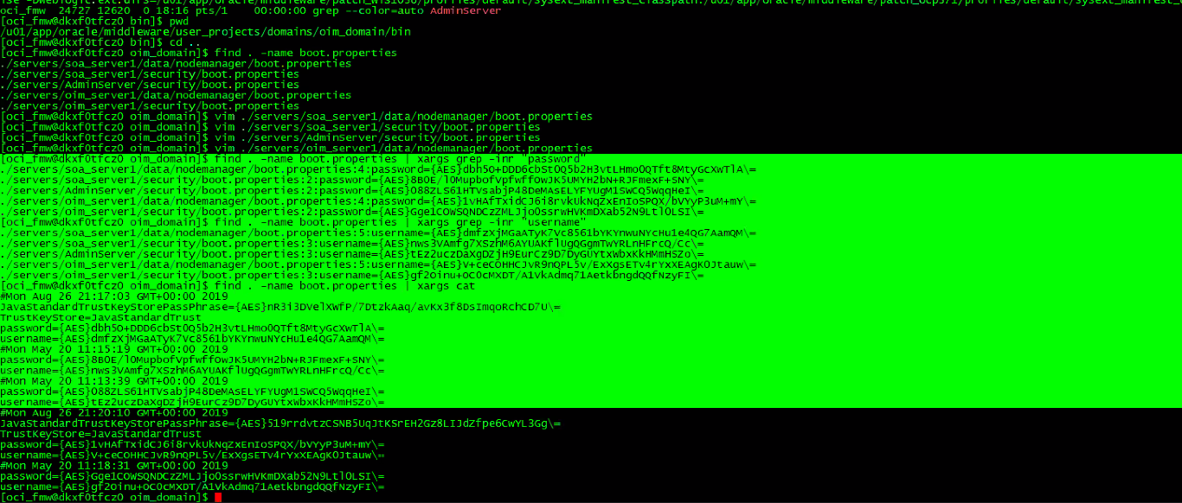

**diff command**

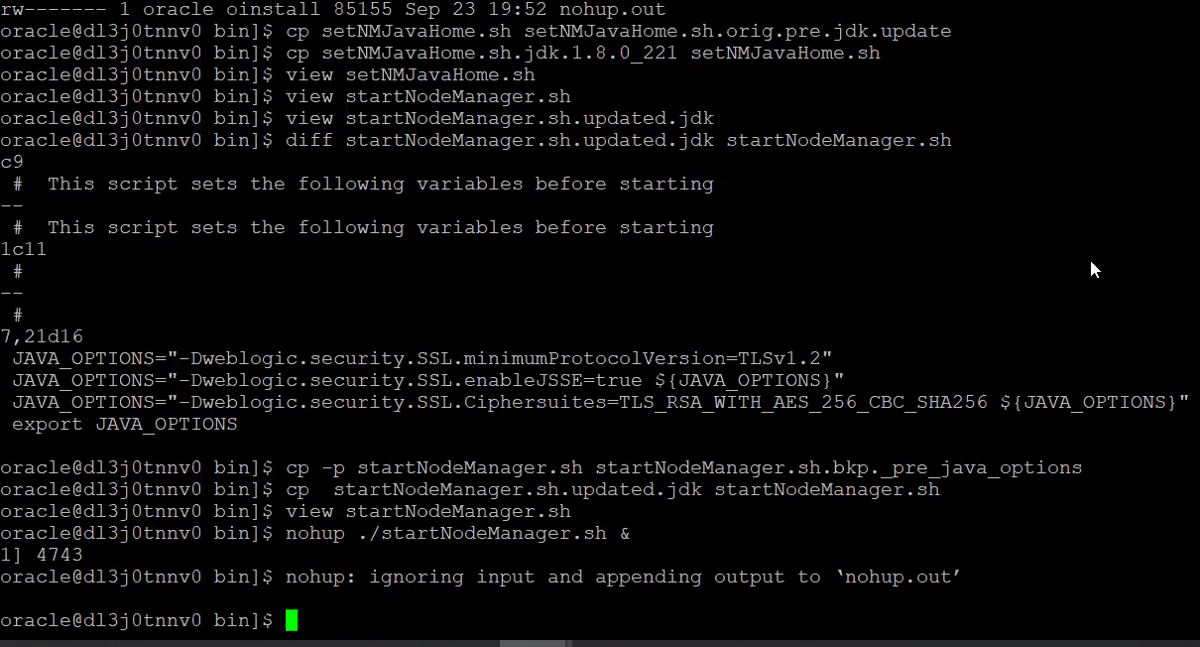

**Find command screenshot**

find . -name V5MACHINE.pem

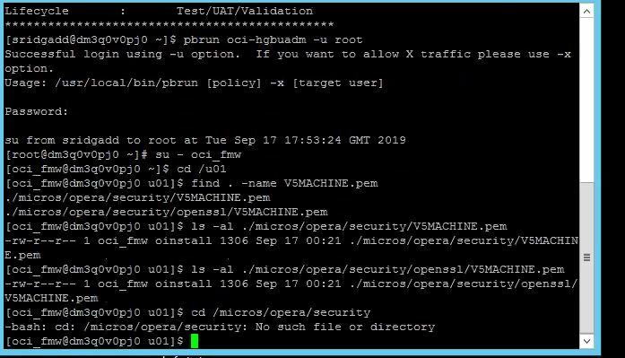

To start and stop servers on windows.we can use the utility below:

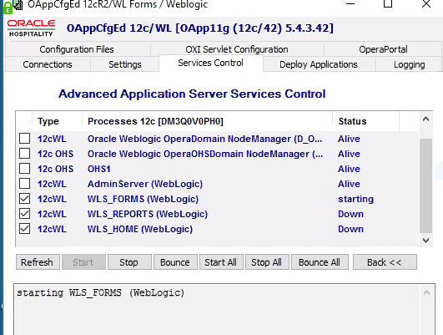

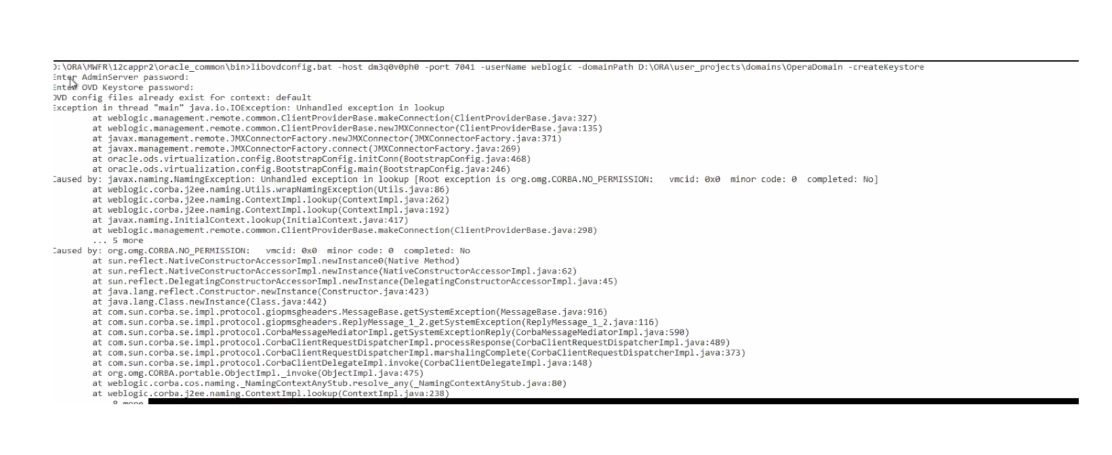

Unable to log into the micros data centre fix : https://www.microsdc.com/DCP/Access/ShowPassword.aspx

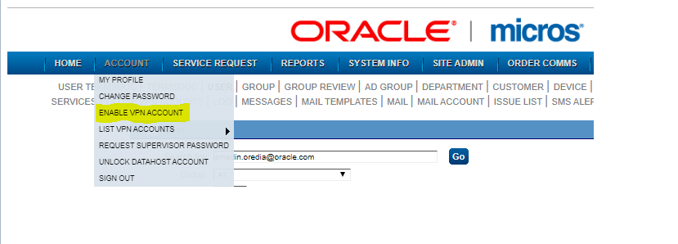

Opmntcl command….start and stops the managed servers not admin servers

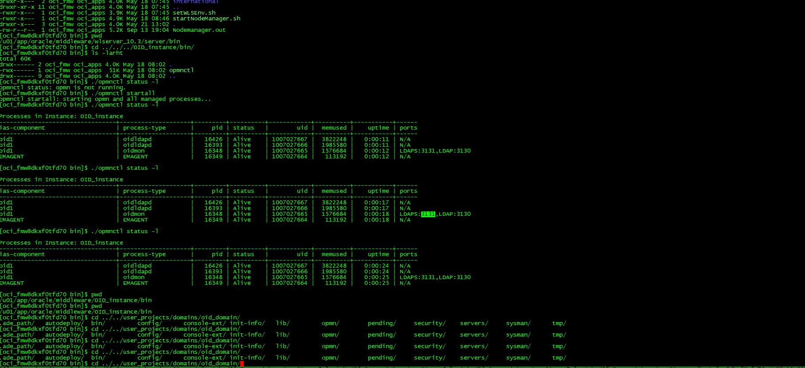

Curl command for patching

take a backup and move to u02/operashare

uat 1...oracle oinstall

uat 2 ..oci_fmw

Oracle12213_Home

Oracle12213_Home

:%s/Oracle_Home/Oracle12213_Home/g find and replace in vi

cd /u01

su - oracle for UAT1/ su - oci_fmw for UAT2

Disney uat 2 no pbrun >>>>>>> use sudo su -

mkdir sre_validation

then use the curl command [curl -f -H 'X-JFrog-Art-Api:AKCp5dLCRdsnPibNFG7NARoNdjgMd4fuajMiT87jJghgjfbo6dC9yvt4UBZeetjh5VKAAVk9t' -L -O](https://artifactory-fg.int.oracleindustry.com/artifactory/list/hgbu-depot/sre/validators/os_validator/os_validator.tar)https://artifactory-fg.int.oracleindustry.com/artifactory/list/hgbu-depot/sre/validators/patches_validator/patches_validator.tar

untar

cd the new tar

run the command ./sre_validation_patches.sh -SB

IF YOU HAVE FAILED ONES.

check the middleware directory for the path to Home.

cd/u01/app/oracle/middleware

then ps -ef | grep Home

then cd

cd sre_validation

cd patches_validator

then VI sre_validation_patches_sh then change with this command :%s/Oracle_Home/Oracle12213_Home/g find and replace in vi

then run the script again..

mv osvalidator* patches_validator*/

**to copy a zip file from bastion to server tmp directory**

you ssh into the server from bastion first then

scp p30158713_122130_Linux-x86-64.zip dl3j0tnnv0.fra.icprod.oracleindustry.com:/tmp

**to search**

history | grep xxxxx

**to untar (create,verbose,zip file*CVZF*)**

tar cvzf middleware_12213_Home_pre-july-cpu-patches-2019.tar.gz /u01/software/july_cpu_patches . this means tar it up and create,verbose,zip file

**to move tar.gz to Disney uat1 backup/ohs**

mv /u01/app/oracle/*.tar.gz /u02/operashare/disn_uat1_backups/ohs/

locate command: locate -i stage

history | grep java

**Command to check if the boot.properties username and pass are encrypted**

**find . -name boot.properties | xargs grep -inr "password"**

**find . -name boot.properties | xargs grep -inr "username"**

**find . -name boot.properties | xargs cat**

**to set the OPATCH PATH**

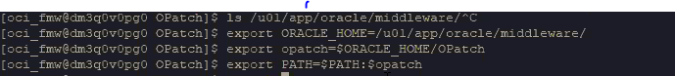

export ORACLE_HOME= /u01/app/oracle/middleware12213_Home

export OPATCH=$ORACLE_HOME/OPatch export opatch=$ORACLE_HOME/OPatch

export PATH=$PATH:$OPATCH

**then**

opatch –version

**NODEMANEGER CONNECT COMMAND**

nmConnect("weblogic","xxxxx","[dl3j0tnnv0.fra.icprod.oracleindustry.com](http://dl3j0tnnv0.fra.icprod.oracleindustry.com/)","5556","ohs_domain","/u01/app/oracle/middleware/user_projects/domains/ohs_domain","ssl")

nmKill(serverName="ohs1", serverType="OHS")

nmStart(serverName="ohs1", serverType="OHS")

to Check all WeblogicCluster targets are individual WLS servers, rather than a load balancer and to Check DynamicServerList is set to default value of ON---- go to the path below:

/u01/micros/opera/security/operaias/opera_wl.conf

**PORTS**

**7002/ui**

**7042/report .......same port for v5 too**

**7022/ws**

**UAT2 WEBLOGIC PASS..Wallyard273**

**UAT1 weblogic pass s9ozVuwri**

**/u01/app/oracle/middleware/Oracle_Home/user_projects/domains/operauidomain/config/jdbc path to check for the initial/min and maximum of datasource in the config directory**

**The jbdc are datasources……**

**The command to check for initial is grep min * must be greater than or equals to 10**

**To check for max grep max * must be greater than or equals to 100**

**To check for min grep ini * must be greater than or equals to 10**

**[oci_fmw@dlzk0uvjv0 jdbc]$ grep min \***

**LocalSvcTblDataSource-jdbc.xml: <min-capacity>10</min-capacity>**

**mds-opss-jdbc.xml: <min-capacity>10</min-capacity>**

**mds-owsm-jdbc.xml: <min-capacity>10</min-capacity>**

**mds-v9app_mds-jdbc.xml: <min-capacity>10</min-capacity>**

**opss-audit-jdbc.xml: <min-capacity>10</min-capacity>**

**opss-auditview-jdbc.xml: <min-capacity>10</min-capacity>**

**opss-datasource-jdbc.xml: <min-capacity>10</min-capacity>**

**WLSSchemaDataSource-jdbc.xml: <min-capacity>10</min-capacity>**

**[oci_fmw@dlzk0uvjv0 jdbc]$ grep max * max must be greater than or equals to 100**

**LocalSvcTblDataSource-jdbc.xml: <max-capacity>150</max-capacity>**

**mds-opss-jdbc.xml: <max-capacity>150</max-capacity>**

**mds-owsm-jdbc.xml: <max-capacity>150</max-capacity>**

**mds-v9app_mds-jdbc.xml: <max-capacity>150</max-capacity>**

**opss-audit-jdbc.xml: <max-capacity>150</max-capacity>**

**opss-auditview-jdbc.xml: <max-capacity>150</max-capacity>**

**opss-datasource-jdbc.xml: <max-capacity>150</max-capacity>**

**WLSSchemaDataSource-jdbc.xml: <max-capacity>150</max-capacity>**

**[oci_fmw@dlzk0uvjv0 jdbc]$ grep ini \***

**LocalSvcTblDataSource-jdbc.xml: <initial-capacity>10</initial-capacity>**

**mds-opss-jdbc.xml: <initial-capacity>10</initial-capacity>**

**mds-owsm-jdbc.xml: <initial-capacity>10</initial-capacity>**

**mds-v9app_mds-jdbc.xml: <initial-capacity>10</initial-capacity>**

**opss-audit-jdbc.xml: <initial-capacity>10</initial-capacity>**

**opss-auditview-jdbc.xml: <initial-capacity>10</initial-capacity>**

**opss-datasource-jdbc.xml: <initial-capacity>10</initial-capacity>**

**WLSSchemaDataSource-jdbc.xml: <initial-capacity>10</initial-capacity>**

**[oci_fmw@dlzk0uvjv0 jdbc]$**

**=================================================================**

**To Confirm that java heap sizes are set correctly ps –ef | grep java**

**ps –ef | grep Xmx for max**

**ps –ef | grep Xms for min**

**command to check to know if you installed the right OS PATCHES**

**rpm -qa \*\*\*\*\***

**sre_validator_patches.sh**

alias ww='/bin/sh /home/lloredia/start_tmux.sh'  
alias ll='ls -larht --color=auto'  
alias pp='pbrun oci-hgbuadm -u root'  
alias ssh='ssh -o ServerAliveInterval=5'  
alias c='clear && history -c'

alias t='tmux'  
alias reboot='reboot now'  
alias ..='cd ..'  
alias ...='cd ../../../'  
alias ....='cd ../../../../'  
alias .....='cd ../../../../'  
alias .4='cd ../../../../'  
alias .5='cd ../../../../..'  
alias getpass="openssl rand -base64 20"

when you are applying **os patch**..you have to be as root/tmp directory..os patches is installing the yum packages.

**Webtier/ohs** ps –ef | grep httpd

=============================================================

Ssh -o ServerAliveInterval=100 fqdn

=================================================================================

**to check the hostname**

hostname -f to check the hostname

=====================================================================

deployment/dms application to targets to cluster or AdminServer from the console.

==============================================================================

**command to check if all the passwords are encrypted**

find . -name boot.properties | xargs grep -inr "password" command to check if all the passwords are encrypted

================================================================================================

in **wydham** the oracle home should point to oracle12.2.1.3 when doing the validation.cos it was upgraded

**path to invoke the wlst**

/u01/app/oracle/middleware/Oracle12213_Home/oracle_common/common/bin >>>> path to invoke the wlst

[oci_fmw@dl410tof60 bin]$ ./wlst.sh

**Then run the command below:Always check the nodemanager listen port to be sure:**

nmConnect("weblogic","MainShell055","dl410tof60.fra.icprod.oracleindustry.com","5558","ui_domain","/u01/app/oracle/middleware/Oracle_Home/user_projects/domains/ui_domain/","ssl") then start the AdminServer with the command below:

nmStart("AdminServer")

ctrl+R >>>>>>> for reversal

**After making changes on the server,do the instructions below:**

after the stopping the admin and managed server from the console….you stop the nodemanager,start it back up with nohup,then run the nmconnect command nmConnect("weblogic","MainShell055","dl410tof60.fra.icprod.oracleindustry.com","5558","ui_domain","/u01/app/oracle/middleware/Oracle_Home/user_projects/domains/ui_domain/","ssl")

then run the command nmStart("AdminServer")

hostname/server-status to check the server-status then run this command to check the server status curl --trace-ascii /var/tmp/dump.txt -k <https://dl6g0trla0.fra.icprod.oracleindustry.com/server-status>

to check for the jmx port ….

netstat -plant | grep 9105 (9105 is the jmx port found in the setOverrides)

to reboot the window servers >>>>>> go to this path D:\MICROS\opera\Tools,the run the oAppconf UTILITY.then click on services control

Go to the cmd>>>> tasklist | grep java to see the services running on java.

/u01/app/oracle/middleware/Oracle_Home/user_projects/domains/ui_domain/bin path to start and stop nodemanager

u01/app/oracle/middleware/Oracle_Home/oracle_common/common/bin path to invoke wlst

nmConnect("weblogic","Y0un9_th3me626","dl410tof60.fra.icprod.oracleindustry.com","5558","ui_domain","/u01/app/oracle/middleware/Oracle_Home/user_projects/domains/ui_domain/","ssl")

reboot the servers before starting back the nodemanager

12c you use the startcomponent to start all components.

In reports..you use the opmntcl and you use the ./startweblogic.sh command to start the admin server,while you use nmconnect command to start all other nodes

**Also, for SSD EMEA UAT OHS, you have to start the OHS from new middleware home(middleware_12213) domain(ohs_domain) unlike Disney UAT1/Wyndham UAT OC env where you started up OHS from old middleware home(middleware) domain(ohs_domain)**

**Query to run to see to** confirm DB passwords/OHRC sensitive for an year applied to Marriott

